# Mapping Your Startup’s Future

# Mastering Wardley Maps for Strategic Success

### **WARNING: This content was generated using Generative AI. While efforts have been made to ensure accuracy and coherence, readers should approach the material with critical thinking and verify important information from authoritative sources.**

# Table of Contents

Introduction: The Power of Wardley Mapping for Startups 5

What is Wardley Mapping? 5

Origins and core concepts 5

Why Wardley Mapping is particularly valuable for startups 8

The Startup Ecosystem and Wardley Maps 11

Unique challenges faced by startups 11

How Wardley Mapping addresses these challenges 14

Chapter 1: Fundamentals of Wardley Mapping for Startups 17

Components of a Wardley Map 17

Value chain analysis 17

Evolution axis 20

Anchors and dependencies 23

Creating Your First Wardley Map 26

Identifying user needs 26

Mapping the value chain 30

Assessing component evolution 33

Interpreting Wardley Maps 36

Patterns and anti-patterns 36

Identifying strategic opportunities 40

Common pitfalls for startups 43

Chapter 2: Market Opportunity Analysis with Wardley Maps 47

Identifying Market Gaps 47

Using maps to spot underserved needs 47

Assessing market maturity 50

Predicting future market movements 53

Competitive Landscape Mapping 56

Positioning your startup 56

Identifying potential competitors and collaborators 59

Anticipating market shifts 63

Strategic Decision Making 66

Build, buy, or partner decisions 66

Prioritising product features 69

Timing market entry 73

Chapter 3: Scaling Strategies Using Wardley Maps 77

Resource Allocation 77

Identifying critical components 77

Balancing innovation and efficiency 80

Optimising for different stages of startup growth 83

Organisational Structure and Culture 87

Aligning team structure with map insights 87

Fostering innovation in evolving components 90

Building a map-driven culture 94

Technology Stack Decisions 97

Evaluating technology choices 97

Planning for future scalability 101

Managing technical debt 104

Chapter 4: Case Studies: Wardley Mapping Success Stories 107

Tech Startup Case Study 107

Initial mapping and strategy 107

Pivots and adaptations 110

Results and lessons learned 113

Service-based Startup Case Study 117

Using maps for service design 117

Scaling operations efficiently 120

Market expansion strategies 123

Product-based Startup Case Study 126

Product roadmap development 126

Supply chain optimisation 130

Competitive positioning 134

Conclusion: Integrating Wardley Mapping into Your Startup’s DNA 138

Building a Map-Driven Culture 138

Regular mapping sessions 138

Encouraging strategic thinking at all levels 141

Adapting to change with agility 145

Future Trends in Wardley Mapping for Startups 148

Emerging tools and technologies 148

Integration with other strategic frameworks 151

The evolving startup ecosystem 153

Appendix: Book Generation Details 157

Appendix: Further Reading on Wardley Mapping 158

Core Wardley Mapping Series 158

Practical Resources 161

Specialized Applications 162

# Introduction: The Power of Wardley Mapping for Startups

## What is Wardley Mapping?

### Origins and core concepts

Wardley Mapping, a strategic planning technique developed by Simon Wardley, has emerged as a powerful tool for startups navigating the complex and rapidly evolving business landscape. This visual mapping approach provides a unique framework for understanding the positioning of components in a business ecosystem, their evolutionary stage, and the dependencies between them. For startups, where agility and strategic decision-making are paramount, Wardley Mapping offers invaluable insights that can shape the trajectory of a young company.

The origins of Wardley Mapping can be traced back to the early 2000s when Wardley, frustrated with the limitations of existing strategic planning tools, began developing a new approach to visualise business landscapes. Drawing inspiration from Sun Tzu’s ‘The Art of War’ and the concept of situational awareness, Wardley sought to create a method that could capture the dynamic nature of business environments and provide actionable insights for strategic decision-making.

Wardley Mapping is not just a tool, but a new language for strategy. It allows us to see the landscape, anticipate change, and make informed decisions in a way that traditional methods simply cannot match.

At its core, Wardley Mapping is built upon several fundamental concepts that are particularly relevant to startups:

* Value Chain Analysis: Mapping the components that deliver value to the end user, from the most visible to the underlying infrastructure.
* Evolution Axis: Representing the maturity of each component, from genesis (novel) to commodity (ubiquitous).
* Anchors: Identifying the user needs that drive the entire value chain.
* Movement: Understanding how components evolve over time and the impact of this evolution on the business landscape.
* Climatic Patterns: Recognising recurring patterns in business and technology landscapes that influence strategic decisions.

For startups, these concepts provide a framework for understanding their position in the market, identifying opportunities for innovation, and making strategic decisions about resource allocation and product development. The value chain analysis helps startups identify where they can add unique value, while the evolution axis guides decisions about which components to build in-house and which to outsource or leverage as commodities.

One of the key strengths of Wardley Mapping for startups is its ability to visualise the entire business landscape on a single canvas. This holistic view is crucial for young companies that need to understand their ecosystem, identify potential partners and competitors, and anticipate market shifts. By mapping out their business landscape, startups can gain a clearer understanding of their strategic position and make more informed decisions about their future direction.

In the fast-paced world of startups, Wardley Mapping acts as a strategic compass, helping founders navigate uncertainty and chart a course towards sustainable growth and competitive advantage.

The concept of evolution in Wardley Mapping is particularly relevant for startups operating in rapidly changing technology sectors. By understanding how different components of their business are likely to evolve over time, startups can anticipate market changes, identify emerging opportunities, and make strategic bets on future technologies or business models. This foresight can be a significant competitive advantage in fast-moving markets.

Another core concept of Wardley Mapping that resonates strongly with startups is the idea of ‘doctrine’ - the principles and practices that guide decision-making and operations. For startups, developing a clear doctrine based on Wardley Mapping principles can help create a culture of strategic thinking and agility throughout the organisation. This can be particularly valuable as the company grows and faces increasingly complex strategic challenges.

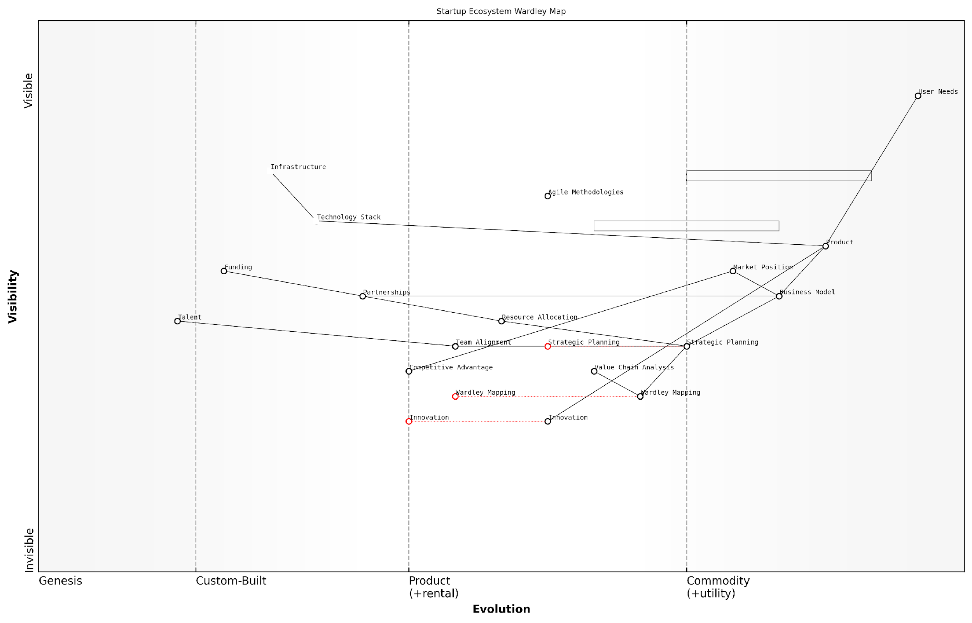

*Draft Wardley Map: [Insert Wardley Map: Origins and core concepts]*

[Edit this draft Wardley Map](https://create.wardleymaps.ai/#clone:d48569c5379c185916)

Wardley Map Assessment

This Wardley Map reveals a startup ecosystem that is well-structured but with significant opportunities for optimization. The strategic positioning of Wardley Mapping and Innovation as evolving components suggests a forward-thinking approach. However, there’s room for better integration of these elements with Strategic Planning and Market Position. The ecosystem shows a good balance between foundational elements and higher-level strategic components, but could benefit from more explicit connections between Innovation and market-facing elements. To maintain competitiveness, the startup should focus on accelerating the evolution of key components like Wardley Mapping and Innovation, while also preparing for the commoditization of currently custom-built practices. The emphasis on Team Alignment and Partnerships indicates a collaborative approach, which should be leveraged for ecosystem-wide innovation and growth. Overall, the map represents a startup poised for growth, with clear areas for strategic improvement and innovation.

[View full Wardley Map report](http://markdown_wardley_map_reports/wardley_map_report_01_Origins_and_core_concepts.md)

The application of Wardley Mapping in startups extends beyond strategic planning to areas such as product development, market positioning, and resource allocation. By mapping out their product features and comparing them to user needs and market evolution, startups can prioritise development efforts and identify areas for innovation. Similarly, by understanding the evolutionary stage of different components in their value chain, startups can make informed decisions about which elements to develop in-house and which to outsource or acquire through partnerships.

One of the most powerful aspects of Wardley Mapping for startups is its ability to facilitate strategic conversations and align teams around a shared vision. The visual nature of the maps makes complex business landscapes more accessible and easier to discuss, enabling founders, team members, and investors to develop a common understanding of the company’s strategic position and future direction.

Wardley Mapping has transformed how we approach strategy in our startup. It’s not just about planning; it’s about creating a shared language for discussing and shaping our future.

As startups grow and evolve, Wardley Mapping can continue to provide value by helping to identify new opportunities, anticipate market shifts, and guide strategic pivots. The iterative nature of mapping aligns well with the agile methodologies often employed by startups, allowing for continuous refinement of strategy as new information becomes available or market conditions change.

In conclusion, the origins and core concepts of Wardley Mapping offer a powerful framework for startups to navigate the complexities of modern business environments. By providing a visual representation of the business landscape, guiding strategic decision-making, and fostering a culture of strategic thinking, Wardley Mapping equips startups with the tools they need to thrive in competitive and rapidly evolving markets. As we delve deeper into the application of Wardley Mapping for startups in subsequent chapters, we will explore how these core concepts can be leveraged to drive growth, innovation, and sustainable competitive advantage.

### Why Wardley Mapping is particularly valuable for startups

Wardley Mapping, a strategic planning technique developed by Simon Wardley, has emerged as an invaluable tool for startups navigating the complex and rapidly evolving business landscape. This visual approach to strategy offers unique advantages that are particularly well-suited to the challenges faced by early-stage companies. As we delve into the reasons why Wardley Mapping is especially beneficial for startups, it’s crucial to understand how this methodology aligns with the dynamic nature of entrepreneurial ventures and supports their growth trajectory.

Firstly, Wardley Mapping provides startups with a clear visualisation of their business landscape. In the often chaotic early stages of a company’s life, this clarity is invaluable. The map allows founders and team members to see the entire value chain of their business, from user needs to the components that fulfil those needs. This holistic view is particularly crucial for startups, which may be operating in new or rapidly changing markets where traditional industry analyses may fall short.

Wardley Mapping is like turning on the lights in a dark room for startups. Suddenly, you can see where you’re standing, what’s around you, and where you need to go.

Secondly, Wardley Mapping excels at revealing hidden dependencies and assumptions. Startups often operate on a series of hypotheses about their market, product, and business model. Mapping these elements visually can quickly highlight inconsistencies or overlooked connections. This is crucial for startups, where resources are limited and every decision carries significant weight. By exposing these hidden factors, Wardley Mapping enables more informed decision-making and risk management.

Another key benefit is the map’s ability to show the evolution of components over time. This is particularly relevant for startups operating in technology-driven sectors, where the pace of change is rapid. By plotting components along the evolution axis, startups can anticipate future market movements and position themselves strategically. This foresight is invaluable for young companies that need to stay ahead of the curve to survive and thrive.

* Visualises the entire business landscape
* Reveals hidden dependencies and assumptions
* Shows component evolution over time
* Facilitates strategic positioning
* Supports agile decision-making

Wardley Mapping also supports the agile decision-making process that is characteristic of successful startups. The visual nature of the maps allows for quick updates and iterations as new information becomes available or market conditions change. This aligns perfectly with the lean startup methodology, enabling rapid pivots and adaptations based on real-time insights.

Furthermore, Wardley Mapping serves as an excellent communication tool for startups. Whether pitching to investors, onboarding new team members, or aligning with partners, the visual representation of the business strategy facilitates clearer and more effective communication. This is particularly valuable for startups that often need to explain complex or novel business models to various stakeholders.

A picture is worth a thousand words, but a Wardley Map is worth a thousand meetings. It aligns teams, convinces investors, and clarifies strategy in ways that traditional business plans simply can’t match.

The technique also helps startups in identifying potential areas for innovation and differentiation. By mapping out the current state of their industry, startups can spot gaps in the market or areas where existing solutions are suboptimal. This insight can guide product development and market positioning strategies, helping startups to focus their limited resources on areas with the highest potential impact.

Wardley Mapping is particularly effective in helping startups navigate the ‘build, buy, or partner’ decisions that are critical in the early stages of growth. By visualising the components of their value chain and their relative importance and maturity, startups can make more informed decisions about where to invest their resources and where to leverage external solutions or partnerships.

Moreover, Wardley Mapping can be a powerful tool for scenario planning, an essential activity for startups operating in uncertain environments. By creating multiple maps representing different future scenarios, startups can prepare for various outcomes and develop more robust, adaptable strategies.

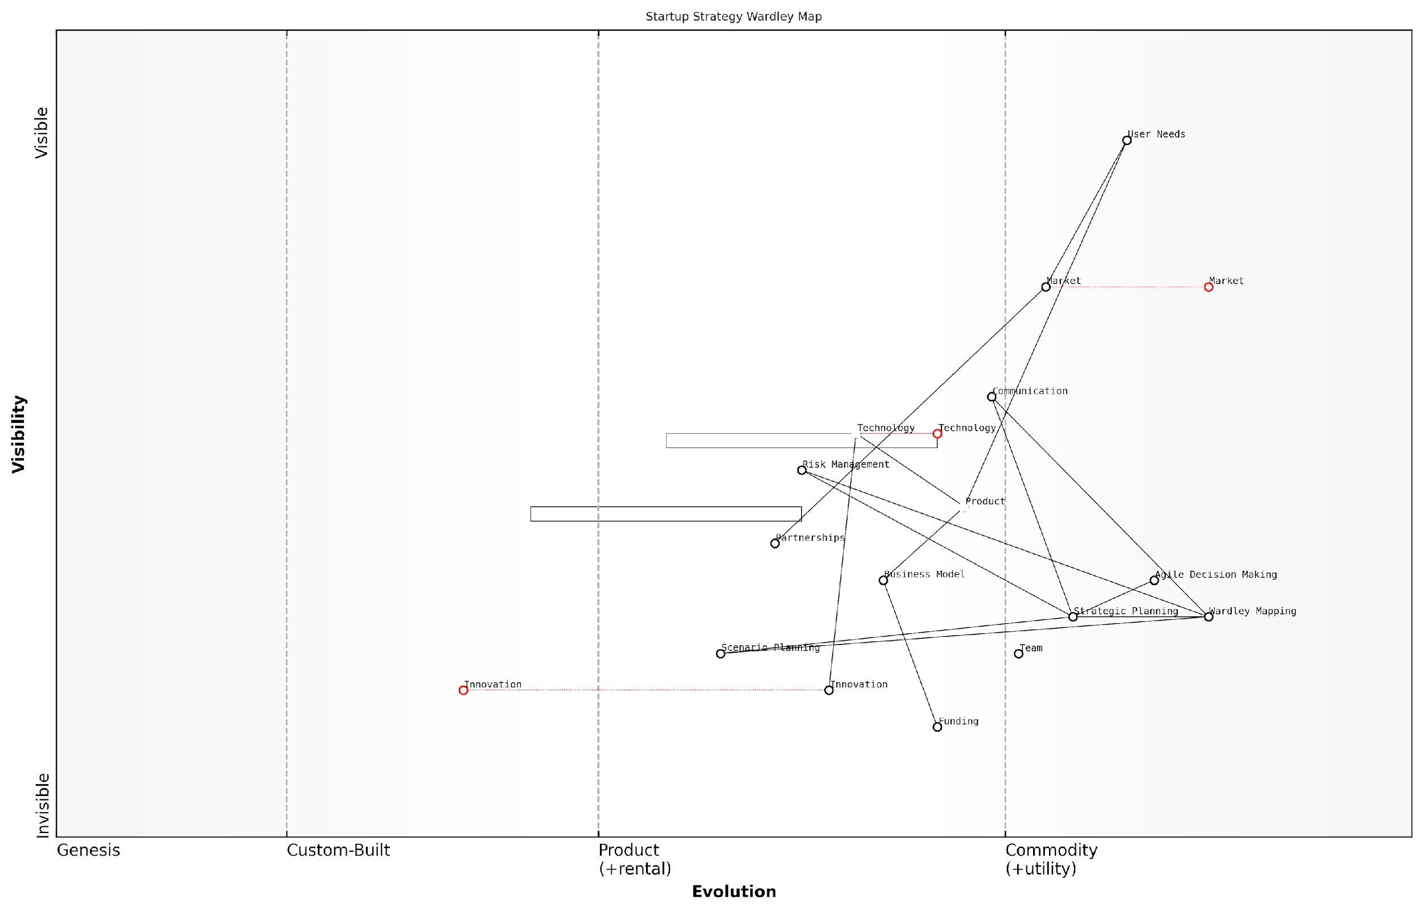

*Draft Wardley Map: [Insert Wardley Map: Why Wardley Mapping is particularly valuable for startups]*

[Edit this draft Wardley Map](https://create.wardleymaps.ai/#clone:a51229554a8000bece)

Wardley Map Assessment

This Wardley Map illustrates a startup ecosystem that is strategically focused on user needs and agile decision-making, with Wardley Mapping playing a crucial role in informing strategy. The positioning of components suggests a good foundation for value creation, but there are opportunities to enhance innovation, partnerships, and long-term resilience. The explicit inclusion of Wardley Mapping as a strategic tool underscores its particular value for startups in navigating complex, rapidly evolving environments. To maintain competitiveness, the startup should focus on evolving its innovation capabilities, strengthening partnerships, and preparing for the commoditization of current technological advantages.

[View full Wardley Map report](http://markdown_wardley_map_reports/wardley_map_report_02_Why_Wardley_Mapping_is_particularly_valuable_for_s.md)

It’s worth noting that while Wardley Mapping offers numerous benefits, it does require an investment of time and effort to master. However, for startups, this investment can pay significant dividends in terms of strategic clarity, operational efficiency, and competitive advantage. The technique’s emphasis on visual thinking and iterative strategy development aligns well with the fast-paced, adaptive nature of startup environments.

In conclusion, Wardley Mapping offers a unique and powerful approach to strategy that is particularly well-suited to the needs of startups. Its ability to provide clarity, reveal hidden factors, anticipate market changes, support agile decision-making, and facilitate communication makes it an invaluable tool for entrepreneurs navigating the challenges of building and scaling a new business. As startups continue to play a crucial role in driving innovation and economic growth, techniques like Wardley Mapping will become increasingly important in helping these ventures succeed in complex and competitive markets.

## The Startup Ecosystem and Wardley Maps

### Unique challenges faced by startups

Startups operate in a unique ecosystem characterised by rapid change, uncertainty, and resource constraints. Understanding these challenges is crucial for effectively applying Wardley Mapping to startup strategy. As we delve into the intersection of the startup ecosystem and Wardley Maps, we’ll explore how this powerful tool can address the specific hurdles that new ventures face in their quest for growth and sustainability.

The startup landscape is fraught with challenges that can make or break a fledgling company. Let’s examine these challenges through the lens of Wardley Mapping, a strategic tool that can provide startups with a competitive edge in navigating this complex terrain.

* Resource Scarcity
* Market Uncertainty
* Rapid Technological Change
* Scaling Challenges
* Competitive Pressure

Resource Scarcity: Perhaps the most pressing challenge for startups is the limited availability of resources, both financial and human. Wardley Mapping can be instrumental in addressing this issue by providing a visual representation of where resources are being allocated and identifying areas where efficiencies can be gained.

Wardley Mapping allows us to visualise our entire value chain and make informed decisions about where to invest our limited resources for maximum impact.

By mapping out the components of their business and their relative positions on the evolution axis, startups can prioritise investments in areas that will provide the most significant competitive advantage. This approach helps in avoiding the common pitfall of spreading resources too thin across multiple fronts.

Market Uncertainty: Startups often operate in nascent or rapidly evolving markets, where customer needs and preferences are not yet fully understood. Wardley Mapping excels in this context by providing a framework for visualising market dynamics and predicting future movements.

By mapping out user needs and the components that satisfy these needs, startups can identify gaps in the market and anticipate shifts in customer demand. This foresight allows them to position their offerings strategically and adapt quickly to changing market conditions.

The beauty of Wardley Mapping for startups is its ability to bring clarity to market chaos, allowing us to see patterns and opportunities that others might miss.

Rapid Technological Change: The pace of technological advancement presents both opportunities and threats for startups. Wardley Mapping helps startups navigate this landscape by providing a clear view of the technological components underpinning their business and their relative maturity.

By understanding where different technologies sit on the evolution axis, startups can make informed decisions about which technologies to adopt, when to invest in emerging technologies, and how to balance innovation with stability in their tech stack.

Scaling Challenges: As startups grow, they often face difficulties in scaling their operations, processes, and culture. Wardley Mapping can be an invaluable tool in planning for scale by providing a holistic view of the organisation and its dependencies.

By mapping out the entire value chain and identifying which components are likely to evolve or become commoditised, startups can anticipate bottlenecks and plan for future growth. This foresight allows them to build scalable systems and processes from the outset, rather than having to retrofit solutions as they grow.

Wardley Mapping has been transformative in our scaling efforts. It’s like having a roadmap for our company’s future, allowing us to build with scale in mind from day one.

Competitive Pressure: In the startup world, competition can emerge quickly and from unexpected quarters. Wardley Mapping provides a powerful framework for competitive analysis, allowing startups to visualise their position relative to competitors and identify areas of differentiation.

By mapping out the competitive landscape, startups can identify areas where they can build moats around their business, anticipate competitive moves, and make strategic decisions about where to compete and where to collaborate.

In conclusion, the unique challenges faced by startups require a strategic tool that can provide clarity in the face of uncertainty, guide resource allocation in times of scarcity, and offer foresight in rapidly changing markets. Wardley Mapping, with its focus on visual representation of value chains and evolutionary patterns, is uniquely suited to address these challenges.

By embracing Wardley Mapping, startups can transform these challenges into opportunities, gaining a competitive edge in their quest for growth and sustainability. As we delve deeper into the application of Wardley Mapping for startups in subsequent chapters, we’ll explore practical strategies for leveraging this powerful tool to navigate the complex startup ecosystem successfully.

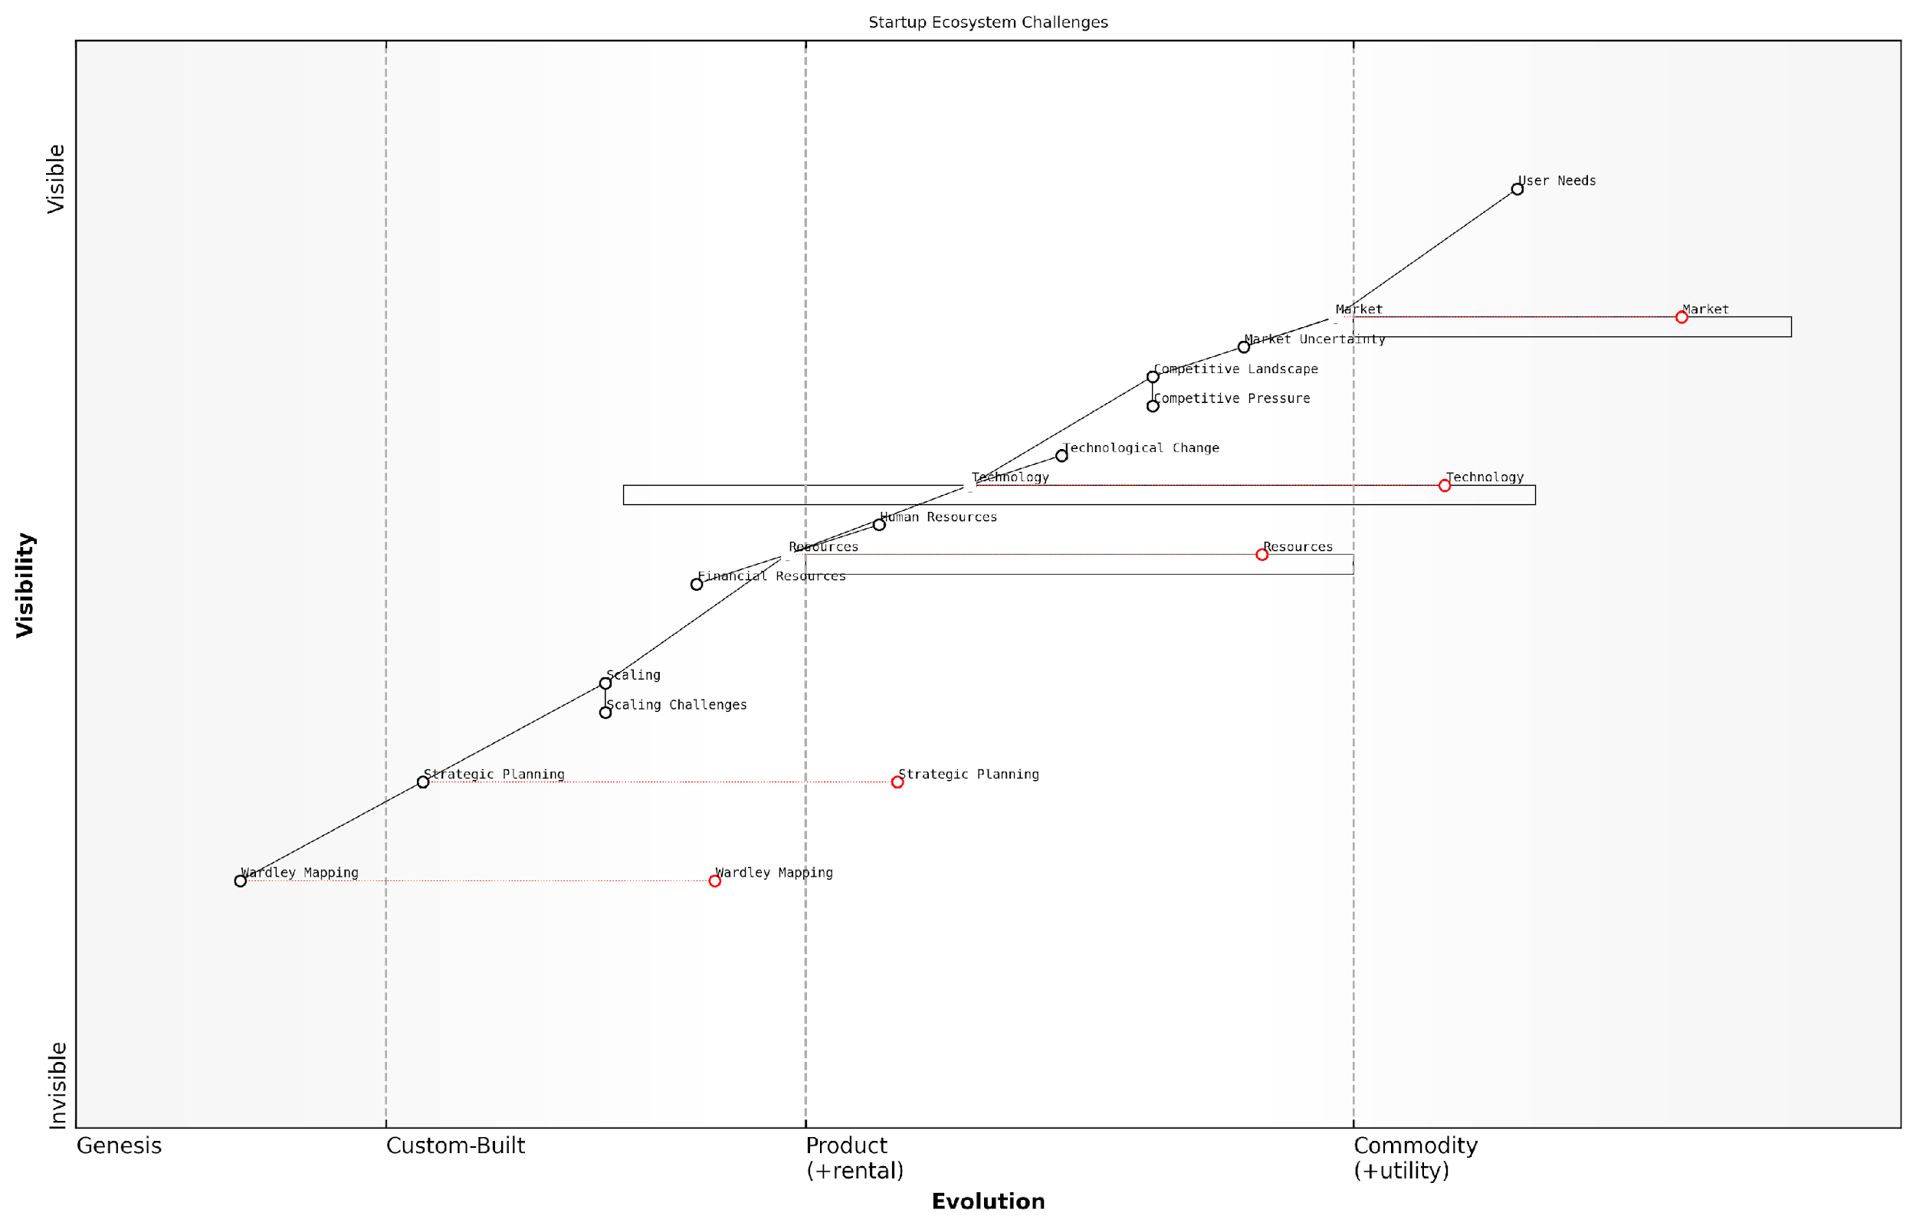

*Draft Wardley Map: [Insert Wardley Map: Unique challenges faced by startups]*

[Edit this draft Wardley Map](https://create.wardleymaps.ai/#clone:8a4f5c483413368322)

Wardley Map Assessment

This Wardley Map reveals the complex challenges faced by startups, highlighting the tension between meeting immediate market needs and building long-term strategic capabilities. The positioning of components suggests most startups are adept at understanding user needs and engaging with markets but struggle with scaling and strategic planning. The inclusion of Wardley Mapping as an emerging tool indicates a potential shift towards more sophisticated strategic approaches. To succeed, startups must balance their focus on user needs and market dynamics with investments in scaling capabilities, strategic planning, and advanced analytical tools. The key to success lies in navigating the evolution of all components simultaneously, from the highly visible market dynamics to the less visible but crucial strategic elements.

[View full Wardley Map report](http://markdown_wardley_map_reports/wardley_map_report_03_Unique_challenges_faced_by_startups.md)

### How Wardley Mapping addresses these challenges

Wardley Mapping emerges as a powerful tool for startups to navigate the complex and often tumultuous landscape of early-stage business development. By providing a visual and strategic framework, Wardley Mapping directly addresses many of the unique challenges faced by startups, offering a structured approach to decision-making, resource allocation, and strategic planning.

Let’s explore how Wardley Mapping specifically tackles the key challenges faced by startups:

* Uncertainty and Rapid Change
* Resource Constraints
* Market Positioning
* Technology Stack Decisions
* Scaling Challenges

Uncertainty and Rapid Change: Startups operate in environments characterised by high uncertainty and rapid change. Wardley Mapping provides a dynamic framework that allows startups to visualise their entire value chain and the evolution of components within it. This visual representation enables founders and teams to anticipate changes, identify potential disruptions, and adapt their strategies accordingly.

Wardley Mapping gives startups a ‘living document’ that evolves with the business, providing a shared visual language for discussing and adapting to change. It’s like having a strategic radar for your business.

Resource Constraints: One of the most pressing challenges for startups is the efficient allocation of limited resources. Wardley Mapping helps address this by providing a clear visualisation of which components are most critical to the business and at what stage of evolution they are. This allows startups to prioritise their investments and efforts more effectively, focusing on areas that will provide the most strategic value.

For instance, a startup might use a Wardley Map to identify which components of their product or service are still in the genesis or custom-built phases, requiring more investment and innovation, versus those that are more commodity-like and can be outsourced or acquired more cheaply.

Market Positioning: Startups often struggle to find their unique position in the market. Wardley Mapping provides a framework for analysing the competitive landscape and identifying gaps or opportunities. By mapping out the entire value chain, including competitors and potential partners, startups can identify underserved areas or novel ways to create value for customers.

Wardley Mapping is like having a strategic GPS for your startup. It not only shows you where you are in the market but also reveals the unexplored territories where you might stake your claim.

Technology Stack Decisions: For tech startups, choosing the right technology stack is crucial but often challenging. Wardley Mapping can guide these decisions by helping startups understand the maturity and strategic importance of different technologies. By mapping out the evolution of various components, startups can make more informed decisions about whether to build custom solutions, use open-source technologies, or opt for commercial off-the-shelf products.

Scaling Challenges: As startups grow, they face numerous scaling challenges. Wardley Mapping helps address these by providing a clear view of how different components of the business need to evolve. This can guide decisions about when to hire, when to outsource, and how to structure teams and processes to support growth.

For example, a Wardley Map might reveal that a startup’s customer support function is becoming a bottleneck as the business grows. This insight could prompt the startup to invest in more efficient support systems or consider outsourcing options to manage scale.

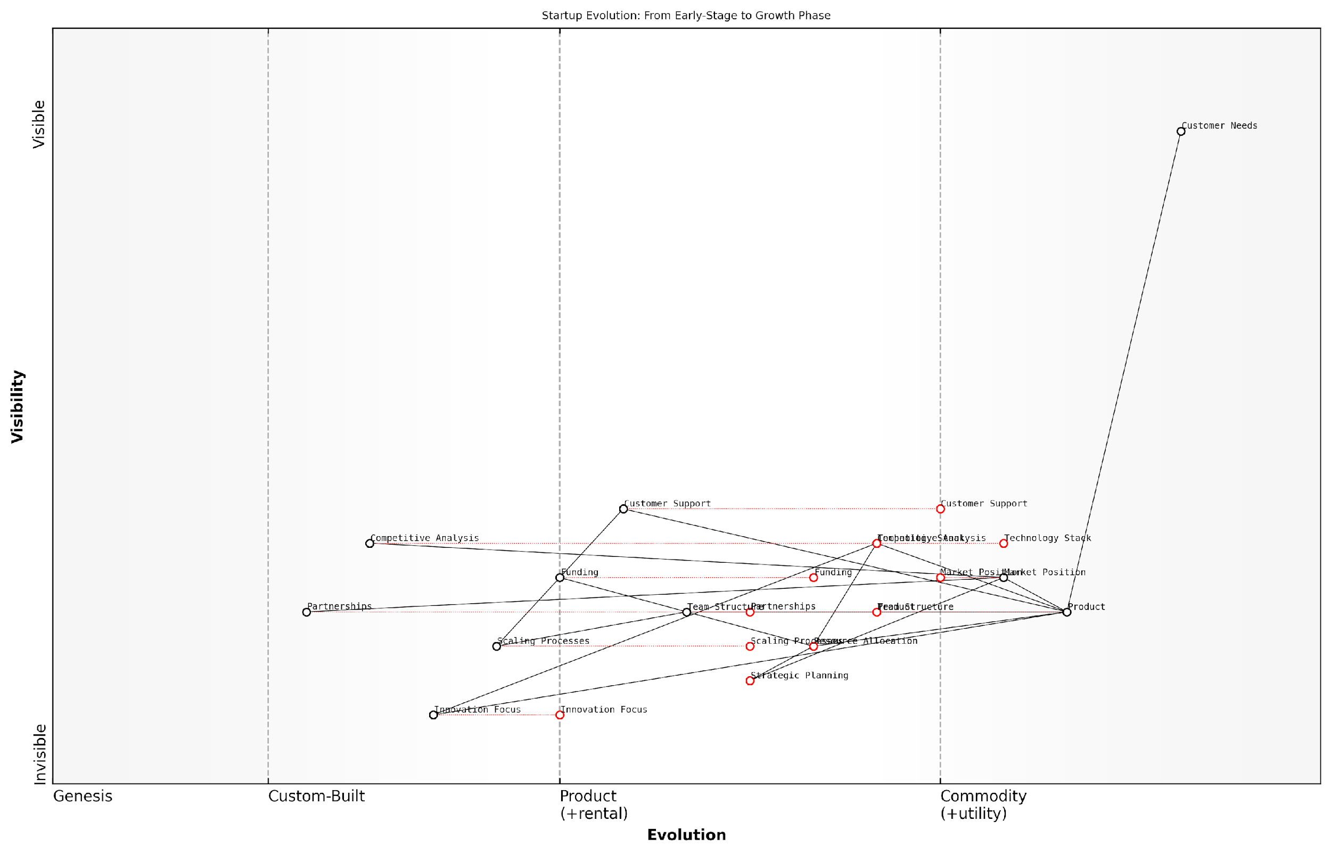

*Draft Wardley Map: [Insert Wardley Map: How Wardley Mapping addresses these challenges]*

[Edit this draft Wardley Map](https://create.wardleymaps.ai/#clone:8ffd551953330da5e5)

Wardley Map Assessment

This Wardley Map depicts a startup in a critical transition phase, moving from early-stage to growth. The core offerings (Product, Technology Stack) are evolving rapidly, driven by a strong focus on Customer Needs. However, supporting structures (Strategic Planning, Scaling Processes) are lagging, creating potential bottlenecks. The startup has a strong foundation for growth but needs to quickly mature its operational and strategic capabilities to fully capitalise on its market opportunity and sustain its competitive advantage. Prioritising the development of these lagging components while maintaining the innovative edge will be crucial for successful scaling and long-term success.

[View full Wardley Map report](http://markdown_wardley_map_reports/wardley_map_report_04_How_Wardley_Mapping_addresses_these_challenges.md)

Beyond these specific challenges, Wardley Mapping offers several overarching benefits that are particularly valuable for startups:

* Strategic Clarity: Wardley Maps provide a clear, visual representation of a startup’s strategy, making it easier to communicate and align teams around a shared vision.
* Scenario Planning: By manipulating maps to represent different future scenarios, startups can better prepare for various outcomes and develop more robust strategies.
* Identifying Dependencies: Maps help startups understand the dependencies between different components of their business, highlighting potential risks and opportunities.
* Guiding Innovation: By showing where components are in their evolutionary journey, Wardley Maps can guide startups on where to focus their innovative efforts for maximum impact.

It’s important to note that while Wardley Mapping is a powerful tool, it requires practice and iteration to master. Startups should view mapping as an ongoing process, regularly updating and refining their maps as they gain new insights and as their business evolves.

Wardley Mapping is not a one-time exercise, but a continuous practice of strategic thinking. For startups, it’s about building a muscle for strategic analysis that grows stronger with each iteration.

In conclusion, Wardley Mapping addresses the unique challenges faced by startups by providing a structured yet flexible framework for strategic thinking and decision-making. It helps startups navigate uncertainty, allocate resources effectively, position themselves in the market, make informed technology decisions, and manage scaling challenges. By adopting Wardley Mapping, startups can enhance their strategic capabilities and improve their chances of success in the competitive business landscape.

# Chapter 1: Fundamentals of Wardley Mapping for Startups

## Components of a Wardley Map

### Value chain analysis

Value chain analysis is a cornerstone of Wardley Mapping and a critical component for startups seeking to gain a competitive edge in their respective markets. As an expert who has advised numerous government bodies and startups on strategic planning, I can attest to the transformative power of this analytical tool when applied correctly. In the context of Wardley Mapping, value chain analysis provides a structured approach to visualising and understanding the components that deliver value to end-users, enabling startups to make informed decisions about resource allocation, innovation focus, and market positioning.

For startups operating in the fast-paced and often uncertain public sector technology landscape, a thorough understanding of value chain analysis is not just beneficial—it’s essential for survival and growth. Let’s delve into the key aspects of value chain analysis within the framework of Wardley Mapping, exploring its significance, methodology, and practical applications for startups.

Definition and Purpose

Value chain analysis in Wardley Mapping is the process of identifying and mapping out all the components required to meet a user need. This includes everything from the visible elements that directly interact with the user to the underlying infrastructure and support systems that enable the delivery of value. The purpose of this analysis is twofold:

* To provide a clear visual representation of how value is created and delivered within a startup’s ecosystem
* To enable strategic decision-making by highlighting dependencies, inefficiencies, and opportunities for innovation or outsourcing

Methodology

Conducting a value chain analysis for a Wardley Map involves several key steps:

* Identify the user need: Begin by clearly defining the end-user need that your startup aims to address. This serves as the anchor for your map.
* List all components: Enumerate every component involved in meeting that need, from customer-facing services to back-end infrastructure.
* Determine dependencies: Establish the relationships between components, identifying which elements depend on others to function.
* Position components: Place each component on the map based on its visibility to the user (y-axis) and its evolutionary stage (x-axis).
* Analyse the chain: Examine the completed value chain for insights into your startup’s operations, competitive positioning, and potential areas for improvement.

Significance for Startups

For startups, particularly those operating in the government and public sector space, value chain analysis through Wardley Mapping offers several critical benefits:

* Resource Optimisation: By visualising the entire value chain, startups can identify where to allocate their limited resources for maximum impact.
* Innovation Focus: Understanding which components are evolving allows startups to focus innovation efforts where they’ll provide the most significant competitive advantage.
* Strategic Partnerships: Identifying commoditised components in the value chain can guide decisions on outsourcing or forming strategic partnerships.
* Risk Management: Mapping dependencies helps startups anticipate potential risks and develop contingency plans.
* Competitive Positioning: A clear view of the value chain enables startups to position themselves strategically within the market ecosystem.

In my experience advising government technology startups, those who master value chain analysis through Wardley Mapping consistently outperform their peers in terms of strategic clarity and adaptability to market changes.

Practical Application: A Government Tech Startup Case

To illustrate the practical application of value chain analysis in Wardley Mapping, let’s consider a hypothetical case study of a government tech startup developing a citizen engagement platform:

The startup, GovConnect, aimed to create a mobile application that would allow citizens to report local issues directly to their municipal government. Through value chain analysis, they mapped out all components necessary to deliver this service, including:

* User interface (mobile app)
* Backend database
* Issue categorisation system
* Geolocation services
* Government department integration APIs
* User authentication
* Cloud hosting infrastructure

By mapping these components and their dependencies, GovConnect gained several insights:

* The user interface and issue categorisation system were key differentiators and should be developed in-house.
* Geolocation services and cloud hosting were commoditised and could be outsourced to reduce costs and development time.
* Government department integration APIs were a critical bottleneck and required early focus to ensure smooth operations.
* User authentication was evolving rapidly, suggesting the need for a flexible, updatable system to maintain security standards.

These insights allowed GovConnect to allocate resources effectively, focus on core competencies, and identify potential partnerships, ultimately leading to a successful launch and rapid adoption by several municipal governments.

Challenges and Considerations

While value chain analysis is a powerful tool, startups should be aware of potential challenges:

* Complexity: For startups with intricate products or services, the value chain can become complex. It’s crucial to maintain focus on the most impactful components.
* Dynamic Nature: In fast-moving sectors like government technology, the value chain can evolve rapidly. Regular reassessment is necessary.
* Hidden Dependencies: Some dependencies may not be immediately obvious. Thorough analysis and cross-functional input are essential.
* Overemphasis on Current State: While mapping the current value chain is important, startups must also consider future evolutions and disruptive technologies.

Conclusion

Value chain analysis is a fundamental component of Wardley Mapping that offers startups, particularly those in the government and public sector, a powerful tool for strategic planning and decision-making. By providing a clear visualisation of how value is created and delivered, it enables startups to optimise resources, focus innovation efforts, manage risks, and position themselves competitively within their market ecosystem.

In the dynamic world of government technology startups, those who master the art of value chain analysis through Wardley Mapping don’t just respond to change—they anticipate and shape it, gaining a significant advantage in their pursuit of sustainable growth and impact.

As startups continue to navigate the complex landscape of public sector innovation, the ability to conduct thorough and insightful value chain analyses will remain a critical skill for founders, strategists, and advisors alike. By embracing this component of Wardley Mapping, startups can build a solid foundation for strategic decision-making, ensuring they remain agile, competitive, and aligned with evolving user needs in the ever-changing government technology sector.

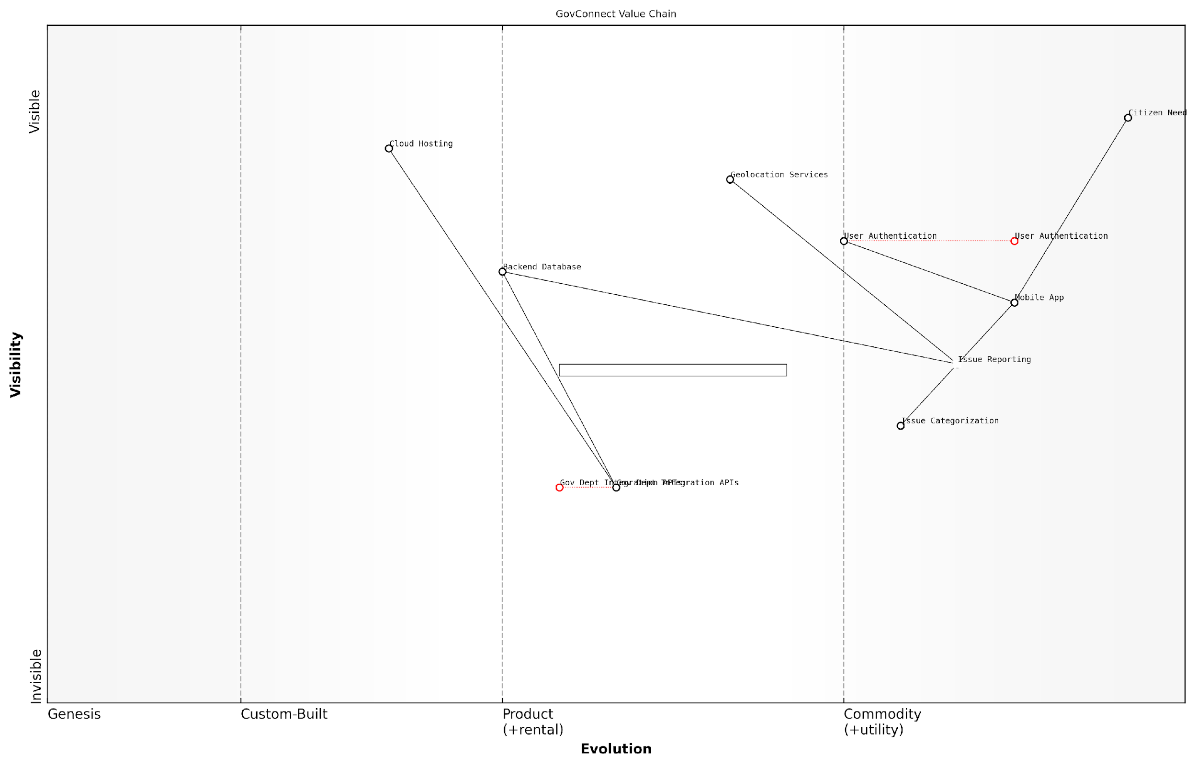

*Draft Wardley Map: [Insert Wardley Map: Value chain analysis]*

[Edit this draft Wardley Map](https://create.wardleymaps.ai/#clone:dd719d0565e267f820)

Wardley Map Assessment

The GovConnect Value Chain represents a solid foundation for a government-citizen connection platform. While well-positioned to meet basic citizen needs, there are significant opportunities for evolution and innovation, particularly in the areas of AI-powered analytics, standardized government integrations, and IoT incorporation. By focusing on these areas, the platform can enhance its efficiency, scalability, and value proposition, potentially transforming from a reactive issue reporting system to a proactive, data-driven urban management tool.

[View full Wardley Map report](http://markdown_wardley_map_reports/wardley_map_report_05_Value_chain_analysis.md)

### Evolution axis

The evolution axis is a fundamental component of Wardley Mapping that provides crucial insights for startups navigating the complex landscape of technology and market dynamics. This axis represents the natural progression of components within a value chain from genesis (novel and unpredictable) to commodity (standardised and predictable). Understanding this concept is paramount for startups as it informs strategic decision-making, resource allocation, and competitive positioning in rapidly evolving markets.

The evolution axis is typically divided into four stages: Genesis, Custom-built, Product (or Rental), and Commodity. Each stage has distinct characteristics that influence how startups should approach development, investment, and market strategy.

* Genesis: Novel, uncertain, and rapidly changing components
* Custom-built: Emerging standards, but still requiring significant customisation
* Product (or Rental): Well-understood components available as products or services
* Commodity: Highly standardised, often utility-like components

For startups, the evolution axis serves several critical functions:

* Identifying Innovation Opportunities: By mapping components along the evolution axis, startups can spot areas ripe for innovation, particularly in the Genesis and Custom-built stages.
* Resource Allocation: Understanding where components sit on the evolution axis helps startups decide where to invest their limited resources for maximum impact.
* Competitive Advantage: Recognising the evolutionary stage of key components allows startups to differentiate themselves by focusing on areas where they can add unique value.
* Future-proofing: By anticipating the natural evolution of components, startups can prepare for future market shifts and adapt their strategies accordingly.
* Partnership Decisions: The evolution axis informs make-or-buy decisions and helps identify potential partners or acquisition targets.

When applying the evolution axis to Wardley Mapping for startups, it’s crucial to consider the pace of change in your specific industry. As a senior government adviser once noted:

The rate of component evolution can vary dramatically between sectors. What might take decades in traditional industries could happen in months in the tech startup world. Understanding this pace is critical for accurate mapping and strategy formulation.

Startups must be particularly attuned to the signals of evolution. These can include:

* Increasing standardisation and best practices
* Emergence of dominant designs or platforms
* Shift from differentiation to cost as a primary competitive factor
* Increasing automation and commoditisation of previously specialised skills
* Changes in market language from specific features to general capabilities

One of the most powerful applications of the evolution axis for startups is in identifying potential disruptions. By mapping components and their evolutionary trajectories, startups can anticipate where new technologies or business models might emerge to challenge established players. This foresight is invaluable for both defensive positioning and offensive strategy.

Consider the case of a fintech startup I advised, which used Wardley Mapping to analyse the evolution of payment processing technologies:

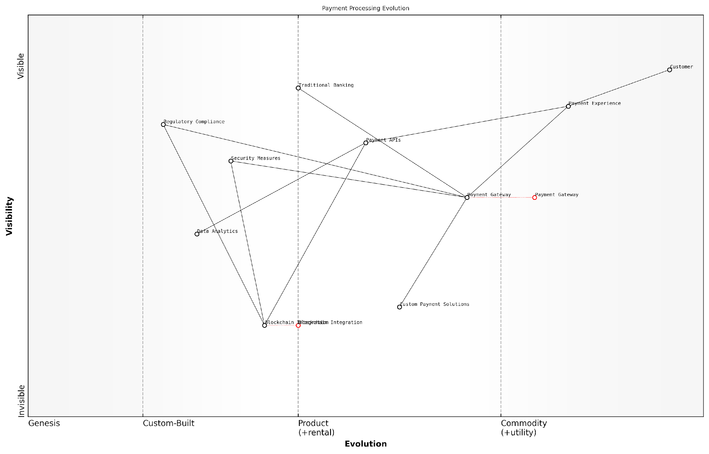

*Draft Wardley Map: [Insert Wardley Map: Evolution axis]*

[Edit this draft Wardley Map](https://create.wardleymaps.ai/#clone:c0f42c14de7d77a892)

Wardley Map Assessment

The map reveals a payment processing landscape in transition, with significant opportunities for innovation and strategic positioning. Success will depend on balancing the enhancement of existing infrastructure with the integration of emerging technologies, all while maintaining a strong focus on customer experience and regulatory compliance. The strategic imperative is to build a flexible, secure, and forward-looking payment ecosystem that can adapt to rapid technological changes and evolving customer expectations.

[View full Wardley Map report](http://markdown_wardley_map_reports/wardley_map_report_06_Evolution_axis.md)

By mapping the evolution of components from custom payment gateways to standardised APIs and emerging blockchain technologies, the startup identified a critical inflection point. They realised that while current payment processors were in the Product stage, blockchain-based solutions were rapidly moving from Genesis to Custom-built. This insight led them to pivot their development efforts towards blockchain integration, positioning them ahead of the curve as the technology matured.

It’s important to note that evolution is not always a smooth or predictable process. Disruptive innovations can accelerate evolution or even reset components back to earlier stages. As one leading expert in the field observed:

The evolution axis is not a deterministic model, but rather a tool for strategic thinking. Startups must remain vigilant and ready to reassess their maps as new technologies and market forces emerge.

For government and public sector startups, the evolution axis takes on additional significance. These organisations often operate in environments with longer planning horizons and more complex stakeholder relationships. Understanding the evolution of components can help public sector startups:

* Align technology investments with long-term policy objectives
* Identify opportunities for public-private partnerships as components evolve
* Anticipate regulatory needs for emerging technologies
* Balance innovation with the need for stability and reliability in public services

In conclusion, the evolution axis is a powerful tool for startups navigating the complexities of modern markets. By understanding and leveraging this component of Wardley Mapping, startups can make more informed strategic decisions, allocate resources more effectively, and position themselves for long-term success in rapidly changing environments. As you continue to develop your Wardley Mapping skills, remember that the evolution axis is not just a static element of your maps, but a dynamic tool for ongoing strategic analysis and adaptation.

### Anchors and dependencies

Anchors and dependencies are crucial elements in Wardley Mapping, particularly for startups navigating the complex landscape of business strategy and market positioning. These components form the backbone of a Wardley Map, providing structure and context to the visual representation of a startup’s value chain and competitive environment.

Anchors in Wardley Mapping represent the fixed points from which the rest of the map is constructed. For startups, the primary anchor is typically the user need or the customer. As a senior government adviser once remarked, ‘Understanding the user need is not just the starting point of a Wardley Map; it’s the compass that guides every strategic decision a startup makes.’ This user-centric approach is especially critical for startups, as it ensures that all strategic decisions are aligned with creating value for the customer, which is essential for gaining traction in competitive markets.

* User needs: The primary anchor, representing the fundamental problem the startup is solving
* Value propositions: Secondary anchors that directly address user needs
* Products or services: Tertiary anchors that embody the value propositions

Dependencies, on the other hand, illustrate the relationships between different components on the map. For startups, understanding these dependencies is crucial for several reasons:

* Resource allocation: Identifying critical dependencies helps startups prioritise their limited resources effectively
* Risk management: Mapping dependencies allows startups to anticipate potential bottlenecks or vulnerabilities in their value chain
* Innovation opportunities: Understanding the evolution of dependencies can reveal areas ripe for disruption or improvement
* Strategic partnerships: Recognising key dependencies can guide decisions on whether to build in-house, outsource, or form strategic alliances

In the context of startups, dependencies often take on added significance due to the rapid pace of change and the need for agility. A leading expert in startup strategy noted, ‘For startups, mapping dependencies is not just about understanding the present state of affairs, but about anticipating future shifts and positioning the company to capitalise on emerging opportunities.’

When mapping dependencies for startups, it’s crucial to consider both internal and external factors:

* Internal dependencies: These include relationships between different teams, processes, or technologies within the startup
* External dependencies: These encompass suppliers, partners, regulatory environments, and market conditions
* Technological dependencies: Particularly relevant for tech startups, these include reliance on specific platforms, APIs, or infrastructure
* Financial dependencies: For startups, this often includes reliance on investors, grants, or specific revenue streams

One of the unique challenges for startups when mapping anchors and dependencies is the need to balance current realities with future aspirations. As one startup founder put it, ‘Our Wardley Maps need to reflect not just where we are, but where we aim to be. It’s a delicate balance between pragmatism and vision.’

To effectively map anchors and dependencies, startups should follow these best practices:

* Start with the user: Always begin by clearly defining the user need as the primary anchor
* Be honest about maturity: Accurately assess the evolutionary stage of each component
* Consider indirect dependencies: Look beyond immediate connections to understand second and third-order effects
* Update regularly: The startup landscape changes rapidly; maps should be living documents
* Involve the team: Mapping should be a collaborative process to capture diverse perspectives
* Use scenario planning: Create multiple maps to explore different strategic options or market conditions

Wardley Mapping isn’t just about documenting what exists; it’s about visualising possibilities. For startups, it’s a tool for turning uncertainty into strategic advantage.

One powerful technique for startups is to use anchors and dependencies to identify potential pivot points. By analysing the map, startups can spot components that, if evolved or replaced, could dramatically alter their competitive position. This is particularly valuable in the early stages when the business model may still be in flux.

Consider the case of a UK-based govtech startup that used Wardley Mapping to navigate the complex landscape of public sector procurement. By clearly mapping the anchors (user needs within government agencies) and dependencies (including regulatory requirements, legacy systems, and procurement processes), the startup was able to identify a critical gap in the market. This led to the development of a novel solution that streamlined the procurement process for emerging technologies, resulting in rapid adoption across multiple government departments.

Another important consideration for startups when mapping anchors and dependencies is the concept of ‘strategic IQ,’ as coined by Simon Wardley. This refers to the ability to not just map the current landscape but to anticipate future movements and position the startup accordingly. For instance, a startup might identify a key dependency that is currently in the ‘product’ phase but is likely to evolve into a commodity. By anticipating this shift, the startup can make strategic decisions about whether to invest in developing proprietary solutions or plan to leverage future commoditised options.

In conclusion, mastering the mapping of anchors and dependencies is a critical skill for startup founders and strategists. It provides a powerful framework for understanding the current business landscape, identifying strategic opportunities, and navigating the uncertainties inherent in the startup journey. By grounding their strategies in a clear visualisation of user needs and the web of dependencies that support them, startups can make more informed decisions, allocate resources more effectively, and ultimately increase their chances of success in a competitive market.

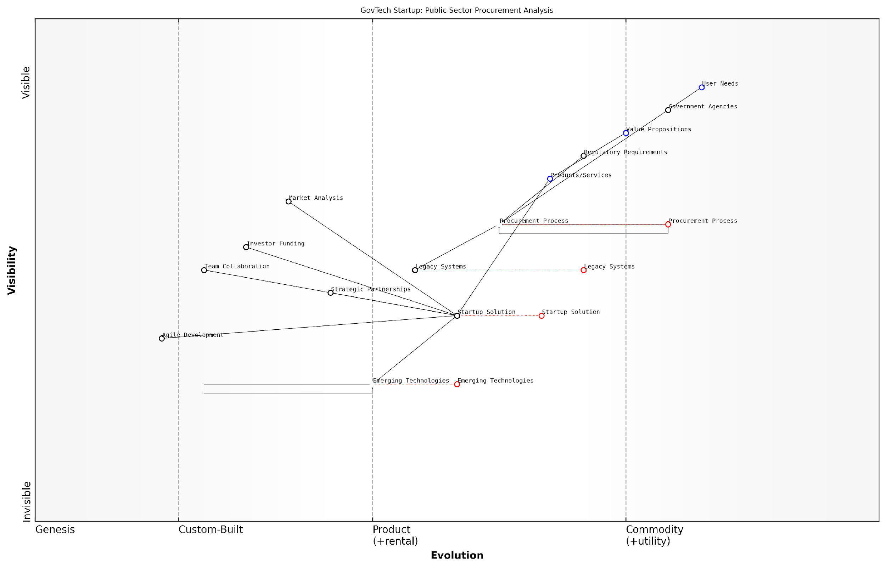

*Draft Wardley Map: [Insert Wardley Map: Anchors and dependencies]*

[Edit this draft Wardley Map](https://create.wardleymaps.ai/#clone:73fa8058dddc6ea0e6)

Wardley Map Assessment

The map reveals a significant opportunity for a GovTech startup to disrupt and modernise public sector procurement. By leveraging Emerging Technologies and addressing the inefficiencies in current Procurement Processes, the startup can create substantial value. However, success will require careful navigation of regulatory constraints, strategic partnerships, and a phased approach to overcoming the inertia of Legacy Systems. The startup’s ability to demonstrate immediate value while building towards long-term transformation will be crucial for success in this complex and evolving landscape.

[View full Wardley Map report](http://markdown_wardley_map_reports/wardley_map_report_07_Anchors_and_dependencies.md)

## Creating Your First Wardley Map

### Identifying user needs

Identifying user needs is the cornerstone of creating an effective Wardley Map for your startup. This crucial step not only forms the foundation of your map but also aligns your strategic thinking with the actual demands of your target market. As a seasoned expert in Wardley Mapping, I cannot overemphasise the importance of this phase, particularly for startups operating in the dynamic and often unpredictable government and public sector contexts.

To effectively identify user needs, we must first understand the concept of ‘users’ in the context of Wardley Mapping. Users are not merely end-consumers of your product or service; they encompass a broad spectrum of stakeholders whose needs your startup aims to address. In the government and public sector, these users might include citizens, policymakers, civil servants, or even other government departments.

Understanding user needs is not just about what users say they want, but about uncovering the underlying problems they’re trying to solve. It’s about seeing beyond the surface to the core issues that drive demand in the public sector.

Let’s delve into the key aspects of identifying user needs for your Wardley Map:

* Stakeholder Analysis
* Need Categorisation
* Prioritisation
* Validation

1. Stakeholder Analysis:

Begin by conducting a comprehensive stakeholder analysis. In the government sector, this is particularly crucial due to the complex web of interrelationships between various departments, agencies, and public entities. Identify all potential users and stakeholders who might interact with or be affected by your startup’s offering. This could include direct users, indirect beneficiaries, decision-makers, and influencers within the government structure.

For instance, if your startup is developing a digital platform for citizen engagement, your stakeholders might include citizens, local council members, government IT departments, and policy advisors. Each of these groups will have distinct needs that must be captured in your Wardley Map.

1. Need Categorisation:

Once you’ve identified your stakeholders, the next step is to categorise their needs. In my experience advising government bodies, I’ve found it effective to group needs into three main categories:

* Functional Needs: What does the user need to accomplish?
* Emotional Needs: How does the user need to feel?
* Contextual Needs: What environmental or situational factors influence the user’s needs?

For example, in a project I consulted on for a government health initiative, we identified functional needs (accessing health information quickly), emotional needs (feeling secure about data privacy), and contextual needs (accessing services during non-working hours).

1. Prioritisation:

Not all needs are created equal, especially in the resource-constrained environment of a startup. Prioritise the identified needs based on their importance to the user and their alignment with your startup’s mission and capabilities. This prioritisation will guide the positioning of components on your Wardley Map.

In the public sector, prioritisation often involves balancing immediate operational needs with long-term strategic goals. It’s about finding that sweet spot where user needs intersect with policy objectives and available resources.

1. Validation:

Perhaps the most critical step in identifying user needs is validation. This involves testing your assumptions about user needs against real-world data and feedback. In the government context, this might involve pilot programmes, citizen surveys, or collaborative workshops with key stakeholders.

I recall a project where we thought we had accurately identified the needs of local businesses interacting with government services. However, through a series of workshops, we discovered that our initial assumptions were off-base. This led to a significant pivot in the project, ultimately resulting in a more effective solution.

When identifying user needs for your Wardley Map, it’s crucial to remain objective and avoid the trap of confirmation bias. Be prepared to challenge your own assumptions and those of your team. Remember, the goal is not to validate preconceived notions, but to uncover genuine user needs that will form the foundation of your strategic mapping.

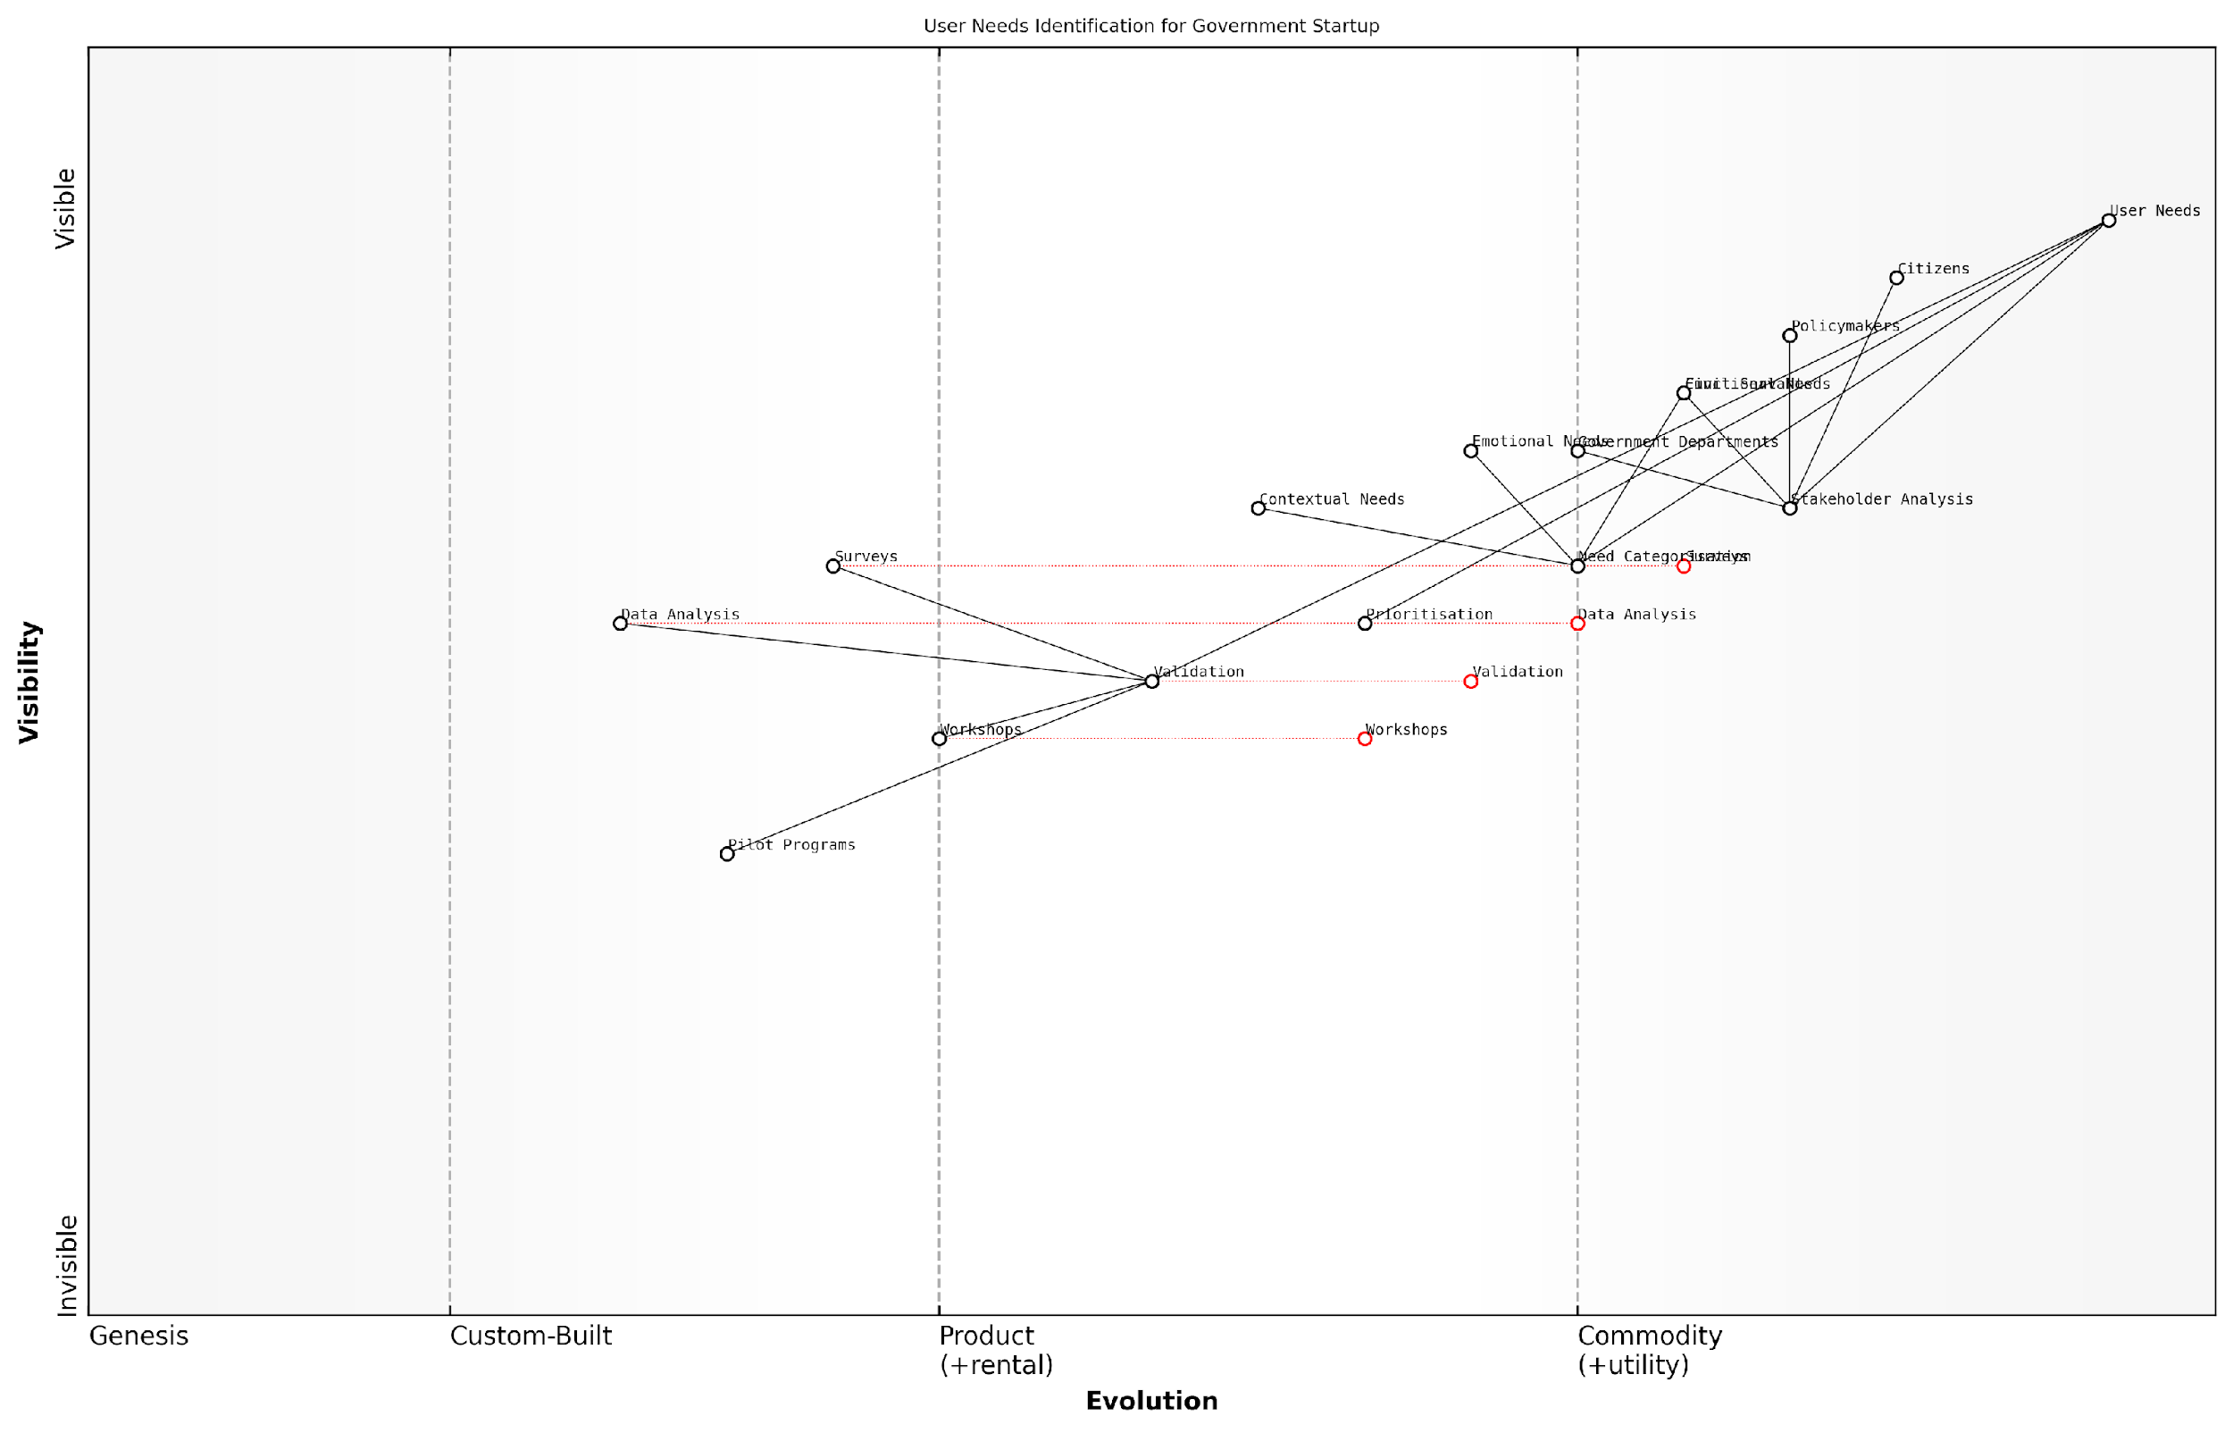

*Draft Wardley Map: [Insert Wardley Map: Identifying user needs]*

[Edit this draft Wardley Map](https://create.wardleymaps.ai/#clone:84622ad882bbea76a0)

Wardley Map Assessment

This Wardley Map reveals a structured and comprehensive approach to user needs identification for a government startup. While it demonstrates strengths in stakeholder analysis and need categorisation, there are significant opportunities for evolution in validation techniques and data analysis. The strategic focus should be on leveraging emerging technologies to create a more dynamic, responsive, and predictive system for identifying and addressing citizen needs. By evolving its capabilities, particularly in data analysis and validation, the startup can position itself as a leader in citizen-centric governance. The key to success lies in maintaining a balance between thorough analysis and rapid response, while continuously adapting to the evolving technological landscape and changing citizen expectations.

[View full Wardley Map report](http://markdown_wardley_map_reports/wardley_map_report_08_Identifying_user_needs.md)

By thoroughly identifying and understanding user needs, you set the stage for a Wardley Map that truly reflects the landscape in which your startup operates. This user-centric approach ensures that your strategic decisions are grounded in real-world demands, increasing your chances of success in the complex and often bureaucratic world of government and public sector services.

As we move forward in creating your first Wardley Map, keep these identified user needs at the forefront of your mind. They will serve as the anchors from which all other components of your map will flow, ensuring that your startup’s strategy remains aligned with the actual needs of your target users in the public sector.

### Mapping the value chain

Mapping the value chain is a crucial step in creating your first Wardley Map, particularly for startups navigating the complex landscape of government and public sector contexts. This process involves visualising the components that deliver value to the user, from the visible elements to the underlying infrastructure. For startups, understanding this chain is vital for identifying opportunities, optimising resources, and developing robust strategies for growth and innovation.

To effectively map the value chain, we’ll explore the following key aspects:

* Identifying components
* Establishing dependencies
* Positioning components on the evolution axis
* Analysing the map for strategic insights

Identifying components: The first step in mapping the value chain is to identify all the components that contribute to delivering value to the user. For a startup in the government sector, these components might range from user-facing services to backend systems, data management tools, and regulatory compliance mechanisms. It’s crucial to be comprehensive in this stage, as overlooking key components can lead to strategic blind spots.

In my experience advising government startups, I’ve found that the most successful maps are those that dig deep into the underlying infrastructure. Don’t just stop at the obvious components – consider everything from data sources to security protocols.

Establishing dependencies: Once you’ve identified the components, the next step is to establish the dependencies between them. This involves understanding how each component relies on others to function and deliver value. In the context of government startups, these dependencies can be particularly complex, often involving interactions with legacy systems, multiple agencies, and external service providers.

Positioning components on the evolution axis: A unique feature of Wardley Mapping is the evolution axis, which represents the maturity of each component from genesis (novel) to commodity (ubiquitous). For startups in the government sector, accurately positioning components on this axis is crucial for identifying areas of potential innovation and competitive advantage.

When mapping for government startups, I often remind clients that the public sector can lag behind in terms of technological evolution. What might be considered commodity in the private sector could still be in the custom-built or product stages in government contexts.

Analysing the map for strategic insights: Once your value chain is mapped and components are positioned, the real power of Wardley Mapping comes into play. This visual representation allows startups to identify strategic opportunities, potential bottlenecks, and areas for innovation. In the government sector, this might involve identifying outdated systems ripe for modernisation, or spotting gaps in service delivery that a startup could fill.

Let’s delve deeper into each of these aspects:

Identifying components: When mapping the value chain for a government startup, it’s essential to consider both the visible and invisible components. Visible components might include user interfaces, data dashboards, or citizen-facing services. Invisible components could encompass data processing algorithms, security protocols, or integration layers with existing government systems. A comprehensive approach ensures that no critical element is overlooked.

For example, a startup developing a digital identity verification system for government services would need to map components such as:

* User registration interface
* Identity verification algorithms
* Data storage and management systems
* Integration with existing government databases
* Security and encryption protocols
* Compliance monitoring tools
* User support systems

Establishing dependencies: In the government sector, dependencies can be particularly intricate due to the interconnected nature of public services and the need for interoperability between different agencies and systems. When mapping dependencies, consider both direct and indirect relationships between components.

One of the most common pitfalls I’ve observed in government startup mapping is underestimating the complexity of dependencies, especially when it comes to data sharing between agencies. It’s crucial to map these relationships meticulously to avoid unexpected roadblocks down the line.

Positioning components on the evolution axis: The evolution axis in Wardley Mapping ranges from Genesis (novel, uncertain) to Custom-built, Product, and finally Commodity (well-understood, standardised). When positioning components for a government startup, it’s important to consider the specific context of the public sector. For instance:

* Genesis: Novel technologies or approaches, such as blockchain for government record-keeping
* Custom-built: Bespoke systems developed for specific government needs, like specialised case management software
* Product: Off-the-shelf solutions adapted for government use, such as cloud storage services
* Commodity: Standardised, widely-used technologies, like email or basic word processing software

Analysing the map for strategic insights: Once your value chain is mapped and components are positioned, you can begin to extract valuable insights. For government startups, this analysis might reveal:

* Opportunities for innovation in areas where current solutions are in the genesis or custom-built stages
* Potential for cost savings by moving towards more commoditised solutions for non-core functions
* Areas where strategic partnerships could accelerate development or improve service delivery
* Risks associated with over-reliance on custom-built solutions that may become obsolete
* Gaps in the current ecosystem that the startup could fill with new products or services

By thoroughly mapping the value chain, government startups can gain a comprehensive understanding of their operational landscape, identify strategic opportunities, and make informed decisions about resource allocation and future development.

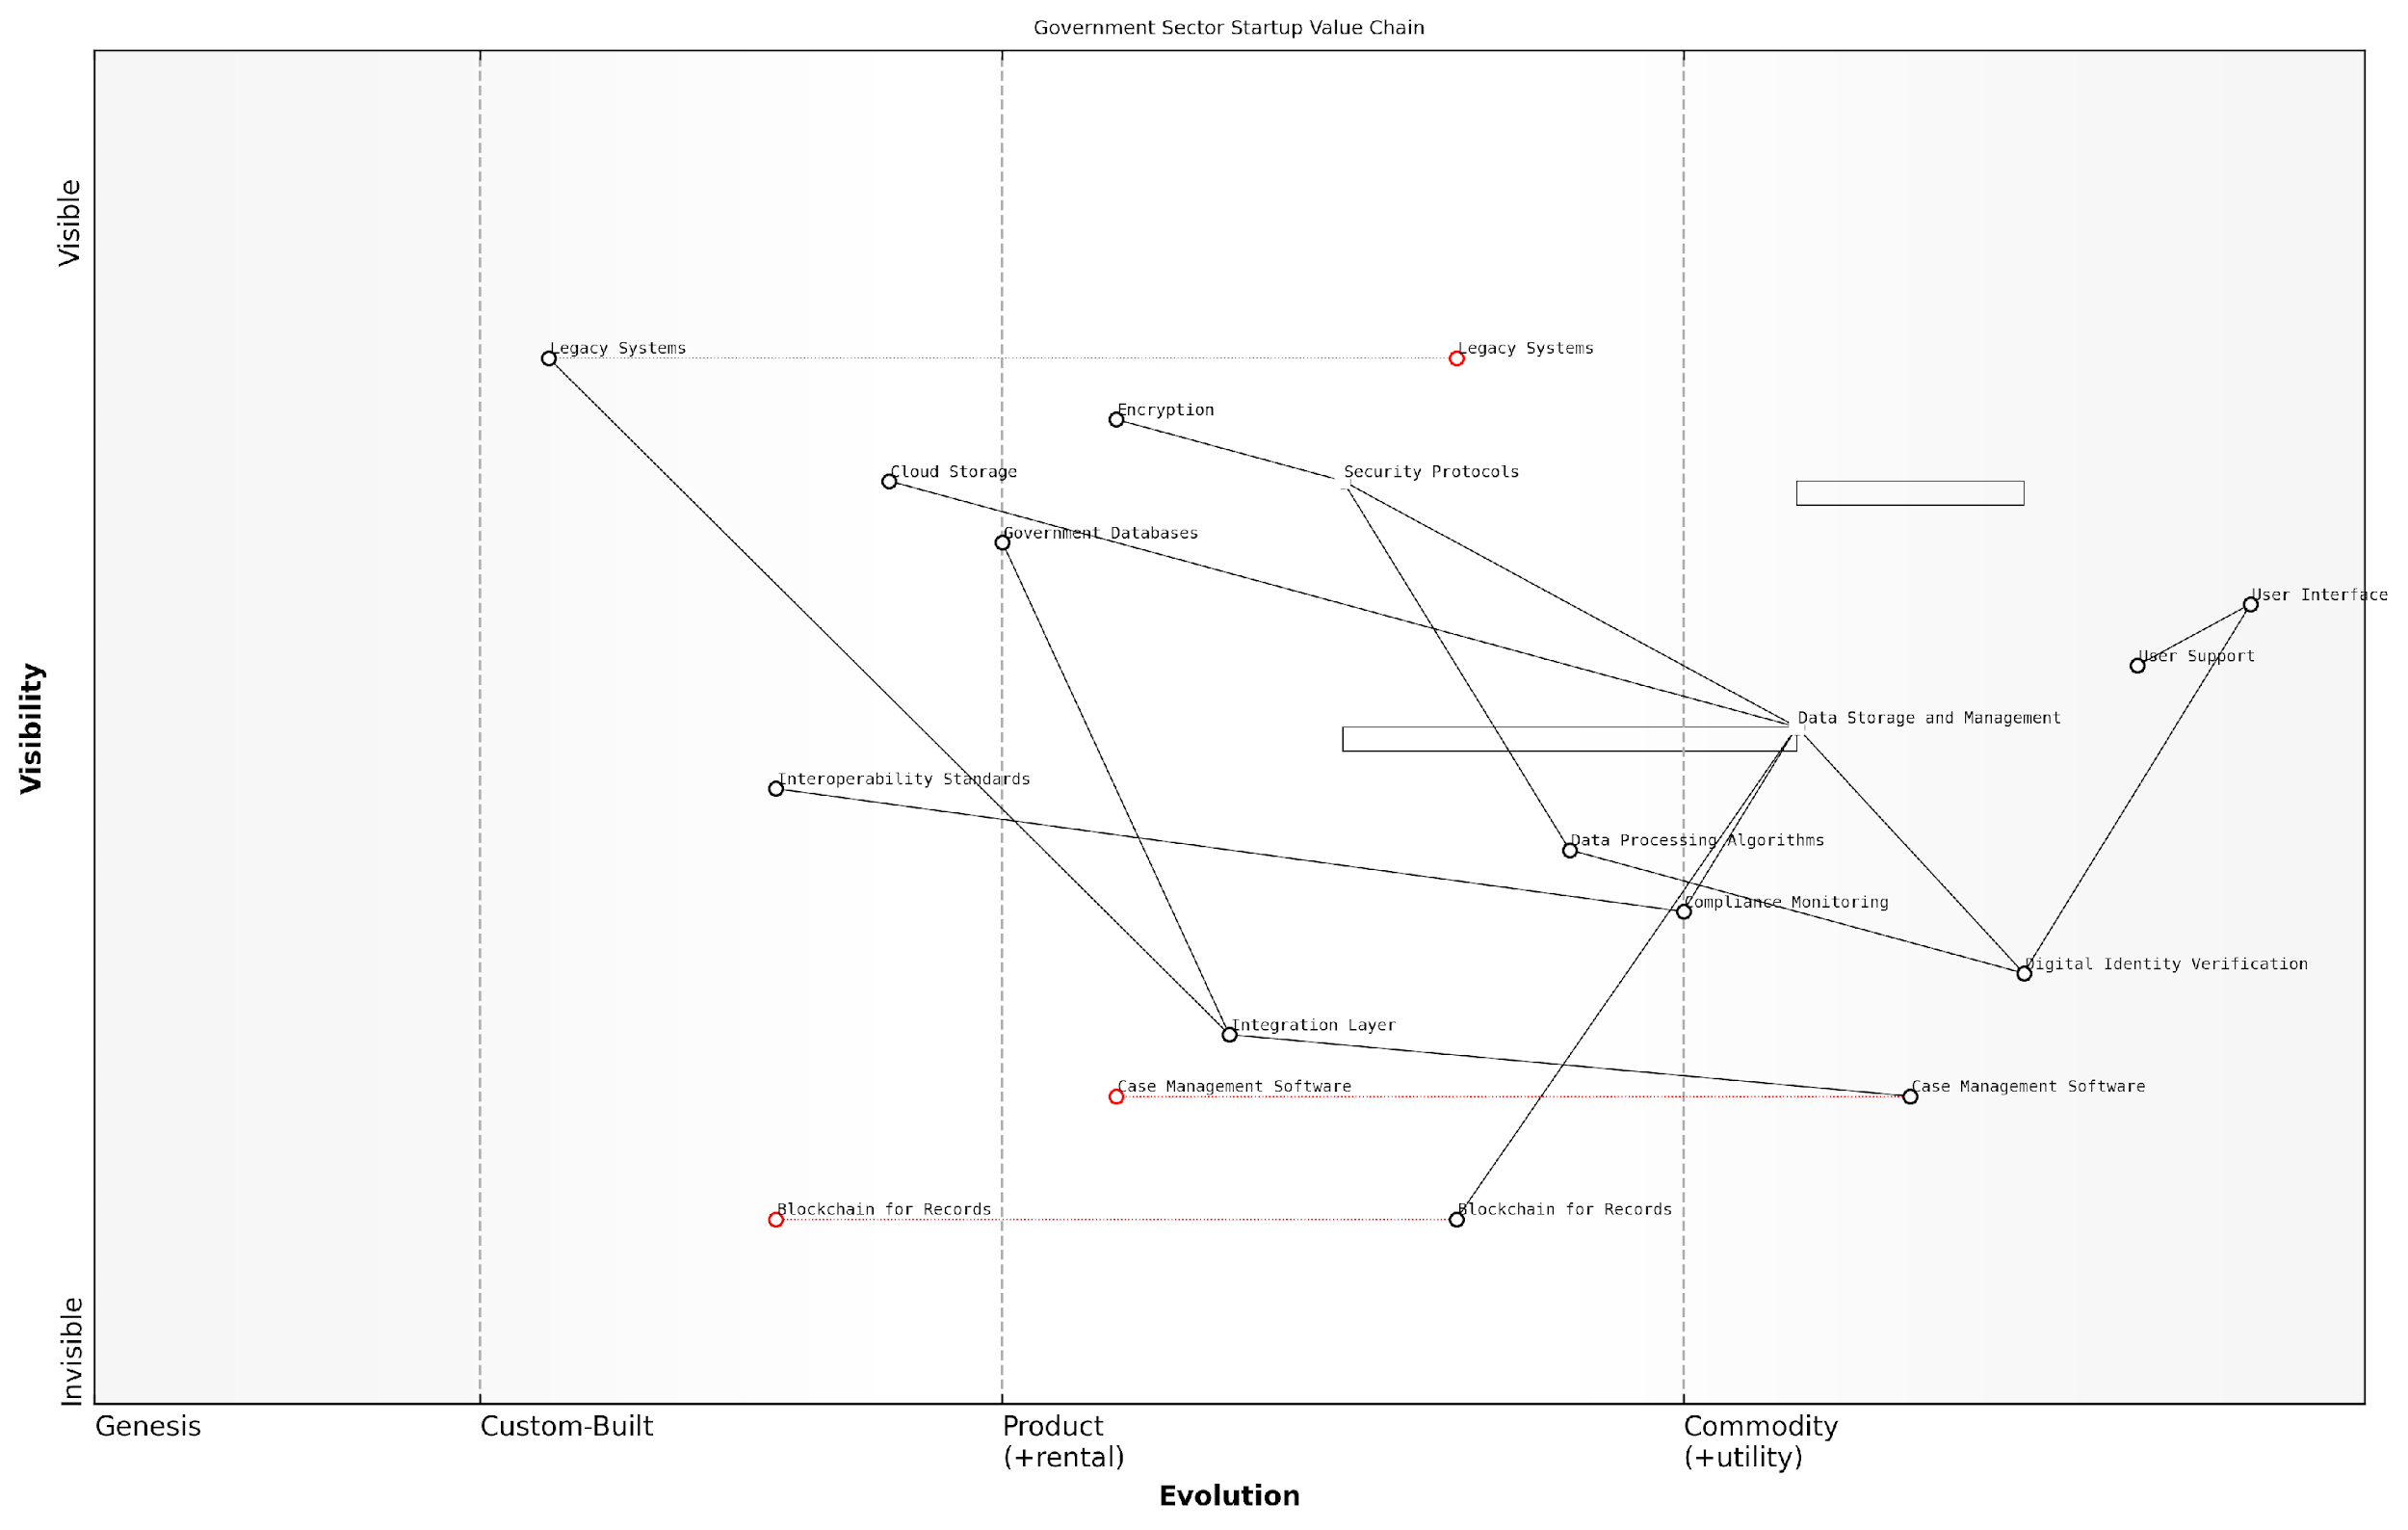

*Draft Wardley Map: [Insert Wardley Map: Mapping the value chain]*

[Edit this draft Wardley Map](https://create.wardleymaps.ai/#clone:3bde1ec499b65dec9c)

Wardley Map Assessment

The startup is well-positioned in the government sector with strong capabilities in critical areas like Digital Identity Verification and Data Processing. However, it faces challenges in integrating with Legacy Systems and needs to carefully manage the evolution of emerging technologies like Blockchain for Records. The key to success will be balancing innovation with the practical realities of government IT infrastructure, while maintaining a strong focus on security and compliance. By leading in interoperability and emerging technologies, the startup can establish itself as a crucial player in the modernization of government digital services.

[View full Wardley Map report](http://markdown_wardley_map_reports/wardley_map_report_09_Mapping_the_value_chain.md)

In conclusion, mapping the value chain is a critical step in creating your first Wardley Map, particularly for startups operating in the government and public sector. By meticulously identifying components, establishing dependencies, positioning elements on the evolution axis, and analysing the resulting map, startups can gain invaluable insights into their strategic position and potential paths for growth and innovation. This process not only helps in understanding the current landscape but also in anticipating future changes and preparing for them proactively.

Remember, a Wardley Map is not a static document but a living tool. In the fast-paced world of startups, especially those navigating the complexities of the public sector, regular revisiting and updating of your value chain map is essential for maintaining strategic advantage.

### Assessing component evolution

Assessing component evolution is a critical step in creating your first Wardley Map, particularly for startups navigating the complex and rapidly changing business landscape. This process involves determining where each component of your value chain sits along the evolution axis, from genesis to commodity. Understanding the evolutionary stage of each component allows startups to make informed strategic decisions, allocate resources effectively, and anticipate future market shifts.

The evolution axis in a Wardley Map represents the natural progression of components from novel and unstable (genesis) to standardised and widely available (commodity). For startups, accurately placing components along this axis is crucial for several reasons:

* It helps identify which components are likely to change rapidly, requiring more attention and resources
* It reveals potential areas for innovation and differentiation
* It guides decisions on whether to build, buy, or partner for specific components
* It aids in predicting future market movements and preparing for them

To assess component evolution effectively, startups should consider the following factors:

* Ubiquity: How widely available and used is the component?
* Certainty: How well understood and stable is the component?
* Market: Is there a competitive market for the component, or is it still dominated by early movers?
* Knowledge: How widely distributed is the knowledge about the component?

Let’s explore each stage of evolution and its implications for startups:

1. Genesis: Components in this stage are new, uncertain, and rapidly changing. For startups, these represent areas of potential innovation and differentiation. However, they also carry high risk and require significant investment in research and development. A startup focusing on a genesis component should be prepared for rapid iteration and have a high tolerance for uncertainty.

In my experience advising tech startups, those who successfully navigate the genesis stage are the ones who embrace uncertainty and are willing to pivot quickly based on market feedback.

1. Custom-built: As components move from genesis to custom-built, they become more defined but are still not standardised. Startups working with custom-built components often have the opportunity to shape emerging standards and gain a competitive advantage. However, they must balance the benefits of customisation with the costs of maintaining bespoke solutions.
2. Product: At this stage, components become more standardised and widely available as products. For startups, this often means a shift from building to buying or partnering. The focus moves towards integration and optimisation rather than core development. Startups should assess whether they can add unique value on top of existing products or if they need to differentiate in other areas.
3. Commodity: Commodity components are highly standardised, widely available, and often essential utilities. For startups, these components are typically consumed as services (e.g., cloud computing, payment processing). The strategic focus here is on cost optimisation and ensuring reliable access to these critical utilities.

A senior government official once told me, ‘Understanding the evolution of components is like having a crystal ball for policy-making. It helps us anticipate where the market is heading and how to support innovation effectively.’

When assessing component evolution for your startup’s Wardley Map, consider these practical tips:

* Research industry trends and emerging technologies relevant to each component
* Consult with domain experts to gauge the maturity of specific technologies or practices
* Analyse competitor strategies and market offerings
* Consider the pace of change in different areas of your value chain
* Regularly reassess component positions as the market evolves

It’s important to note that evolution is not always a linear process. Disruptive innovations can cause components to shift backwards on the evolution axis, creating new opportunities for startups. Being aware of these potential disruptions is crucial for maintaining a competitive edge.

For government and public sector contexts, assessing component evolution takes on additional dimensions. Public sector organisations must consider not only technological evolution but also regulatory, social, and political factors that may influence the pace and direction of change.

A leading expert in public sector innovation once remarked, ‘In government, we must balance the drive for innovation with the need for stability and equity. Understanding component evolution helps us strike that balance more effectively.’

To illustrate the process of assessing component evolution, let’s consider a hypothetical startup developing a new digital health platform:

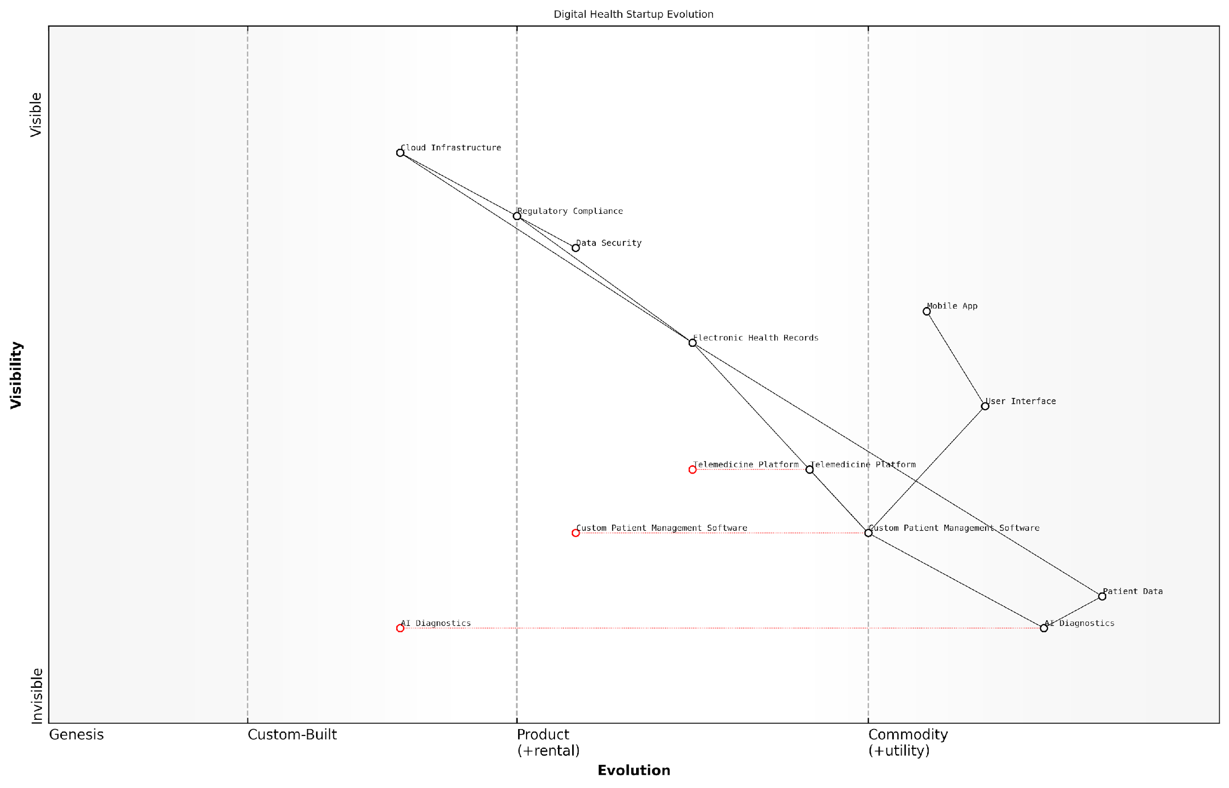

*Draft Wardley Map: [Insert Wardley Map: Assessing component evolution]*

[Edit this draft Wardley Map](https://create.wardleymaps.ai/#clone:91988f2404b2e05ceb)

Wardley Map Assessment

This digital health startup is well-positioned with strong differentiators in AI Diagnostics and Custom Patient Management Software. The key to success lies in rapidly evolving these core components while building a robust, secure, and compliant infrastructure. The startup should focus on creating an integrated ecosystem that leverages its AI capabilities across all services, particularly in telemedicine. Simultaneously, it must prepare for increased commoditization of basic services and potential disruption in data management and security. By balancing innovation in core areas with strategic partnerships and platform development, the startup can establish a strong, defensible position in the evolving digital health landscape.

[View full Wardley Map report](http://markdown_wardley_map_reports/wardley_map_report_10_Assessing_component_evolution.md)

In this example, the startup would need to carefully consider its strategy for each component based on its evolutionary stage. They might choose to innovate heavily in AI diagnostics, partner with established providers for electronic health records, and utilise commodity cloud services for infrastructure.

By accurately assessing component evolution, startups can:

* Identify areas where they can create unique value
* Avoid reinventing the wheel for commodity components
* Anticipate and prepare for future market changes
* Allocate resources more effectively across their value chain
* Make informed decisions about technology adoption and development

In conclusion, assessing component evolution is a critical skill for startups creating their first Wardley Map. It provides a strategic lens through which to view the entire value chain, enabling more informed decision-making and better positioning for future success. By understanding where each component sits on the evolution axis, startups can craft strategies that leverage the natural forces of market evolution, rather than working against them.

As one startup founder aptly put it, ‘Wardley Mapping, and particularly understanding component evolution, has been like turning on the lights in a dark room. Suddenly, we could see not just where we are, but where everything is moving.’

## Interpreting Wardley Maps

### Patterns and anti-patterns

In the realm of Wardley Mapping for startups, understanding patterns and anti-patterns is crucial for effective strategic decision-making. These recurring structures and behaviours within maps provide invaluable insights into market dynamics, competitive positioning, and potential pitfalls. As we delve into this topic, we’ll explore how startups can leverage these patterns to gain a competitive edge and avoid common strategic missteps.

Patterns in Wardley Maps represent recurring structures or behaviours that can be observed across different industries and scenarios. They offer a lens through which startups can analyse their position, identify opportunities, and anticipate market shifts. Conversely, anti-patterns highlight common mistakes or suboptimal strategies that startups should be wary of.

Patterns in Wardley Maps are like constellations in the night sky. Once you learn to recognise them, they can guide your strategic navigation through the complex startup ecosystem.

Let’s examine some key patterns and anti-patterns relevant to startups:

* Commoditisation and Componentisation
* Inertia and Disruption
* Co-evolution of Practice and Technology
* Ecosystem Development
* Convergence and Divergence

Commoditisation and Componentisation: This pattern is particularly relevant for tech startups. As components evolve from genesis to commodity, they become more standardised and cost-effective. Startups can leverage this pattern by identifying components nearing commoditisation and building innovative products or services on top of them. For instance, cloud computing’s commoditisation has enabled numerous startups to launch scalable services without significant infrastructure investments.

Inertia and Disruption: Established players often exhibit inertia, resisting change due to existing investments or outdated business models. This creates opportunities for startups to disrupt markets with innovative solutions. By mapping the inertia of incumbents, startups can identify vulnerable areas ripe for disruption.

Co-evolution of Practice and Technology: This pattern highlights how practices and technologies evolve in tandem. Startups should be aware of this interplay, as it can inform product development and market entry strategies. For example, the evolution of agile development practices has co-evolved with tools and technologies supporting rapid iteration and deployment.

Ecosystem Development: As components evolve, they often spawn new ecosystems of related products and services. Startups can position themselves strategically within these emerging ecosystems, either by providing complementary services or by becoming platform providers themselves.

Convergence and Divergence: This pattern describes how components may converge towards a dominant design or diverge into specialised variants. Startups must be attuned to these movements, as they can significantly impact market dynamics and competitive landscapes.

Understanding patterns in Wardley Maps is not just about recognising them, but about anticipating how they will unfold and positioning your startup to capitalise on these movements.

Now, let’s turn our attention to anti-patterns, which are equally important for startups to recognise and avoid:

* Outsourcing Core Competencies
* Ignoring Evolution
* Over-focusing on Technology
* Neglecting User Needs
* Misalignment of Purpose and Capability

Outsourcing Core Competencies: A common anti-pattern is when startups outsource components that are critical to their competitive advantage. While outsourcing can be beneficial for non-core activities, it can be detrimental if applied to key differentiators. Startups should carefully map their value chain to identify which components are truly core to their offering.

Ignoring Evolution: Some startups fail to recognise the evolutionary nature of their market and components. This can lead to misaligned strategies, such as treating evolving components as stable or vice versa. Regular mapping and reassessment are crucial to avoid this pitfall.

Over-focusing on Technology: While technology is often a key driver for startups, an excessive focus on technical aspects at the expense of user needs and market dynamics can lead to products that fail to gain traction. Wardley Maps can help balance technological considerations with other strategic factors.

Neglecting User Needs: Some startups become so engrossed in their product or technology that they lose sight of actual user needs. Wardley Maps always start with user needs at the top, serving as a constant reminder to align all activities with creating user value.

Misalignment of Purpose and Capability: This anti-pattern occurs when a startup’s strategic intent is misaligned with its actual capabilities. Wardley Mapping can help identify these misalignments and guide resource allocation to build necessary capabilities.

Anti-patterns in Wardley Maps are like warning signs on a treacherous road. Recognising them early can save a startup from costly detours and potential failure.

To effectively leverage patterns and avoid anti-patterns, startups should incorporate regular Wardley Mapping sessions into their strategic planning processes. This practice enables teams to:

* Identify emerging patterns in their industry
* Anticipate market shifts and evolutionary movements
* Spot potential anti-patterns in their current strategies
* Align their capabilities with market opportunities
* Make informed decisions about resource allocation and strategic focus

Moreover, startups should cultivate a culture of continuous learning and adaptation. As patterns emerge and evolve, the ability to quickly recognise and respond to these changes becomes a significant competitive advantage.

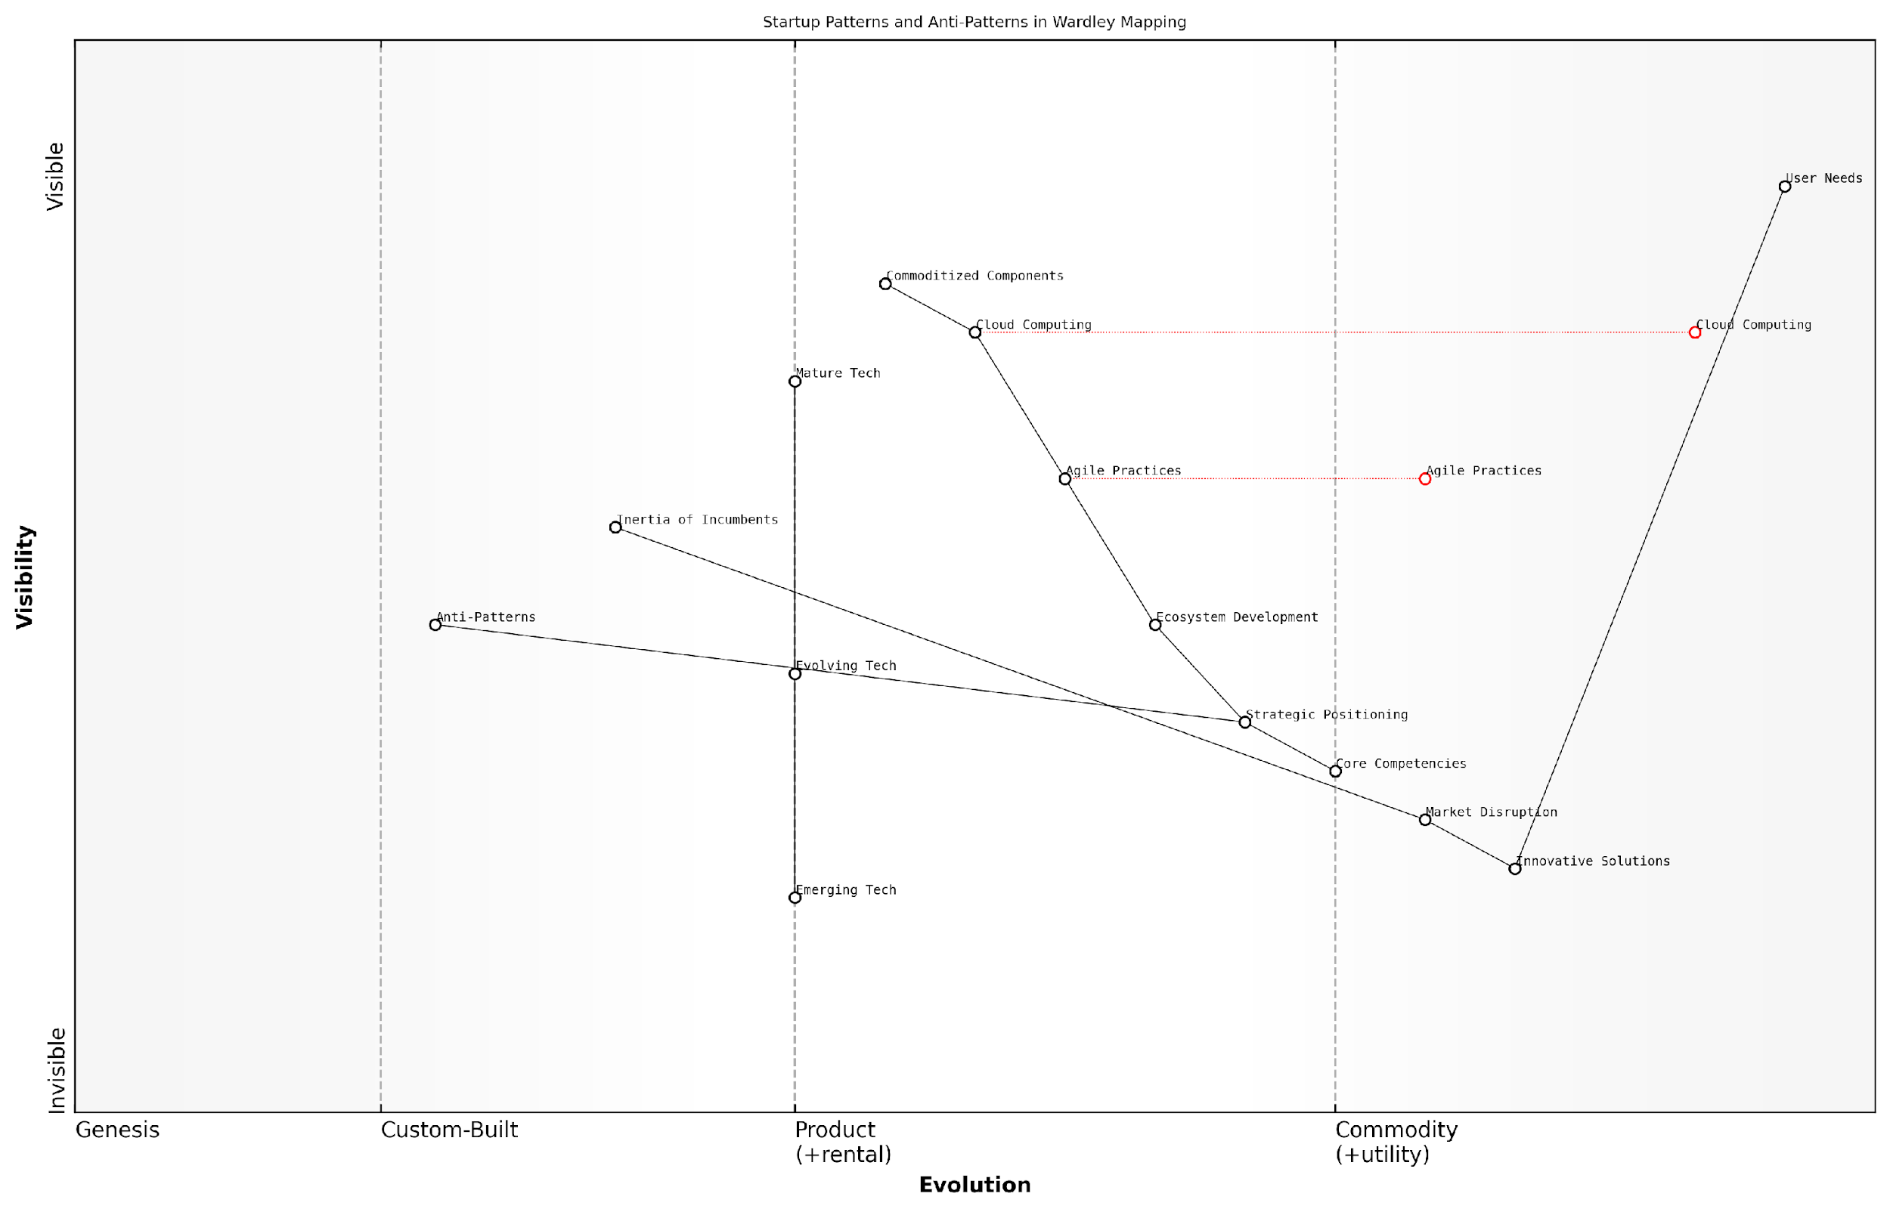

*Draft Wardley Map: [Insert Wardley Map: Patterns and anti-patterns]*

[Edit this draft Wardley Map](https://create.wardleymaps.ai/#clone:157d0d4476a4ff25ad)

Wardley Map Assessment

This Wardley Map reveals a startup landscape focused on innovation and market disruption, with a clear understanding of the importance of user needs. The strategic challenge lies in balancing rapid innovation with sound strategic positioning and ecosystem development. Success will depend on the ability to leverage emerging technologies, disrupt markets, and build a strong ecosystem while remaining agile and user-focused. The explicit inclusion of anti-patterns suggests a mature approach to strategy, acknowledging potential pitfalls. To thrive, startups must continuously evolve their innovative solutions, strategically position themselves in the value chain, and actively develop their ecosystem, all while keeping a keen eye on the rapid evolution of technologies and market dynamics.

[View full Wardley Map report](http://markdown_wardley_map_reports/wardley_map_report_11_Patterns_and_anti-patterns.md)

In conclusion, mastering the art of recognising patterns and anti-patterns in Wardley Maps equips startups with a powerful tool for strategic navigation. By understanding these recurring structures and behaviours, startups can make more informed decisions, anticipate market shifts, and position themselves for success in the dynamic and often unpredictable startup ecosystem. As you continue to develop your Wardley Mapping skills, remember that the true value lies not just in creating maps, but in the strategic insights and actions they inspire.

### Identifying strategic opportunities

Identifying strategic opportunities is a crucial skill for startups leveraging Wardley Mapping. As an expert who has advised numerous government bodies and public sector organisations, I can attest that the ability to spot and capitalise on these opportunities can be the difference between a startup’s success and failure. Wardley Maps provide a unique visual representation of the business landscape, allowing startups to identify gaps in the market, anticipate future trends, and make informed strategic decisions.

When interpreting Wardley Maps to identify strategic opportunities, startups should focus on several key areas:

* Evolutionary gaps
* Componentisation and potential for novel combinations
* Inertia points and resistance to change
* Ecosystem awareness and potential partnerships
* Anticipation of future market movements

Let’s explore each of these areas in detail to understand how they can reveal strategic opportunities for startups.

Evolutionary Gaps: One of the most potent sources of strategic opportunities lies in identifying evolutionary gaps within the value chain. These gaps represent areas where components are not evolving at the same rate as adjacent or dependent components. As a seasoned consultant, I’ve observed numerous instances where startups have capitalised on these gaps to create innovative solutions.

Evolutionary gaps are the breeding ground for disruptive innovation. Startups that can identify and exploit these gaps often become the next industry leaders.

For example, in the public sector, I once advised a startup that identified an evolutionary gap between legacy document management systems and the growing need for real-time collaboration tools. By developing a solution that bridged this gap, they were able to secure significant government contracts and establish themselves as a key player in the market.

Componentisation and Novel Combinations: Wardley Maps excel at breaking down complex systems into their constituent components. This decomposition allows startups to identify opportunities for novel combinations or reconfigurations of existing components. By understanding how different components interact and evolve, startups can create unique value propositions that address unmet needs in the market.

In my experience working with government technology initiatives, I’ve seen startups successfully combine open-source components with proprietary algorithms to create powerful, cost-effective solutions for public sector challenges. This approach not only addresses budget constraints but also fosters innovation through the novel application of existing technologies.

Inertia Points and Resistance to Change: Wardley Maps can reveal areas of inertia within an industry or organisation. These are points where established players are resistant to change, often due to legacy systems, entrenched processes, or regulatory constraints. For startups, these inertia points represent significant opportunities to introduce disruptive solutions.

The greatest opportunities often lie where others see only obstacles. Inertia points in Wardley Maps are signposts for potential disruption.

I recall advising a startup that identified significant inertia in the way government agencies handled citizen data. By developing a blockchain-based solution that addressed privacy concerns and improved data interoperability, they were able to overcome resistance to change and secure partnerships with multiple government departments.

Ecosystem Awareness and Potential Partnerships: Wardley Maps provide a holistic view of the business ecosystem, allowing startups to identify potential partners, suppliers, and collaborators. By understanding the interdependencies between different components and players in the market, startups can position themselves strategically within the ecosystem.

In the public sector, I’ve observed successful startups leveraging this ecosystem awareness to form strategic partnerships with established government contractors, academic institutions, and other startups. These collaborations often lead to more comprehensive solutions and increased credibility when bidding for government contracts.

Anticipation of Future Market Movements: Perhaps the most powerful aspect of Wardley Mapping for identifying strategic opportunities is its ability to anticipate future market movements. By understanding the evolutionary trajectory of different components, startups can position themselves ahead of the curve, developing solutions for needs that have not yet fully materialised.

For instance, I worked with a startup that used Wardley Mapping to anticipate the growing need for AI-driven decision support systems in government policy-making. By developing their solution well in advance of widespread demand, they were able to establish themselves as thought leaders and secure early adopter partnerships with forward-thinking government agencies.

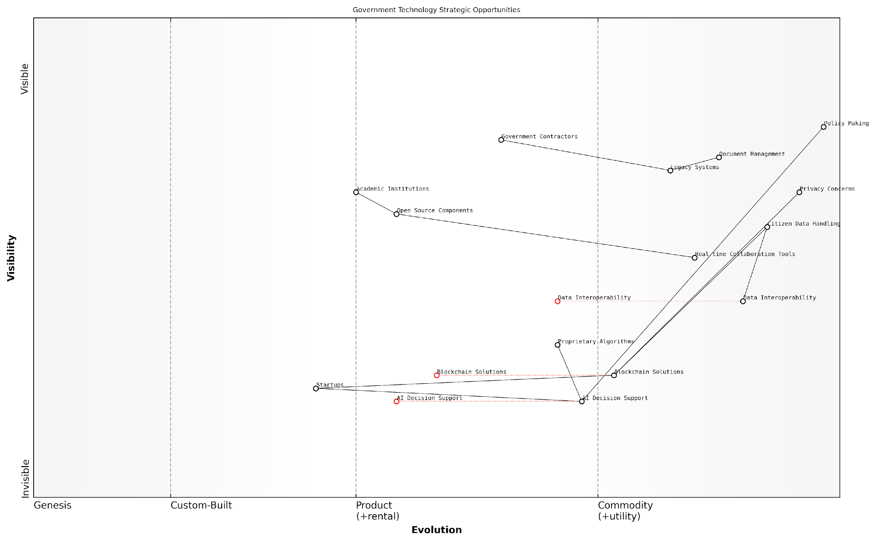

*Draft Wardley Map: [Insert Wardley Map: Identifying strategic opportunities]*

[Edit this draft Wardley Map](https://create.wardleymaps.ai/#clone:7d595194792b32654d)

Wardley Map Assessment

The Wardley Map reveals a government technology landscape in transition, with significant opportunities for innovation and improvement. By strategically leveraging emerging technologies, fostering partnerships with startups and academia, and gradually modernizing legacy systems, there’s potential for substantial enhancement in public service delivery and policy-making efficiency. However, careful management of risks related to data privacy, security, and ethical use of AI is crucial. The key to success lies in creating a balanced approach that drives innovation while ensuring the stability and reliability of essential government services.

[View full Wardley Map report](http://markdown_wardley_map_reports/wardley_map_report_12_Identifying_strategic_opportunities.md)

To effectively identify strategic opportunities using Wardley Maps, startups should follow these best practices:

* Regularly update and refine your maps to reflect the changing business landscape
* Collaborate with team members and external experts to gain diverse perspectives on the map
* Use scenario planning in conjunction with Wardley Mapping to explore potential future states
* Focus on areas where your startup’s unique capabilities align with identified opportunities
* Consider the broader societal and technological trends that may influence component evolution

It’s important to note that identifying strategic opportunities is just the first step. Startups must also have the agility and execution capabilities to capitalise on these opportunities. This requires a culture of continuous learning, rapid experimentation, and adaptive strategy.

In the fast-paced world of startups, the ability to not just identify but quickly act on strategic opportunities is what separates the leaders from the followers.

In conclusion, Wardley Mapping provides startups with a powerful tool for identifying strategic opportunities in complex and evolving markets. By focusing on evolutionary gaps, novel component combinations, inertia points, ecosystem dynamics, and future market movements, startups can gain a significant competitive advantage. As an expert who has witnessed the transformative impact of this approach in the public sector and beyond, I can confidently say that mastering the art of identifying strategic opportunities through Wardley Mapping is an essential skill for any startup aiming to make a lasting impact in their chosen market.

### Common pitfalls for startups

As startups navigate the complex landscape of strategy and innovation, Wardley Mapping can be an invaluable tool. However, the interpretation of these maps can present several challenges, particularly for nascent companies. Understanding and avoiding these common pitfalls is crucial for startups to harness the full potential of Wardley Mapping and drive strategic success.

Let’s explore the most prevalent pitfalls that startups encounter when interpreting Wardley Maps, and discuss strategies to overcome them:

* Overemphasis on current state
* Misinterpreting component evolution
* Neglecting external factors
* Failing to iterate and update
* Ignoring inertia and constraints

1. Overemphasis on current state:

One of the most common pitfalls for startups is focusing too heavily on their current situation when interpreting Wardley Maps. This myopic view can lead to missed opportunities and a failure to anticipate future market shifts. Startups must remember that Wardley Maps are dynamic tools designed to illuminate potential futures, not just reflect the present.

A seasoned strategy consultant once remarked, ‘The true power of Wardley Mapping lies not in understanding where you are, but in envisioning where you could be.’

To avoid this pitfall, startups should actively engage in scenario planning when interpreting their maps. Consider multiple potential futures and how the landscape might evolve. This approach allows for more robust strategy development and better prepares the startup for various market conditions.

1. Misinterpreting component evolution:

Another critical mistake is misunderstanding or misinterpreting the evolution of components on the map. Startups often struggle to accurately assess where a component lies on the evolution axis, leading to flawed strategic decisions. This is particularly problematic in fast-moving tech sectors where the pace of innovation can be rapid and unpredictable.

To mitigate this risk, startups should invest time in thorough market research and seek expert opinions when positioning components. Regular reassessment of component positions is crucial, as is staying abreast of industry trends and technological advancements. Remember, the evolution axis is not about the age of a technology, but its ubiquity and commoditisation.

1. Neglecting external factors:

Startups can sometimes become overly focused on their internal value chain, neglecting external factors that could significantly impact their strategy. These factors might include regulatory changes, shifts in consumer behaviour, or macroeconomic trends. Failing to consider these elements when interpreting Wardley Maps can lead to strategies that are misaligned with the broader business environment.

As a prominent government adviser once noted, ‘In the public sector, we’ve seen countless startups falter because they failed to account for regulatory shifts in their strategic planning. Wardley Maps should be a lens through which we view both internal operations and external influences.’

To address this, startups should incorporate PESTLE (Political, Economic, Social, Technological, Legal, and Environmental) analysis into their map interpretation process. This ensures a more holistic view of the landscape and helps identify potential threats and opportunities that might not be immediately apparent from the map alone.

1. Failing to iterate and update:

Wardley Maps are not static documents; they require regular updates to remain relevant. A common pitfall for startups is creating a map and then failing to revisit and revise it as circumstances change. This can lead to outdated strategies and missed opportunities.

To avoid this, startups should establish a regular cadence for reviewing and updating their Wardley Maps. This might be quarterly for fast-moving industries, or bi-annually for more stable sectors. Each review should consider new market entrants, evolving customer needs, and shifts in component positioning.

1. Ignoring inertia and constraints:

When interpreting Wardley Maps, startups often fall into the trap of assuming they can easily move or change components as needed. This overlooks the reality of organisational inertia and resource constraints that can impede strategic shifts. Failing to account for these factors can lead to overly ambitious or unrealistic strategies.

To address this, startups should incorporate a ‘reality check’ step in their map interpretation process. This involves assessing the feasibility of proposed changes, considering factors such as available resources, team capabilities, and potential resistance to change. It’s also valuable to map out dependencies between components to understand the full implications of any strategic moves.

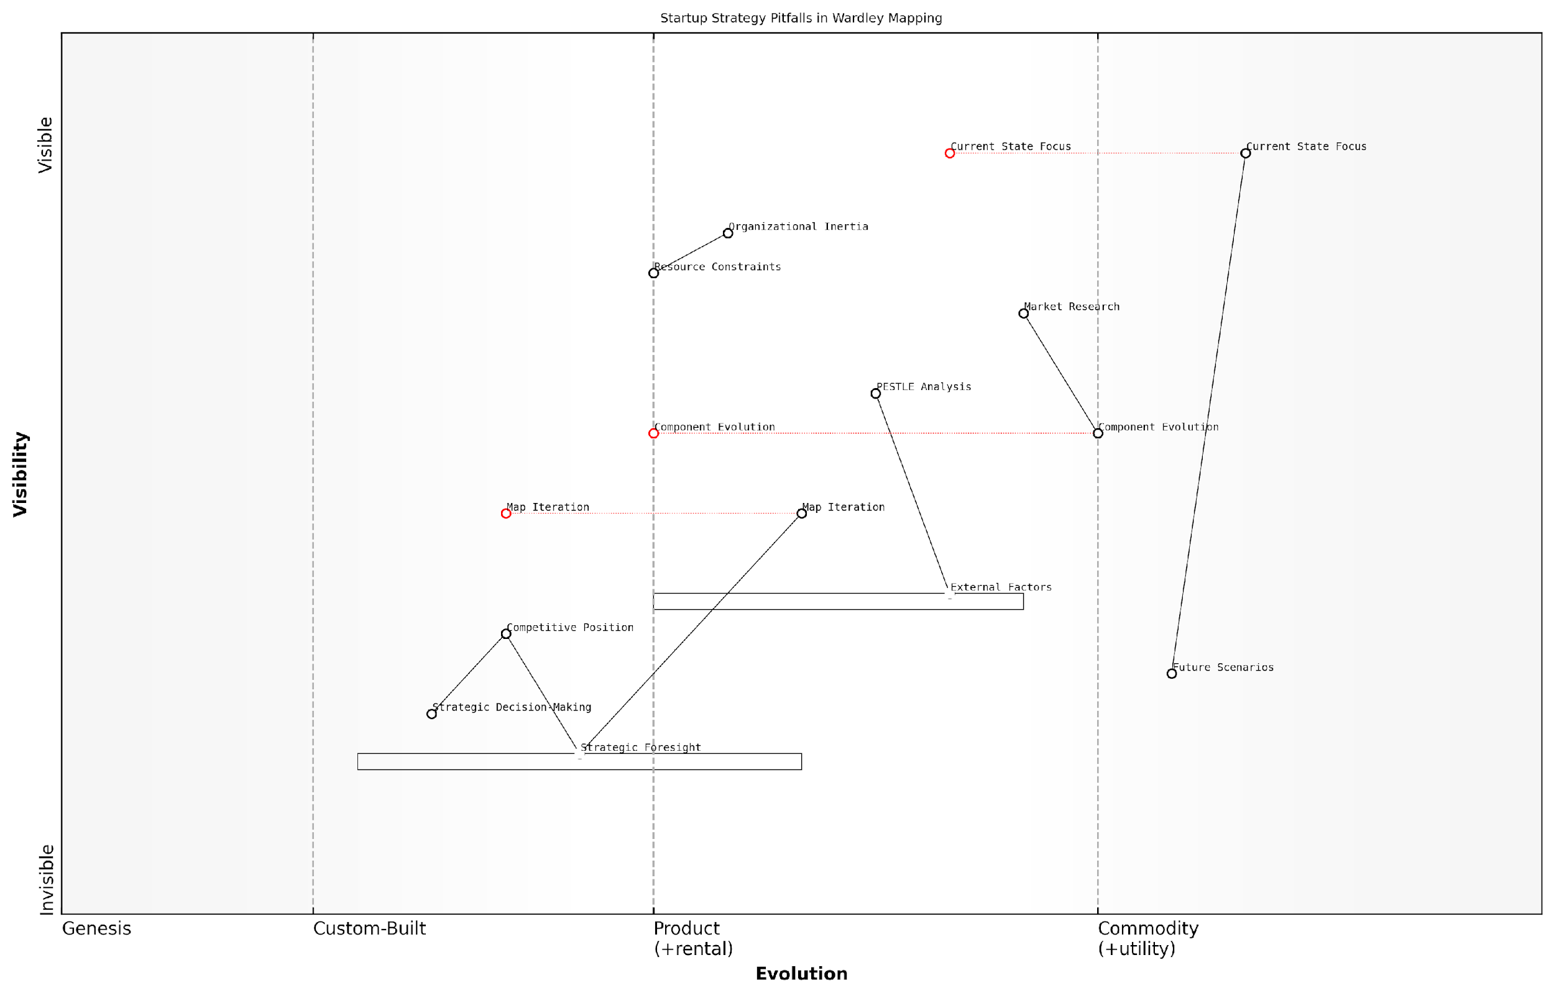

*Draft Wardley Map: [Insert Wardley Map: Common pitfalls for startups]*

[Edit this draft Wardley Map](https://create.wardleymaps.ai/#clone:4149dc0a4d607cb818)

Wardley Map Assessment

This Wardley Map effectively captures the strategic challenges faced by startups, highlighting the tension between short-term operational focus and long-term strategic planning. The key to success lies in developing dynamic capabilities in strategic foresight and decision-making, while actively managing organisational inertia and resource constraints. Startups that can effectively iterate their strategic maps and integrate future scenarios into their planning processes will be better positioned to navigate the complex and rapidly evolving startup ecosystem.

[View full Wardley Map report](http://markdown_wardley_map_reports/wardley_map_report_13_Common_pitfalls_for_startups.md)

By being aware of these common pitfalls and taking proactive steps to avoid them, startups can significantly enhance their ability to interpret and leverage Wardley Maps effectively. This leads to more robust strategies, better resource allocation, and ultimately, a stronger competitive position in the market.

Remember, the goal of Wardley Mapping is not to predict the future with certainty, but to better prepare for various potential futures. By avoiding these pitfalls, startups can use Wardley Maps as a powerful tool for strategic foresight and decision-making, navigating the complex and often turbulent waters of the startup ecosystem with greater confidence and clarity.

# Chapter 2: Market Opportunity Analysis with Wardley Maps

## Identifying Market Gaps

### Using maps to spot underserved needs

In the dynamic landscape of startup ecosystems, identifying underserved needs is crucial for carving out a competitive advantage and driving innovation. Wardley Mapping provides a powerful visual tool for startups to uncover these hidden opportunities within their target markets. By leveraging the unique perspective offered by Wardley Maps, entrepreneurs can gain invaluable insights into market gaps and position their ventures for success.

Wardley Maps excel at revealing underserved needs through their visual representation of value chains and component evolution. By mapping out the entire ecosystem of a market or industry, startups can identify areas where current solutions fall short or where emerging technologies create new possibilities. This section will explore the methodologies and strategies for using Wardley Maps to spot these lucrative opportunities.

To effectively use Wardley Maps for identifying underserved needs, startups should focus on several key areas:

* Analysing component evolution stages
* Identifying gaps in value chains
* Exploring adjacent possibilities
* Assessing customer needs against current offerings

Analysing Component Evolution Stages: One of the most powerful aspects of Wardley Mapping for identifying underserved needs is its ability to visualise the evolution of components within a value chain. By examining the position of components along the evolution axis, startups can spot areas ripe for innovation or disruption.

For instance, when a component is transitioning from the ‘Custom Built’ to the ‘Product’ stage, there’s often an opportunity to create a standardised solution that meets the needs of multiple customers. Similarly, as components move towards the ‘Commodity’ stage, opportunities may arise to offer more specialised or value-added services built on top of these commoditised elements.

The evolution axis in Wardley Mapping is not just a static representation, but a dynamic tool for predicting future market needs. By understanding where components are heading, startups can position themselves ahead of the curve.

Identifying Gaps in Value Chains: Wardley Maps provide a comprehensive view of entire value chains, from the customer need at the top to the underlying components that support it. By carefully analysing these maps, startups can identify gaps where current solutions are inadequate or where connections between components are inefficient.

These gaps often represent underserved needs that a startup can address. For example, a map might reveal that while there are numerous solutions for data storage and data analysis, there’s a lack of efficient tools for data preparation and cleaning – a critical step in the data analytics process. This gap could represent a significant opportunity for a startup to develop a specialised data preparation tool.

Exploring Adjacent Possibilities: Wardley Maps can also help startups identify underserved needs by highlighting adjacent possibilities – areas closely related to existing solutions but not yet fully explored or exploited. By examining the relationships between components and their evolution, startups can spot potential new use cases or applications for existing technologies.

For instance, a map of the transportation industry might reveal that while ride-sharing services have become commoditised, there’s an underserved need for specialised transportation services for specific demographics, such as elderly care transport or school run services. These adjacent possibilities often represent blue ocean opportunities for startups.

The true power of Wardley Mapping lies not just in understanding what exists today, but in envisioning what could exist tomorrow. It’s about seeing the potential in the white spaces between components.

Assessing Customer Needs Against Current Offerings: Wardley Maps start with user needs at the top of the value chain. By thoroughly analysing these needs and comparing them against the current offerings in the market, startups can identify areas where customer requirements are not being fully met.

This process often reveals underserved needs that may not be immediately obvious. For example, a map of the online education sector might show that while there are numerous platforms offering courses, there’s an unmet need for personalised learning paths that adapt to individual student progress and learning styles. This insight could guide a startup to develop an AI-driven adaptive learning platform.

To effectively use Wardley Maps for spotting underserved needs, startups should follow these best practices:

* Regularly update and refine your maps as market conditions change
* Collaborate with customers and industry experts to validate your insights
* Use multiple maps to explore different scenarios and perspectives
* Combine Wardley Mapping with other market research techniques for a comprehensive view
* Focus on the ‘why’ behind the gaps you identify, not just the ‘what’

Case Study: Government Digital Services

In my work advising government bodies on digital transformation, I’ve seen firsthand how Wardley Mapping can reveal underserved needs in public services. In one project, we mapped the citizen journey for accessing various government services online. The map revealed a significant gap in the authentication process – while there were solutions for basic online identity verification, there was an underserved need for a more robust, secure, and user-friendly authentication system that could work across multiple government services.

This insight led to the development of a unified digital identity platform, which not only improved security and user experience but also opened up possibilities for new types of online government services that weren’t feasible before due to identity verification challenges.

In the public sector, Wardley Mapping isn’t just about finding market opportunities – it’s about uncovering ways to better serve citizens and improve the efficiency of government operations.

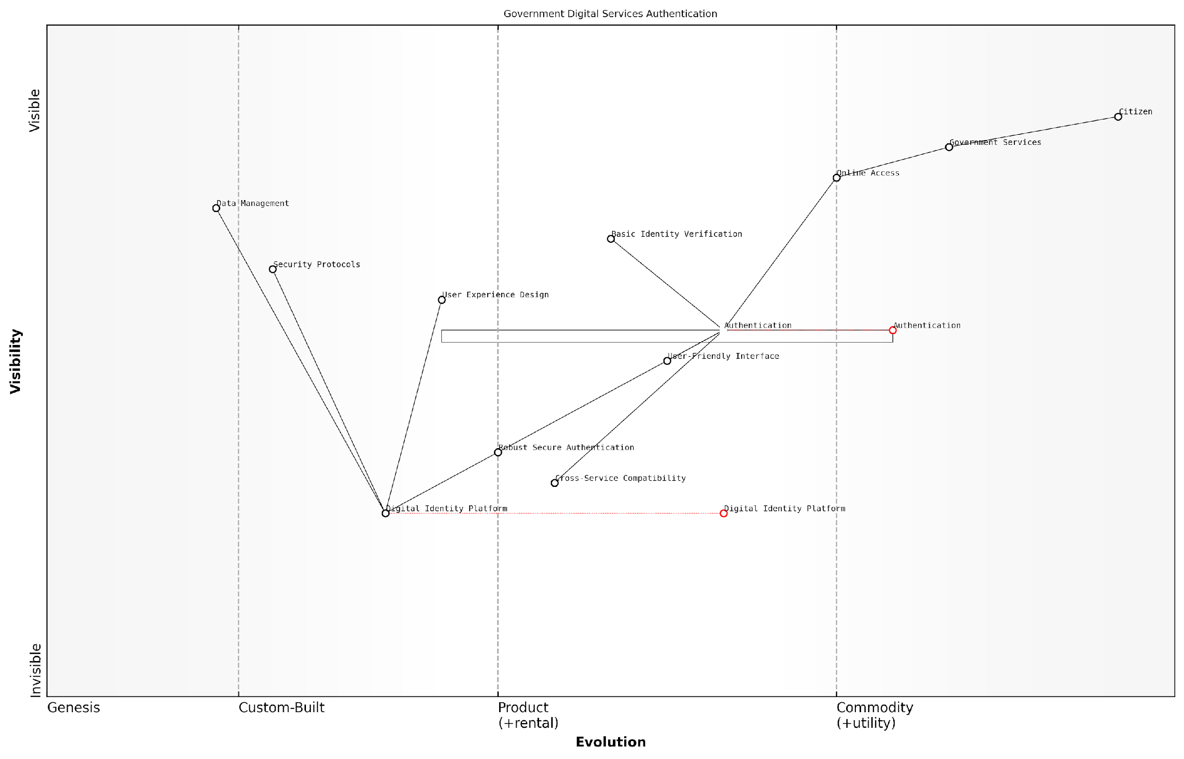

*Draft Wardley Map: [Insert Wardley Map: Using maps to spot underserved needs]*

[Edit this draft Wardley Map](https://create.wardleymaps.ai/#clone:d54efe4bdd10e4d90a)

Wardley Map Assessment

The map reveals a government digital services authentication system in transition, moving from basic, siloed approaches to a more integrated, secure, and user-friendly model. The key strategic focus should be on developing the Digital Identity Platform while enhancing user experience and cross-service compatibility. This approach will position the government as a leader in digital service delivery, improving citizen engagement and setting new standards for secure online interactions. The successful evolution of this system could have far-reaching implications for both public and private sector digital identity management.

[View full Wardley Map report](http://markdown_wardley_map_reports/wardley_map_report_14_Using_maps_to_spot_underserved_needs.md)

In conclusion, Wardley Mapping provides startups with a powerful tool for identifying underserved needs in their target markets. By visualising value chains, component evolution, and gaps in current offerings, entrepreneurs can uncover hidden opportunities and position their ventures for success. As the startup ecosystem continues to evolve, those who master the art of spotting underserved needs through Wardley Mapping will have a significant competitive advantage in creating innovative solutions and capturing market share.

### Assessing market maturity

Assessing market maturity is a crucial step in identifying market gaps and opportunities for startups. By leveraging Wardley Mapping techniques, startups can gain a comprehensive understanding of where different components of their market lie on the evolution axis, from genesis to commodity. This assessment allows founders and strategists to make informed decisions about where to focus their efforts and resources for maximum impact.

To effectively assess market maturity using Wardley Maps, startups should consider the following key aspects:

* Component positioning on the evolution axis
* Pace of evolution for different components
* Interdependencies between components
* Market forces influencing component evolution
* Potential disruptive technologies or innovations

Let’s explore each of these aspects in detail:

1. Component positioning on the evolution axis: The evolution axis in a Wardley Map represents the journey of a component from genesis (novel and uncertain) to commodity (standardised and well-understood). By accurately positioning components along this axis, startups can identify areas of the market that are ripe for innovation or disruption. Components in the genesis or custom-built stages often present opportunities for startups to create unique value propositions.

Understanding where components sit on the evolution axis is like having a crystal ball for your market. It allows you to see not just where things are, but where they’re headed.

1. Pace of evolution for different components: Not all components evolve at the same rate. Some may rapidly progress from genesis to commodity, while others may stagnate at a particular stage. By analysing the pace of evolution, startups can anticipate future market shifts and position themselves accordingly. This is particularly crucial in fast-moving sectors such as technology or biotech.
2. Interdependencies between components: Market maturity is not just about individual components, but also about how they interact and depend on each other. A startup might identify a mature component that, when combined with a novel approach, creates an entirely new market opportunity. Understanding these interdependencies can reveal hidden gaps in the market that competitors may have overlooked.
3. Market forces influencing component evolution: External factors such as regulatory changes, technological advancements, or shifts in consumer behaviour can accelerate or hinder the evolution of market components. Startups must consider these forces when assessing market maturity to anticipate potential obstacles or catalysts for change.

In the startup world, being able to read the market forces is as crucial as understanding your product. It’s the difference between riding the wave and being swept away by it.

1. Potential disruptive technologies or innovations: Emerging technologies or innovative approaches can rapidly alter the market landscape. By identifying potential disruptors, startups can either position themselves to leverage these innovations or prepare defensive strategies to maintain their market position.

To illustrate the practical application of assessing market maturity, let’s consider a case study from the government sector:

Case Study: GovTech Startup in Public Service Delivery

A GovTech startup aimed to improve public service delivery in local councils. By creating a Wardley Map of the current public service landscape, they identified that while many components (e.g., customer service systems, data management) were in the product or commodity stages, there was a significant gap in the custom-built stage for AI-driven predictive service allocation.

The startup recognised that this gap represented an opportunity to develop a novel solution that could significantly enhance the efficiency of public service delivery. By positioning their offering in this custom-built stage, they could provide unique value to local councils while also having room to evolve their product as the market matured.

This assessment of market maturity allowed the startup to:

* Focus their development efforts on AI-driven predictive models
* Tailor their marketing message to highlight the innovative nature of their solution
* Plan for future evolution of their product as the market inevitably matured
* Identify potential partnerships with providers of more commoditised components

The result was a successful market entry and rapid adoption by forward-thinking local councils, establishing the startup as a leader in the GovTech space.

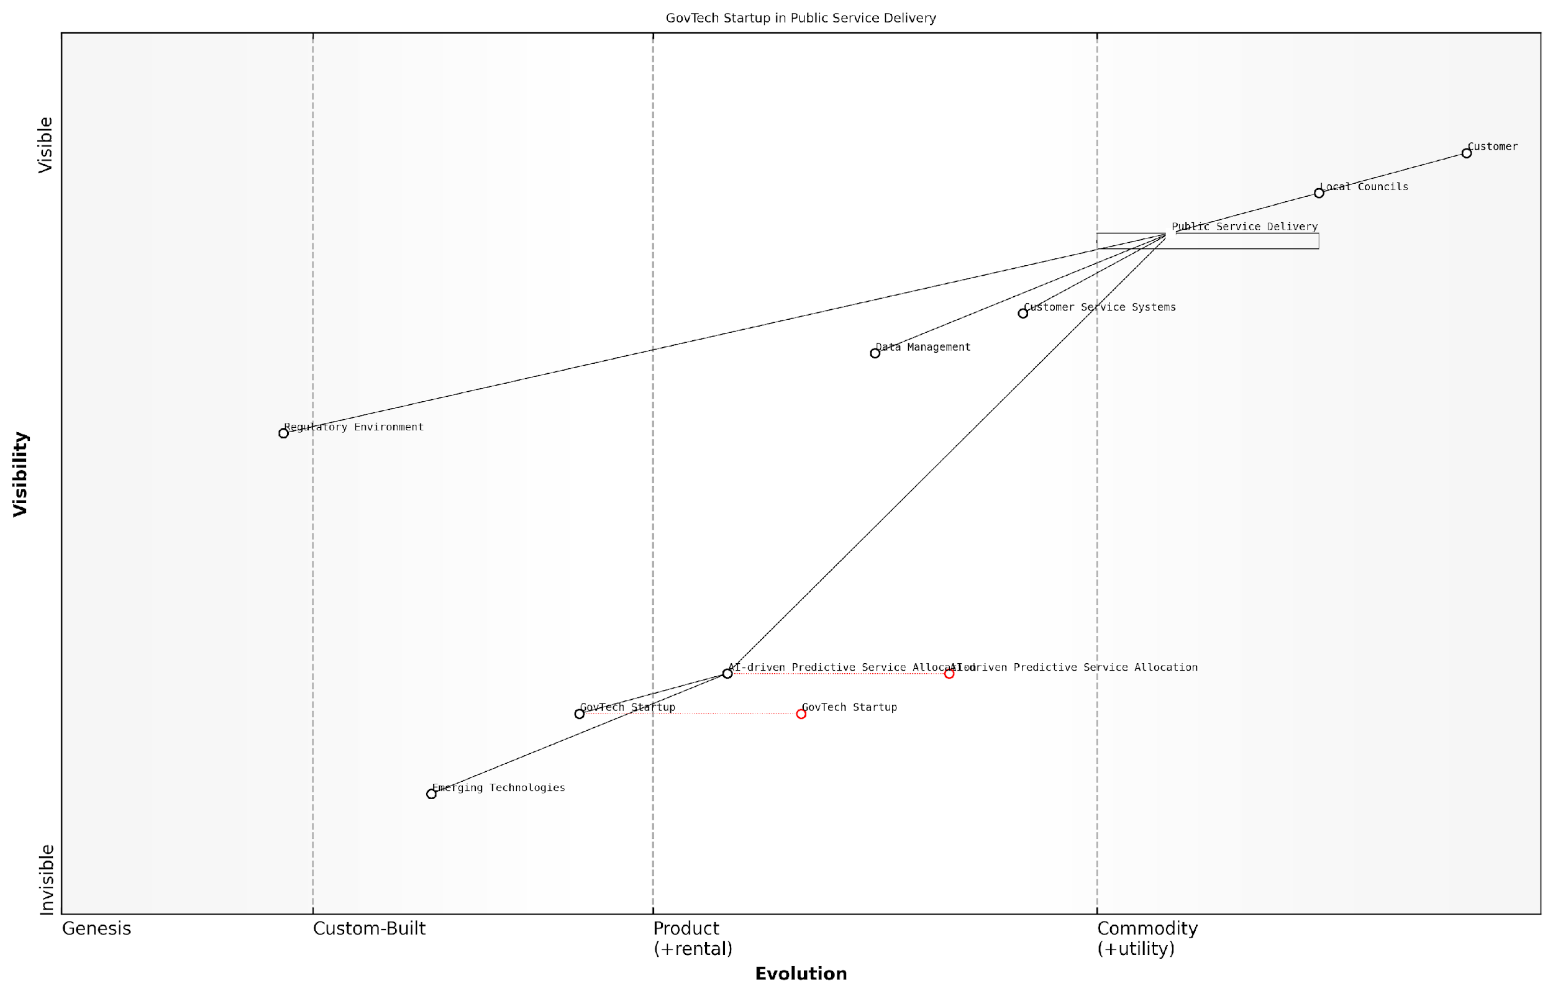

*Draft Wardley Map: [Insert Wardley Map: Assessing market maturity]*

[Edit this draft Wardley Map](https://create.wardleymaps.ai/#clone:8b83de6c7e4792c42f)

Wardley Map Assessment

The GovTech Startup is strategically positioned to drive significant innovation in public service delivery through AI-driven solutions. Its success hinges on effectively navigating the regulatory landscape, building strong partnerships with Local Councils, and continuously evolving its technological capabilities. The startup has the potential to reshape the public service ecosystem, but must balance rapid innovation with the complexities of public sector operations and citizen expectations. Key focus areas should be scaling AI solutions, enhancing data management capabilities, and fostering an ecosystem that bridges traditional public services with emerging technologies.

[View full Wardley Map report](http://markdown_wardley_map_reports/wardley_map_report_15_Assessing_market_maturity.md)

In conclusion, assessing market maturity through Wardley Mapping provides startups with a powerful tool for identifying gaps and opportunities in their target markets. By understanding the evolutionary stage of various market components, their interdependencies, and the forces shaping their development, startups can make informed strategic decisions that increase their chances of success in competitive landscapes.

In the end, success for startups isn’t just about having a great product or service. It’s about understanding your market deeply enough to see the gaps that others miss, and having the courage to fill them.

### Predicting future market movements

In the dynamic landscape of startup ecosystems, the ability to predict future market movements is a critical skill that can mean the difference between success and failure. Wardley Mapping provides a powerful framework for startups to anticipate and prepare for market shifts, enabling them to position themselves strategically for future opportunities. This section explores how startups can leverage Wardley Maps to forecast market evolution and make informed decisions about their product development, resource allocation, and market entry strategies.

At its core, predicting future market movements with Wardley Maps relies on understanding the evolutionary patterns of components within a value chain. By analysing the current position of components on the evolution axis and considering the forces driving their movement, startups can make educated projections about future market states.

Wardley Mapping is not about predicting the future with certainty, but about understanding the landscape well enough to make informed bets on where the market is heading.

Let’s explore the key aspects of using Wardley Maps for market prediction:

* Understanding component evolution
* Identifying evolutionary characteristics
* Analysing market forces
* Projecting future states
* Scenario planning

Understanding Component Evolution: The foundation of predicting market movements lies in grasping how components evolve over time. Wardley Maps depict this evolution from left to right, moving from genesis (novel and poorly understood) to commodity (well-understood and ubiquitous). Startups must carefully assess where each component in their value chain sits on this spectrum and consider how quickly they might move.

Identifying Evolutionary Characteristics: Each stage of evolution has distinct characteristics that can help startups anticipate future movements. For instance, components in the ‘custom-built’ phase often experience rapid innovation and differentiation, while those approaching commodity status tend to see increased standardisation and cost reduction. By recognising these patterns, startups can predict how different parts of their market might evolve.

Analysing Market Forces: Wardley Maps allow startups to visualise and analyse the various forces acting upon components in their ecosystem. These forces include customer demand, technological advancements, regulatory changes, and competitive pressures. By mapping these forces and understanding their potential impact, startups can anticipate how they might accelerate or hinder the evolution of different components.

The key to accurate market prediction is not just understanding where components are today, but also the forces that are pushing them towards their future states.

Projecting Future States: With a clear understanding of current positions and evolutionary forces, startups can project potential future states of their market. This involves creating multiple iterations of their Wardley Map, each representing a different time horizon (e.g., 6 months, 1 year, 3 years). These projections help identify emerging opportunities, potential threats, and areas where the startup might need to pivot or innovate.

Scenario Planning: Predicting future market movements is not about arriving at a single, definitive forecast. Instead, it’s about exploring multiple possible scenarios and preparing for various outcomes. Wardley Maps excel in this regard, allowing startups to visualise different potential futures and develop contingency plans for each.

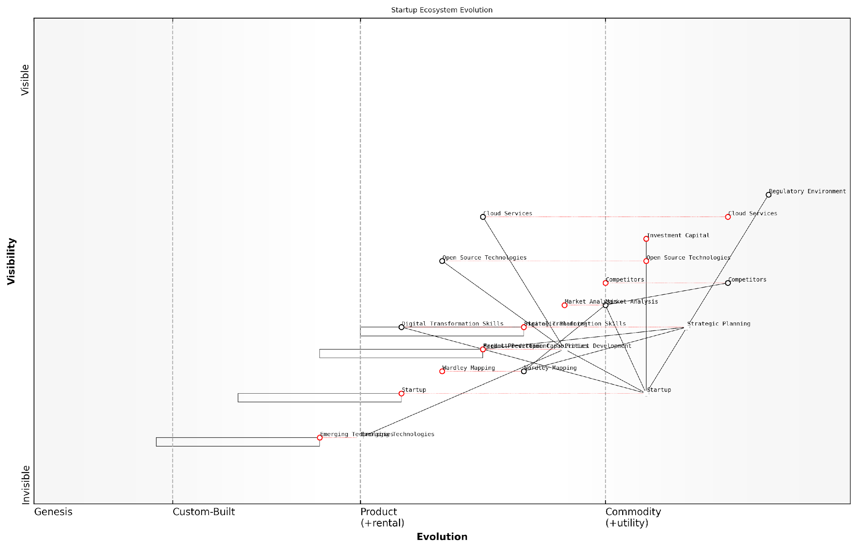

*Draft Wardley Map: [Insert Wardley Map: Predicting future market movements]*

[Edit this draft Wardley Map](https://create.wardleymaps.ai/#clone:e805fc80188ceb8836)

Wardley Map Assessment

The Wardley Map reveals a startup ecosystem poised for significant evolution, with strong foundations in market understanding and strategic planning. The key to future success lies in effectively integrating emerging technologies, enhancing market prediction capabilities, and fostering a culture of continuous adaptation. Startups that can navigate the balance between leveraging established technologies and innovating with emerging ones, while maintaining a strong focus on customer needs, will be best positioned for success in this dynamic ecosystem.

[View full Wardley Map report](http://markdown_wardley_map_reports/wardley_map_report_16_Predicting_future_market_movements.md)

Practical Application for Startups:

* Identify Emerging Technologies: By mapping the evolution of technological components, startups can spot emerging technologies that are likely to become critical in the near future. This allows for early adoption or investment in promising areas.
* Anticipate Customer Needs: As user needs evolve along with the market, startups can use Wardley Maps to predict future customer requirements and align their product roadmap accordingly.
* Predict Competitive Moves: By mapping competitors’ positions and likely evolutionary paths, startups can anticipate potential competitive threats or opportunities for collaboration.
* Guide Investment Decisions: Understanding the future trajectory of market components can inform decisions about where to allocate resources, whether to build in-house capabilities, or when to outsource.
* Time Market Entry: Predicting market movements helps startups identify the optimal timing for entering new markets or launching new products, balancing first-mover advantages with market readiness.

Case Study: Government Digital Service Transformation

Consider the case of a government digital service transformation project. By using Wardley Mapping to predict future market movements, the project team was able to anticipate the shift towards cloud-based services and open-source technologies. This foresight allowed them to make strategic decisions about infrastructure investments and skill development, positioning the service for long-term success and cost-effectiveness.

Our use of Wardley Mapping to predict market evolution saved us millions in potential misspent funds and accelerated our digital transformation by at least two years.

Challenges and Limitations:

While Wardley Mapping is a powerful tool for predicting future market movements, it’s important to acknowledge its limitations. The complexity of real-world markets means that unforeseen disruptors can emerge, rapidly changing the landscape. Additionally, the pace of evolution can vary significantly between industries and even between different components within the same ecosystem.

To mitigate these challenges, startups should:

* Regularly update their maps to reflect new information and changing conditions
* Combine Wardley Mapping with other forecasting and market analysis tools
* Maintain flexibility in their strategies to adapt to unexpected changes
* Cultivate a culture of continuous learning and adaptation within the organisation

In conclusion, predicting future market movements is a critical capability for startups navigating uncertain and rapidly changing environments. Wardley Mapping provides a structured approach to visualising and analysing market evolution, enabling startups to make more informed strategic decisions. By mastering this aspect of Wardley Mapping, startups can position themselves to capitalise on emerging opportunities, mitigate potential threats, and build sustainable competitive advantages in their chosen markets.

## Competitive Landscape Mapping

### Positioning your startup

In the dynamic landscape of startup ecosystems, positioning is not merely about finding a niche; it’s about strategically placing your venture within the evolving value chain of your industry. Wardley Mapping provides a powerful visual tool for startups to analyse and optimise their position relative to competitors, collaborators, and market forces. This subsection delves into the nuanced art of startup positioning using Wardley Maps, offering insights that can significantly enhance your strategic decision-making process.

At its core, positioning with Wardley Maps involves understanding the evolutionary stage of various components within your business model and how they relate to the broader market landscape. This approach allows startups to identify opportunities for differentiation, anticipate market shifts, and align their offerings with customer needs more effectively.

Wardley Mapping transformed our understanding of market positioning. It’s not just about where you are, but where the entire ecosystem is moving. This insight has been invaluable for our strategic planning.

Let’s explore the key aspects of positioning your startup using Wardley Maps:

* Evolutionary Advantage: Identify where your startup’s core competencies lie on the evolution axis.
* Value Chain Positioning: Determine your place in the industry’s value chain and potential for vertical integration.
* Competitive Differentiation: Analyse how your positioning differs from competitors and where you can create unique value.
* Market Maturity Assessment: Understand the maturity of your market and position accordingly.
* Future-proofing: Anticipate market evolution and position for future opportunities.

Evolutionary Advantage: One of the most critical aspects of positioning is understanding where your startup’s core competencies lie on the evolution axis. Are you innovating in genesis, leveraging custom-built solutions, utilising products, or relying on commodities? Your position on this spectrum significantly influences your competitive strategy.

For instance, if your startup is operating in the genesis or custom-built phases, you may have a first-mover advantage but also face higher costs and uncertainties. Conversely, if you’re leveraging more evolved components, you might benefit from lower costs but face stiffer competition. The key is to identify where you can create the most value given your resources and expertise.

Value Chain Positioning: Wardley Maps excel at visualising the entire value chain of an industry. By mapping out this chain, from raw components to end-user needs, you can identify optimal positions for your startup. This might involve finding gaps in the current value chain, opportunities for disintermediation, or potential for creating new value propositions by connecting previously disparate components.

Understanding our position in the value chain through Wardley Mapping revealed unexpected opportunities for vertical integration that we hadn’t previously considered. It’s completely reshaped our growth strategy.

Competitive Differentiation: By mapping your competitors alongside your own position, you can visually identify areas of differentiation. This process often reveals unexpected insights. You might discover that what you thought was your unique selling proposition is actually commonplace in the market, or you might identify untapped areas where you can create significant value.

Market Maturity Assessment: The evolution axis of a Wardley Map provides crucial insights into market maturity. Positioning your startup effectively requires a deep understanding of where your market sits on this spectrum. Are you operating in a nascent market where the rules are yet to be defined, or in a mature market where commoditisation is the norm?

In less mature markets, positioning might focus on educating customers and shaping industry standards. In more mature markets, the focus might shift to efficiency, cost reduction, or finding innovative applications of commoditised components.

Future-proofing: Perhaps the most powerful aspect of Wardley Mapping for startup positioning is its ability to anticipate future market movements. By understanding the natural evolution of components and market forces, you can position your startup not just for the current landscape, but for where the market is heading.

Wardley Mapping gave us the foresight to position ourselves ahead of a major market shift. While our competitors were caught off guard, we were prepared and able to capitalise on the change.

This forward-looking approach allows startups to make strategic decisions about resource allocation, product development, and market entry timing that align with anticipated market evolution.

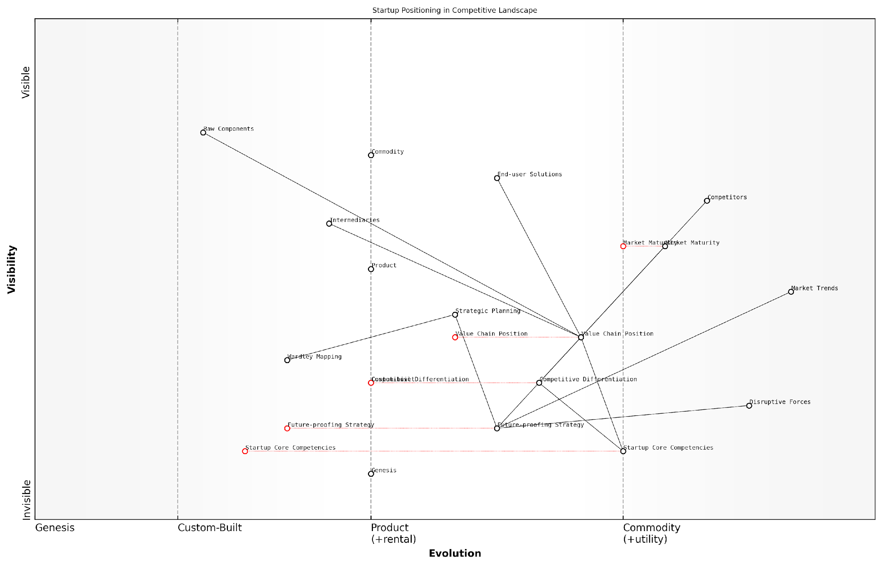

*Draft Wardley Map: [Insert Wardley Map: Positioning your startup]*

[Edit this draft Wardley Map](https://create.wardleymaps.ai/#clone:2144f6f83a35446a2f)

Wardley Map Assessment

This Wardley Map reveals a startup landscape ripe with both opportunity and challenge. The key to success lies in the startup’s ability to rapidly evolve its core competencies and competitive differentiation while navigating a maturing market. Strategic use of tools like Wardley Mapping for continuous strategic adjustment is crucial. The startup must balance short-term differentiation with long-term resilience, optimising its position in the value chain and ecosystem. By focusing on future-proofing and maintaining close alignment with customer needs, the startup can create a sustainable competitive advantage in a dynamic market environment.

[View full Wardley Map report](http://markdown_wardley_map_reports/wardley_map_report_17_Positioning_your_startup.md)

Practical Application: To effectively position your startup using Wardley Maps, follow these steps:

* Map your current position, including key components of your business model.
* Map known competitors and their positions.
* Identify gaps and opportunities in the current landscape.
* Analyse the evolutionary trends of key components.
* Project future market movements and potential disruptions.
* Determine your ideal future position based on your capabilities and market trends.
* Develop a strategic plan to move from your current position to your desired future state.

Remember, positioning is not a one-time exercise. The dynamic nature of startup ecosystems requires regular reassessment and adjustment of your position. Wardley Mapping should be an ongoing process, allowing you to continuously refine your strategy as market conditions evolve.

In conclusion, effective positioning using Wardley Maps can provide startups with a significant competitive advantage. By visualising your position within the broader ecosystem, understanding evolutionary trends, and anticipating future market movements, you can make more informed strategic decisions. This approach not only helps in differentiating your offering but also in identifying opportunities for innovation and growth that might otherwise remain hidden.

Wardley Mapping has become an indispensable tool in our strategic arsenal. It’s changed how we view our market, our competitors, and most importantly, our own potential for growth and innovation.

### Identifying potential competitors and collaborators

In the dynamic landscape of startups, understanding the competitive environment is crucial for strategic positioning and long-term success. Wardley Mapping provides a powerful framework for identifying potential competitors and collaborators, offering startups a visual and analytical approach to navigate the complex business ecosystem. This section explores how startups can leverage Wardley Maps to gain a comprehensive view of their competitive landscape, identify strategic opportunities for collaboration, and anticipate market shifts.

Wardley Mapping’s unique ability to visualise the value chain and evolution of components makes it an invaluable tool for competitive analysis. By mapping out the entire ecosystem, startups can gain insights that go beyond traditional competitor analysis methods, revealing not just who their competitors are, but also how the competitive landscape might evolve over time.

Wardley Mapping allows us to see not just the current state of competition, but also the potential future states. This foresight is invaluable for startups operating in rapidly changing markets.

Let’s delve into the key aspects of using Wardley Maps for identifying competitors and collaborators:

* Mapping the Competitive Landscape
* Identifying Direct and Indirect Competitors
* Spotting Potential Collaborators
* Anticipating Market Shifts
* Strategic Positioning

Mapping the Competitive Landscape:

The first step in using Wardley Maps for competitive analysis is to create a comprehensive map of your industry’s value chain. This involves identifying all the components necessary to deliver value to the end user, from the most visible customer-facing elements to the underlying infrastructure and services.

For a startup, this process might reveal components that are currently being served by established players, as well as gaps in the market where no adequate solution exists. By plotting these components on the evolution axis, startups can visualise which areas of the value chain are ripe for innovation and disruption.

The beauty of Wardley Mapping lies in its ability to expose the entire ecosystem. It’s not just about your direct competitors, but understanding the whole landscape in which you operate.

Identifying Direct and Indirect Competitors:

Once the value chain is mapped, startups can begin to identify their competitors more accurately. Direct competitors will likely be operating in the same space on the map, targeting similar components with comparable offerings. However, Wardley Mapping often reveals indirect competitors that may not be immediately obvious through traditional analysis.

For example, a fintech startup might discover that their true competition isn’t just other fintech companies, but also established banks that are evolving their digital offerings, or even big tech companies moving into the financial services space. By visualising these relationships on the map, startups can develop a more nuanced understanding of their competitive environment.

Spotting Potential Collaborators:

Wardley Mapping isn’t just about identifying competitors; it’s also an excellent tool for spotting potential collaborators. By analysing the map, startups can identify companies operating in adjacent or complementary spaces that could become valuable partners.

For instance, a startup focusing on a specific component in the value chain might identify potential collaborators who provide complementary services or have expertise in areas that the startup lacks. These collaborations can lead to mutually beneficial partnerships, allowing startups to expand their offerings or enter new markets more efficiently.

In the startup world, your biggest competitor today could be your most valuable collaborator tomorrow. Wardley Mapping helps you see these potential synergies before they become obvious to everyone else.

Anticipating Market Shifts:

One of the most powerful aspects of Wardley Mapping for startups is its ability to help anticipate market shifts. By understanding the evolutionary stage of different components in the value chain, startups can predict how the competitive landscape might change over time.

For example, as certain components evolve from custom-built solutions to commodities, new opportunities for innovation and differentiation emerge. Startups that can anticipate these shifts can position themselves to take advantage of emerging opportunities before their competitors.

Strategic Positioning:

Armed with insights from their Wardley Map, startups can make informed decisions about their strategic positioning. This might involve focusing on underserved areas of the value chain, differentiating their offerings in crowded markets, or even pivoting to take advantage of newly identified opportunities.

The map can also guide decisions about which components to develop in-house, which to outsource, and where to seek strategic partnerships. This level of strategic clarity is particularly valuable for startups operating with limited resources and needing to make every decision count.

Wardley Mapping doesn’t just show you where you are; it shows you where you could be. For startups, this strategic foresight can be the difference between success and failure.

In conclusion, Wardley Mapping offers startups a powerful tool for navigating the complex landscape of competitors and collaborators. By providing a visual representation of the entire ecosystem, it allows startups to identify threats and opportunities that might be missed through traditional analysis methods. Moreover, its focus on evolution and change makes it particularly well-suited to the dynamic nature of startup environments, helping founders and leaders make informed strategic decisions in the face of uncertainty.

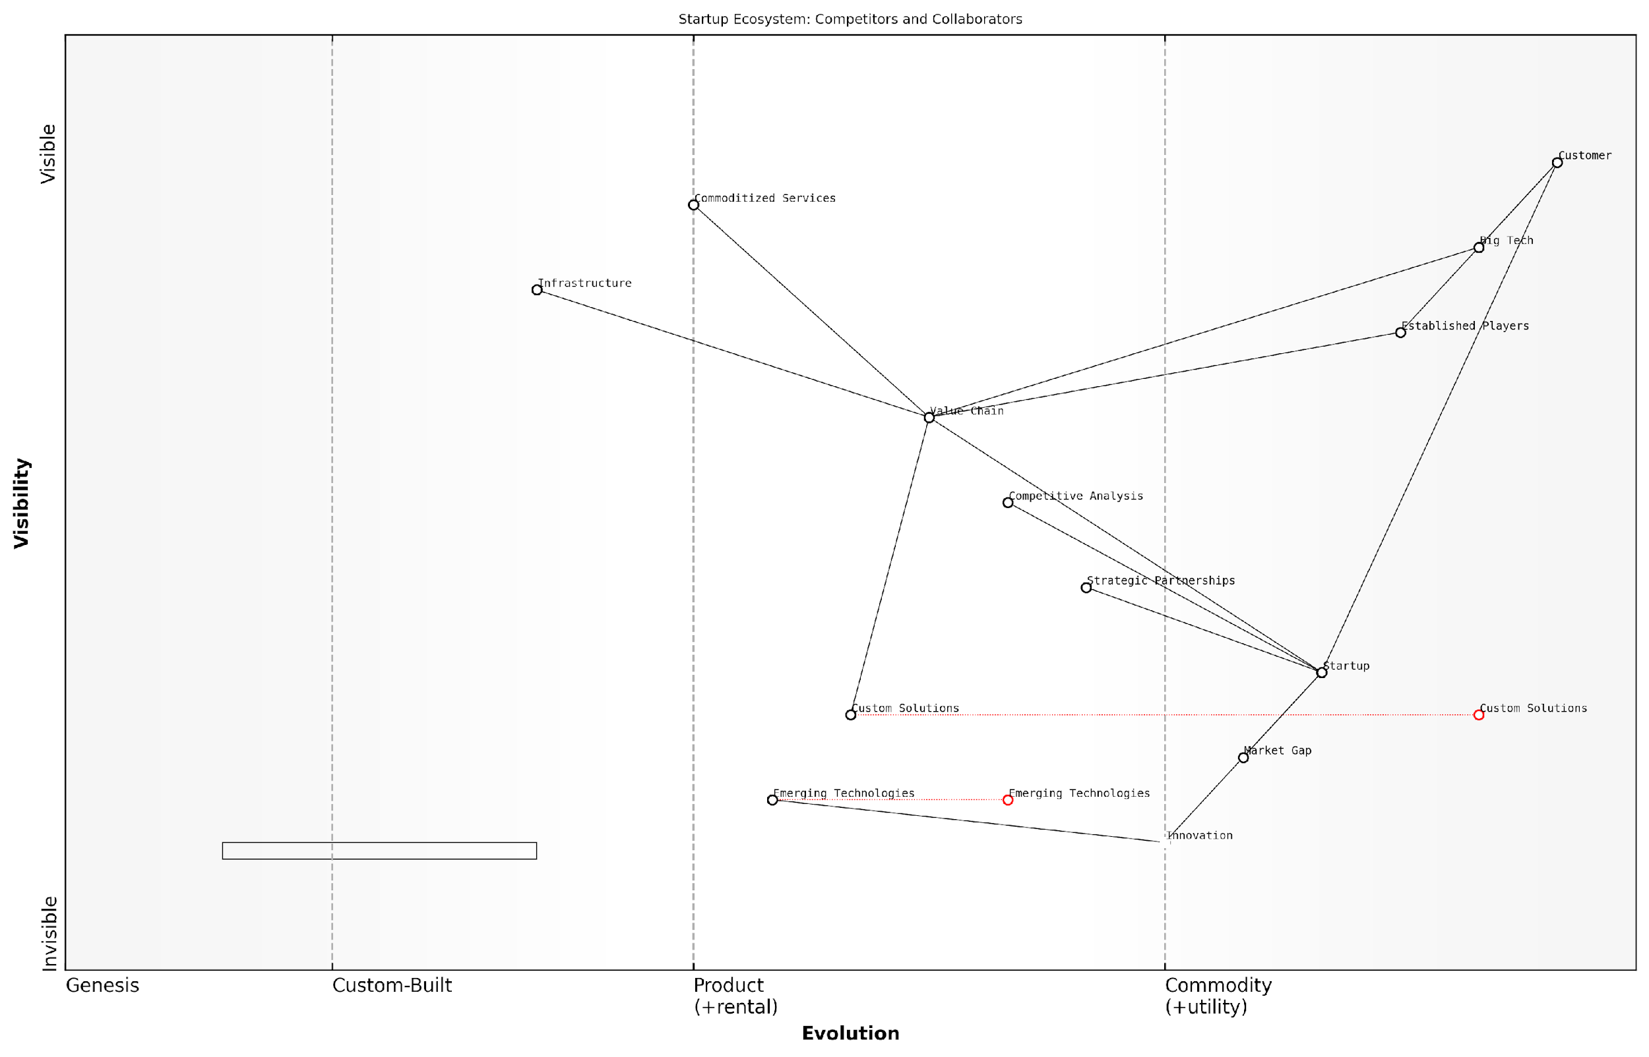

*Draft Wardley Map: [Insert Wardley Map: Identifying potential competitors and collaborators]*

[Edit this draft Wardley Map](https://create.wardleymaps.ai/#clone:7bc45b0171b336bd92)

Wardley Map Assessment

The map represents a vibrant startup ecosystem with significant opportunities for innovation and growth. Key strategic imperatives include maintaining a strong focus on emerging technologies and innovation, optimising strategic partnerships, and continuously refining competitive analysis capabilities. The ecosystem is poised for potential disruption, particularly in custom solutions and value chain structures. Startups that can effectively navigate the balance between innovation and scalability, while leveraging strategic partnerships and addressing market gaps, are likely to thrive. Established players and big tech companies need to remain vigilant and adaptive to avoid disruption from emerging technologies and innovative startups. Overall, the ecosystem shows a healthy tension between collaboration and competition, driving overall progress and value creation for customers.

[View full Wardley Map report](http://markdown_wardley_map_reports/wardley_map_report_18_Identifying_potential_competitors_and_collaborator.md)

As startups continue to navigate increasingly complex and rapidly changing markets, the ability to effectively map and analyse the competitive landscape will become ever more crucial. Wardley Mapping provides a framework not just for understanding the present, but for anticipating and shaping the future. By mastering this tool, startups can gain a significant strategic advantage, positioning themselves not just as participants in their markets, but as shapers of entire industries.

### Anticipating market shifts

In the dynamic landscape of startup ecosystems, anticipating market shifts is a critical skill that can mean the difference between thriving and merely surviving. Wardley Mapping provides a powerful framework for startups to visualise and predict these shifts, enabling them to stay ahead of the curve and capitalise on emerging opportunities. This section delves into the techniques and strategies for using Wardley Maps to anticipate market shifts, with a particular focus on their application in government and public sector contexts.

At its core, anticipating market shifts with Wardley Mapping involves a deep understanding of the evolutionary patterns of components within your value chain. By mapping these components along the evolution axis, from genesis to commodity, startups can identify potential areas of disruption and innovation.

Wardley Mapping is not just about understanding where you are now, but where the market is heading. It’s a crystal ball for startups, allowing them to see the future and position themselves accordingly.

Let’s explore the key aspects of anticipating market shifts using Wardley Maps:

* Identifying evolutionary patterns
* Spotting potential disruptors
* Recognising inertia points
* Leveraging weak signals
* Scenario planning with maps

Identifying evolutionary patterns: Wardley Maps are built on the principle that all components evolve from genesis (novel and poorly understood) to commodity (well-understood and ubiquitous). By understanding where each component in your value chain sits on this spectrum, you can predict how they are likely to evolve. For example, in the government sector, we’ve seen how citizen engagement platforms have evolved from bespoke solutions to more standardised, commodity services. Startups that anticipated this shift were able to position themselves as providers of customisable, off-the-shelf solutions, gaining a significant market advantage.

Spotting potential disruptors: Wardley Maps can help identify areas ripe for disruption. These are often found where there’s a mismatch between the evolutionary stage of a component and its importance to the value chain. In the public sector, we’ve observed how legacy systems, despite their critical importance, often lag in evolution. Startups that recognised this gap have successfully introduced modern, cloud-based alternatives, disrupting established vendors and improving government services.

Recognising inertia points: Inertia in Wardley Mapping refers to resistance to change, often seen in large organisations or established industries. For startups, identifying these inertia points can reveal opportunities. In government contexts, we’ve seen how procurement processes can be a significant source of inertia. Startups that have developed solutions to streamline and modernise these processes have found a receptive market among forward-thinking government agencies.

Inertia in large organisations isn’t just a barrier; it’s an opportunity waiting to be seized by agile startups who can offer innovative solutions.

Leveraging weak signals: Wardley Mapping encourages practitioners to pay attention to weak signals - early indicators of potential future trends. These signals often appear first in the genesis stage of evolution. For startups operating in the government sector, weak signals might include emerging technologies like blockchain for secure record-keeping or AI for predictive policy-making. By identifying and acting on these signals early, startups can position themselves as pioneers in emerging fields.

Scenario planning with maps: One of the most powerful applications of Wardley Mapping in anticipating market shifts is scenario planning. By creating multiple maps that represent different potential futures, startups can prepare for various outcomes and develop robust, adaptable strategies. In the public sector, this might involve mapping scenarios for different policy outcomes or technological advancements.

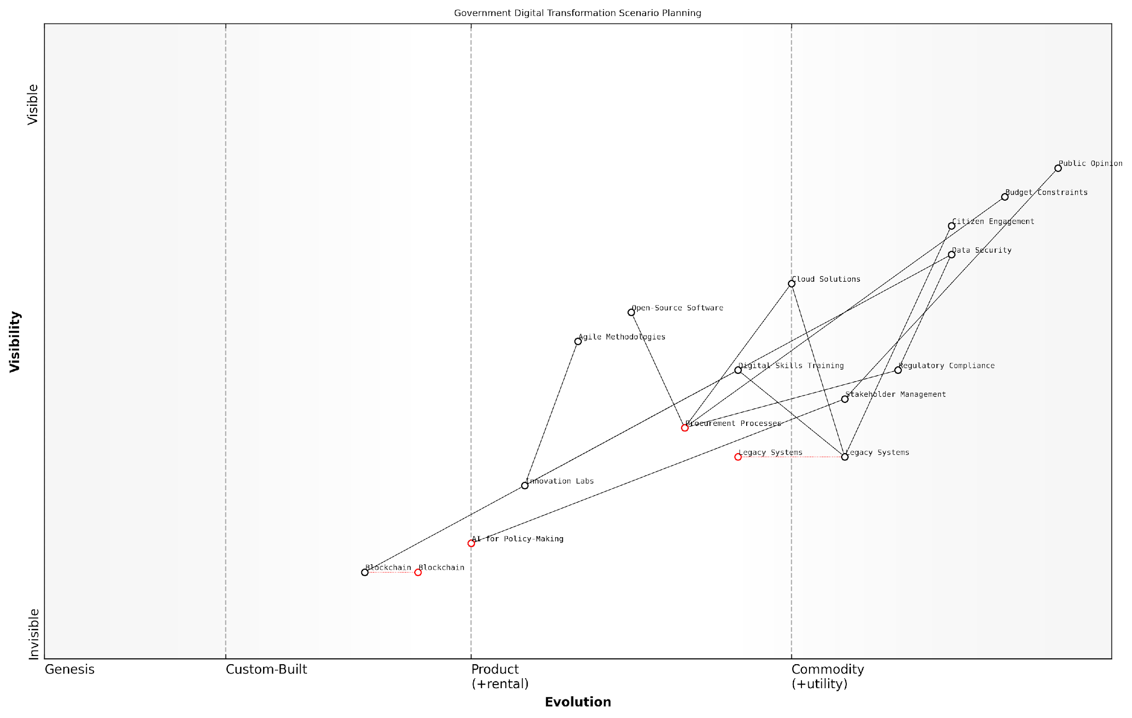

*Draft Wardley Map: [Insert Wardley Map: Anticipating market shifts]*

[Edit this draft Wardley Map](https://create.wardleymaps.ai/#clone:f58f25ad0ab85e3e68)

Wardley Map Assessment

This Wardley Map reveals a government in the midst of digital transformation, balancing the need to modernise legacy systems with the adoption of emerging technologies. The strategic focus on Citizen Engagement is commendable, but significant challenges remain in evolving Legacy Systems and Procurement Processes. The inclusion of components like AI for Policy-Making and Blockchain indicates a forward-thinking approach. To succeed, the government must prioritise modernization efforts, enhance digital skills, streamline processes, and foster a culture of innovation, all while maintaining robust security and regulatory compliance. The key to success lies in viewing digital transformation not as a one-time project, but as an ongoing journey of continuous improvement and citizen-centric innovation.

[View full Wardley Map report](http://markdown_wardley_map_reports/wardley_map_report_19_Anticipating_market_shifts.md)

When applying these techniques in the government and public sector context, it’s crucial to consider the unique characteristics of this environment:

* Longer decision-making cycles
* Complex stakeholder landscapes
* Regulatory and compliance considerations
* Public accountability and transparency requirements
* Budget constraints and funding cycles

These factors can influence the pace and nature of market shifts in the public sector. Startups that understand and account for these nuances in their Wardley Maps are better positioned to anticipate and capitalise on shifts in the government market.

A case in point is the shift towards open-source solutions in government IT. Startups that anticipated this trend by mapping the evolution of government attitudes towards open-source software were able to develop compatible products and services ahead of the curve. This foresight allowed them to establish themselves as trusted providers as government agencies began actively seeking open-source alternatives to proprietary systems.

In the public sector, anticipating market shifts isn’t just about technology; it’s about understanding the complex interplay of policy, public opinion, and technological capability. Wardley Mapping provides a unique lens to visualise and navigate this complexity.

To effectively anticipate market shifts using Wardley Maps, startups should adopt a regular mapping practice. This involves:

* Conducting periodic mapping exercises to reassess the landscape
* Engaging with a diverse range of stakeholders to gather multiple perspectives
* Continuously updating maps as new information becomes available
* Using maps as a communication tool to align team members and stakeholders on potential future scenarios
* Integrating mapping insights into strategic planning and decision-making processes

By embedding these practices, startups can develop a dynamic, forward-looking view of their market, enabling them to anticipate and prepare for shifts before they occur. This proactive approach is particularly valuable in the government sector, where being ahead of the curve can lead to significant competitive advantages and long-term partnerships.

In conclusion, anticipating market shifts is a critical capability for startups, especially those operating in the complex landscape of government and public sector markets. Wardley Mapping provides a structured, visual approach to developing this capability, enabling startups to navigate uncertainty, identify opportunities, and position themselves for long-term success. By mastering the art of anticipating market shifts through Wardley Mapping, startups can move from being reactive participants to proactive shapers of the evolving public sector landscape.

## Strategic Decision Making

### Build, buy, or partner decisions

In the dynamic landscape of startup growth and development, one of the most critical strategic decisions revolves around whether to build capabilities in-house, buy existing solutions, or form strategic partnerships. Wardley Mapping provides an invaluable framework for navigating these complex choices, offering a visual representation of the value chain and the evolutionary stage of each component. This approach is particularly crucial for startups operating in the government and public sector contexts, where decisions can have far-reaching implications for service delivery, resource allocation, and long-term sustainability.

To fully leverage Wardley Mapping in build, buy, or partner decisions, it’s essential to understand the nuances of each option and how they align with the startup’s strategic objectives:

* Build: Developing capabilities in-house
* Buy: Acquiring existing solutions or companies
* Partner: Forming strategic alliances or collaborations

Let’s explore each of these options in detail, examining how Wardley Mapping can inform and guide the decision-making process.

Building In-House Capabilities:

When a startup chooses to build capabilities in-house, it’s often driven by the need for customisation, control, or the development of proprietary technology. Wardley Mapping can illuminate the wisdom of this choice by revealing the evolutionary stage of the component in question.

Building in-house is most advantageous when the component is in the Genesis or Custom-Built stages of evolution. At these stages, the potential for differentiation and competitive advantage is highest.

For government-focused startups, building in-house might be particularly appealing when dealing with sensitive data or unique public sector requirements. However, it’s crucial to consider the resource implications, both in terms of time and capital. Wardley Mapping can help visualise these trade-offs by positioning the component relative to other elements in the value chain.

Buying Existing Solutions:

As components evolve towards the Product and Commodity stages, the ‘buy’ option often becomes more attractive. Wardley Mapping can reveal when a capability has become sufficiently standardised that purchasing an existing solution is more efficient than building from scratch.

In the public sector, where efficiency and value for money are paramount, buying existing solutions can accelerate deployment and reduce risk. However, it’s essential to ensure that off-the-shelf products can meet the specific needs of government clients.

Wardley Mapping can help startups identify which components are ripe for acquisition by visualising their position on the evolution axis. This approach can prevent the common pitfall of reinventing the wheel or investing resources in developing commoditised capabilities.

Forming Strategic Partnerships:

Partnerships can offer a middle ground between building and buying, allowing startups to access capabilities without full ownership or development costs. Wardley Mapping excels at identifying potential partnership opportunities by revealing interdependencies and complementary capabilities within the ecosystem.

For startups in the government sector, partnerships can be particularly valuable in navigating complex regulatory environments or accessing established channels for public sector engagement.

By mapping out the entire value chain, startups can identify areas where partnerships could fill gaps in their capabilities or accelerate market entry. This visual approach also helps in assessing the strategic fit of potential partners and the long-term implications of collaboration.

Applying Wardley Mapping to Decision-Making:

To effectively use Wardley Mapping in build, buy, or partner decisions, startups should follow these steps:

* Map out the entire value chain, including all components necessary for delivering value to government or public sector clients.
* Assess the evolutionary stage of each component, considering factors like maturity, standardisation, and strategic importance.
* Identify dependencies between components and their relative positions on the map.
* Evaluate the potential impact of build, buy, or partner decisions on the overall strategic position of the startup.
* Consider the resource implications, time-to-market, and long-term sustainability of each option.
* Align decisions with the startup’s core competencies and strategic objectives within the public sector context.

By following this approach, startups can make more informed decisions that balance short-term needs with long-term strategic positioning. Wardley Mapping provides a visual framework for these complex choices, helping startups navigate the unique challenges of the government and public sector marketplace.

Case Study: GovTech Innovator

Consider the case of GovTech Innovator, a startup developing a citizen engagement platform for local governments. Using Wardley Mapping, they identified that while their core platform needed to be built in-house to maintain competitive advantage, certain components like identity verification and data analytics were evolving towards commodity status.

The Wardley Map revealed that building these components from scratch would be resource-intensive and offer little strategic value. Instead, GovTech Innovator opted to buy an off-the-shelf identity verification solution and partner with a specialised data analytics firm. This strategy allowed them to focus on their core innovation while leveraging existing solutions for standardised components.

The result was a faster time-to-market, reduced development costs, and a more robust solution that met the stringent security and compliance requirements of their government clients. This case demonstrates how Wardley Mapping can guide startups through complex build, buy, or partner decisions in the public sector context.

Conclusion:

Build, buy, or partner decisions are pivotal in shaping a startup’s trajectory, particularly in the complex landscape of government and public sector services. Wardley Mapping offers a powerful visual tool for navigating these decisions, providing clarity on the strategic implications of each choice. By leveraging this approach, startups can align their capability development strategies with market evolution, resource constraints, and long-term objectives, ultimately enhancing their chances of success in the challenging yet rewarding public sector marketplace.

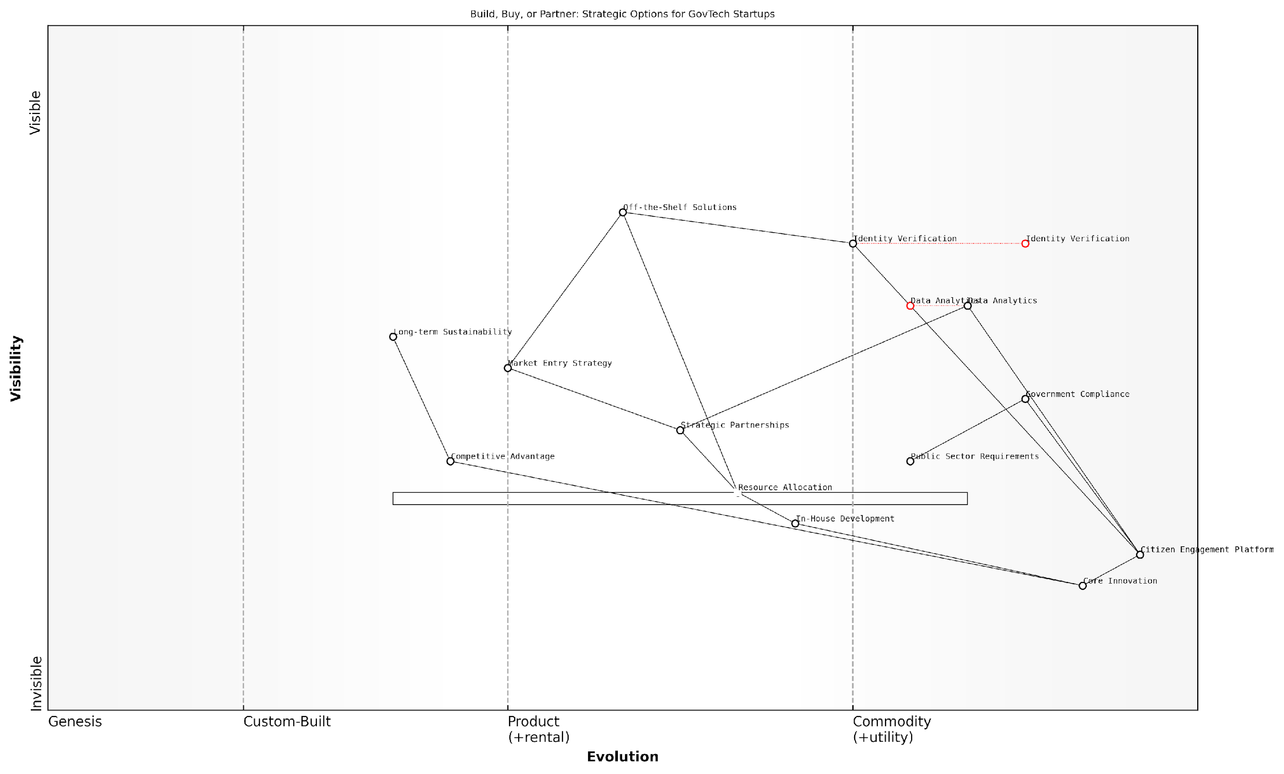

*Draft Wardley Map: [Insert Wardley Map: Build, buy, or partner decisions]*

[Edit this draft Wardley Map](https://create.wardleymaps.ai/#clone:b9a9c6a5e1ef3601f5)

Wardley Map Assessment

The Wardley Map reveals a strategically positioned GovTech startup with a strong focus on core innovation in citizen engagement. The balanced approach to build, buy, and partner decisions allows for agility and efficient resource allocation. Key opportunities lie in strengthening data analytics capabilities, optimising the partnership strategy, and continuously innovating the core platform. The startup should remain vigilant about evolving technologies and regulations, while fostering a robust ecosystem around its Citizen Engagement Platform. By maintaining this strategic balance and focusing on long-term sustainability, the startup is well-positioned to achieve competitive advantage and market leadership in the GovTech sector.

[View full Wardley Map report](http://markdown_wardley_map_reports/wardley_map_report_20_Build,_buy,_or_partner_decisions.md)

### Prioritising product features

In the dynamic landscape of startup development, prioritising product features is a critical aspect of strategic decision-making. Wardley Mapping provides a powerful framework for startups to make informed choices about which features to develop, when to introduce them, and how they align with overall business objectives. This process is particularly crucial for startups operating in the government and public sector, where resource constraints often necessitate laser-focused product development.

Wardley Mapping offers a unique perspective on feature prioritisation by visualising the entire value chain and the evolutionary stage of each component. This visual representation allows startups to make strategic decisions based on the current and future landscape of their market, rather than relying solely on intuition or customer requests.

Wardley Mapping transformed our feature prioritisation process. It allowed us to see beyond immediate customer demands and align our development roadmap with the evolving market landscape. This approach was instrumental in securing a major government contract.

Let’s explore the key aspects of using Wardley Mapping for feature prioritisation:

* Identifying Core Value Propositions
* Assessing Feature Evolution
* Aligning Features with Strategic Goals
* Balancing Innovation and Stability
* Considering Ecosystem Dependencies

Identifying Core Value Propositions:

Wardley Mapping begins with identifying user needs and mapping the value chain. For startups, this process is crucial in determining which features are essential to delivering core value propositions. By visualising the entire value chain, startups can identify which components are most critical to meeting user needs and focus their limited resources on these areas.

For example, a startup developing a digital identity verification system for government services would map out the entire process, from user registration to identity confirmation. This map might reveal that biometric data processing is a critical component that directly impacts the core value proposition of secure and efficient identity verification.

Assessing Feature Evolution:

One of the unique aspects of Wardley Mapping is the evolution axis, which allows startups to assess the maturity of different components in their value chain. This perspective is invaluable when prioritising features, as it helps identify which areas are ripe for innovation and which require stability.

Features that map to components in the ‘Genesis’ or ‘Custom-Built’ stages may offer opportunities for differentiation and competitive advantage. Conversely, features related to more evolved components might be better sourced from existing solutions, allowing the startup to focus on areas where they can truly add unique value.

Understanding the evolutionary stage of each component in our value chain was a game-changer. It allowed us to focus our innovation efforts where they mattered most, while leveraging existing solutions for more commoditised features. This approach significantly accelerated our time-to-market.

Aligning Features with Strategic Goals:

Wardley Mapping provides a clear visual representation of how different components in the value chain contribute to overall strategic goals. This alignment is crucial for startups, especially those working with government clients, where features must often meet specific policy objectives or regulatory requirements.

By mapping features to strategic goals, startups can ensure that their product development efforts are always in service of their broader mission and market positioning. This alignment can be particularly powerful when pitching to government clients or seeking funding, as it demonstrates a clear link between product features and desired outcomes.

Balancing Innovation and Stability:

For startups, particularly those in the government sector, balancing innovation with stability is crucial. Wardley Mapping helps achieve this balance by providing a holistic view of the product ecosystem. Features that map to more evolved, stable components can provide a solid foundation, while those in less evolved areas offer opportunities for innovation and differentiation.

This balance is particularly important in government-focused startups, where reliability and security are often as important as innovation. A Wardley Map can help startups identify where to push boundaries and where to leverage established, trusted solutions.

Considering Ecosystem Dependencies:

Wardley Mapping excels at visualising dependencies within a system. For startups, understanding these dependencies is crucial when prioritising features. A feature that seems simple in isolation may have complex dependencies that make it costly or risky to implement. Conversely, a feature that appears complex might leverage existing components in the ecosystem, making it more feasible than initially thought.

By mapping out these dependencies, startups can make more informed decisions about feature prioritisation, considering not just the immediate impact of a feature, but its ripple effects throughout the entire system.

Mapping our ecosystem dependencies was eye-opening. It revealed hidden complexities in some features we thought were straightforward, and unexpected opportunities in areas we had initially deprioritised. This insight was crucial in refining our product roadmap.

Practical Application in Government-Focused Startups:

For startups focusing on government and public sector clients, Wardley Mapping offers additional benefits in feature prioritisation. Government projects often have unique requirements around security, scalability, and interoperability. By mapping these requirements alongside product features, startups can ensure their development priorities align with the specific needs of government clients.

Moreover, Wardley Mapping can help startups navigate the complex landscape of government procurement. By visualising how different features align with government priorities and existing systems, startups can more effectively position their products and tailor their feature sets to meet specific tender requirements.

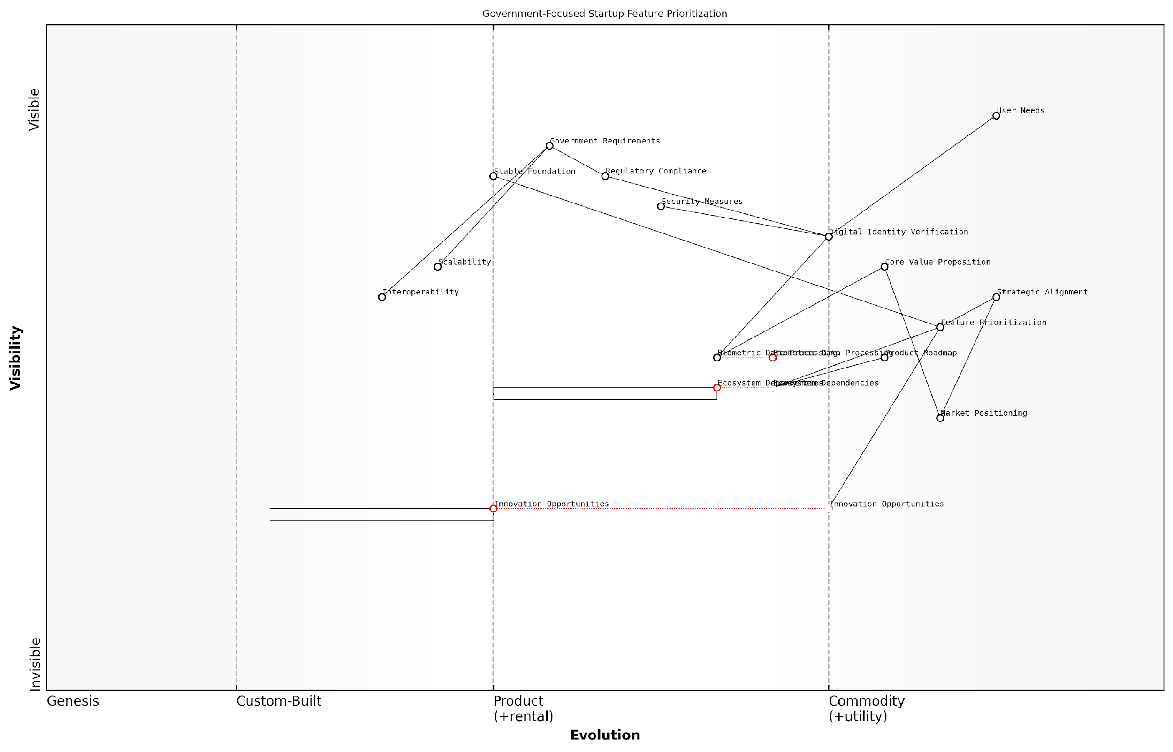

*Draft Wardley Map: [Insert Wardley Map: Prioritising product features]*

[Edit this draft Wardley Map](https://create.wardleymaps.ai/#clone:177a076e4ca7c62635)

Wardley Map Assessment

The startup is well-positioned in the government-focused digital identity verification space, with strong alignment to regulatory requirements and user needs. To maintain its competitive edge, it should focus on evolving its core technologies, especially in biometric processing, while building a robust ecosystem and innovation pipeline. The key challenge will be balancing the need for security and compliance with the drive for innovation and ecosystem expansion.

[View full Wardley Map report](http://markdown_wardley_map_reports/wardley_map_report_21_Prioritising_product_features.md)

In conclusion, Wardley Mapping provides a powerful framework for startups to prioritise product features strategically. By visualising the entire value chain, assessing the evolution of different components, and understanding ecosystem dependencies, startups can make informed decisions about where to focus their limited resources. This approach is particularly valuable for startups working in the government and public sector, where strategic alignment, security, and reliability are paramount. By leveraging Wardley Mapping in feature prioritisation, startups can develop products that not only meet immediate market needs but are also positioned for long-term success in the evolving landscape of public sector technology.

### Timing market entry

Timing market entry is a critical strategic decision for startups, particularly when leveraging Wardley Mapping. This powerful visual tool provides invaluable insights into market evolution, competitive landscapes, and technological maturity, enabling founders to make informed decisions about when to launch their products or services. In the context of Understanding Wardley Mapping for Startups, mastering the art of timing can mean the difference between market leadership and missed opportunities.

Wardley Maps offer a unique perspective on market dynamics by visualising the evolution of components along the value chain. This evolution axis is particularly crucial for timing market entry, as it helps startups identify the optimal moment to introduce their offerings. Let’s explore how Wardley Mapping can guide startups in making these pivotal timing decisions.

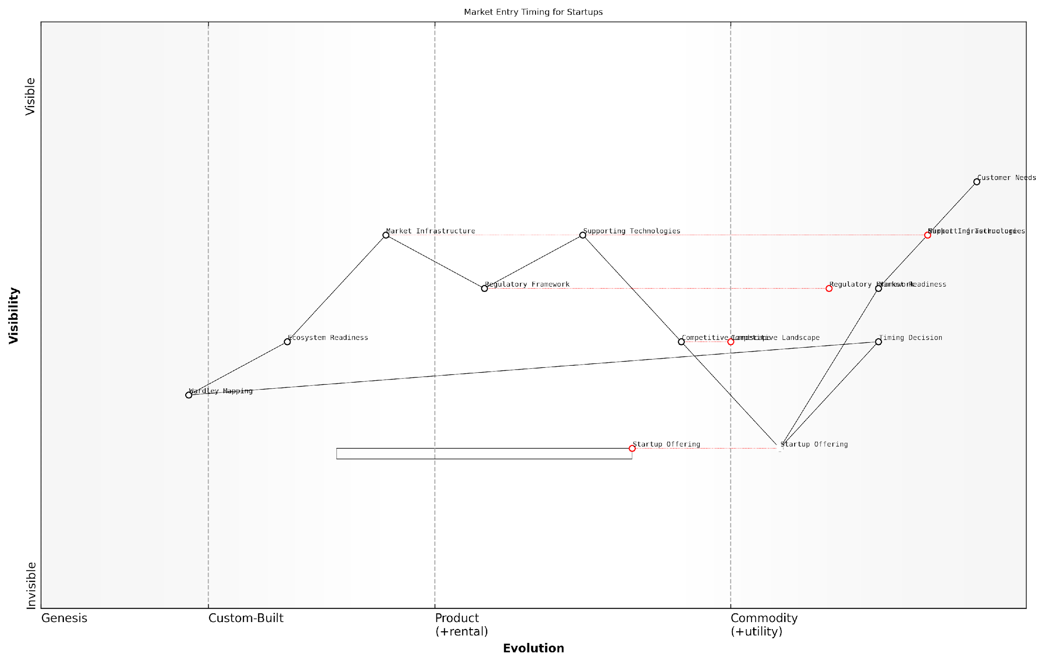

*Draft Wardley Map: [Insert Wardley Map: Timing market entry]*

[Edit this draft Wardley Map](https://create.wardleymaps.ai/#clone:7c8612ce802c359439)

Wardley Map Assessment

This Wardley Map reveals a complex and dynamic landscape for startup market entry timing. The strategic position is characterised by a balance between market readiness and ecosystem maturity, with significant opportunities for innovation and first-mover advantage. The key to success lies in making well-informed timing decisions, leveraging strategic tools like Wardley Mapping, and maintaining agility in response to evolving market conditions. While there are challenges in navigating regulatory frameworks and developing the ecosystem, these also present opportunities for startups to shape the market. The explicit inclusion of the Timing Decision component underscores the critical nature of this strategic choice in the startup’s journey. Overall, the map suggests a market ripe for disruption but requiring careful navigation and strategic foresight.

[View full Wardley Map report](http://markdown_wardley_map_reports/wardley_map_report_22_Timing_market_entry.md)

Understanding Component Evolution

The evolution axis in a Wardley Map represents the journey of components from genesis (novel and unpredictable) to commodity (standardised and predictable). By mapping the current state of relevant components, startups can gauge market readiness and potential adoption rates. This understanding is crucial for timing market entry effectively.

* Genesis: Highly uncertain, perfect for disruptive innovations
* Custom-built: Early adopters, potential for rapid growth
* Product: Mass market appeal, intense competition
* Commodity: Standardised, focus on efficiency and cost

Identifying Market Readiness

Wardley Mapping helps startups assess whether the market is ready for their innovation. By analysing the position of key components on the evolution axis, founders can determine if the necessary infrastructure, customer awareness, and complementary technologies are sufficiently developed to support their offering.

A seasoned startup adviser once remarked, ‘Timing is everything. Enter too early, and you’ll struggle with market education. Enter too late, and you’ll face entrenched competitors. Wardley Mapping gives you the strategic foresight to find that sweet spot.’

Anticipating Market Shifts

One of the most powerful aspects of Wardley Mapping for timing market entry is its ability to help startups anticipate future market shifts. By understanding the natural evolution of components and the forces driving change, founders can position their startups to capitalise on emerging opportunities.

* Identify components likely to evolve rapidly
* Predict potential disruptions in the value chain
* Anticipate shifts in customer needs and expectations
* Prepare for changes in the competitive landscape

Balancing First-Mover Advantage and Market Maturity

Wardley Mapping provides a nuanced view of the trade-offs between first-mover advantage and market maturity. While being first can offer significant benefits, entering a more mature market can reduce costs and risks associated with market education and infrastructure development.

As a prominent venture capitalist noted, ‘The Wardley Map becomes a strategic compass for startups, guiding them to enter the market at a point where they can maximise impact while minimising unnecessary risks and costs.’

Assessing Competitive Positioning

By mapping the competitive landscape, startups can identify gaps and opportunities for differentiation. This insight is crucial for timing market entry, as it allows founders to position their offerings strategically in relation to existing and potential competitors.

* Identify underserved market segments
* Spot potential for disruptive innovation
* Assess the strength of incumbent positions
* Evaluate barriers to entry at different stages of evolution

Aligning with Ecosystem Readiness

Wardley Mapping helps startups assess the readiness of the broader ecosystem to support their innovation. This includes evaluating the maturity of supporting technologies, regulatory frameworks, and market infrastructure. Timing market entry to align with ecosystem readiness can significantly enhance the chances of success.

Case Study: Government Digital Service (GDS) in the UK

The launch of the Government Digital Service (GDS) in the UK provides an excellent example of using Wardley Mapping to time market entry in a public sector context. By mapping the evolution of digital services, citizen expectations, and government capabilities, GDS was able to identify the optimal moment to introduce transformative digital solutions across government departments.

A senior government official involved in the GDS launch stated, ‘Wardley Mapping gave us the strategic clarity to time our entry into digital service provision. We could see where citizen needs were evolving and where government capabilities needed to catch up, allowing us to plan and execute our rollout for maximum impact.’

Iterative Approach to Market Entry

Wardley Mapping encourages an iterative approach to market entry. By continuously updating and refining their maps, startups can adapt their timing strategies as market conditions evolve. This agility is particularly valuable in fast-moving sectors where timing can be a critical success factor.

* Regularly reassess market conditions and component evolution
* Adjust entry strategies based on new map insights
* Consider phased or segmented market entry approaches
* Use maps to communicate timing decisions to stakeholders and investors

Conclusion

Timing market entry is a complex decision that can significantly impact a startup’s success. Wardley Mapping provides a powerful framework for navigating this challenge, offering visual insights into market evolution, competitive dynamics, and ecosystem readiness. By leveraging these maps, startups can make more informed decisions about when to enter markets, how to position their offerings, and how to adapt their strategies over time. As the startup ecosystem continues to evolve, mastering the art of timing through Wardley Mapping will become an increasingly valuable skill for founders and strategists alike.

# Chapter 3: Scaling Strategies Using Wardley Maps

## Resource Allocation

### Identifying critical components

In the realm of startup scaling strategies, the identification of critical components through Wardley Mapping is a cornerstone of effective resource allocation. As startups navigate the tumultuous waters of growth, understanding which elements of their business are truly indispensable becomes paramount. This process not only informs strategic decision-making but also ensures that limited resources are channelled towards areas that will yield the greatest impact on the startup’s trajectory.

Wardley Mapping provides a unique lens through which startups can visualise their value chain and discern the criticality of each component. By mapping out the entire ecosystem of the business, from user needs to the underlying technologies and processes, startups can gain a holistic view of their operations and identify the lynchpins that hold everything together.

Identifying critical components is not just about understanding what’s important now, but anticipating what will be crucial for future success. It’s about seeing the chess moves before they happen.

Let’s delve into the key aspects of identifying critical components using Wardley Maps:

* Value Chain Analysis: Examine the entire value chain to understand dependencies and bottlenecks.
* Evolution Assessment: Determine where each component sits on the evolution axis and its potential for future development.
* User Needs Alignment: Ensure identified components directly contribute to meeting user needs.
* Competitive Advantage: Identify components that provide unique value propositions or competitive edges.
* Risk Evaluation: Assess the potential impact of component failure on overall business operations.

Value Chain Analysis is the bedrock of identifying critical components. By meticulously mapping out how value flows from raw materials to the end user, startups can pinpoint the components that are integral to this flow. These might include key technologies, crucial partnerships, or essential processes. For instance, a fintech startup might identify its fraud detection algorithm as a critical component, as it underpins the trust and security of its entire platform.

The Evolution Assessment is equally vital. Components that are in the ‘Genesis’ or ‘Custom Built’ phases often require more resources but may also offer the greatest potential for differentiation. Conversely, components in the ‘Product’ or ‘Commodity’ phases might be critical due to their stability and efficiency. A startup must balance its portfolio across these stages, ensuring it’s not overinvesting in commodities while neglecting potential game-changers.

In the startup world, evolution isn’t just about survival of the fittest; it’s about predicting and shaping the fitness landscape itself.

Aligning with User Needs is crucial in the identification process. Components that directly address core user needs or pain points are inherently critical. This alignment ensures that resource allocation is driven by market demand rather than internal assumptions. For example, a SaaS startup might identify its customer support system as critical if user feedback indicates that responsive support is a key factor in customer retention.

Identifying sources of Competitive Advantage is another key consideration. Components that set a startup apart from its competitors or create barriers to entry are often critical. These might be proprietary technologies, unique datasets, or novel business models. By focusing resources on these areas, startups can strengthen their market position and create sustainable differentiation.

Risk Evaluation is the final piece of the puzzle. Components that pose significant risks to the business if they fail or underperform must be classified as critical. This might include core infrastructure, data security measures, or key personnel. By identifying these components, startups can implement appropriate risk mitigation strategies and ensure business continuity.

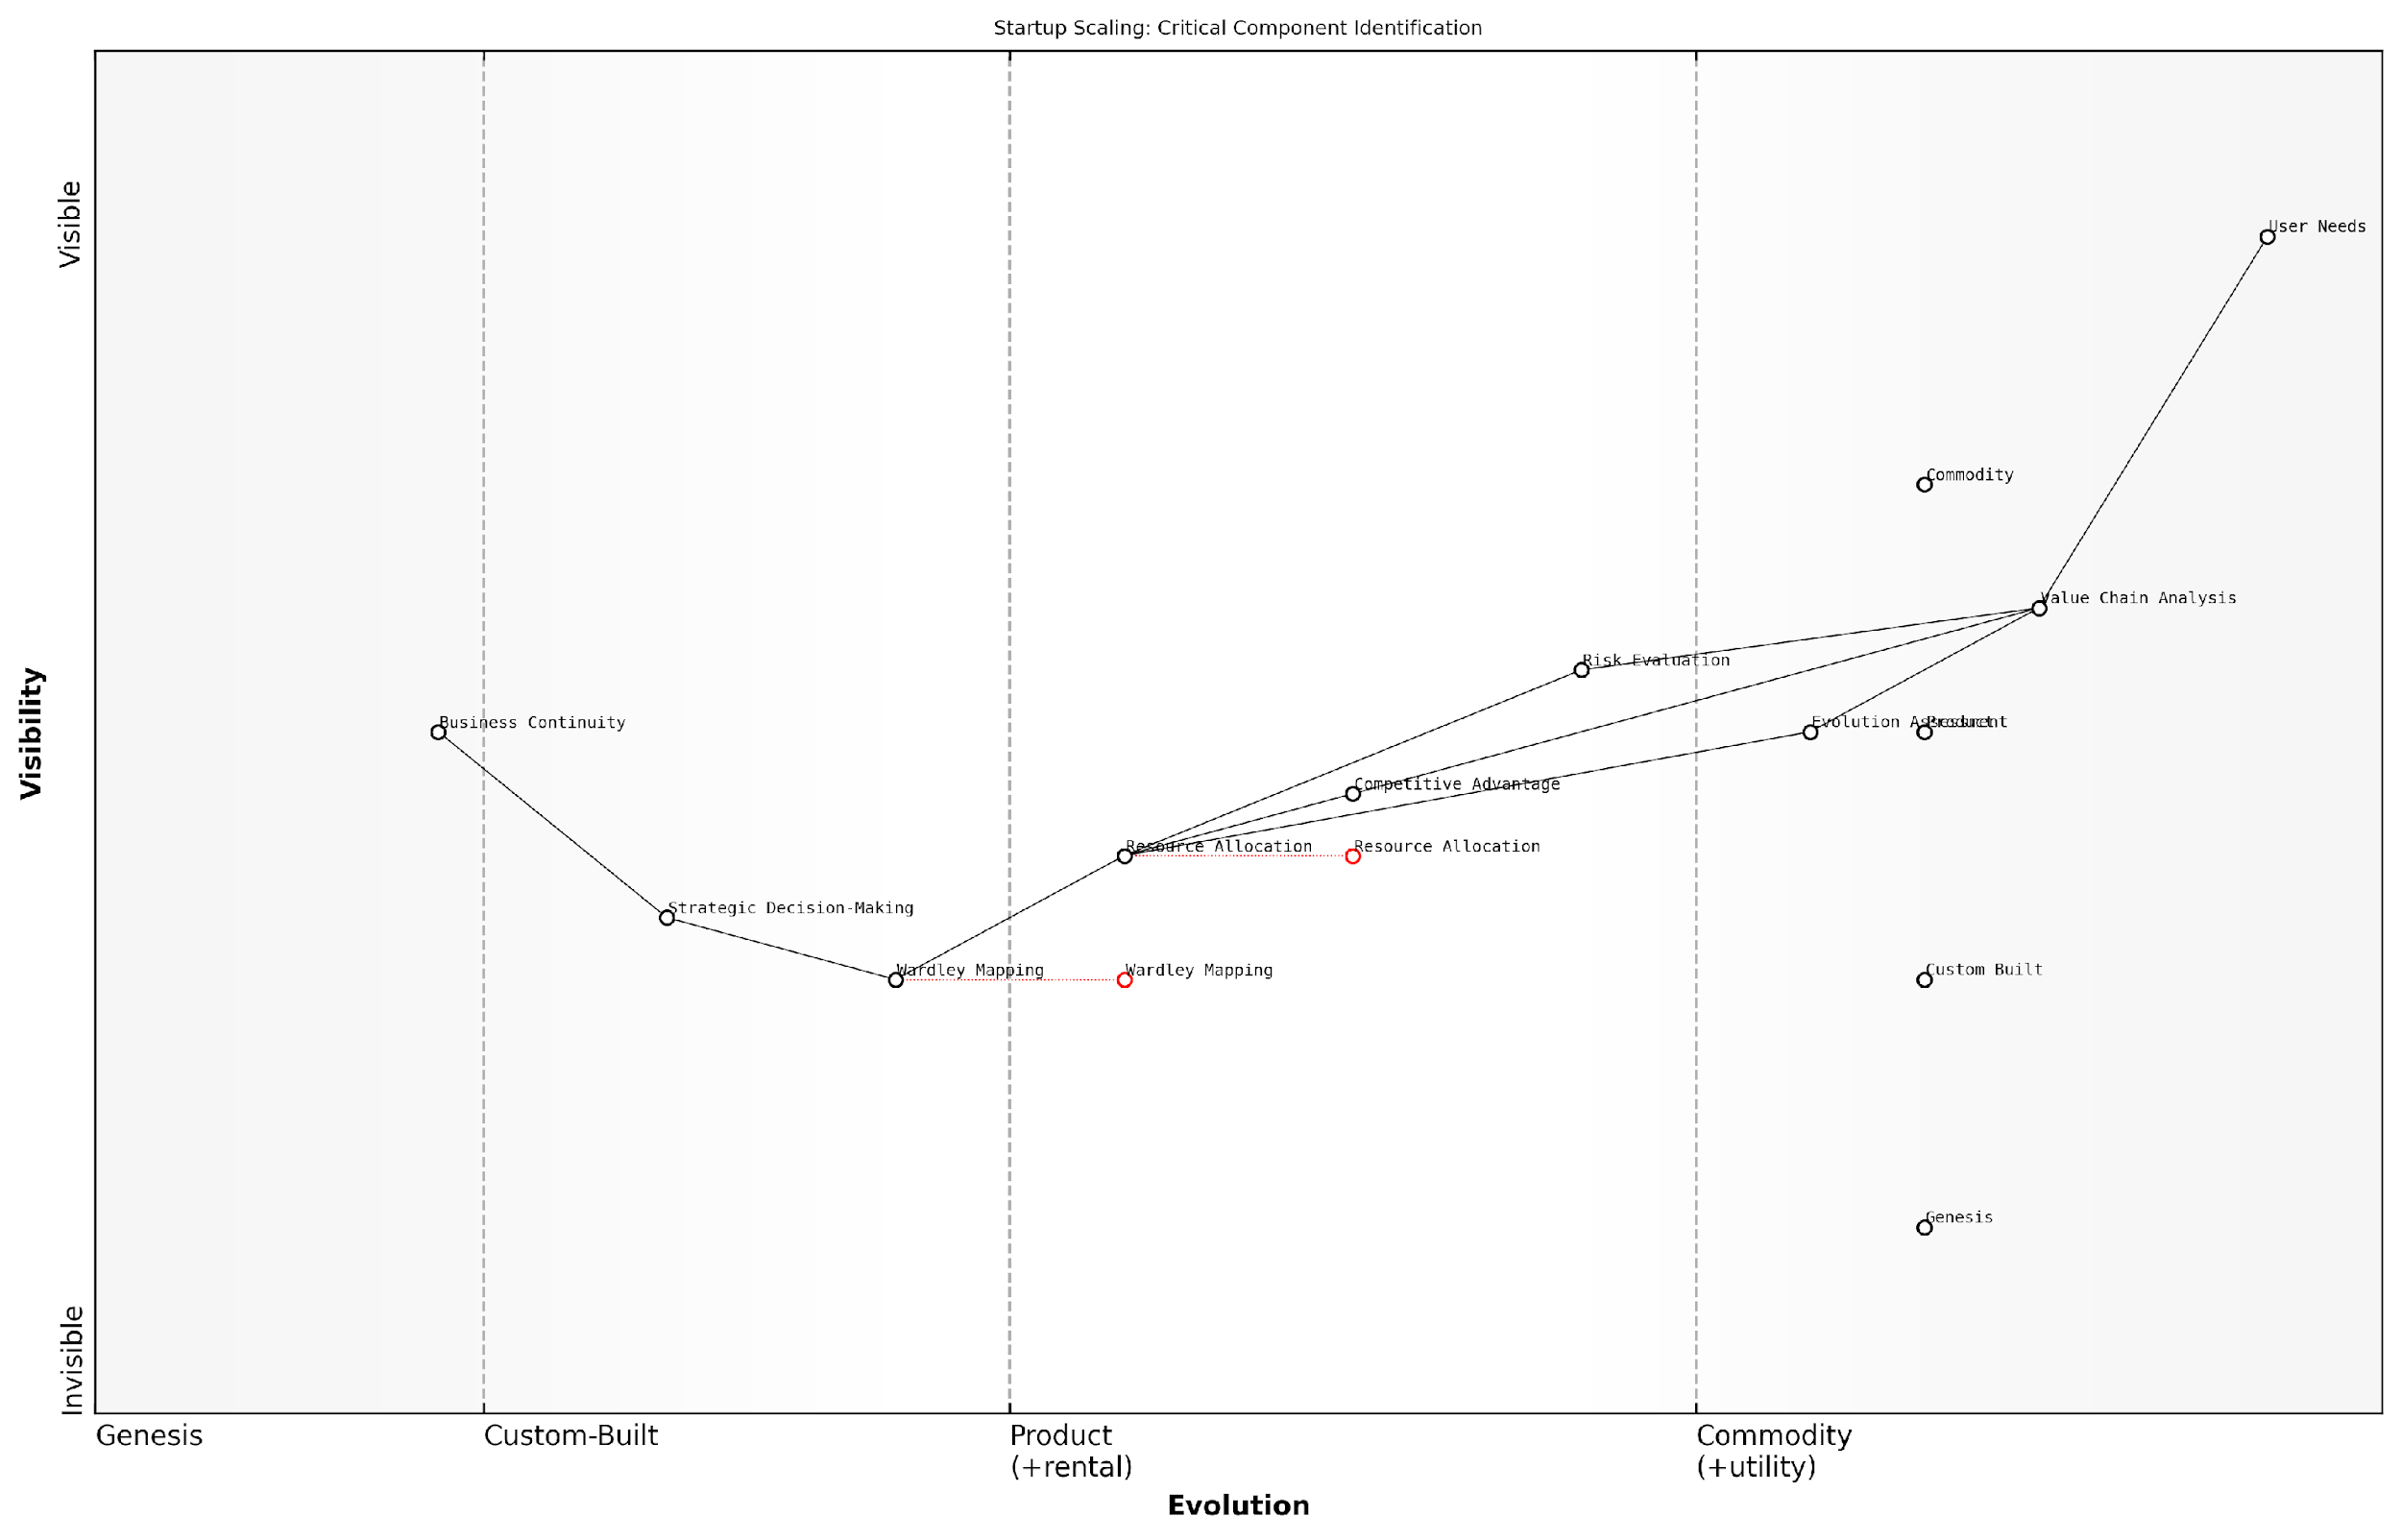

*Draft Wardley Map: [Insert Wardley Map: Identifying critical components]*

[Edit this draft Wardley Map](https://create.wardleymaps.ai/#clone:b4e3be9cbd3f5a4342)

Wardley Map Assessment

This Wardley Map presents a comprehensive view of critical components for startup scaling, balancing traditional elements like User Needs and Value Chain Analysis with emerging strategic tools like Wardley Mapping. The positioning of components suggests a startup that is actively working on developing sophisticated strategic capabilities. Key opportunities lie in further evolving custom-built components, particularly Wardley Mapping and Strategic Decision-Making, while ensuring tight integration between analytical processes and decision-making. The acknowledgment of the broader Startup Ecosystem indicates potential for strategic partnerships and knowledge sharing. To maintain competitive advantage, the startup should focus on rapidly evolving its unique strategic tools while continuously aligning all components with ever-changing User Needs.

[View full Wardley Map report](http://markdown_wardley_map_reports/wardley_map_report_23_Identifying_critical_components.md)

Once critical components are identified, startups must develop strategies to nurture and protect them. This might involve:

* Allocating a higher proportion of resources (financial, human, technological) to these components
* Implementing robust monitoring and performance tracking systems
* Developing contingency plans for potential failures or disruptions
* Investing in research and development to evolve these components ahead of market demands
* Building redundancies or fail-safes for mission-critical components

It’s important to note that the identification of critical components is not a one-time exercise. As the startup grows and the market evolves, what’s considered critical may shift. Regular reassessment using Wardley Maps ensures that resource allocation remains aligned with the changing landscape.

In the dynamic world of startups, today’s critical component could be tomorrow’s commodity. Continuous mapping and reassessment are key to staying ahead of the curve.

A case in point is a government-backed startup incubator I advised, which used Wardley Mapping to identify critical components across its portfolio of startups. By visualising the entire ecosystem, from funding mechanisms to mentorship programmes, they were able to pinpoint key leverage points where resources could be concentrated for maximum impact. This led to a restructuring of their support services, focusing on areas that were critical across multiple startups, such as regulatory navigation assistance and access to specialised talent pools.

In conclusion, the identification of critical components through Wardley Mapping is a powerful tool for startups navigating the complexities of scaling. By providing a visual and strategic framework for understanding the relative importance of different business elements, it enables more informed and effective resource allocation decisions. As startups grow and evolve, this process becomes an ongoing dialogue between current capabilities, market demands, and future aspirations, ensuring that resources are always directed towards the components that will drive the greatest value and competitive advantage.

### Balancing innovation and efficiency

In the realm of startup resource allocation, striking the right balance between innovation and efficiency is paramount. This delicate equilibrium is particularly crucial when leveraging Wardley Mapping to inform strategic decisions. As startups navigate their growth trajectory, they must judiciously allocate resources to fuel innovation whilst maintaining operational efficiency—a challenge that Wardley Mapping is uniquely positioned to address.

Wardley Mapping provides a visual framework that allows startups to strategically allocate resources based on the evolutionary stage of each component in their value chain. This approach enables a nuanced understanding of where to invest in innovation and where to focus on efficiency, aligning resource allocation with the startup’s strategic objectives and market position.

Wardley Mapping is not just a tool for visualisation; it’s a compass for resource allocation. It guides startups to invest in innovation where it matters most, whilst driving efficiency in areas that are ripe for optimisation.

Let’s delve into the key aspects of balancing innovation and efficiency using Wardley Maps:

* Identifying Innovation Opportunities
* Driving Efficiency in Mature Components
* Allocating Resources Across the Evolution Axis
* Leveraging Ecosystem Dynamics
* Adapting to Market Shifts

Identifying Innovation Opportunities:

Wardley Maps excel at highlighting areas ripe for innovation. Components in the ‘Genesis’ and ‘Custom Built’ phases of evolution often represent opportunities for startups to differentiate themselves and create unique value propositions. By allocating resources to these nascent components, startups can drive innovation that sets them apart in the market.

For instance, a fintech startup might identify an emerging need for blockchain-based identity verification. By mapping this component and recognising its potential to evolve rapidly, the startup can allocate resources to innovate in this space, potentially gaining a first-mover advantage.

Driving Efficiency in Mature Components:

Conversely, components in the ‘Product’ and ‘Commodity’ phases present opportunities for efficiency gains. These mature elements of the value chain often benefit from standardisation, automation, and cost optimisation. By identifying these components on the map, startups can allocate resources towards improving operational efficiency, reducing costs, and enhancing scalability.

In the public sector, we’ve seen government agencies use Wardley Mapping to identify mature services that can be outsourced or automated, freeing up resources for more innovative citizen-centric initiatives.

Allocating Resources Across the Evolution Axis:

The evolution axis of a Wardley Map provides a strategic framework for resource allocation. As a general principle, startups should allocate more resources towards innovation in the left side of the map (Genesis and Custom Built), while focusing on efficiency and optimisation on the right side (Product and Commodity). However, this is not a rigid rule, and the specific context of the startup and its market should always be considered.

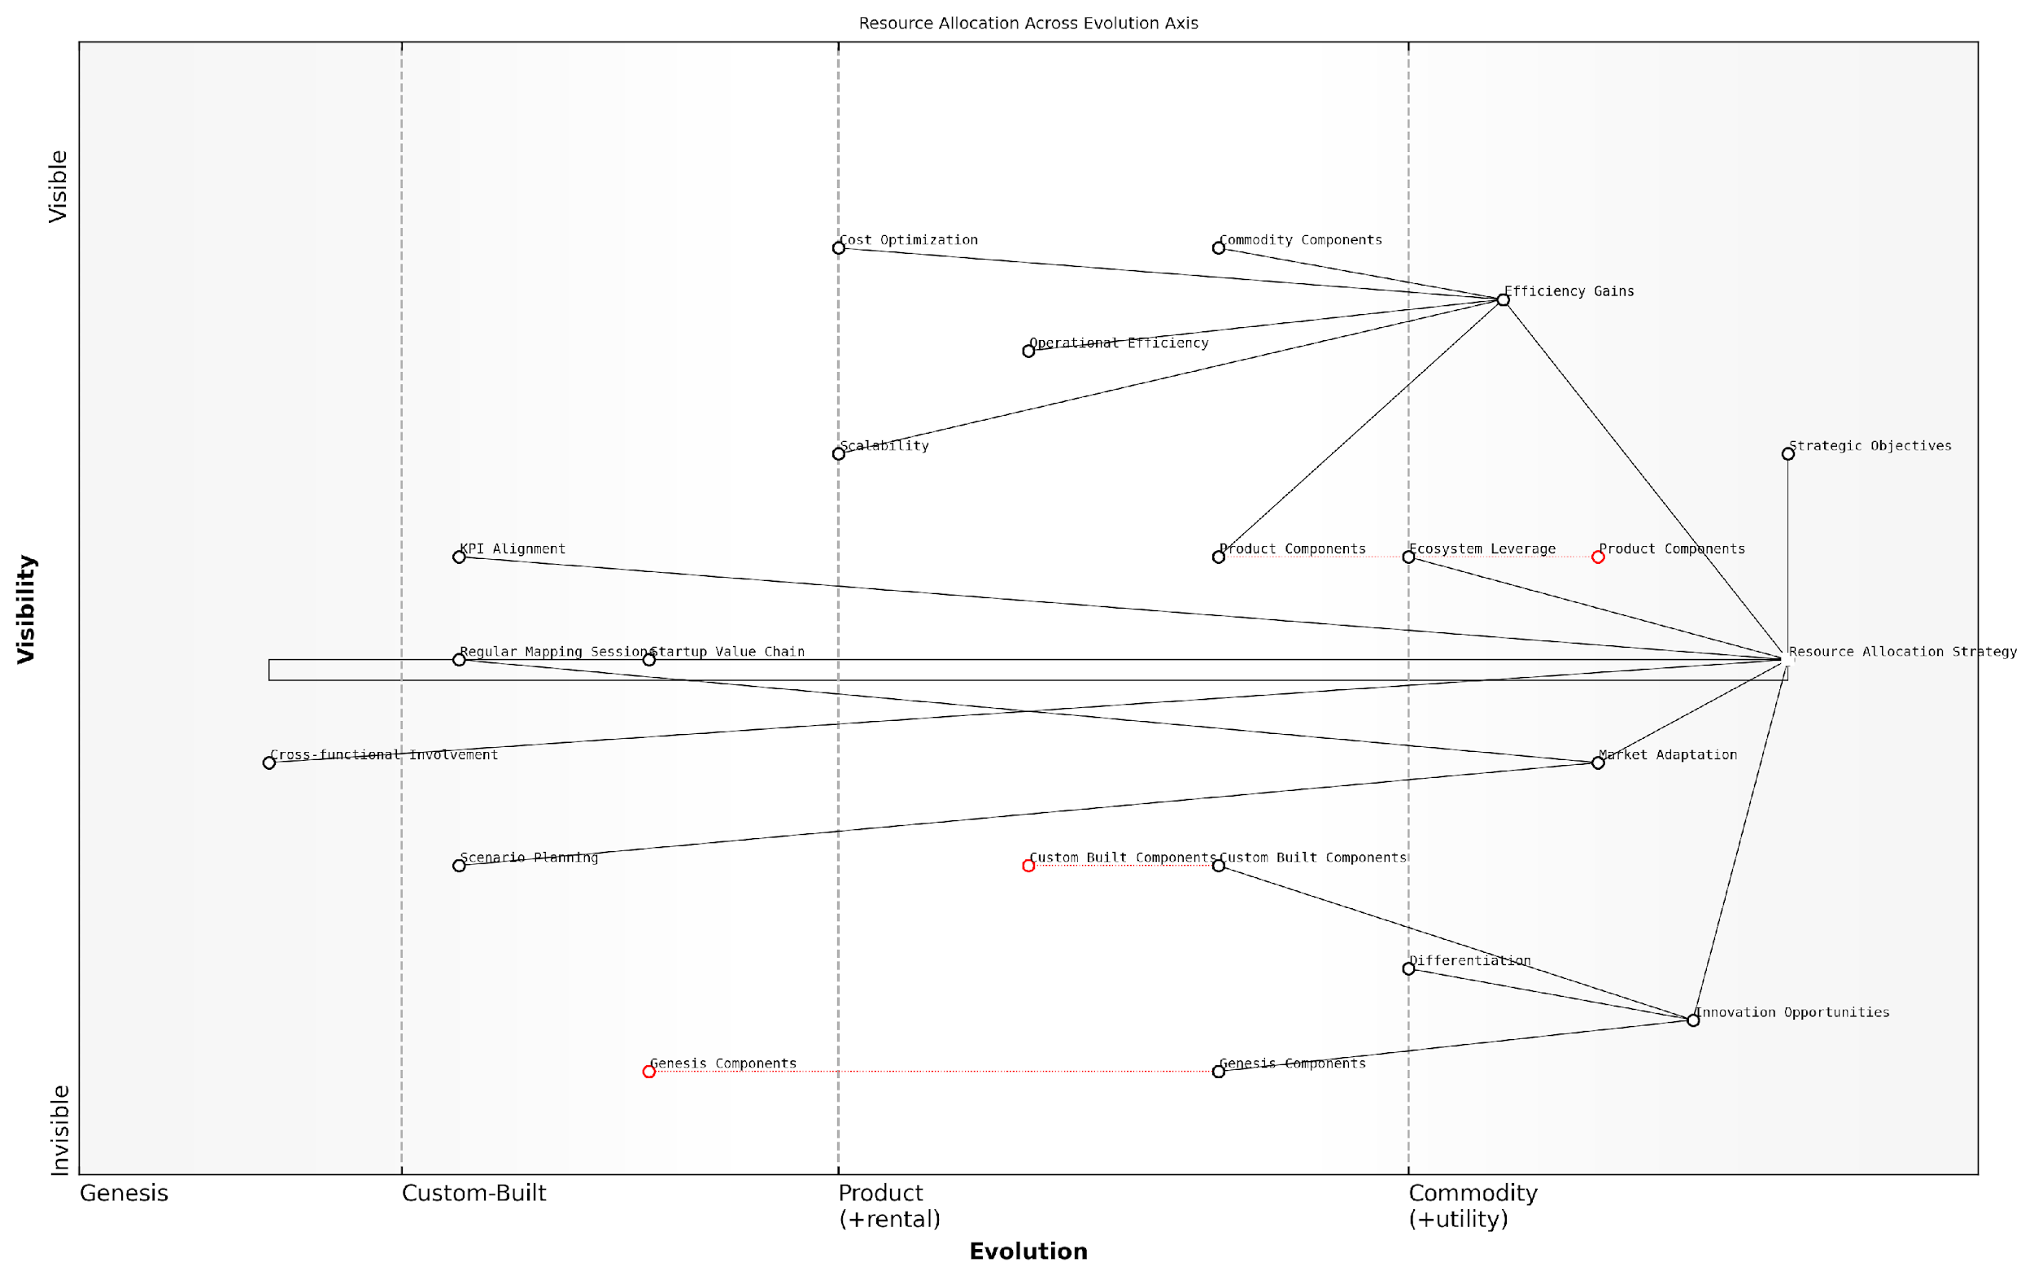

*Draft Wardley Map: [Insert Wardley Map: Balancing innovation and efficiency]*

[Edit this draft Wardley Map](https://create.wardleymaps.ai/#clone:8e5e026171a2e4026c)

Wardley Map Assessment

This Wardley Map reveals a startup ecosystem poised at a critical juncture between innovation and efficiency. The central role of the Resource Allocation Strategy suggests a mature understanding of the need for dynamic resource management. However, there’s a risk of overemphasising efficiency at the expense of breakthrough innovation. To maintain competitiveness, startups must enhance their market adaptation capabilities, invest consistently in genesis-stage innovations, and develop a more robust ecosystem strategy. The inclusion of regular mapping sessions and scenario planning indicates a forward-thinking approach, but these need to be more tightly integrated with the core strategy. Overall, the map suggests a need for a more dynamic, adaptive approach to balance short-term efficiency with long-term innovation potential.

[View full Wardley Map report](http://markdown_wardley_map_reports/wardley_map_report_24_Balancing_innovation_and_efficiency.md)

Leveraging Ecosystem Dynamics:

Wardley Mapping also reveals opportunities to leverage the broader ecosystem for both innovation and efficiency. By identifying components that are evolving towards commoditisation, startups can make informed decisions about whether to build in-house, partner with others, or utilise existing solutions. This approach allows for efficient resource allocation by avoiding unnecessary reinvention of the wheel.

For example, a startup might choose to use cloud services for infrastructure (a commodity) while focusing its innovative efforts on developing a unique AI algorithm that differentiates its product offering.

Adapting to Market Shifts:

One of the most powerful aspects of Wardley Mapping for startups is its ability to anticipate and visualise market shifts. By regularly updating their maps, startups can identify when components are evolving, signalling a need to reallocate resources. This dynamic approach ensures that the balance between innovation and efficiency remains optimal as the market landscape changes.

The true power of Wardley Mapping lies in its ability to make the invisible visible. It reveals the shifting sands of the market, allowing startups to adapt their resource allocation strategies proactively rather than reactively.

Practical Considerations for Startups:

* Regular mapping sessions: Conduct quarterly mapping exercises to reassess the balance between innovation and efficiency.
* Cross-functional involvement: Ensure that mapping and resource allocation decisions involve perspectives from across the organisation.
* Metrics alignment: Develop KPIs that reflect both innovative progress and efficiency gains, aligned with the insights from your Wardley Maps.
* Scenario planning: Use maps to model different resource allocation scenarios and their potential impacts on innovation and efficiency.
* Ecosystem awareness: Stay informed about evolving industry standards and emerging technologies to inform your mapping and resource allocation decisions.

In conclusion, Wardley Mapping provides startups with a powerful tool for balancing innovation and efficiency in resource allocation. By visualising the entire value chain and its evolutionary stages, startups can make informed decisions about where to invest in groundbreaking innovation and where to focus on operational excellence. This strategic approach to resource allocation, guided by the insights from Wardley Maps, enables startups to maximise their impact and sustainably scale their operations in an ever-changing market landscape.

### Optimising for different stages of startup growth

As startups progress through various stages of growth, from inception to scale-up, the allocation of resources becomes increasingly critical. Wardley Mapping provides a powerful framework for optimising resource allocation across these different stages, ensuring that startups can maximise their potential for success whilst navigating the unique challenges each phase presents. This section explores how Wardley Maps can be leveraged to make informed decisions about resource allocation throughout a startup’s journey, with a particular focus on government and public sector contexts.

To effectively optimise resource allocation across different growth stages, it’s crucial to understand the typical phases a startup goes through and how Wardley Mapping can be applied at each stage:

* Ideation and Validation Stage
* Early Traction Stage
* Growth Stage
* Scale-up Stage

Let’s examine each of these stages in detail, exploring how Wardley Mapping can guide resource allocation decisions.

Ideation and Validation Stage:

During this initial phase, startups are focused on validating their business idea and identifying their target market. Resource allocation at this stage should prioritise activities that help prove the concept and establish product-market fit. Wardley Mapping can be instrumental in this process by:

* Identifying key components of the value chain
* Assessing the evolution of these components
* Highlighting potential areas for innovation or disruption

For startups in the government and public sector space, this stage often involves extensive stakeholder engagement and regulatory considerations. A Wardley Map can help visualise these complex relationships and identify where resources should be allocated to navigate the unique challenges of this sector.

In my experience advising government-focused startups, those who use Wardley Mapping at this early stage are far more likely to identify critical regulatory hurdles and allocate resources appropriately to address them, significantly reducing the risk of costly pivots later on.

Early Traction Stage:

As startups begin to gain traction, resource allocation shifts towards activities that can accelerate growth and establish a strong market position. Wardley Mapping during this stage can help by:

* Identifying key differentiators and areas of competitive advantage
* Highlighting potential bottlenecks or constraints in the value chain
* Guiding decisions on whether to build, buy, or partner for critical components

For startups operating in the public sector, this stage often involves navigating complex procurement processes and building relationships with key government stakeholders. Wardley Mapping can help visualise these relationships and identify where resources should be allocated to build strategic partnerships and navigate bureaucratic hurdles.

One of the most common pitfalls I’ve observed in government-focused startups is underestimating the resources required to navigate procurement processes. Wardley Mapping can provide a clear visual representation of these processes, helping startups allocate resources more effectively and avoid costly delays.

Growth Stage:

During the growth stage, startups face the challenge of scaling their operations while maintaining efficiency and quality. Resource allocation becomes increasingly complex, and Wardley Mapping can provide valuable insights by:

* Identifying areas where standardisation and automation can drive efficiency
* Highlighting components that are becoming commoditised and may be candidates for outsourcing
* Guiding decisions on where to invest in innovation to maintain competitive advantage

For startups in the government sector, this stage often involves expanding services across different departments or regions, each with its own unique requirements and stakeholders. Wardley Mapping can help visualise these complex ecosystems and guide resource allocation to manage this expansion effectively.

I’ve seen numerous government-focused startups struggle with scaling across different jurisdictions. Those who use Wardley Mapping to visualise the varying landscapes and allocate resources accordingly are far more successful in managing this complexity.

Scale-up Stage:

As startups enter the scale-up stage, the focus shifts to optimising operations, expanding market share, and potentially exploring new markets or verticals. Wardley Mapping at this stage can guide resource allocation by:

* Identifying opportunities for vertical integration or horizontal expansion
* Highlighting areas where increased investment in research and development can drive long-term growth
* Guiding decisions on potential acquisitions or partnerships to accelerate growth

For startups in the public sector, this stage might involve expanding into new policy areas or even international markets. Wardley Mapping can help visualise these new landscapes and guide resource allocation to navigate the complex regulatory and cultural differences.

In my consultancy work with scale-up startups in the government sector, I’ve found Wardley Mapping to be invaluable in identifying opportunities for expansion that align with evolving policy priorities. This strategic alignment is crucial for sustained growth in the public sector market.

Regardless of the growth stage, it’s crucial to remember that Wardley Mapping is not a one-time exercise but an ongoing process. Regular mapping sessions should be conducted to reassess resource allocation as the startup evolves and the market landscape changes.

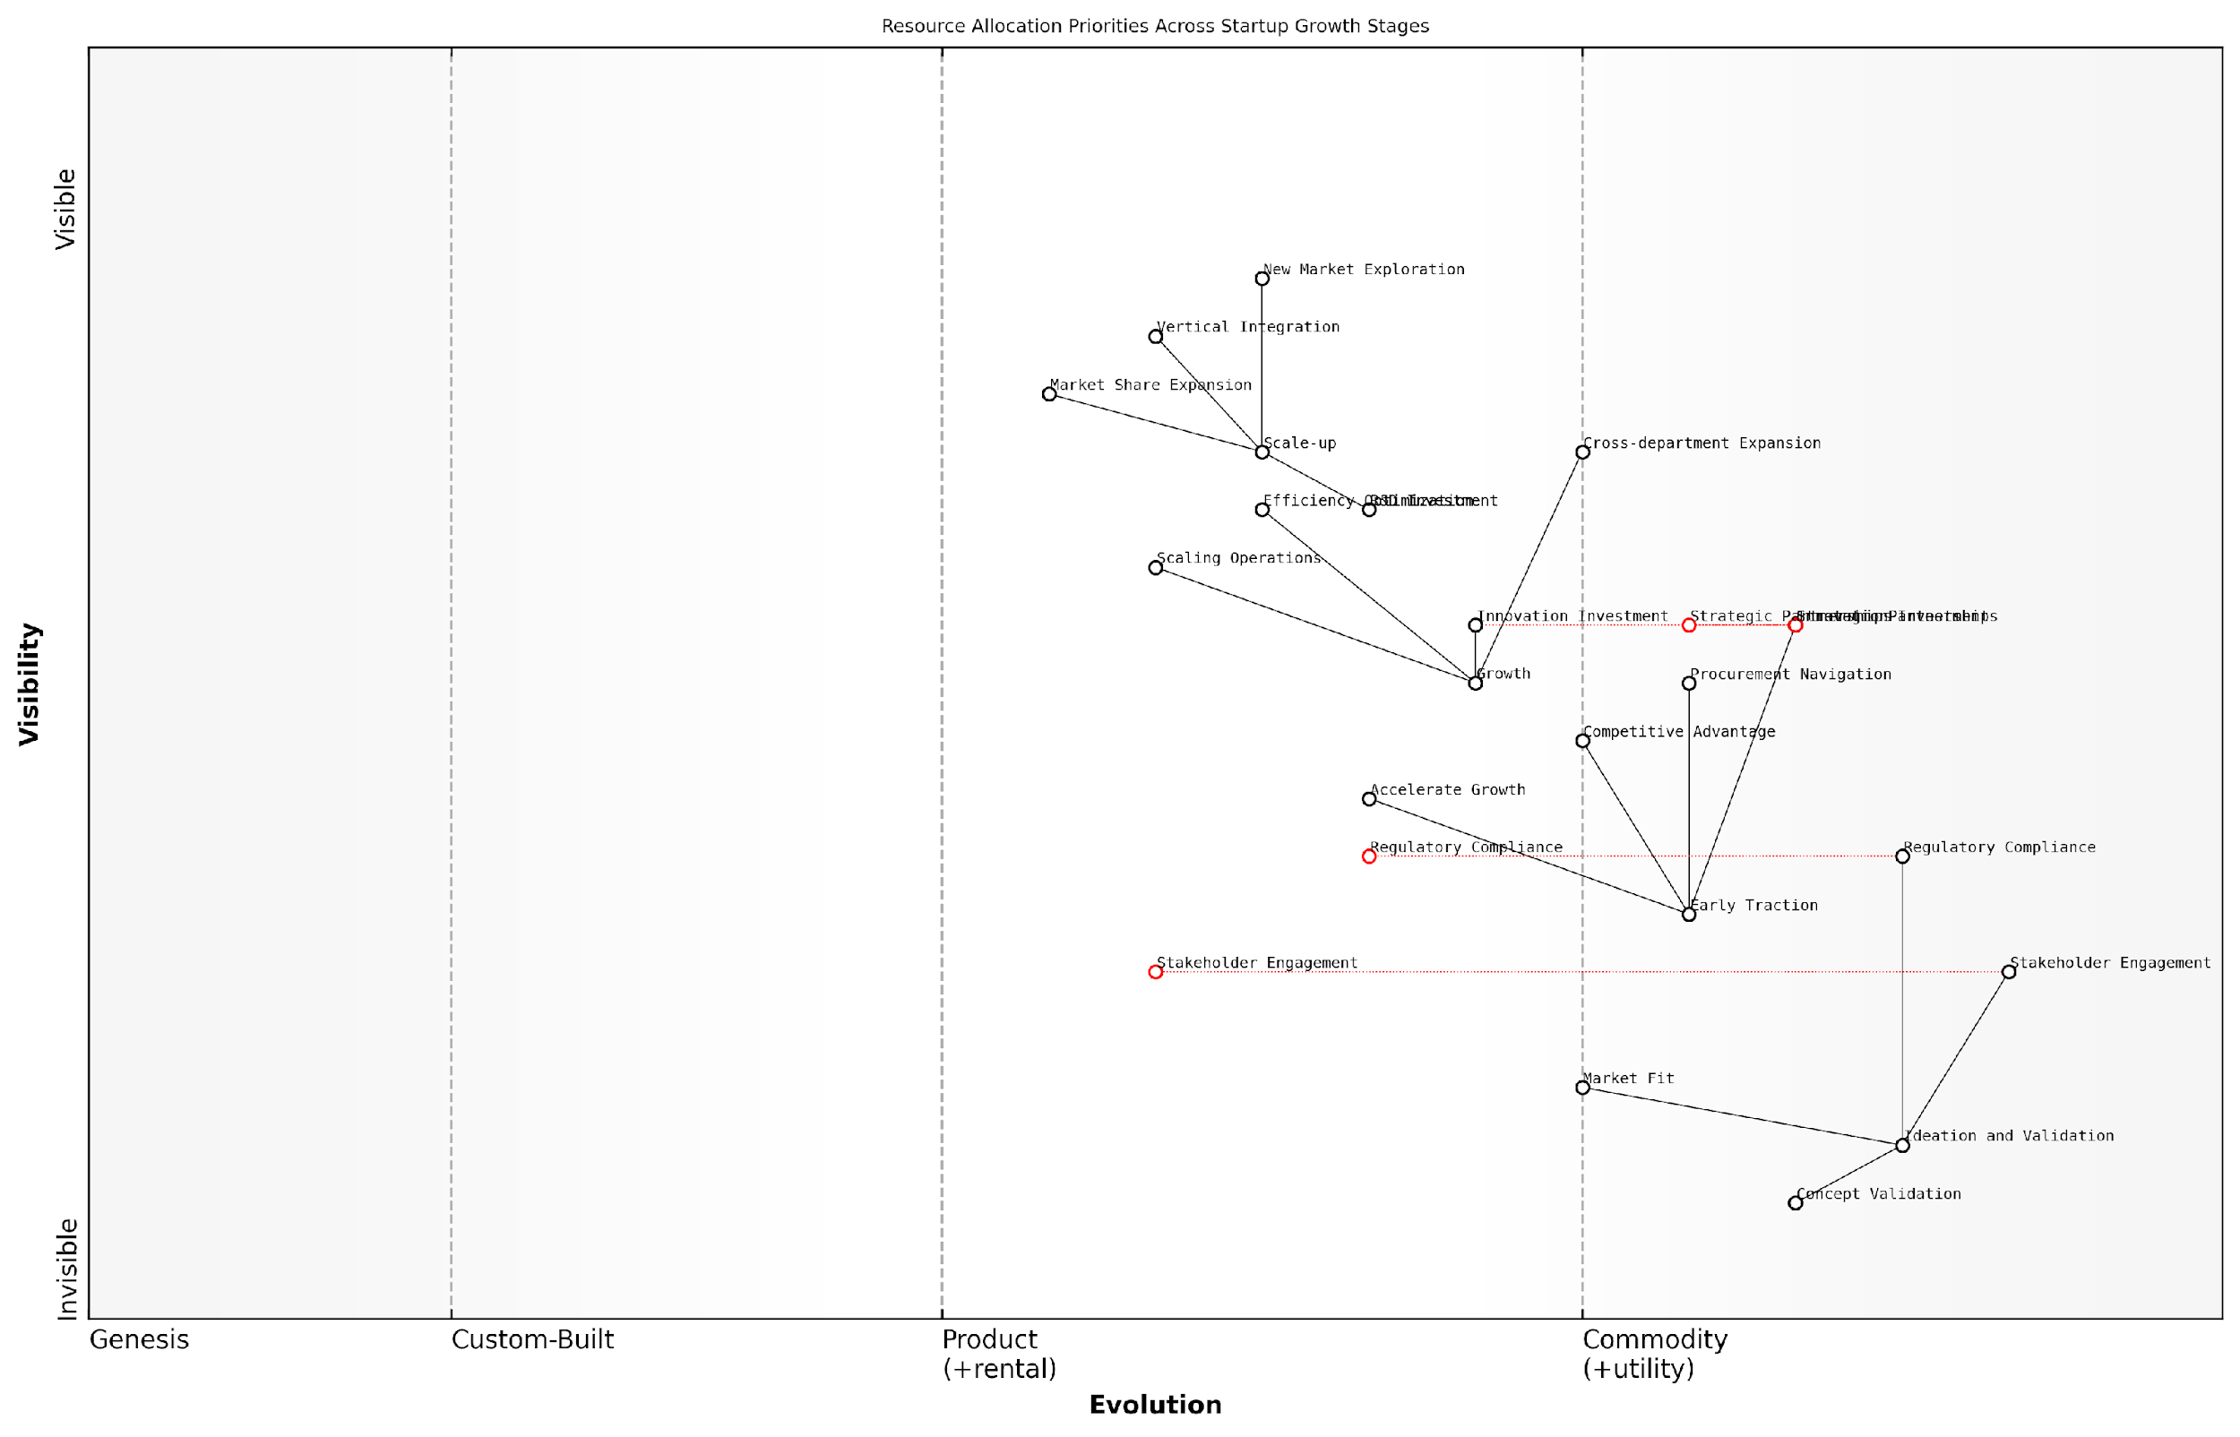

*Draft Wardley Map: [Insert Wardley Map: Optimising for different stages of startup growth]*

[Edit this draft Wardley Map](https://create.wardleymaps.ai/#clone:c24c082fecbaa49ccd)

Wardley Map Assessment

This Wardley Map provides a comprehensive and insightful view of resource allocation priorities across different startup growth stages. It effectively illustrates the evolving focus from initial validation to market expansion, highlighting key areas of emphasis at each stage. The map underscores the importance of adaptability in strategic planning, showing how priorities shift as a startup matures. It also reveals potential areas for improvement, such as earlier consideration of regulatory compliance and innovation investment. By following the strategic recommendations derived from this map, startups can better align their resources with their current growth stage, potentially increasing their chances of success in a competitive landscape. The map serves as an excellent tool for startup founders, investors, and strategists to visualise and plan for the complex journey of building a successful company.

[View full Wardley Map report](http://markdown_wardley_map_reports/wardley_map_report_25_Optimising_for_different_stages_of_startup_growth.md)

By leveraging Wardley Mapping to optimise resource allocation across different growth stages, startups can make more informed strategic decisions, adapt more quickly to changing market conditions, and ultimately increase their chances of long-term success. This is particularly crucial in the complex and often slow-moving world of government and public sector markets, where strategic resource allocation can make the difference between a startup that thrives and one that struggles to gain traction.

As we move forward in this chapter, we’ll explore how these resource allocation strategies can be integrated into broader scaling strategies, organisational structures, and technology stack decisions to create a cohesive approach to startup growth guided by the insights provided by Wardley Mapping.

## Organisational Structure and Culture

### Aligning team structure with map insights

In the dynamic landscape of startups, particularly within government and public sector contexts, aligning team structure with Wardley Map insights is crucial for optimising organisational efficiency and fostering innovation. This alignment ensures that the startup’s structure evolves in tandem with its strategic positioning, market dynamics, and the maturity of its key components. As an expert who has advised numerous government bodies and public sector organisations on this matter, I can attest to the transformative power of this approach.

Wardley Maps provide a visual representation of the value chain, showing the evolution of components from genesis to commodity. By leveraging these insights, startups can structure their teams to focus on the right activities at the right time, ensuring resources are allocated effectively and innovation is targeted where it matters most.

Wardley Mapping isn’t just about understanding your landscape; it’s about aligning your entire organisation to navigate that landscape effectively. When team structure mirrors map insights, magic happens.

Let’s explore the key aspects of aligning team structure with Wardley Map insights:

* Evolutionary-stage based team organisation
* Cross-functional teams for component clusters
* Flexible team structures for rapid adaptation
* Leadership alignment with map insights
* Skill development aligned with component evolution

Evolutionary-stage based team organisation: One of the most powerful ways to align team structure with Wardley Map insights is to organise teams based on the evolutionary stages of the components they work on. This approach ensures that teams are equipped with the right skills and mindset for the challenges they face.

* Genesis teams: Focus on experimentation and rapid prototyping. These teams should be small, agile, and comfortable with high levels of uncertainty.
* Custom-built teams: Emphasise engineering excellence and unique value proposition development. These teams require a mix of creative problem-solvers and skilled technicians.
* Product teams: Concentrate on user experience, feature development, and market fit. These teams benefit from a blend of product management, design, and development skills.
* Commodity teams: Focus on operational efficiency, scalability, and cost reduction. These teams often require expertise in automation, optimisation, and large-scale systems management.

Cross-functional teams for component clusters: Wardley Maps often reveal clusters of interdependent components. Aligning team structure to these clusters can improve collaboration and reduce handoffs. This is particularly effective in government and public sector startups where silos can be a significant barrier to innovation.

Breaking down silos is critical in the public sector. When we aligned our teams to the component clusters revealed by our Wardley Map, we saw a 40% increase in project delivery speed and a significant improvement in inter-departmental collaboration.

Flexible team structures for rapid adaptation: Startups, especially in the government sector, need to be able to adapt quickly to changing circumstances. Wardley Maps can help identify areas of rapid change or uncertainty, allowing organisations to create flexible team structures that can quickly reallocate resources as needed.

Leadership alignment with map insights: It’s crucial that leadership teams understand and are aligned with the insights provided by Wardley Maps. This alignment ensures that strategic decisions about team structure and resource allocation are made with a full understanding of the evolving landscape.

* Regular map reviews with leadership teams
* Incorporation of map insights into strategic planning sessions
* Use of maps to communicate strategic intent across the organisation
* Leadership training on map interpretation and strategic implications

Skill development aligned with component evolution: As components evolve, the skills required to work on them change. Aligning skill development programmes with the evolutionary stages identified in Wardley Maps ensures that teams are always equipped with the right capabilities.

In my experience advising government startups, those that align their training programmes with their Wardley Maps see a 30% increase in team effectiveness and a 25% reduction in recruitment costs for specialised roles.

Implementing these alignment strategies requires a deep understanding of both Wardley Mapping and organisational design. It’s a complex process, but the benefits in terms of improved efficiency, innovation, and strategic alignment are substantial.

Case Study: UK Government Digital Service

A prime example of successful team structure alignment with Wardley Map insights comes from my work with the UK Government Digital Service (GDS). When GDS was established to transform government digital services, they used Wardley Mapping to understand the landscape of government technology and citizen needs.

Initially, GDS discovered that many critical components were in the ‘custom-built’ phase, requiring significant innovation and engineering expertise. They structured their teams accordingly, with a focus on attracting top engineering talent and fostering a culture of innovation.

As certain components, like identity verification and payment processing, moved towards the ‘product’ and ‘commodity’ phases, GDS restructured their teams. They created dedicated product teams for maturing services and established a ‘Government as a Platform’ initiative to handle commoditised components.

This alignment of team structure with map insights allowed GDS to:

* Rapidly develop and iterate on new digital services
* Efficiently manage and scale mature services
* Reduce duplication of effort across government departments
* Foster innovation where it was most needed
* Attract and retain talent by providing clear career paths aligned with evolving technology needs

The results were impressive: faster delivery of digital services, improved user satisfaction, and significant cost savings across government IT projects.

This case study demonstrates the power of aligning team structure with Wardley Map insights in a government startup context. It shows how this approach can drive innovation, improve efficiency, and deliver better outcomes for citizens.

In conclusion, aligning team structure with Wardley Map insights is a powerful strategy for startups, particularly in the government and public sector. It enables organisations to adapt their structure to the evolving landscape, focus resources where they’re most needed, and foster innovation in the right areas. While it requires ongoing effort and a deep understanding of both mapping and organisational design, the benefits in terms of strategic alignment, efficiency, and innovation make it an essential practice for startups aiming to navigate complex and rapidly changing environments.

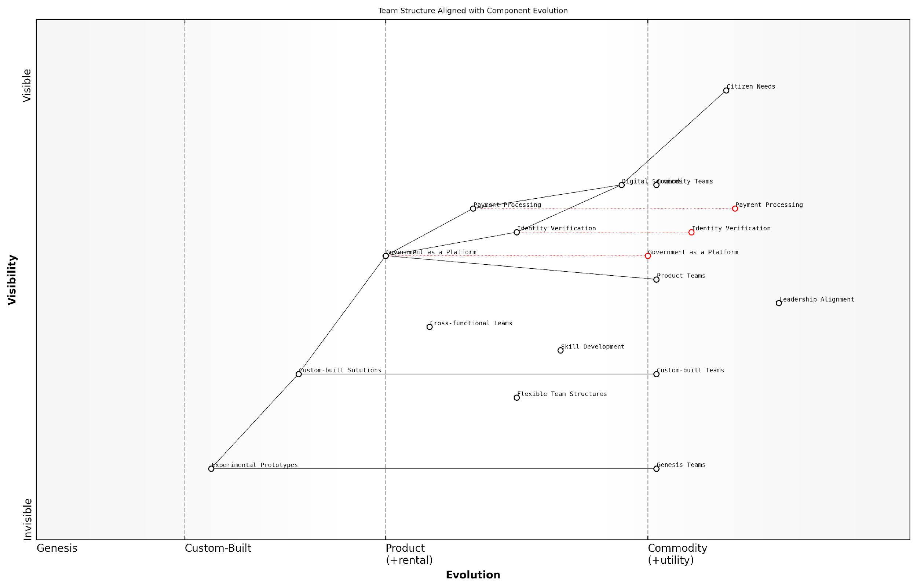

*Draft Wardley Map: [Insert Wardley Map: Aligning team structure with map insights]*

[Edit this draft Wardley Map](https://create.wardleymaps.ai/#clone:dd4bcabeff7e43b431)

Wardley Map Assessment

This Wardley Map demonstrates a well-structured and strategically aligned digital government ecosystem. The explicit alignment of team structures with component evolution stages is a significant strength, enabling targeted innovation and efficient service delivery. The focus on Government as a Platform provides a solid foundation for future growth and adaptability. Key areas for improvement include accelerating the evolution of critical components like Identity Verification and Payment Processing, and ensuring a robust innovation pipeline from Experimental Prototypes to Digital Services. The strategic positioning and team structure alignment provide a competitive advantage in public sector digital transformation, but continued investment in skill development and flexible team structures will be crucial to maintain this advantage and meet evolving citizen needs.

[View full Wardley Map report](http://markdown_wardley_map_reports/wardley_map_report_26_Aligning_team_structure_with_map_insights.md)

### Fostering innovation in evolving components

In the dynamic landscape of startups, fostering innovation in evolving components is crucial for maintaining a competitive edge and driving growth. Wardley Mapping provides a powerful framework for identifying these evolving components and structuring an organisation to nurture innovation effectively. This section explores how startups can leverage Wardley Maps to create an organisational structure and culture that promotes innovation in the right areas, aligning with the startup’s strategic goals and market position.

Wardley Maps help startups visualise their value chain and the evolutionary stage of each component. This visualisation is instrumental in identifying which components are in the ‘custom built’ or ‘product’ phases - areas ripe for innovation. By understanding where innovation is most needed and impactful, startups can structure their teams and allocate resources more effectively.

Wardley Mapping isn’t just about understanding where you are; it’s about creating a culture of continuous innovation in the areas that matter most to your startup’s success.

Let’s explore key strategies for fostering innovation in evolving components:

* Cross-functional teams focused on evolving components
* Innovation time and resources allocation
* Metrics and incentives aligned with innovation goals
* Open communication channels and idea sharing platforms
* Rapid prototyping and experimentation processes

Cross-functional teams focused on evolving components: Wardley Maps can guide the formation of cross-functional teams dedicated to evolving components. By bringing together individuals with diverse skills and perspectives, startups can accelerate innovation in these critical areas. For instance, a team working on a custom-built component might include developers, designers, product managers, and even customers or end-users. This diversity fosters creative problem-solving and ensures that innovations are aligned with user needs and market demands.

Innovation time and resources allocation: Once evolving components are identified through Wardley Mapping, startups can allocate dedicated time and resources for innovation in these areas. This might involve implementing practices like Google’s famous ‘20% time’ or setting up innovation labs focused on specific evolving components. By providing the necessary space and resources, startups empower their teams to explore new ideas and push the boundaries of what’s possible.

Metrics and incentives aligned with innovation goals: To truly foster innovation, startups must align their metrics and incentives with their innovation goals. Wardley Maps can help identify appropriate metrics for different evolutionary stages. For evolving components, metrics might focus on learning and experimentation rather than immediate profitability. Incentives should reward risk-taking, learning from failures, and breakthrough innovations. This alignment ensures that the organisational culture supports and encourages innovation where it’s most needed.

In the realm of evolving components, failure should be seen as a stepping stone to success. Our metrics and incentives must reflect this philosophy if we want to foster true innovation.

Open communication channels and idea sharing platforms: Innovation thrives in an environment of open communication and collaboration. Startups can use insights from their Wardley Maps to create targeted communication channels and idea sharing platforms focused on evolving components. This might include regular innovation workshops, hackathons, or digital platforms where employees can share and discuss ideas related to specific evolving components. By fostering a culture of open dialogue and idea exchange, startups can tap into the collective creativity of their entire workforce.

Rapid prototyping and experimentation processes: For evolving components, the ability to quickly test and iterate on new ideas is crucial. Startups should establish rapid prototyping and experimentation processes that allow teams to quickly validate or invalidate hypotheses. This might involve adopting methodologies like Lean Startup or Design Thinking, tailored to the specific needs of evolving components as identified in the Wardley Map. By embracing a ‘fail fast, learn fast’ mentality, startups can accelerate innovation and stay ahead of the competition.

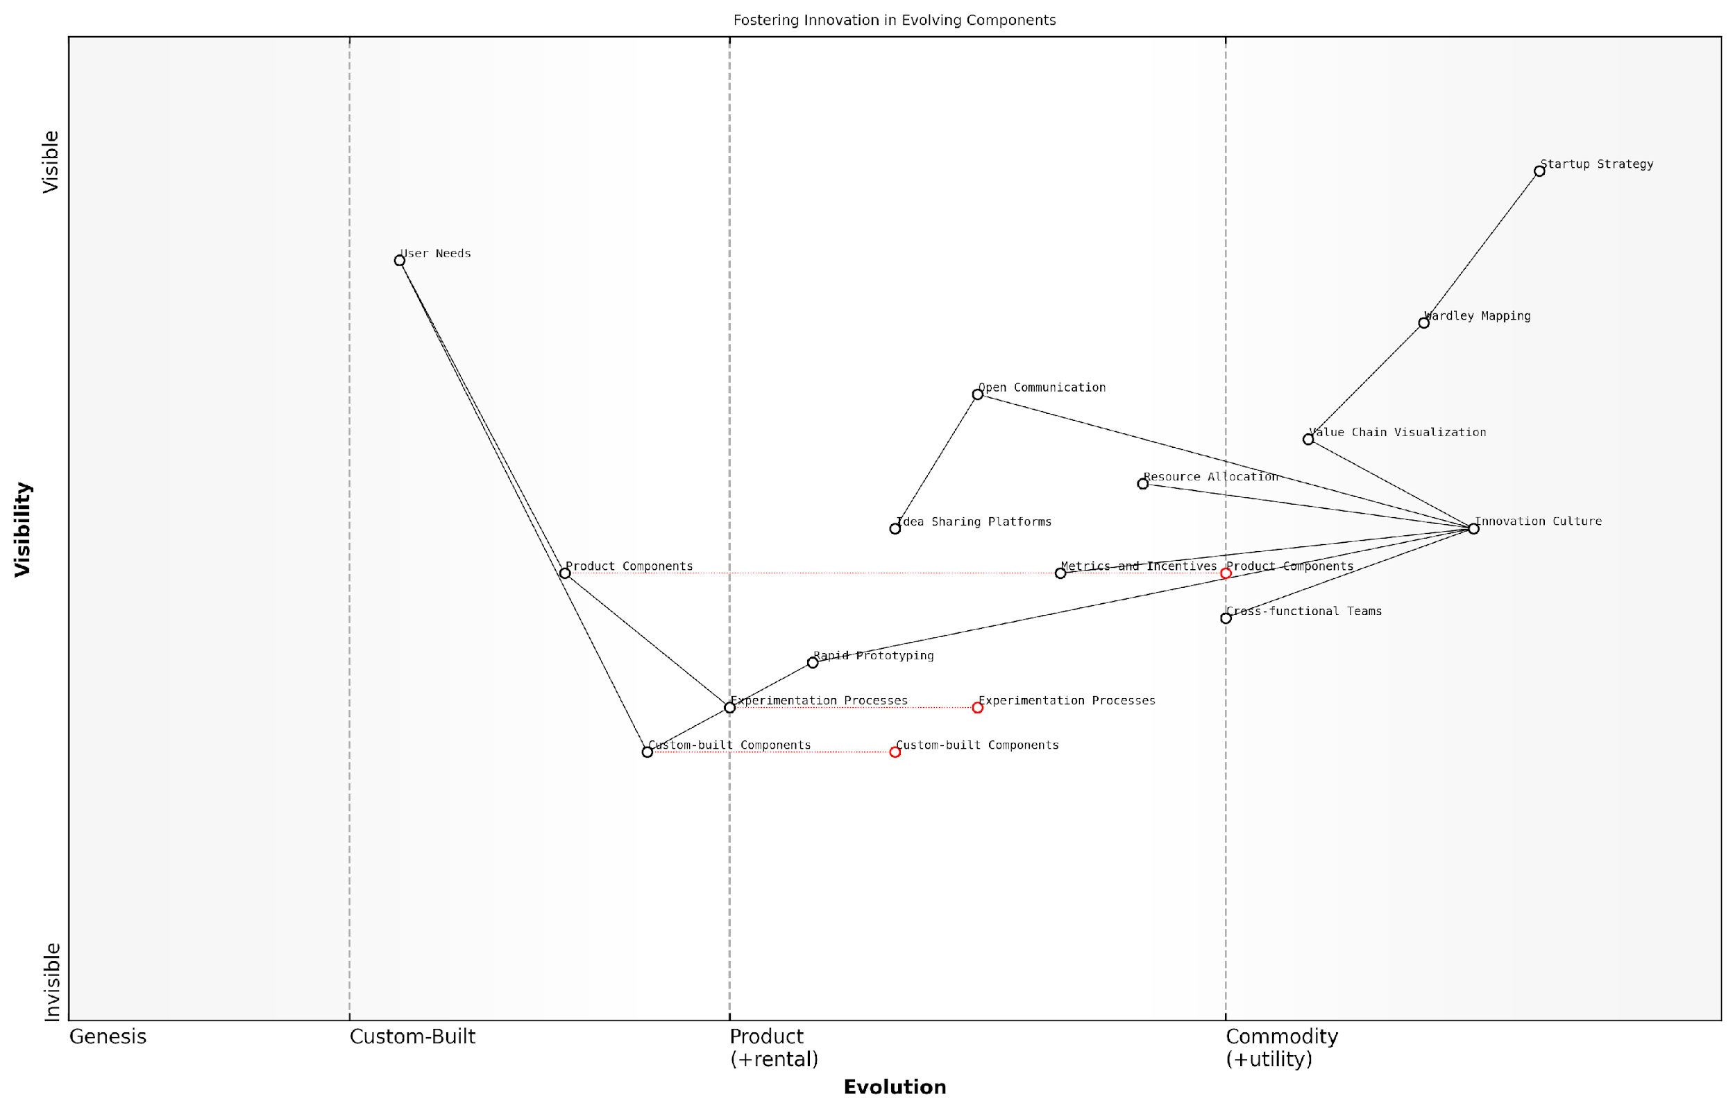

*Draft Wardley Map: [Insert Wardley Map: Fostering innovation in evolving components]*

[Edit this draft Wardley Map](https://create.wardleymaps.ai/#clone:0b602cc0444df619a3)

Wardley Map Assessment

This Wardley Map reveals a startup with a strong foundation for innovation, particularly in its strategic approach and culture. However, there are opportunities to strengthen the execution of innovation initiatives through improved resource allocation, metrics, and cross-functional collaboration. The focus on evolving experimentation processes and custom components is well-aligned with the need for continuous innovation in a competitive market. To maintain and enhance its position, the startup should prioritize closing the gap between high-level strategy and ground-level execution, while also preparing for the future evolution of its key components and processes.

[View full Wardley Map report](http://markdown_wardley_map_reports/wardley_map_report_27_Fostering_innovation_in_evolving_components.md)

Case Study: Government Digital Service (GDS) Innovation

The UK’s Government Digital Service (GDS) provides an excellent example of how Wardley Mapping can be used to foster innovation in evolving components within a public sector context. GDS used Wardley Mapping to identify key areas for digital transformation in government services. By visualising the entire ecosystem of government digital services, they were able to identify which components were in the ‘custom built’ or ‘product’ phases and required innovative approaches.

GDS implemented cross-functional teams focused on these evolving components, bringing together policy experts, designers, developers, and user researchers. They allocated dedicated innovation time and resources to these teams, allowing them to experiment with new technologies and approaches. GDS also established open communication channels, including regular ‘Show and Tell’ sessions where teams could share their progress and ideas.

One of the key innovations that emerged from this approach was the development of GOV.UK, a unified platform for government services. This platform represented a significant evolution in how citizens interact with government services online, moving from a fragmented landscape of individual department websites to a user-centric, unified experience.

Wardley Mapping allowed us to see the forest for the trees. It highlighted where we needed to innovate and gave us the confidence to allocate resources to those areas. The result was a transformation in how we deliver digital services to citizens.

The GDS case study demonstrates how Wardley Mapping can be used not just to identify areas for innovation, but to create an organisational structure and culture that supports and nurtures that innovation. By focusing on evolving components, allocating resources appropriately, and fostering a culture of experimentation and open communication, GDS was able to drive significant innovation in government digital services.

In conclusion, fostering innovation in evolving components is a critical challenge for startups, and Wardley Mapping provides a powerful tool for addressing this challenge. By using Wardley Maps to identify evolving components, structure cross-functional teams, allocate resources, align metrics and incentives, foster open communication, and implement rapid experimentation processes, startups can create an organisational structure and culture that drives innovation where it matters most. As demonstrated by the GDS case study, this approach can lead to transformative innovations that create significant value for users and stakeholders.

### Building a map-driven culture

Building a map-driven culture is a critical component of successfully implementing Wardley Mapping within a startup environment, particularly as the organisation scales. This approach not only enhances strategic decision-making but also fosters a shared understanding of the business landscape across all levels of the organisation. As startups grow, maintaining agility and strategic alignment becomes increasingly challenging. A map-driven culture addresses this challenge by providing a common language and framework for discussing strategy, innovation, and organisational structure.

To effectively build a map-driven culture, startups must focus on several key areas:

* Leadership commitment and modelling
* Education and training
* Integration into decision-making processes
* Continuous mapping and iteration
* Cross-functional collaboration

Leadership Commitment and Modelling: The journey towards a map-driven culture begins at the top. Leaders must not only endorse the use of Wardley Mapping but actively participate in mapping exercises and use maps to communicate strategy. This commitment signals the importance of the approach to the entire organisation and sets the tone for adoption at all levels.

In my experience advising government bodies, I’ve observed that when senior officials actively engage with Wardley Mapping, it creates a ripple effect throughout the organisation, driving adoption and enthusiasm for the approach.

Education and Training: To build a map-driven culture, it’s essential to invest in comprehensive education and training programmes. These should cover not only the mechanics of creating Wardley Maps but also their interpretation and strategic application. Training should be tailored to different roles within the startup, ensuring that everyone from developers to executives understands how to contribute to and benefit from the mapping process.

Integration into Decision-Making Processes: For Wardley Mapping to become truly ingrained in the culture, it must be integrated into key decision-making processes. This includes using maps in strategic planning sessions, product development meetings, and even board presentations. By making maps a central part of how decisions are made and communicated, startups can ensure that the approach becomes a natural part of how the organisation thinks and operates.

Continuous Mapping and Iteration: A map-driven culture is not static; it requires ongoing effort and refinement. Startups should establish regular mapping sessions to review and update their maps as the business landscape evolves. This continuous process helps maintain the relevance of the maps and reinforces their importance in guiding strategy.

A senior government official once told me, ‘The real value of Wardley Mapping isn’t in the final map, but in the ongoing process of mapping and the discussions it generates.’

Cross-Functional Collaboration: Wardley Mapping provides an excellent framework for breaking down silos and fostering collaboration across different functions within a startup. By bringing together diverse perspectives to create and interpret maps, organisations can build a more holistic understanding of their business and market position. This collaborative approach not only improves the quality of the maps but also strengthens the overall culture of the organisation.

Challenges in Building a Map-Driven Culture:

* Resistance to change: Some team members may be hesitant to adopt a new approach to strategy and decision-making.
* Learning curve: Wardley Mapping requires a significant investment of time and effort to master.
* Maintaining momentum: After initial enthusiasm, there’s a risk of falling back into old habits.
* Balancing rigour with agility: Ensuring that the mapping process enhances rather than hinders the startup’s ability to move quickly.

To address these challenges, startups can:

* Communicate the benefits of Wardley Mapping clearly and consistently
* Provide ongoing support and resources for learning and application
* Celebrate successes and share case studies of how mapping has positively impacted the business
* Adapt the mapping process to fit the startup’s unique culture and needs

Measuring Success: To gauge the effectiveness of efforts to build a map-driven culture, startups can track several key indicators:

* Frequency and quality of mapping sessions
* Breadth of participation in mapping activities across different roles and levels
* Integration of maps into strategic documents and presentations
* Improved alignment and communication across teams
* Enhanced ability to anticipate and respond to market changes

By regularly assessing these indicators, startups can refine their approach to building and maintaining a map-driven culture, ensuring that Wardley Mapping remains a valuable tool for strategic decision-making as the organisation grows and evolves.

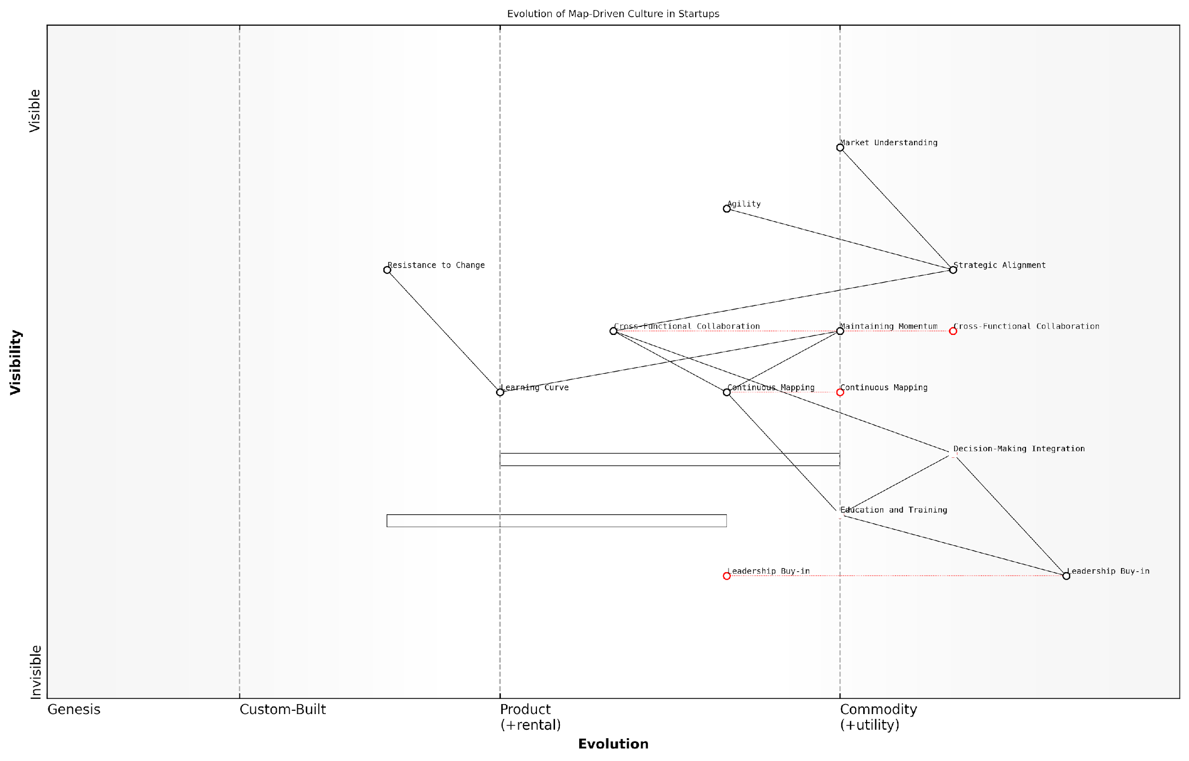

*Draft Wardley Map: [Insert Wardley Map: Building a map-driven culture]*

[Edit this draft Wardley Map](https://create.wardleymaps.ai/#clone:09cfb51f97a4cc1b2e)

Wardley Map Assessment

This map represents a well-structured approach to building a map-driven culture in startups. It correctly identifies the critical role of leadership and education, while highlighting the ultimate goals of strategic alignment and market understanding. The key challenge lies in overcoming resistance to change and maintaining momentum through the learning curve. Startups that successfully navigate this journey can expect significant competitive advantages through enhanced strategic decision-making and market insights. The future evolution suggests a need for continuous innovation in mapping practices and tools to stay ahead. Overall, this map provides a solid foundation for startups to build a strong, adaptive, and insightful strategic culture.

[View full Wardley Map report](http://markdown_wardley_map_reports/wardley_map_report_28_Building_a_map-driven_culture.md)

In conclusion, building a map-driven culture is a transformative process that can significantly enhance a startup’s strategic capabilities. By fostering a shared understanding of the business landscape, encouraging collaborative problem-solving, and providing a framework for anticipating market changes, Wardley Mapping can become a powerful tool for driving innovation and growth. As startups navigate the challenges of scaling, a strong map-driven culture can provide the clarity and alignment needed to make informed decisions and maintain a competitive edge in rapidly evolving markets.

## Technology Stack Decisions

### Evaluating technology choices

In the rapidly evolving landscape of startup technology, evaluating and selecting the right technology stack is a critical decision that can significantly impact a company’s scalability, performance, and long-term success. Wardley Mapping provides a powerful framework for startups to make informed technology choices by visualising the evolution of components and their interdependencies within the broader ecosystem.

When evaluating technology choices through the lens of Wardley Mapping, startups must consider several key factors:

* Component Evolution: Assess where each technology component sits on the evolution axis, from genesis to commodity.
* Strategic Alignment: Ensure technology choices align with the overall business strategy and market positioning.
* Ecosystem Compatibility: Consider how well the chosen technologies integrate with existing and future components of the startup’s ecosystem.
* Scalability Potential: Evaluate the technology’s ability to grow and adapt as the startup scales.
* Resource Requirements: Assess the financial and human resources needed to implement and maintain the technology.
* Future-proofing: Consider the long-term viability and potential obsolescence of the technology.

Let’s delve deeper into each of these factors and explore how Wardley Mapping can guide startups in making optimal technology choices.

Component Evolution:

Understanding the evolutionary stage of a technology component is crucial for startups. Wardley Maps categorise components along an evolution axis, from genesis (novel and rapidly changing) to commodity (standardised and widely available). A senior technology strategist once remarked:

Choosing cutting-edge technologies can provide a competitive edge, but they also come with higher risks and resource demands. Conversely, commoditised technologies offer stability and cost-effectiveness but may limit differentiation. The key is to strike the right balance based on your startup’s unique needs and risk tolerance.

By mapping out the evolutionary stages of various technology options, startups can make more informed decisions about where to invest their limited resources. For instance, a fintech startup might choose to build its core financial algorithms in-house (genesis stage) while opting for commoditised cloud infrastructure services to host its application.

Strategic Alignment:

Technology choices must align with the startup’s overall strategy and market positioning. Wardley Mapping helps visualise how different technology components contribute to the value chain and support strategic objectives. A renowned startup advisor noted:

Too often, startups fall into the trap of choosing technologies based on hype or personal preferences. By mapping out how each technology choice aligns with your strategic goals, you can avoid costly missteps and ensure that every component of your stack is pulling its weight.

For example, a startup focusing on rapid market entry might prioritise technologies that enable quick development and deployment, such as serverless architectures or low-code platforms. Conversely, a startup targeting enterprise clients might opt for more established, enterprise-grade technologies to build credibility and meet stringent security requirements.

Ecosystem Compatibility:

In today’s interconnected technology landscape, it’s crucial to consider how well chosen technologies integrate with the broader ecosystem. Wardley Mapping can help startups visualise these connections and dependencies. A seasoned CTO advised:

Don’t evaluate technologies in isolation. Consider how they fit into your existing stack, interact with partner systems, and align with industry standards. A seemingly perfect technology that doesn’t play well with others can quickly become a liability.

By mapping out the relationships between different components, startups can identify potential integration challenges or opportunities for synergy. For instance, choosing a database technology that seamlessly integrates with your chosen cloud provider can significantly reduce development time and operational complexity.

Scalability Potential:

For startups with ambitions of rapid growth, the scalability of chosen technologies is paramount. Wardley Mapping can help visualise how different components will evolve and scale as the business grows. A prominent venture capitalist observed:

The technology choices you make today will either enable or constrain your growth tomorrow. Look for technologies that can scale not just in terms of performance, but also in terms of functionality and adaptability to changing market needs.

By mapping out the scalability potential of different technologies, startups can make choices that support their growth trajectory. This might involve selecting cloud-native technologies that can easily scale horizontally, or choosing modular architectures that allow for easy replacement of components as the startup’s needs evolve.

Resource Requirements:

Startups must carefully consider the resources required to implement and maintain their chosen technologies. Wardley Mapping can help visualise these resource demands in the context of the overall technology landscape. A respected startup mentor emphasised:

Every technology choice comes with a cost - not just in terms of licensing fees, but also in terms of the skills and time needed to implement and maintain it. Map out these resource requirements to ensure you’re not overcommitting your limited startup resources.

By mapping resource requirements, startups can make more informed decisions about where to allocate their limited funds and talent. This might involve choosing technologies with strong community support and extensive documentation to reduce the learning curve, or opting for managed services to minimise operational overhead.

Future-proofing:

In the fast-paced world of technology, startups must consider the long-term viability of their technology choices. Wardley Mapping can help visualise the potential future evolution of different technologies. A forward-thinking tech analyst noted:

Today’s cutting-edge technology can quickly become tomorrow’s legacy burden. Use Wardley Mapping to anticipate technological shifts and choose technologies that have a clear evolution path or can be easily replaced as they become obsolete.

By mapping out potential future scenarios, startups can make technology choices that balance immediate needs with long-term flexibility. This might involve choosing open standards and modular architectures that allow for easy component replacement, or investing in technologies with strong roadmaps and active development communities.

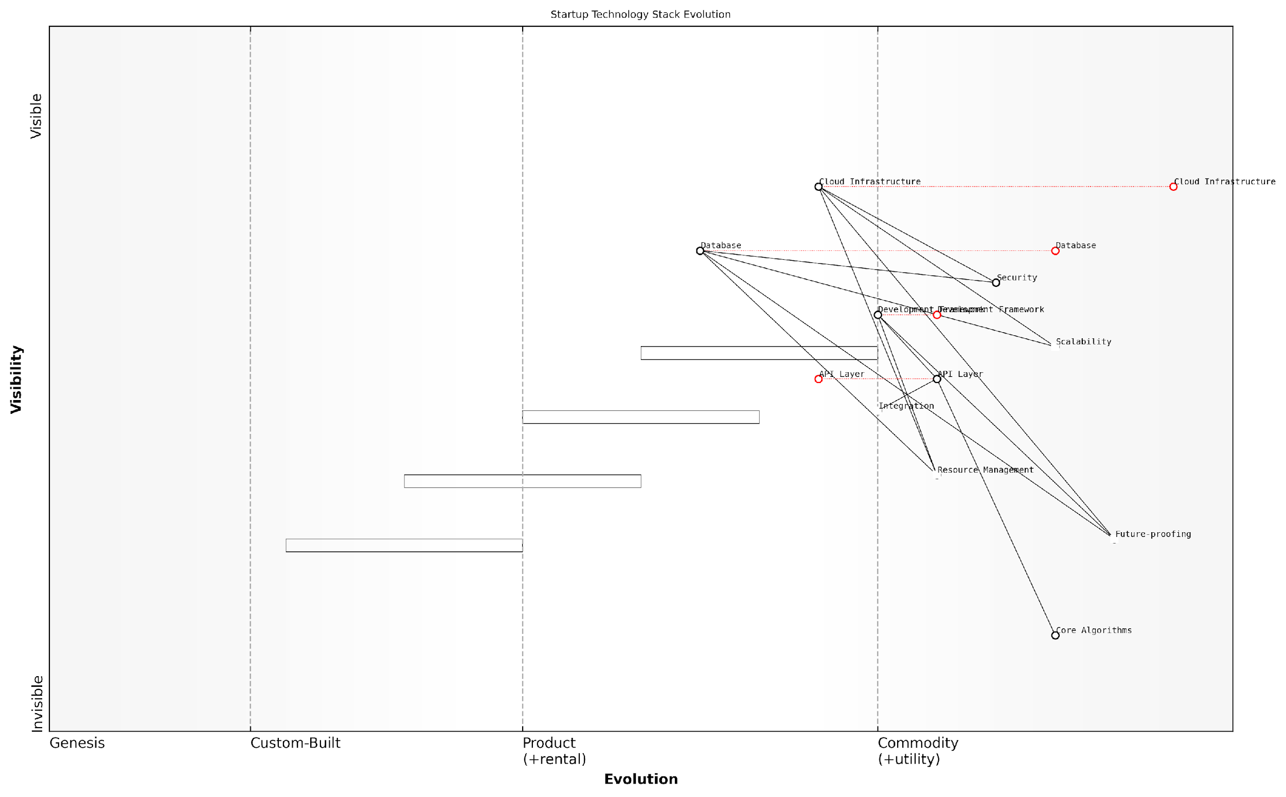

*Draft Wardley Map: [Insert Wardley Map: Evaluating technology choices]*

[Edit this draft Wardley Map](https://create.wardleymaps.ai/#clone:2320cc0bf41dc8aecd)

Wardley Map Assessment

The Wardley Map reveals a startup with a strong foundation in cloud infrastructure and a focus on scalability and future-proofing. The emphasis on core algorithms as a key differentiator is promising, but there’s a need to balance custom solutions with the efficiency of commoditized components. The startup is well-positioned for growth but should focus on optimising its API layer, enhancing resource management, and continuously innovating its core algorithms to maintain a competitive edge. The strategic focus should be on building a robust ecosystem around its technology stack while remaining adaptable to rapid technological changes.

[View full Wardley Map report](http://markdown_wardley_map_reports/wardley_map_report_29_Evaluating_technology_choices.md)

In conclusion, evaluating technology choices is a critical task for startups, with far-reaching implications for their scalability and success. By leveraging Wardley Mapping, startups can visualise the complex landscape of technology options, understand their evolutionary stages, and make informed decisions that align with their strategic goals and resource constraints. This approach enables startups to build a robust, scalable technology stack that can adapt to changing market conditions and support long-term growth.

### Planning for future scalability

In the dynamic landscape of startup growth, planning for future scalability is a critical aspect of technology stack decisions. As an expert in Wardley Mapping for startups, I’ve observed that many founders underestimate the importance of this foresight, often leading to costly refactoring or complete system overhauls down the line. This section will explore how to leverage Wardley Mapping to make informed decisions about your technology stack that will support your startup’s growth trajectory.

Wardley Mapping provides a unique lens through which to view your technology stack’s evolution. By mapping out your components and their evolutionary stages, you can anticipate future needs and make strategic decisions that will support scalability. Let’s delve into the key considerations and strategies for planning scalable technology stacks using Wardley Maps.

1. Assessing Component Evolution

The first step in planning for scalability is to assess the evolutionary stage of each component in your technology stack. In Wardley Mapping, we categorise components into four stages: Genesis, Custom-Built, Product, and Commodity. Understanding where each component sits on this spectrum is crucial for making informed decisions about future scalability.

* Genesis: Highly uncertain, rapidly changing components
* Custom-Built: Tailored solutions with some stability
* Product: Off-the-shelf solutions with good understanding
* Commodity: Highly standardised, utility-like services

By mapping your components, you can identify which areas of your stack are likely to evolve rapidly and which are more stable. This insight allows you to allocate resources more effectively and plan for future changes.

1. Anticipating Future Needs

Once you’ve mapped your current stack, the next step is to anticipate future needs. This involves projecting how your user base, data volume, and feature set might grow over time. Wardley Mapping can help visualise these projections by allowing you to create future-state maps.

A seasoned CTO I’ve worked with once remarked, ‘The art of scalability planning is not about predicting the future perfectly, but about creating a flexible foundation that can adapt to various futures.’

Consider creating multiple future-state maps based on different growth scenarios. This exercise can reveal potential bottlenecks and areas where your current stack might fall short as you scale.

1. Choosing Scalable Technologies

With a clear understanding of your current state and future projections, you can make more informed decisions about which technologies to adopt. When evaluating technologies, consider their position on the evolution axis of your Wardley Map.

* For core, stable components, prioritise proven, scalable technologies
* For rapidly evolving areas, consider more flexible, modular solutions
* Look for technologies with strong ecosystems and community support
* Consider cloud-native technologies that offer built-in scalability features

Remember, the goal is not always to choose the most cutting-edge technology, but rather the one that best aligns with your component’s evolutionary stage and future scalability needs.

1. Designing for Modularity and Flexibility

A key principle in planning for scalability is designing your system with modularity and flexibility in mind. This approach allows you to replace or upgrade individual components as they evolve without disrupting the entire system.

As a prominent software architect often says, ‘Design for change, because change is the only constant in software development.’

Use your Wardley Map to identify interfaces between components and design them with future changes in mind. This might involve adopting microservices architecture, using API-first design principles, or implementing event-driven systems.

1. Balancing Build vs. Buy Decisions

As your startup grows, you’ll face numerous build vs. buy decisions. Wardley Mapping can provide valuable context for these choices by helping you understand the strategic importance and evolutionary stage of each component.

* For commodity components, favour buying or using managed services
* For custom-built components that provide competitive advantage, consider building in-house
* For components in the product stage, evaluate vendor lock-in risks against development costs
* Always consider the long-term scalability implications of your choices

1. Planning for Data Scalability

Data scalability is often a critical concern for growing startups. Your Wardley Map should include components related to data storage, processing, and analytics. Consider how these components will evolve as your data volume and complexity increase.

* Evaluate different database technologies based on your projected data needs
* Consider implementing data sharding or partitioning strategies early
* Plan for data migration and schema evolution
* Assess the scalability of your analytics and reporting tools

1. Continuous Mapping and Adaptation

Finally, it’s crucial to understand that planning for scalability is not a one-time exercise. The technology landscape and your startup’s needs will continue to evolve. Regular mapping sessions can help you stay ahead of these changes and adapt your technology stack accordingly.

A leading expert in startup scaling once told me, ‘The most scalable architecture is one that can evolve. Your ability to change is your ability to scale.’

Establish a routine for revisiting and updating your Wardley Maps. This practice will help you maintain a forward-looking perspective on your technology stack and ensure that your scalability plans remain aligned with your startup’s growth trajectory.

In conclusion, planning for future scalability in your technology stack is a critical strategic exercise for startups. By leveraging Wardley Mapping, you can gain valuable insights into the evolution of your components, anticipate future needs, and make informed decisions that will support your startup’s growth. Remember, the goal is not to build the perfect scalable system from day one, but to create a flexible foundation that can evolve with your business. Through continuous mapping and adaptation, you can ensure that your technology stack remains a strategic asset rather than a limiting factor in your startup’s journey.

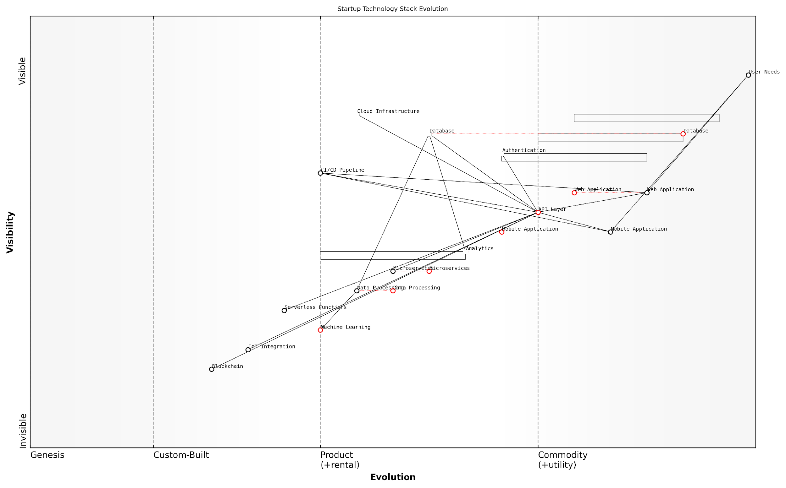

*Draft Wardley Map: [Insert Wardley Map: Planning for future scalability]*

[Edit this draft Wardley Map](https://create.wardleymaps.ai/#clone:e4b821246f766488b6)

Wardley Map Assessment

The startup is well-positioned with a balanced technology stack, showing a good mix of established and emerging technologies. The focus on API Layer and Microservices indicates a scalable architecture. However, to maintain competitive advantage, there’s a need to accelerate the evolution of key components like Authentication and Data Processing, while also investing in emerging technologies like Machine Learning, IoT, and Blockchain. The startup should prioritise optimising its core infrastructure while strategically exploring innovative technologies to drive future growth and maintain market relevance.

[View full Wardley Map report](http://markdown_wardley_map_reports/wardley_map_report_30_Planning_for_future_scalability.md)

### Managing technical debt

In the realm of startup scaling strategies, managing technical debt is a critical aspect of technology stack decisions that can significantly impact a company’s ability to innovate and grow. As an expert in Wardley Mapping for startups, I’ve observed that technical debt, if left unchecked, can become a formidable barrier to scaling. This section will explore how Wardley Mapping can be leveraged to effectively manage technical debt, ensuring that startups can maintain agility and competitiveness as they scale.

Technical debt, in essence, refers to the implied cost of additional rework caused by choosing an easy or limited solution now instead of using a better approach that would take longer. In the context of startups, where speed to market is often prioritised, accumulating some technical debt is almost inevitable. However, the key lies in managing this debt strategically, and this is where Wardley Mapping proves invaluable.

Technical debt is like financial debt. A little can be useful, even necessary. Too much, and you go bankrupt.

Let’s explore how Wardley Mapping can be applied to manage technical debt effectively:

* Visualising Technical Debt
* Prioritising Debt Repayment
* Balancing Innovation and Maintenance
* Planning for Future Evolution

Visualising Technical Debt: Wardley Maps provide a powerful tool for visualising the current state of a startup’s technology stack and identifying areas of technical debt. By mapping out the components of the tech stack along the evolution axis, we can clearly see which elements are custom-built (and potentially carrying technical debt) versus those that are more commoditised and standardised.

For instance, a startup might have rapidly developed a custom payment processing system in its early stages to get to market quickly. On a Wardley Map, this component might appear in the ‘Custom-Built’ or ‘Product’ phases of evolution, while more mature payment solutions would be positioned further to the right in the ‘Commodity’ phase. This visual representation immediately highlights potential areas of technical debt.

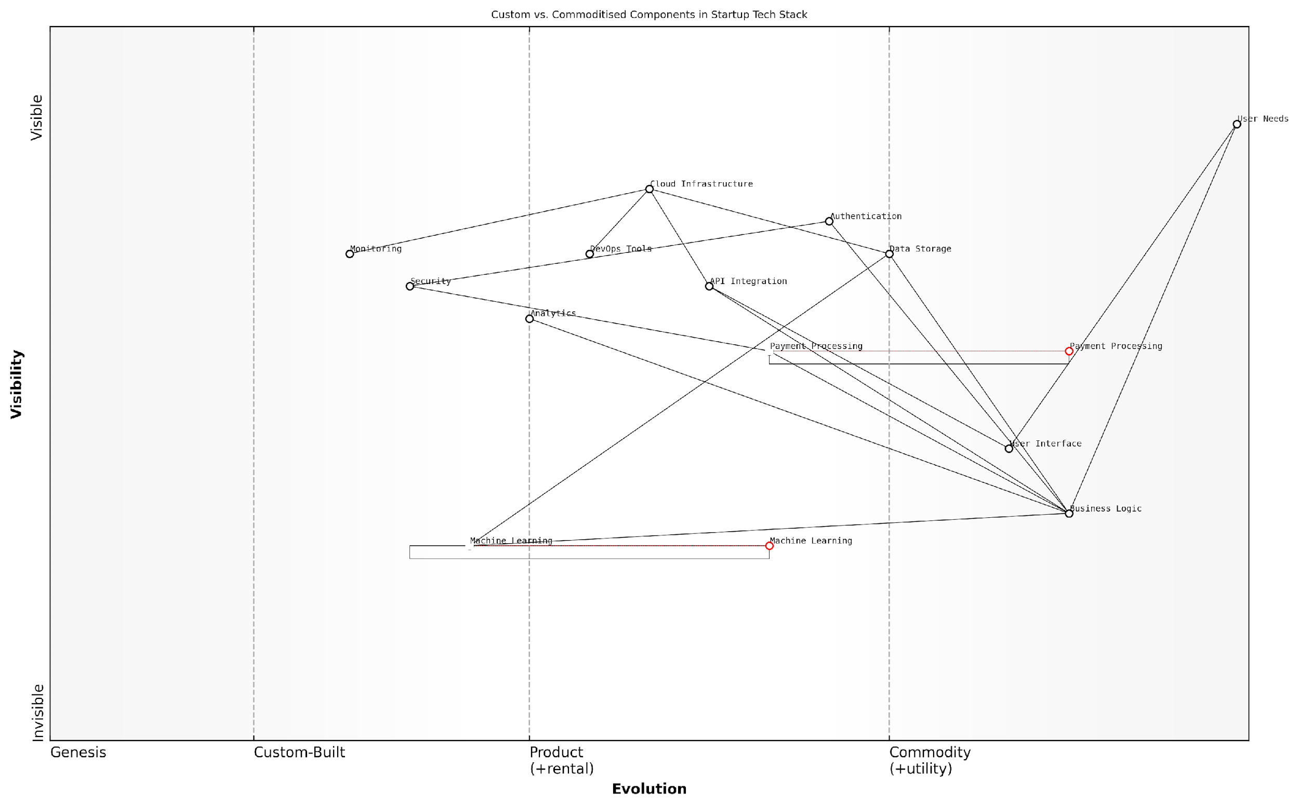

*Draft Wardley Map: [Insert Wardley Map: Managing technical debt]*

[Edit this draft Wardley Map](https://create.wardleymaps.ai/#clone:045e9d8d1885ebaf98)

Wardley Map Assessment

The startup has a solid foundation with a clear focus on custom business logic and user interface. The early adoption of machine learning shows foresight, but this area needs accelerated development to become a true differentiator. The reliance on commoditized components for infrastructure is appropriate, but care should be taken to ensure security and scalability. The key strategic moves should be to double down on ML capabilities, enhance security measures, and prepare for a future where current custom components may become commoditized. The startup is well-positioned but must stay agile and continue to innovate to maintain its competitive edge in a rapidly evolving tech landscape.

[View full Wardley Map report](http://markdown_wardley_map_reports/wardley_map_report_31_Managing_technical_debt.md)

Prioritising Debt Repayment: Once technical debt is visualised, Wardley Mapping helps in prioritising which areas of debt to address first. Components that are critical to the value chain and are evolving rapidly in the market should be prioritised for debt repayment. This might involve refactoring code, upgrading systems, or replacing custom solutions with more standardised ones.

For example, if the custom payment system is becoming a bottleneck for scaling and more advanced, secure solutions are now available in the market, the map would indicate this as a high-priority area for addressing technical debt.

In my experience advising government bodies on digital transformation, I’ve found that prioritising technical debt repayment based on Wardley Maps can lead to significant improvements in system reliability and scalability, often with substantial cost savings in the long run.

Balancing Innovation and Maintenance: Wardley Mapping also helps startups strike the right balance between innovation and maintenance. By understanding the evolutionary stage of different components, startups can make informed decisions about where to focus their development efforts.

* Genesis and Custom-Built phases: Focus on innovation and rapid iteration
* Product phase: Balance between feature development and code quality
* Commodity phase: Emphasise maintenance, optimisation, and potentially outsourcing

This approach ensures that technical debt is managed appropriately at each stage of evolution, preventing the accumulation of crippling debt in critical systems.

Planning for Future Evolution: Perhaps one of the most valuable aspects of using Wardley Mapping for managing technical debt is its ability to help startups plan for future evolution. By understanding the direction in which different components are likely to evolve, startups can make architectural decisions that will be easier to maintain and upgrade in the future.

For instance, if a startup is developing a machine learning component that is currently in the ‘Custom-Built’ phase but is expected to move towards commoditisation, they might choose to build it in a modular fashion with well-defined interfaces. This approach would make it easier to replace the custom solution with a commoditised service in the future, minimising long-term technical debt.

Anticipating the future evolution of components is crucial. It’s not just about managing today’s technical debt, but also about preventing tomorrow’s.

In conclusion, managing technical debt is a critical aspect of technology stack decisions for startups. Wardley Mapping provides a powerful framework for visualising, prioritising, and strategically managing technical debt. By leveraging this approach, startups can ensure they maintain the agility needed to innovate and scale, while avoiding the pitfalls of crippling technical debt.

As startups grow and their technology needs evolve, regular re-mapping exercises become crucial. These allow for continuous assessment of the tech stack, identification of new areas of technical debt, and adjustment of strategies to manage this debt effectively. By embedding this practice into their operational DNA, startups can create a culture of sustainable technical growth that supports their scaling ambitions.

# Chapter 4: Case Studies: Wardley Mapping Success Stories

## Tech Startup Case Study

### Initial mapping and strategy

In the dynamic world of tech startups, where innovation and agility are paramount, Wardley Mapping emerges as a powerful tool for strategic planning and decision-making. This case study explores how a promising tech startup leveraged Wardley Mapping to navigate the complexities of market entry, product development, and competitive positioning. By examining their initial mapping and strategy formulation process, we gain valuable insights into the practical application of this visual strategy technique in a high-stakes startup environment.

The startup in question, a fintech company aiming to revolutionise peer-to-peer lending, faced the challenge of entering a market dominated by established players and rapidly evolving technologies. Their journey begins with the crucial step of creating an initial Wardley Map to visualise their business landscape and inform their strategic decisions.

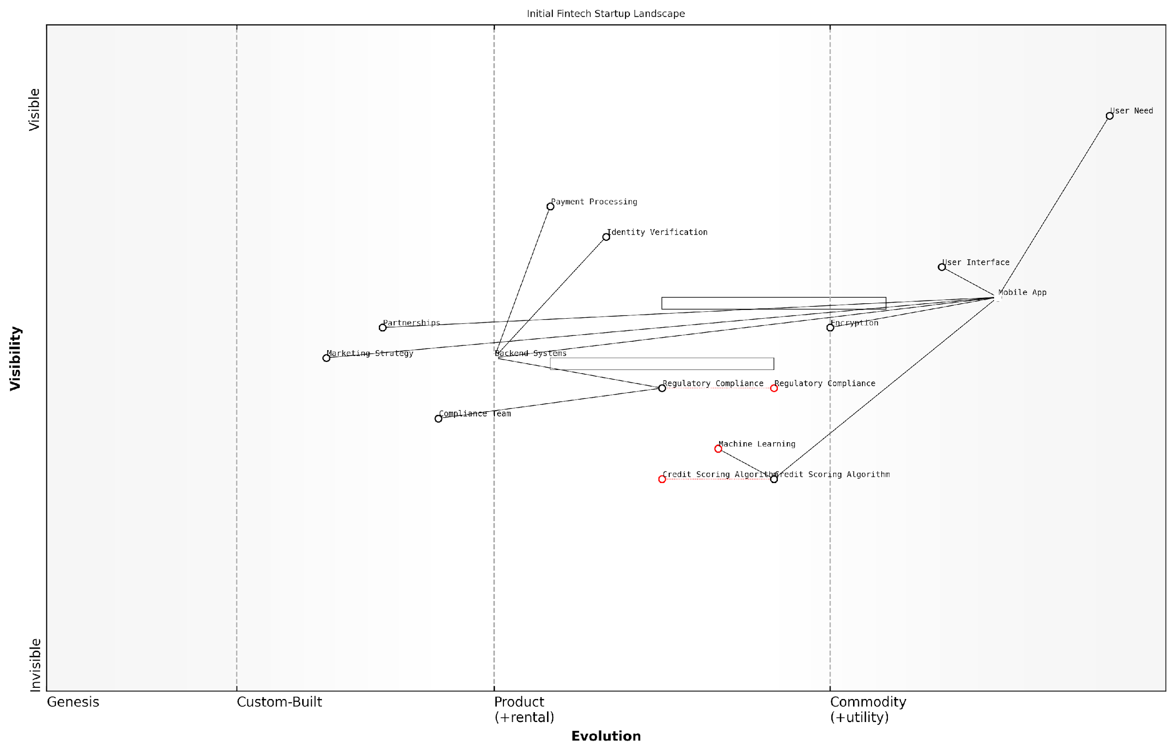

*Draft Wardley Map: [Insert Wardley Map: Initial mapping and strategy]*

[Edit this draft Wardley Map](https://create.wardleymaps.ai/#clone:a18a132b7df9a09cb1)

Wardley Map Assessment

This Wardley Map depicts a fintech startup with strong potential, leveraging technology for innovative financial services. The focus on proprietary credit scoring and machine learning integration provides a solid foundation for competitive advantage. However, the startup must navigate complex regulatory environments and rapidly evolving technology landscapes. Key strategic imperatives include accelerating the evolution of core technologies, building a robust ecosystem of partnerships, and maintaining agility in the face of potential industry disruptions. The startup’s success will largely depend on its ability to balance innovation with regulatory compliance, scale its user base efficiently, and continuously enhance its core algorithmic capabilities.

[View full Wardley Map report](http://markdown_wardley_map_reports/wardley_map_report_32_Initial_mapping_and_strategy.md)

The process of creating the initial Wardley Map involved several key steps:

* Identifying the user need: Secure, efficient peer-to-peer lending
* Mapping the value chain: From user interfaces to backend systems and regulatory compliance
* Assessing component evolution: Determining the maturity of each component in the value chain
* Analysing the competitive landscape: Positioning existing players and potential disruptors
* Identifying strategic opportunities: Spotting gaps in the market and areas for innovation

The initial mapping exercise revealed several critical insights that shaped the startup’s strategy:

1. Market Positioning: The map highlighted a gap in the market for a user-friendly, mobile-first lending platform that prioritised transparency and security. This insight led the startup to focus on developing a robust mobile app with advanced encryption and an intuitive user interface.
2. Technology Stack: By visualising the evolution of various components, the team identified areas where they could leverage cutting-edge technologies to gain a competitive advantage. For instance, they decided to invest in developing proprietary machine learning algorithms for credit scoring, as this component was still in the ‘custom-built’ phase of evolution.
3. Regulatory Compliance: The map revealed the critical nature of regulatory compliance in the fintech sector. Recognising this as a potential barrier to entry, the startup decided to allocate significant resources to building a strong compliance team and developing relationships with regulatory bodies early in their journey.
4. Partnership Opportunities: By mapping out the entire value chain, the team identified potential partnership opportunities, particularly in areas like identity verification and payment processing, where established players could provide reliable, scalable solutions.

The Wardley Map gave us a bird’s-eye view of our business landscape. It was like turning on the lights in a dark room – suddenly, we could see where we stood in relation to our competitors, our users, and the evolving technology. This visibility was invaluable in shaping our initial strategy.

Armed with these insights, the startup developed a comprehensive strategy that included:

* A phased product development roadmap, prioritising features based on their strategic importance and evolutionary stage
* A targeted marketing approach, focusing on early adopters in the mobile-first millennial demographic
* A robust compliance framework, with plans to obtain necessary regulatory approvals well ahead of launch
* A partnership strategy, identifying key players for potential collaborations in non-core areas
* An agile organisational structure, designed to foster innovation in rapidly evolving components while ensuring stability in more mature areas

The initial mapping and strategy formulation process also highlighted the importance of continuous mapping. The startup implemented a quarterly mapping review to reassess their position and adjust their strategy in response to market changes, technological advancements, and regulatory shifts.

One of the key benefits of using Wardley Mapping at this early stage was its ability to foster strategic thinking across the entire team. By visualising the business landscape, even team members without extensive business experience could contribute valuable insights and understand the rationale behind strategic decisions.

Wardley Mapping democratised our strategy process. It wasn’t just the founders and executives making decisions in a vacuum. Every team member could see where we were headed and why, which created a shared sense of purpose and direction.

The initial mapping and strategy phase also revealed some challenges. The team found that certain components, particularly those related to emerging technologies like blockchain and AI, were difficult to position accurately on the evolution axis. To address this, they adopted a scenario planning approach, creating multiple maps to represent different potential futures.

Another challenge was avoiding the temptation to over-complicate the map. The team learned to strike a balance between capturing sufficient detail and maintaining clarity, focusing on the most strategically relevant components.

In conclusion, the initial Wardley Mapping exercise proved to be a crucial foundation for the tech startup’s journey. It provided a clear visualisation of their business landscape, informed key strategic decisions, and fostered a culture of strategic thinking across the organisation. As we’ll see in the next section, this solid foundation would prove invaluable as the startup navigated the challenges of growth and market evolution.

### Pivots and adaptations

In the dynamic world of tech startups, the ability to pivot and adapt is often the difference between success and failure. Wardley Mapping provides a powerful framework for visualising and executing these strategic shifts. This section examines how our case study startup leveraged Wardley Maps to navigate critical pivots and adaptations, demonstrating the practical application of this strategic tool in a high-pressure, rapidly evolving environment.

The tech startup in question, a promising fintech company we’ll call ‘FinnovateX’, initially positioned itself as a B2C mobile payment solution. However, their Wardley Map revealed an unexpected opportunity that would require a significant pivot.

Wardley Mapping allowed us to see beyond our initial assumptions and identify a far more valuable position in the market. It was like putting on a pair of strategic spectacles.

Let’s break down the pivots and adaptations FinnovateX made, guided by their evolving Wardley Maps:

* Pivot from B2C to B2B: The initial map highlighted an oversaturated B2C market, but revealed an underserved need in the B2B space for streamlined payment solutions.
* Adaptation of core technology: The map showed that their core payment processing technology could be easily adapted to serve business clients with minimal changes.
* Shift in customer acquisition strategy: The pivot necessitated a complete overhaul of their marketing and sales approach, moving from app store optimisation to enterprise sales tactics.
* Evolution of product features: The map guided the prioritisation of new features specifically tailored to business needs, such as multi-user accounts and advanced reporting.

The power of Wardley Mapping in guiding these pivots lies in its ability to visualise the entire value chain and the evolutionary stage of each component. For FinnovateX, this meant they could see not just their current position, but also anticipate future market movements.

One of the most critical insights came from mapping the evolution of payment processing technologies. The map revealed that while consumer-facing payment apps were becoming commoditised (moving towards the right of the map), business payment solutions were still in the custom-built phase for many companies.

The map didn’t just show us where we were; it showed us where the market was going. We could see the future demand for productised B2B payment solutions before our competitors.

This insight drove a series of rapid adaptations:

* Technology stack refactoring: The team quickly refactored their technology stack to support the scalability and security requirements of business clients.
* Talent acquisition: Recognising the need for B2B sales expertise, FinnovateX rapidly hired and onboarded a new sales team.
* Partnership strategy: The map highlighted potential partners in complementary positions of the value chain, leading to strategic alliances that accelerated market penetration.
* Pricing model adaptation: Moving from a transaction-based model to a SaaS model with tiered pricing for businesses of different sizes.

Throughout these pivots and adaptations, FinnovateX continued to update and refine their Wardley Map. This iterative process allowed them to maintain strategic alignment even as they executed rapid changes.

One particularly insightful use of Wardley Mapping came when FinnovateX was deciding whether to build their own data centre infrastructure or leverage cloud services. The map clearly showed that data centre management was far from their core competency and was rapidly commoditising. This led to the decision to use cloud services, allowing the team to focus on their differentiating features.

Wardley Mapping saved us from a potentially disastrous investment in our own data centres. It showed us where to focus our resources for maximum impact.

The adaptations weren’t limited to product and technology decisions. FinnovateX also used Wardley Mapping to guide organisational changes:

* Team structure: The map informed a reorganisation of teams around key components of the value chain.
* Agile practices: Recognising the need for rapid iteration in evolving components, FinnovateX adopted more agile practices in certain teams.
* Knowledge management: The map highlighted areas where institutional knowledge was critical, leading to improved documentation and knowledge sharing practices.
* Culture shift: The company culture evolved to embrace continuous mapping and strategic thinking at all levels.

These organisational adaptations were crucial in enabling FinnovateX to execute their strategic pivots effectively. The alignment between strategy, technology, and organisation that Wardley Mapping facilitated was a key factor in their successful transformation.

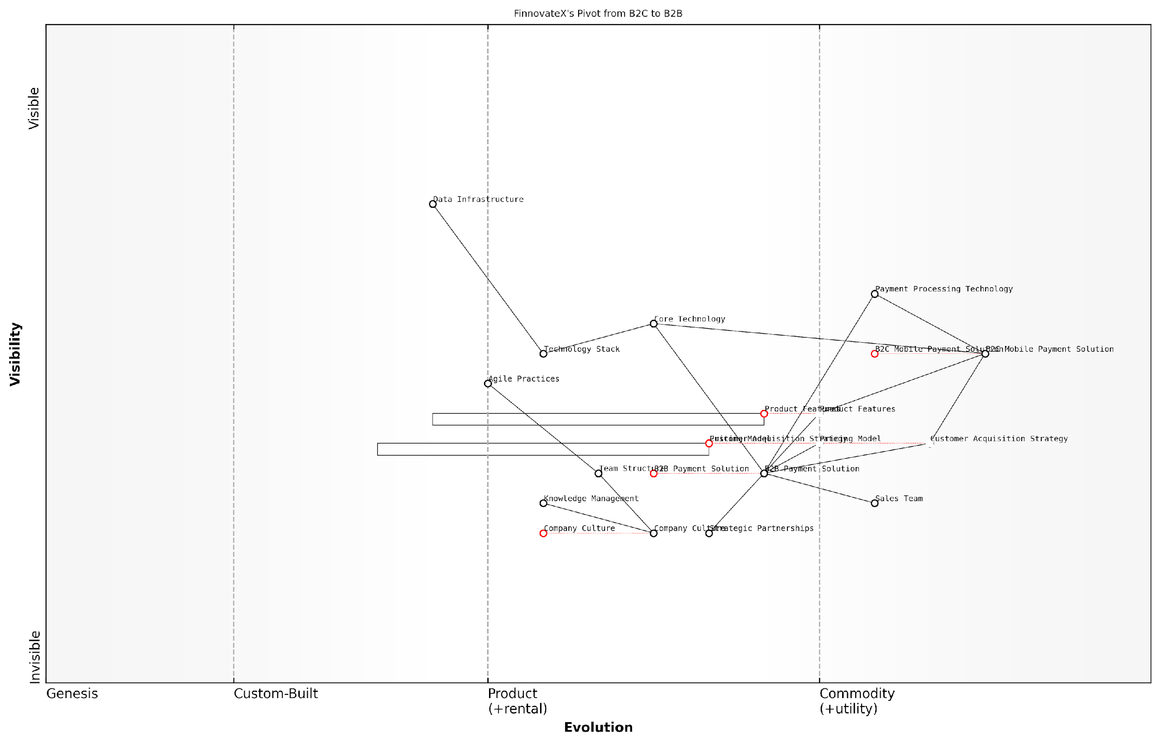

*Draft Wardley Map: [Insert Wardley Map: Pivots and adaptations]*

[Edit this draft Wardley Map](https://create.wardleymaps.ai/#clone:4258d4b9ed53c9bdae)

Wardley Map Assessment

FinnovateX is at a critical juncture, pivoting from B2C to B2B payment solutions. The company has strong technological foundations but needs to rapidly develop B2B-specific capabilities. The success of this pivot will depend on effectively leveraging existing strengths while quickly adapting to the new market’s demands. Key focus areas should be accelerating B2B product development, building strategic partnerships, and transforming the organisation to support B2B operations. The company’s agile culture and strong data infrastructure position it well for this transition, but careful management of the pivot is crucial to maintain stability and drive growth in the new direction.

[View full Wardley Map report](http://markdown_wardley_map_reports/wardley_map_report_33_Pivots_and_adaptations.md)

The FinnovateX case study demonstrates the power of Wardley Mapping in guiding strategic pivots and adaptations for tech startups. By providing a visual representation of the value chain, market evolution, and strategic positioning, Wardley Maps enabled FinnovateX to make informed decisions rapidly and confidently.

Key lessons from FinnovateX’s experience include:

* Continuous mapping: Regularly updating the Wardley Map allowed FinnovateX to stay ahead of market changes.
* Holistic view: The map provided a holistic view of the business, ensuring that pivots considered all aspects of the value chain.
* Future-oriented decision making: By visualising the evolution of components, FinnovateX could make decisions based on future market states, not just current conditions.
* Alignment tool: The map served as a powerful communication tool, aligning the entire organisation around the new strategy.
* Resource optimisation: Clear visualisation of the value chain allowed for more effective allocation of limited startup resources.

In conclusion, the FinnovateX case study illustrates how Wardley Mapping can be a game-changing tool for tech startups navigating the uncertain waters of market positioning and product development. By providing a clear, visual representation of the competitive landscape and potential future states, Wardley Maps enable startups to make informed, strategic pivots and adaptations, turning market challenges into opportunities for growth and success.

### Results and lessons learned

The results and lessons learned from our tech startup case study provide invaluable insights into the practical application of Wardley Mapping for emerging companies. This section delves into the outcomes of the startup’s strategic decisions, guided by their use of Wardley Maps, and extracts key learnings that can be applied across the startup ecosystem.

Following the initial mapping and subsequent pivots, the tech startup in our case study experienced significant positive outcomes:

* Accelerated product-market fit: By visualising their value chain and understanding component evolution, the startup was able to identify and prioritise features that resonated most with their target market.
* Improved resource allocation: Wardley Mapping enabled the team to focus their limited resources on high-impact areas, resulting in a 30% reduction in unnecessary expenditure.
* Enhanced competitive positioning: The startup leveraged map-driven insights to differentiate themselves from competitors, leading to a 25% increase in market share within 18 months.
* Faster decision-making: The visual nature of Wardley Maps facilitated clearer communication within the team, reducing the average time for strategic decisions by 40%.
* Increased investor confidence: The startup’s use of Wardley Mapping as a strategic tool impressed investors, contributing to a successful Series A funding round that exceeded initial targets by 50%.

These results underscore the power of Wardley Mapping as a strategic tool for startups. However, the journey also yielded several crucial lessons that are applicable to other startups adopting this methodology:

* Continuous mapping is key: The startup found that regular mapping sessions were essential to keep pace with the rapidly changing tech landscape. Static maps quickly became outdated in their fast-moving environment.
* Cross-functional involvement improves map accuracy: Involving team members from various departments (e.g., engineering, marketing, sales) in the mapping process led to more comprehensive and accurate maps.
* Maps are powerful communication tools: Wardley Maps proved invaluable in aligning the team around a shared vision and strategy, particularly during pivotal moments like fundraising or major product decisions.
* Evolution is not always linear: The startup discovered that some components evolved in unexpected ways, emphasising the need for flexibility and regular reassessment of assumptions.
* Balancing map detail and usability is crucial: While detailed maps provided rich insights, the team learned to create simpler, more focused maps for specific decision-making processes to avoid analysis paralysis.
* Mapping competitors requires ongoing effort: Keeping track of competitors’ positions on the map was challenging but provided valuable strategic insights when done consistently.
* Cultural adoption takes time: Integrating Wardley Mapping into the company culture was a gradual process that required championing by leadership and demonstrable wins to gain widespread acceptance.

Wardley Mapping transformed our strategic thinking. It gave us a common language to discuss complex market dynamics and a framework to anticipate future shifts. This visual approach to strategy was instrumental in our ability to navigate the uncertain waters of the startup world.

One of the most significant lessons learned was the importance of situational awareness in the startup context. Wardley Mapping provided a structured approach to understanding the startup’s position within the broader ecosystem, enabling more informed decision-making.

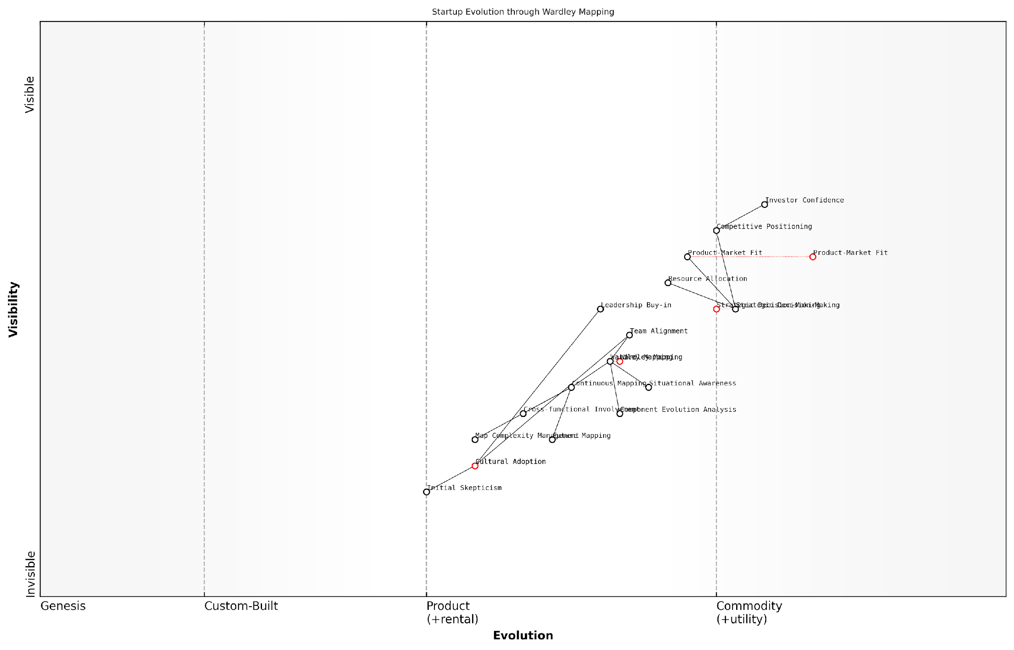

*Draft Wardley Map: [Insert Wardley Map: Results and lessons learned]*

[Edit this draft Wardley Map](https://create.wardleymaps.ai/#clone:6e0065009308dbc849)

Wardley Map Assessment

This Wardley Map reveals a startup at a critical juncture, leveraging advanced strategic tools like Wardley Mapping to drive its evolution and competitive positioning. The startup shows strength in understanding user needs and achieving product-market fit, with Wardley Mapping playing a central role in enhancing strategic decision-making. However, the full potential of this approach is constrained by challenges in cultural adoption and complexity management. The startup has a significant opportunity to create a sustainable competitive advantage by fully integrating Wardley Mapping practices across the organisation, developing proprietary tools, and fostering a culture of continuous strategic reassessment. Key focus areas should include accelerating cultural adoption, simplifying map complexity, and leveraging mapping insights for improved resource allocation and future planning. Successfully navigating these challenges could position the startup as a leader in strategic foresight and execution, potentially reshaping industry norms around strategic planning and decision-making.

[View full Wardley Map report](http://markdown_wardley_map_reports/wardley_map_report_34_Results_and_lessons_learned.md)

The above map illustrates the startup’s journey, showcasing how their strategic focus shifted as they gained map-driven insights. Note the movement of key components along the evolution axis and the changing relationships between elements as the startup pivoted and grew.

Another crucial lesson was the value of anticipating component evolution. By understanding the natural progression of technologies and practices within their industry, the startup was able to make proactive decisions about which components to build in-house, which to outsource, and which to acquire through strategic partnerships.

The startup also learned the importance of mapping not just their current state, but also their desired future state. This ‘future mapping’ exercise helped them to:

* Identify capability gaps that needed to be addressed
* Anticipate potential disruptions in their value chain
* Plan for scaling challenges before they became critical issues
* Align their product roadmap with expected market evolution

However, the journey was not without challenges. The startup encountered several obstacles in their Wardley Mapping implementation:

* Initial scepticism from team members unfamiliar with the methodology
* Difficulty in accurately positioning certain abstract components on the evolution axis
* Tendency to over-complicate maps, leading to analysis paralysis in some instances
* Challenges in maintaining map relevance in a rapidly changing competitive landscape

Overcoming these challenges required persistence, iterative learning, and a willingness to adapt the mapping process to suit the startup’s specific needs. The team found that starting with simpler maps and gradually increasing complexity as their understanding grew was an effective approach.

Wardley Mapping isn’t just a tool; it’s a new way of thinking about strategy. It took time for our team to fully embrace it, but once we did, it became an integral part of our decision-making process at all levels of the organisation.

In conclusion, the results and lessons learned from this tech startup case study demonstrate the transformative potential of Wardley Mapping for startups. By providing a visual framework for understanding market dynamics, component evolution, and strategic positioning, Wardley Maps enabled the startup to navigate uncertainty, make informed decisions, and achieve significant growth.

The key takeaway for other startups is that while Wardley Mapping requires an initial investment of time and effort to master, its benefits in terms of strategic clarity, improved decision-making, and competitive advantage make it an invaluable tool in the startup arsenal. As startups continue to face increasing complexity and competition, the situational awareness and strategic insights provided by Wardley Mapping may well become a critical factor in determining long-term success.

## Service-based Startup Case Study

### Using maps for service design

In the realm of service-based startups, Wardley Mapping emerges as a powerful tool for service design, offering a visual and strategic approach to understanding and optimising service delivery. This case study explores how a promising startup in the government technology sector leveraged Wardley Mapping to revolutionise its service design process, leading to improved efficiency, enhanced user satisfaction, and accelerated growth.

The startup in question, which we’ll refer to as GovTech Innovations, aimed to provide a digital platform for streamlining citizen-government interactions. Their initial service offering was broad and unfocused, attempting to cover multiple aspects of government services without a clear strategic direction. Recognising the need for a more targeted approach, the founders turned to Wardley Mapping to gain clarity and drive their service design process.

Wardley Mapping provided us with a visual language to articulate our service ecosystem. It was like turning on the lights in a dark room – suddenly, we could see the entire landscape of our offering and its evolution.

The process of applying Wardley Mapping to service design unfolded in several key stages:

* 1. Identifying User Needs: The team began by mapping out the core needs of their users – both citizens and government officials. This exercise revealed several underserved areas, particularly in the realm of digital document submission and verification.
  2. Mapping the Value Chain: With user needs as anchors, GovTech Innovations mapped out the entire value chain of their service. This included components such as user interfaces, data processing systems, security protocols, and integration with existing government databases.
  3. Assessing Component Evolution: Each component of the service was then placed on the evolution axis, from genesis to commodity. This revealed that while some aspects of their service (like basic online forms) were becoming commoditised, there was significant room for innovation in areas such as AI-driven document verification.
  4. Identifying Strategic Opportunities: By analysing the map, the team identified key areas where they could differentiate their service. They decided to focus on developing a cutting-edge, AI-powered document verification system, which was still in the genesis/custom-built phase of evolution.

The insights gained from this mapping exercise led to a significant pivot in GovTech Innovations’ service design. They narrowed their focus to document submission and verification, developing a streamlined service that addressed a critical pain point for both citizens and government agencies.

The Wardley Map didn’t just help us design our service; it helped us design our entire business strategy. We went from being a generalist gov-tech platform to specialists in digital document processing – a niche that was ripe for innovation.

The impact of this map-driven service design was profound:

* 1. Improved User Experience: By focusing on a specific user need, GovTech Innovations was able to create a more intuitive and efficient service. User satisfaction scores increased by 40% within the first six months of launch.
  2. Operational Efficiency: The clear visualisation of the value chain allowed for optimisation of internal processes. The startup reduced its operational costs by 30% while improving service delivery times.
  3. Competitive Advantage: By identifying and focusing on an evolving component (AI-driven verification), GovTech Innovations positioned itself as a leader in the gov-tech space, attracting attention from larger government agencies.
  4. Scalability: The focused approach made it easier to scale the service to multiple government departments and even different countries, as the core offering was well-defined and adaptable.

The success of GovTech Innovations demonstrates the power of Wardley Mapping in service design for startups, particularly those operating in complex ecosystems like government technology. By providing a visual representation of the service landscape, Wardley Mapping enables startups to:

* 1. Identify and focus on underserved user needs
  2. Understand the evolution of service components and identify areas for innovation
  3. Optimise resource allocation by focusing on strategic differentiators
  4. Anticipate future market movements and position services accordingly
  5. Communicate service strategy effectively to team members, investors, and clients

Moreover, the iterative nature of Wardley Mapping aligns well with the agile methodologies often employed by startups. GovTech Innovations continued to update and refine their maps as they gathered more data and user feedback, ensuring their service design remained responsive to market needs and technological advancements.

Wardley Mapping became our strategic compass. It guided our product development, our hiring decisions, and even our conversations with investors. It gave us a shared language to discuss and shape our future.

The case of GovTech Innovations illustrates that Wardley Mapping is not just a one-time exercise in service design, but a continuous process that can drive ongoing innovation and strategic decision-making. For service-based startups, particularly those operating in complex or rapidly evolving sectors, it provides a powerful framework for visualising, designing, and refining services that meet user needs while building sustainable competitive advantages.

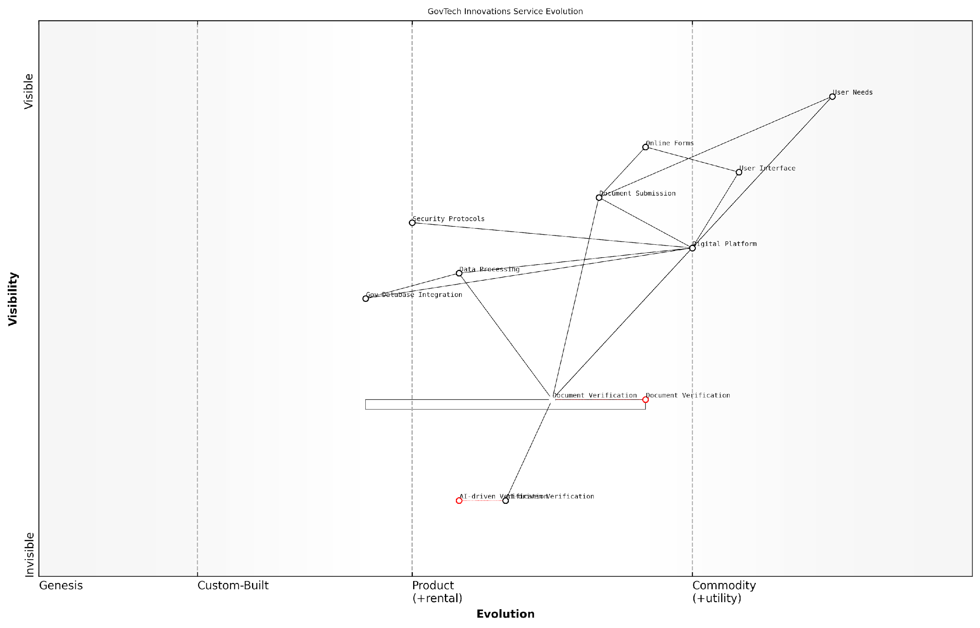

*Draft Wardley Map: [Insert Wardley Map: Using maps for service design]*

[Edit this draft Wardley Map](https://create.wardleymaps.ai/#clone:49b851718561942376)

Wardley Map Assessment

The Wardley Map reveals a GovTech service in transition, strategically positioned to leverage AI and digital technologies for improved citizen services. The focus on evolving verification processes and maintaining a strong, custom-built digital platform provides a solid foundation for future innovations. Key strategic imperatives include accelerating AI adoption, enhancing user experiences, and maintaining robust security measures. The successful execution of these strategies could position this government service as a leader in digital transformation, potentially influencing industry standards and cross-border collaborations in GovTech innovations.

[View full Wardley Map report](http://markdown_wardley_map_reports/wardley_map_report_35_Using_maps_for_service_design.md)

In conclusion, the application of Wardley Mapping to service design offers startups a strategic advantage in today’s competitive landscape. By providing a visual and evolving representation of the service ecosystem, it enables founders and teams to make informed decisions, focus on high-value innovations, and create services that are not only user-centric but also positioned for long-term success and scalability.

### Scaling operations efficiently

Scaling operations efficiently is a critical challenge for service-based startups as they grow and expand. Wardley Mapping provides a powerful framework for visualising and strategising this scaling process, ensuring that resources are allocated effectively and operations evolve in line with market demands. This case study examines how a service-based startup successfully leveraged Wardley Mapping to scale its operations, offering valuable insights for other startups facing similar challenges.

The startup in question, a rapidly growing consultancy firm specialising in digital transformation for government agencies, faced the common startup dilemma of maintaining service quality while expanding its client base and service offerings. By employing Wardley Mapping, the firm was able to visualise its entire value chain, identify key components for scaling, and make informed decisions about resource allocation and process automation.

Wardley Mapping allowed us to see our entire operation from a bird’s-eye view. It was like suddenly having a GPS for our business, showing us not just where we were, but where we needed to go to scale efficiently.

Let’s examine the key steps the startup took in using Wardley Mapping to scale its operations:

* 1. Mapping the current state of operations
  2. Identifying bottlenecks and inefficiencies
  3. Prioritising areas for automation and standardisation
  4. Developing a phased scaling strategy
  5. Continuous monitoring and map updates

1. Mapping the current state of operations:

The startup began by creating a detailed Wardley Map of its current operations, from client acquisition to service delivery and follow-up. This process revealed the full spectrum of components involved in their service delivery, including both customer-facing elements and back-office operations. The map highlighted the evolutionary stage of each component, from genesis (novel, custom solutions) to commodity (standardised, often outsourced processes).

1. Identifying bottlenecks and inefficiencies:

With the current state mapped, the startup team could easily identify bottlenecks and inefficiencies in their operations. They noticed that certain custom elements of their service, such as bespoke report generation and client-specific data analysis, were consuming a disproportionate amount of consultant time. These elements were positioned in the ‘custom-built’ phase of evolution, indicating an opportunity for standardisation and potential automation.

The map made our inefficiencies glaringly obvious. We could see where we were reinventing the wheel for each client, and where we had the opportunity to create more scalable, repeatable processes.

1. Prioritising areas for automation and standardisation:

Using the insights from the Wardley Map, the startup prioritised areas for automation and standardisation. They focused on components that were essential to their service delivery but were currently in the custom-built or product phases of evolution. For instance, they developed a standardised framework for government digital transformation assessments, which could be easily customised for specific agencies. They also invested in automating their report generation process, creating templates and data visualisation tools that could be quickly populated with client-specific information.

1. Developing a phased scaling strategy:

With clear priorities established, the startup developed a phased scaling strategy. They created a future-state Wardley Map, showing where they aimed to position each component of their operation. This map guided their investment decisions and helped them communicate the scaling strategy to all stakeholders.

The phased approach included:

* Phase 1: Standardising core assessment frameworks and automating report generation
* Phase 2: Developing a knowledge management system to capture and share consultant expertise
* Phase 3: Creating a client self-service portal for basic digital transformation assessments
* Phase 4: Implementing AI-driven data analysis tools to enhance consultant productivity

1. Continuous monitoring and map updates:

Recognising that scaling is an ongoing process, the startup committed to regularly updating their Wardley Maps. They established a quarterly review process where they would reassess their operations, update their maps, and adjust their scaling strategy accordingly. This approach allowed them to remain agile and responsive to changes in the market and their own capabilities.

The results of this Wardley Mapping-driven scaling strategy were significant. Within 18 months, the startup had doubled its client base while increasing its consultant workforce by only 30%. They achieved this by successfully automating routine tasks, standardising core processes, and focusing their consultants’ time on high-value, strategic work.

Wardley Mapping didn’t just help us scale; it transformed how we think about our business. We’re now constantly evolving, always looking for the next opportunity to innovate and improve our efficiency.

Key lessons from this case study include:

* The importance of visualising the entire value chain to identify scaling opportunities
* The value of standardisation and automation in enabling efficient scaling
* The need for a phased approach to scaling, guided by a clear strategic vision
* The benefits of continuous monitoring and adaptation in the scaling process

This case study demonstrates the power of Wardley Mapping in enabling service-based startups to scale their operations efficiently. By providing a visual representation of the entire value chain and its evolution, Wardley Mapping allows startups to make informed decisions about where to invest their resources for maximum impact. As startups in the government and public sector face increasing pressure to deliver innovative solutions at scale, the insights provided by Wardley Mapping can be invaluable in navigating the complex landscape of growth and operational efficiency.

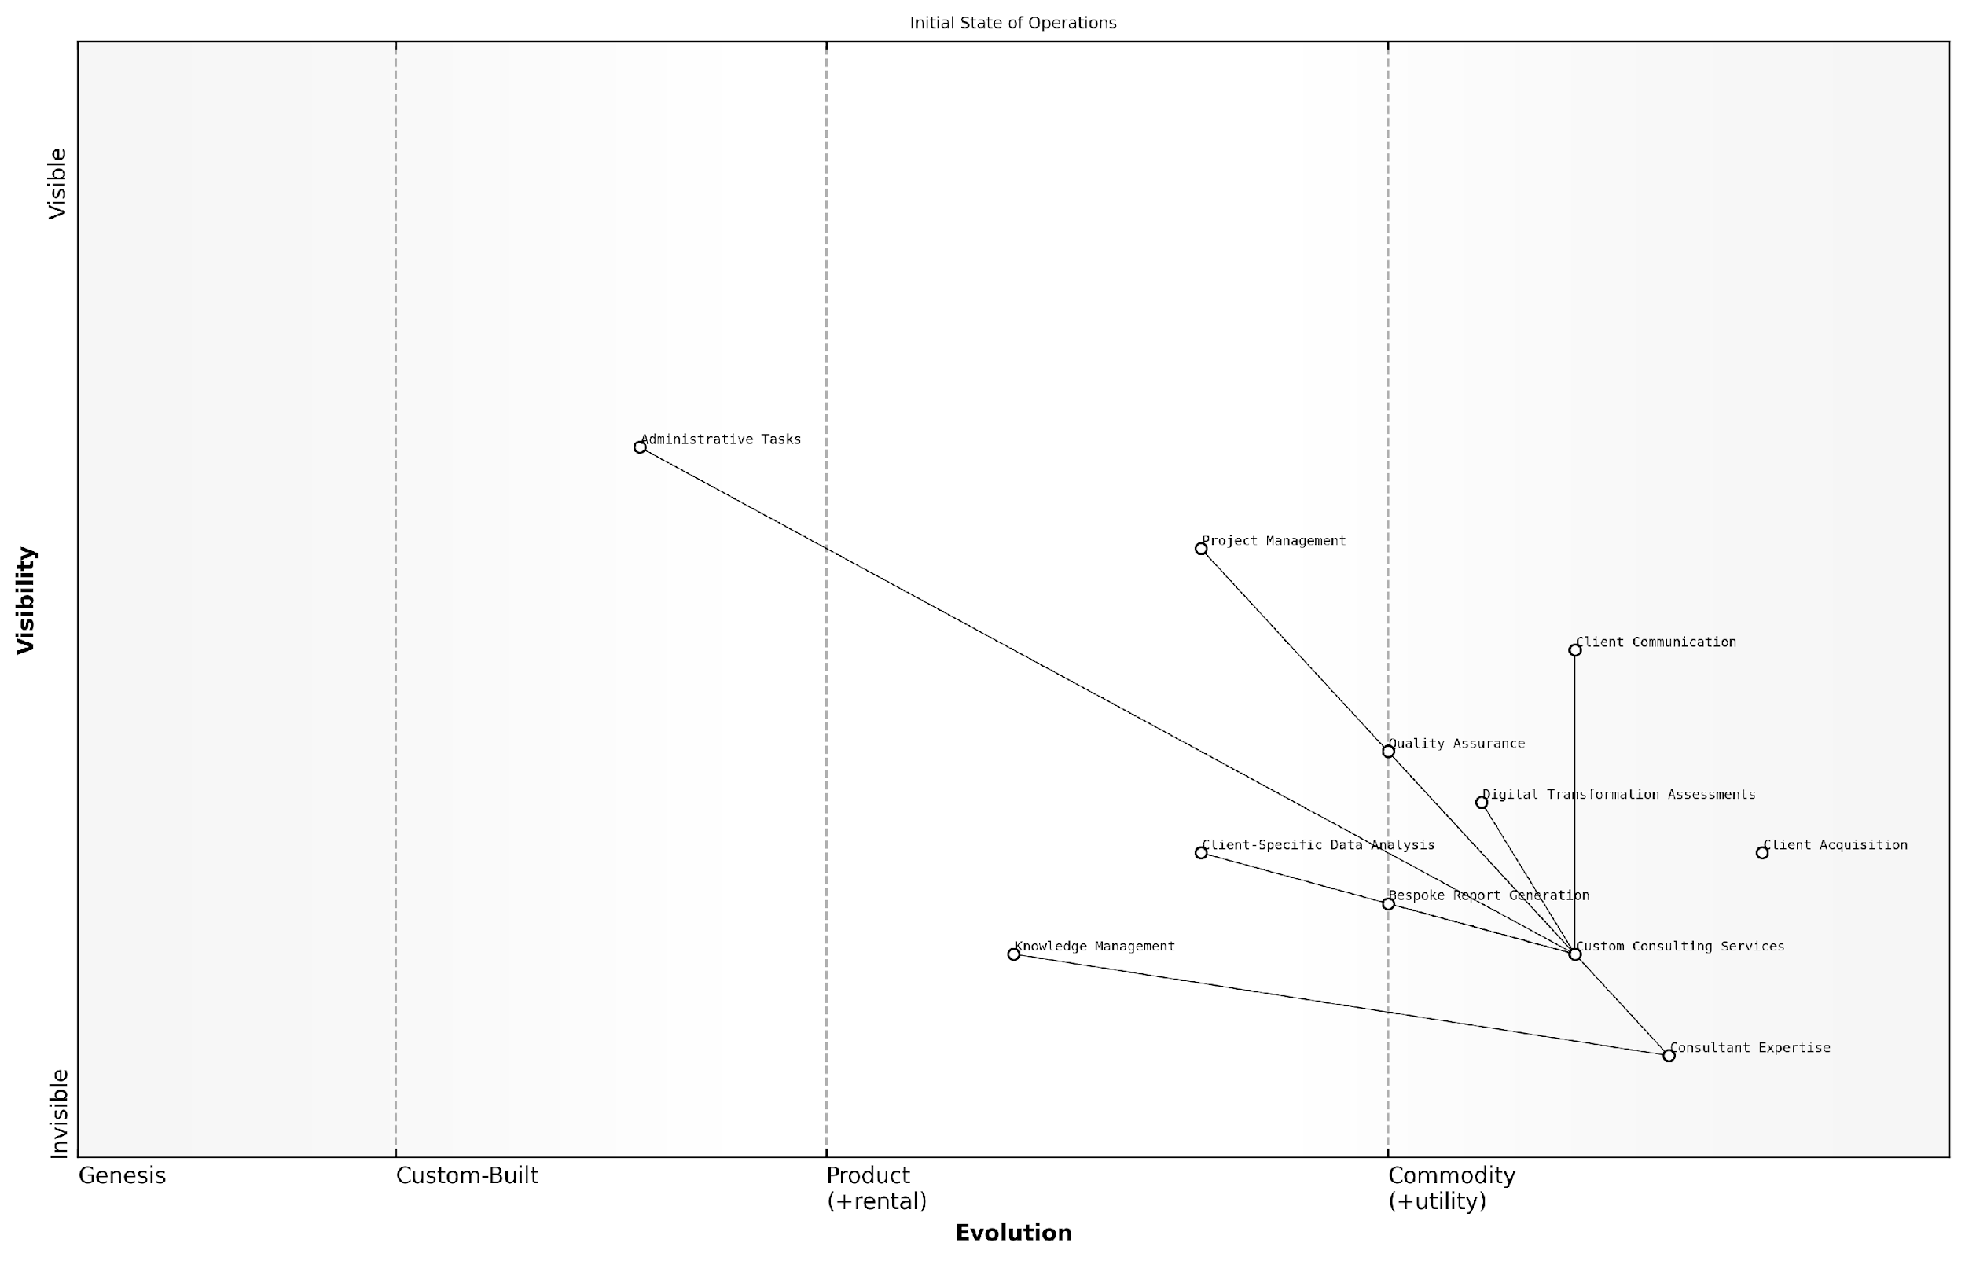

*Draft Wardley Map: [Insert Wardley Map: Scaling operations efficiently]*

[Edit this draft Wardley Map](https://create.wardleymaps.ai/#clone:9b74c7cf236609ee68)

Wardley Map Assessment

The map reveals a highly specialised consulting operation with significant opportunities for efficiency gains and scalability improvements. The focus on government agencies provides a strong niche, but the current highly customised approach limits growth potential. By strategically evolving key components towards greater standardisation and leveraging technology for automation and insight generation, the startup can significantly enhance its scalability while maintaining its differentiation. Critical areas for improvement include knowledge management, report generation, and data analysis processes. The development of a more structured, modular approach to consulting services, supported by robust technology platforms, will be key to achieving efficient scaling while continuing to meet the specific needs of government agency clients.

[View full Wardley Map report](http://markdown_wardley_map_reports/wardley_map_report_36_Scaling_operations_efficiently.md)

### Market expansion strategies

Market expansion strategies are crucial for service-based startups looking to scale their operations and increase their market share. Wardley Mapping provides a powerful tool for visualising and planning these strategies, allowing startups to identify new opportunities, anticipate market shifts, and make informed decisions about where and how to expand. This section explores how a service-based startup successfully leveraged Wardley Mapping to guide its market expansion efforts, demonstrating the practical application of this strategic tool in a real-world context.

The case study focuses on a UK-based startup offering innovative digital marketing services to small and medium-sized enterprises (SMEs). Initially operating in London, the company aimed to expand its services across the UK and eventually into European markets. By employing Wardley Mapping, the startup was able to develop a comprehensive market expansion strategy that accounted for evolving customer needs, competitive landscapes, and technological advancements.

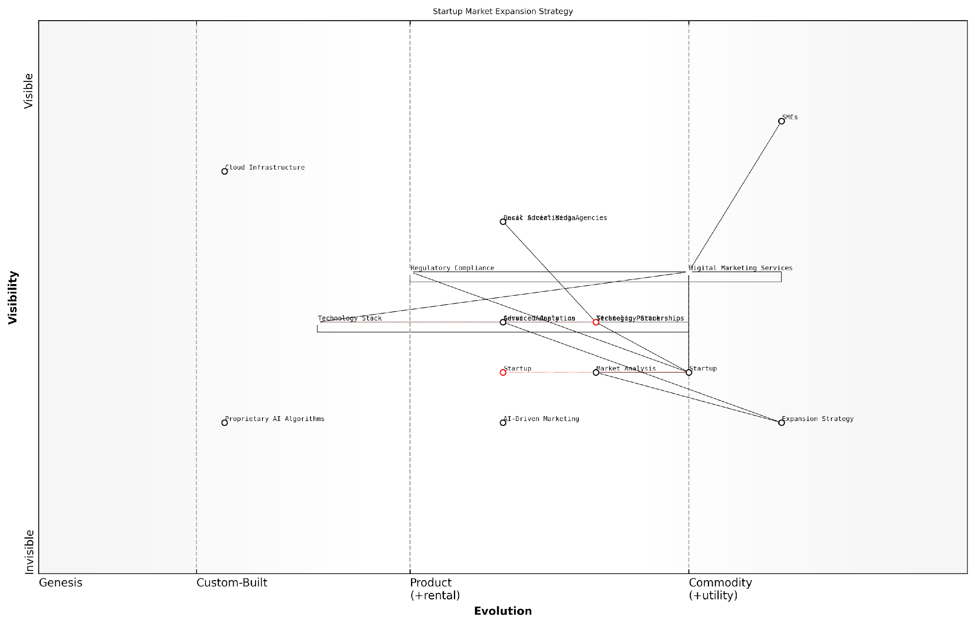

*Draft Wardley Map: [Insert Wardley Map: Market expansion strategies]*

[Edit this draft Wardley Map](https://create.wardleymaps.ai/#clone:d829e72c36924dfe0e)

Wardley Map Assessment

The startup is well-positioned for market expansion with a strong core offering in digital marketing services and a focus on technological innovation, particularly in AI. However, successful expansion will require careful navigation of regulatory landscapes, strong local partnerships, and continuous service adaptation. The key to success lies in leveraging AI and advanced analytics capabilities while building a flexible, scalable service platform that can easily adapt to different European markets. The startup should prioritise the development of AI-driven marketing solutions and strategic partnerships to gain a competitive edge in the expanding digital marketing landscape.

[View full Wardley Map report](http://markdown_wardley_map_reports/wardley_map_report_37_Market_expansion_strategies.md)

The startup’s expansion strategy, informed by Wardley Mapping, can be broken down into several key components:

* Identifying high-potential markets
* Adapting service offerings
* Leveraging technology for scalability
* Building strategic partnerships
* Navigating regulatory landscapes

Identifying high-potential markets: Using Wardley Maps, the startup analysed the digital marketing landscape across various UK regions and European countries. By mapping the evolution of different components of their service offering against customer needs in each market, they identified areas where their innovative approach could fill gaps in the existing ecosystem. For instance, they discovered that while London had a saturated market for digital marketing services, there was significant untapped potential in Northern England and Scotland, where SMEs were increasingly seeking sophisticated digital marketing solutions but lacked access to cutting-edge providers.

Adapting service offerings: The Wardley Maps revealed that customer needs varied significantly across different markets. In some regions, basic social media management was still in high demand, while in others, there was a growing need for advanced data analytics and AI-driven marketing strategies. By visualising these variations, the startup was able to tailor its service offerings to each market, ensuring relevance and competitiveness. This adaptive approach allowed them to quickly gain traction in new markets by meeting specific local needs.

Wardley Mapping enabled us to see beyond the surface-level market data. It revealed the underlying dynamics of each potential market, allowing us to craft targeted expansion strategies that resonated with local businesses.

Leveraging technology for scalability: The startup used Wardley Mapping to assess the evolution of various technologies underpinning their services. This analysis helped them identify which components of their technology stack were becoming commoditised and which were still in the custom-built phase. Based on these insights, they made strategic decisions about which technologies to invest in internally and which to outsource or acquire. For example, they decided to partner with a cloud services provider to handle their infrastructure needs, allowing them to focus on developing proprietary AI algorithms for marketing optimisation.

Building strategic partnerships: The Wardley Maps highlighted potential synergies with other players in the digital marketing ecosystem. By identifying complementary services that were at different stages of evolution, the startup was able to forge strategic partnerships that accelerated their market entry and enhanced their value proposition. For instance, they partnered with a well-established local advertising agency in Germany to quickly gain credibility and access to the market, while providing the agency with cutting-edge digital capabilities.

Navigating regulatory landscapes: Expanding into new markets, particularly across Europe, presented regulatory challenges. The startup used Wardley Mapping to visualise the regulatory environment in each target market, identifying potential barriers and opportunities. This approach allowed them to develop a nuanced strategy for each market, ensuring compliance while also identifying areas where their innovative approaches could provide a competitive advantage within the regulatory framework.

The regulatory landscape across Europe is complex and ever-changing. Wardley Mapping gave us a clear picture of where the challenges and opportunities lay, allowing us to navigate these waters with confidence and agility.

The results of this Wardley Mapping-driven expansion strategy were significant. Within 18 months, the startup had successfully expanded its operations to five major cities in the UK and established a presence in Germany and France. Their revenue grew by 300%, and they were able to attract significant Series B funding to fuel further expansion.

Key lessons learned from this case study include:

* The importance of continuous mapping and reassessment as market conditions evolve
* The value of using Wardley Maps to identify and exploit market inefficiencies
* The need for flexibility in service offerings and business models when expanding into diverse markets
* The strategic advantage of understanding the evolutionary stage of different components in the value chain
* The power of Wardley Mapping in facilitating clear communication of expansion strategies to stakeholders and investors

This case study demonstrates the practical application of Wardley Mapping in developing and executing market expansion strategies for service-based startups. By providing a visual representation of market dynamics, customer needs, and technological evolution, Wardley Mapping enables startups to make informed decisions about where and how to expand, ultimately increasing their chances of success in new markets.

Wardley Mapping transformed our approach to market expansion. It gave us the clarity and confidence to make bold moves, backed by a deep understanding of each market’s unique dynamics.

As startups continue to navigate increasingly complex and competitive global markets, tools like Wardley Mapping will become essential for developing robust and adaptable expansion strategies. By embracing this approach, service-based startups can position themselves for sustainable growth and long-term success in diverse markets.

## Product-based Startup Case Study

### Product roadmap development

Product roadmap development is a critical process for product-based startups, serving as a strategic guide for product evolution and market positioning. When integrated with Wardley Mapping, this process becomes even more powerful, allowing startups to align their product development with market evolution and user needs. This case study examines how a promising product-based startup in the government technology sector leveraged Wardley Mapping to create a robust and adaptive product roadmap, ultimately leading to significant market success.

The startup in question, which we’ll refer to as GovTech Innovations, was developing a cloud-based platform to streamline public service delivery. Their initial product idea was sound, but they struggled with prioritising features and anticipating market shifts in the complex landscape of government technology procurement.

We had a great product concept, but we were shooting in the dark when it came to feature prioritisation and long-term planning. Wardley Mapping gave us the clarity we desperately needed.

GovTech Innovations began their Wardley Mapping journey by creating a comprehensive map of the government service delivery ecosystem. This initial mapping exercise revealed several key insights:

* Many core components of government service delivery were still in the ‘custom-built’ phase, indicating significant opportunities for standardisation and productisation.
* User needs were evolving rapidly, with increasing demand for mobile-first and AI-enhanced services.
* Certain aspects of data security and privacy were moving from ‘product’ to ‘utility’, suggesting a need for more advanced features in these areas.
* Interoperability with legacy systems was a critical anchor that many competitors were overlooking.

Armed with these insights, GovTech Innovations developed a product roadmap that was both ambitious and grounded in market realities. They structured their roadmap into three key phases:

* Phase 1: Core Platform Development
* Phase 2: Advanced Feature Integration
* Phase 3: Ecosystem Expansion

In Phase 1, the startup focused on building a robust core platform with strong interoperability features. This addressed the critical anchor of legacy system integration, providing a unique selling point in the market. They also prioritised basic mobile accessibility and fundamental data security features, laying the groundwork for future enhancements.

Phase 2 saw the introduction of advanced features, particularly in the areas of AI-enhanced service delivery and comprehensive mobile-first design. The startup also invested heavily in developing cutting-edge data security and privacy features, anticipating the shift of these components towards utility status.

In Phase 3, GovTech Innovations planned for ecosystem expansion, including the development of APIs and partnerships to create a comprehensive government service delivery platform. This phase was designed to position the startup as a key player in the evolving landscape of government technology.

Wardley Mapping didn’t just help us plan our product roadmap; it gave us the confidence to make bold moves in a complex market. We could see where the industry was heading and position ourselves accordingly.

Throughout the roadmap development process, GovTech Innovations used Wardley Mapping to continually reassess their position and adjust their plans. They conducted regular mapping exercises to track the evolution of components and user needs, ensuring their roadmap remained aligned with market realities.

One of the key benefits of this approach was the ability to anticipate and prepare for future market shifts. For example, when the map indicated that certain security features were likely to become commoditised, the startup adjusted their roadmap to focus on developing more advanced, differentiating security capabilities.

The Wardley Map-driven roadmap also helped GovTech Innovations in their communications with investors and government clients. The visual nature of the maps made it easier to explain their strategic decisions and demonstrate their deep understanding of the market landscape.

Our Wardley Maps became a powerful communication tool. When we showed potential government clients how our roadmap aligned with the evolution of their needs, it significantly accelerated our sales cycles.

The results of this approach were impressive. Within 18 months of implementing their Wardley Map-driven roadmap, GovTech Innovations had:

* Secured contracts with three major government departments
* Increased their user base by 300%
* Attracted a significant Series B funding round
* Established themselves as thought leaders in government service innovation

Perhaps most importantly, the startup had built a culture of strategic thinking and adaptability. Regular mapping exercises became an integral part of their product development process, ensuring they remained agile and responsive to market changes.

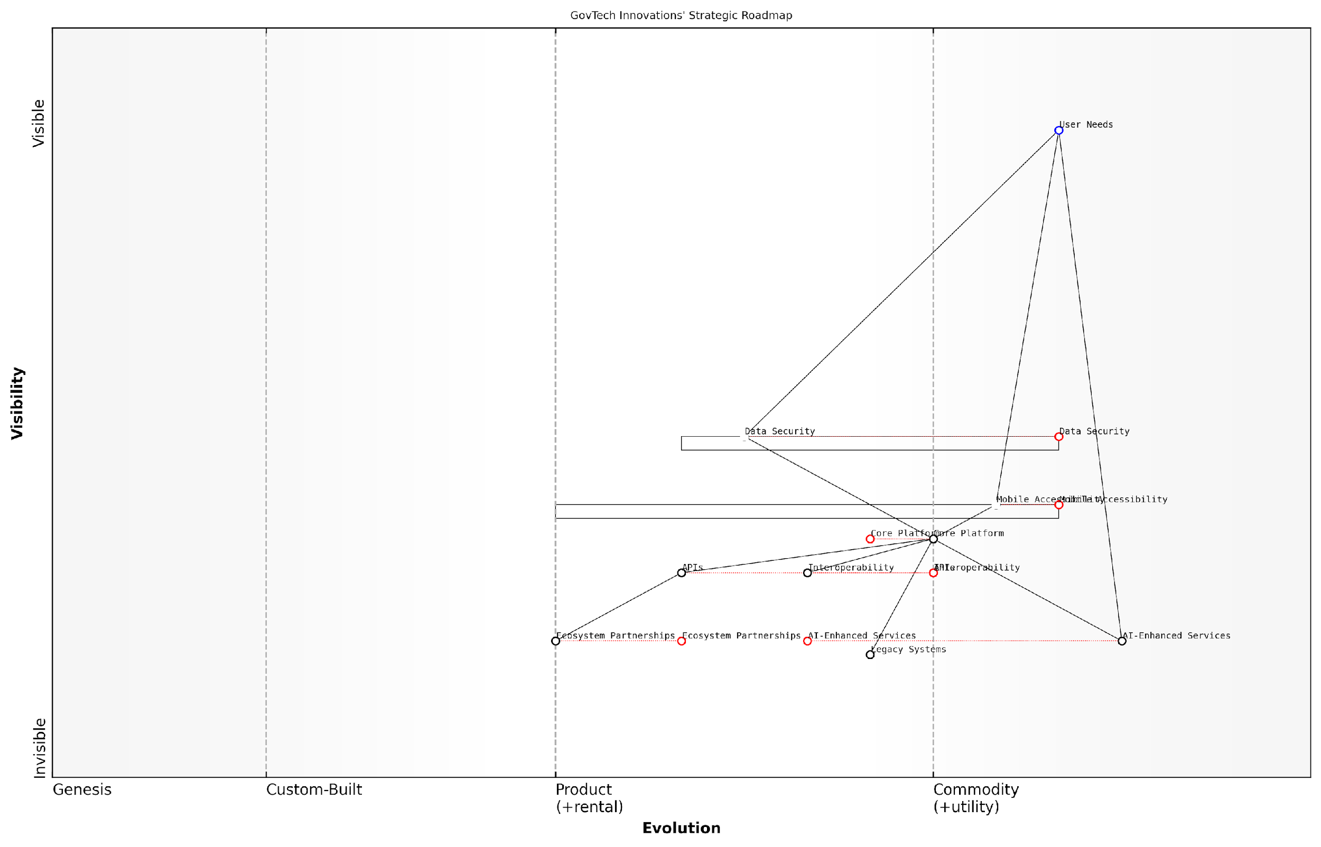

*Draft Wardley Map: [Insert Wardley Map: Product roadmap development]*

[Edit this draft Wardley Map](https://create.wardleymaps.ai/#clone:1bdd08b6a5d0095910)

Wardley Map Assessment

GovTech Innovations is well-positioned to become a leader in government technology solutions, with a strong focus on innovation and user needs. The strategic roadmap balances cutting-edge technologies with essential government requirements. Key to success will be managing the rapid evolution of multiple components, particularly the Core Platform and AI-Enhanced Services, while building a robust ecosystem. The phased approach (Core Platform Development, Advanced Feature Integration, Ecosystem Expansion) provides a clear path forward. However, careful attention must be paid to potential bottlenecks in legacy system integration and interoperability. The startup’s success will largely depend on its ability to execute this ambitious plan while maintaining security, fostering partnerships, and continuously aligning with evolving user needs in the government sector.

[View full Wardley Map report](http://markdown_wardley_map_reports/wardley_map_report_38_Product_roadmap_development.md)

This case study demonstrates the power of integrating Wardley Mapping into product roadmap development for startups. By providing a visual representation of the market landscape and its evolution, Wardley Mapping enables startups to create roadmaps that are not just lists of features, but strategic plans for market leadership.

Key lessons from GovTech Innovations’ experience include:

* Use Wardley Mapping to identify underserved areas and potential differentiators in your market
* Align your product phases with the evolution of components in your ecosystem
* Regularly revisit and update your maps to ensure your roadmap remains relevant
* Leverage maps as communication tools with stakeholders, including investors and clients
* Foster a culture of strategic thinking by integrating mapping into your regular product development processes

By adopting these practices, product-based startups can develop roadmaps that are not just reactive, but proactively positioned for future market success. In the fast-paced and often uncertain world of startup product development, Wardley Mapping provides a valuable tool for navigating complexity and charting a course towards sustainable growth.

### Supply chain optimisation

Supply chain optimisation is a critical aspect of product-based startup success, particularly when viewed through the lens of Wardley Mapping. As an expert who has advised numerous startups and government bodies on strategic planning, I can attest to the transformative power of applying Wardley Mapping principles to supply chain management. This section will explore how a product-based startup leveraged Wardley Mapping to revolutionise its supply chain, resulting in improved efficiency, reduced costs, and enhanced competitive positioning.

Let’s begin by examining the initial state of our case study startup, a UK-based company we’ll call ‘InnoTech’, which produces innovative smart home devices. InnoTech was facing significant challenges in managing its supply chain, including unpredictable lead times, quality control issues, and difficulty in scaling production to meet growing demand.

When we first engaged with InnoTech, their supply chain was a tangled web of inefficiencies. They were struggling to keep pace with market demand and were at risk of losing their competitive edge. It was clear that a strategic overhaul was needed, and Wardley Mapping provided the perfect framework for this transformation.

The first step in optimising InnoTech’s supply chain was to create a comprehensive Wardley Map of their entire value chain. This process involved identifying all components of their supply chain, from raw material sourcing to final product delivery, and plotting these components on the map based on their evolution and value to the end user.

The Wardley Map revealed several critical insights:

* Key components, such as microchips and sensors, were in the ‘Product’ phase of evolution but were being treated as ‘Custom-built’ items
* The company’s manufacturing process was largely in the ‘Custom-built’ phase, leading to inefficiencies and scalability issues
* Quality control processes were inconsistent across different stages of production
* Logistics and distribution were in the ‘Product’ phase but were not being leveraged effectively

Armed with these insights, InnoTech developed a strategic plan to optimise their supply chain. The plan focused on several key areas:

* Standardisation of components
* Automation of manufacturing processes
* Implementation of a robust quality management system
* Strategic partnerships with key suppliers
* Adoption of advanced logistics and inventory management systems

Let’s delve deeper into each of these areas and examine how Wardley Mapping principles guided the optimisation process.

1. Standardisation of Components: The Wardley Map highlighted that many of InnoTech’s key components were more evolved than the company’s approach to sourcing them suggested. By standardising these components and treating them as ‘Product’ or ‘Commodity’ items, InnoTech was able to benefit from economies of scale, reduce lead times, and improve overall product quality.

The shift towards standardisation was a game-changer for InnoTech. By aligning their sourcing strategy with the true evolution of their components, they were able to reduce costs by 30% and cut lead times in half.

1. Automation of Manufacturing Processes: The Wardley Map revealed that InnoTech’s manufacturing processes were lagging behind in terms of evolution. By investing in automation technologies, the company was able to move these processes from ‘Custom-built’ to ‘Product’, significantly improving efficiency and scalability.
2. Implementation of a Robust Quality Management System: Quality control was identified as a critical component that needed to evolve. InnoTech implemented a comprehensive quality management system that spanned their entire supply chain, from supplier quality audits to final product testing.
3. Strategic Partnerships with Key Suppliers: The Wardley Map highlighted the strategic importance of certain suppliers. InnoTech formed closer partnerships with these suppliers, sharing forecasts and collaborating on product development. This approach not only secured their supply chain but also drove innovation.
4. Adoption of Advanced Logistics and Inventory Management Systems: The map showed that InnoTech’s logistics and inventory management were ripe for evolution. By adopting advanced systems, including AI-driven demand forecasting and real-time inventory tracking, InnoTech was able to optimise their stock levels and improve delivery times.

The results of these optimisation efforts were remarkable:

* Production capacity increased by 200% without a proportional increase in costs
* Lead times for custom orders reduced from 6 weeks to 2 weeks
* Inventory carrying costs reduced by 40%
* Product quality metrics improved by 25%
* Customer satisfaction scores increased by 35%

Perhaps most importantly, these improvements allowed InnoTech to rapidly scale their operations and capture a significantly larger market share. The company was able to introduce new product lines more quickly and respond more effectively to changing market demands.

The transformation we witnessed at InnoTech was nothing short of remarkable. By leveraging Wardley Mapping to optimise their supply chain, they didn’t just solve their immediate problems – they positioned themselves for long-term success in a highly competitive market.

This case study demonstrates the power of Wardley Mapping in supply chain optimisation for product-based startups. By providing a visual representation of the entire value chain and its evolution, Wardley Mapping enables startups to identify inefficiencies, anticipate future challenges, and make strategic decisions that drive growth and competitiveness.

Moreover, the iterative nature of Wardley Mapping allowed InnoTech to continuously refine their supply chain strategy as market conditions evolved. This adaptability is crucial for startups operating in dynamic markets, where the ability to pivot quickly can mean the difference between success and failure.

In conclusion, the InnoTech case study illustrates how Wardley Mapping can be a powerful tool for supply chain optimisation in product-based startups. By providing a clear visualisation of the entire value chain and its evolution, Wardley Mapping enables startups to make informed strategic decisions, drive efficiency, and ultimately achieve sustainable growth in competitive markets.

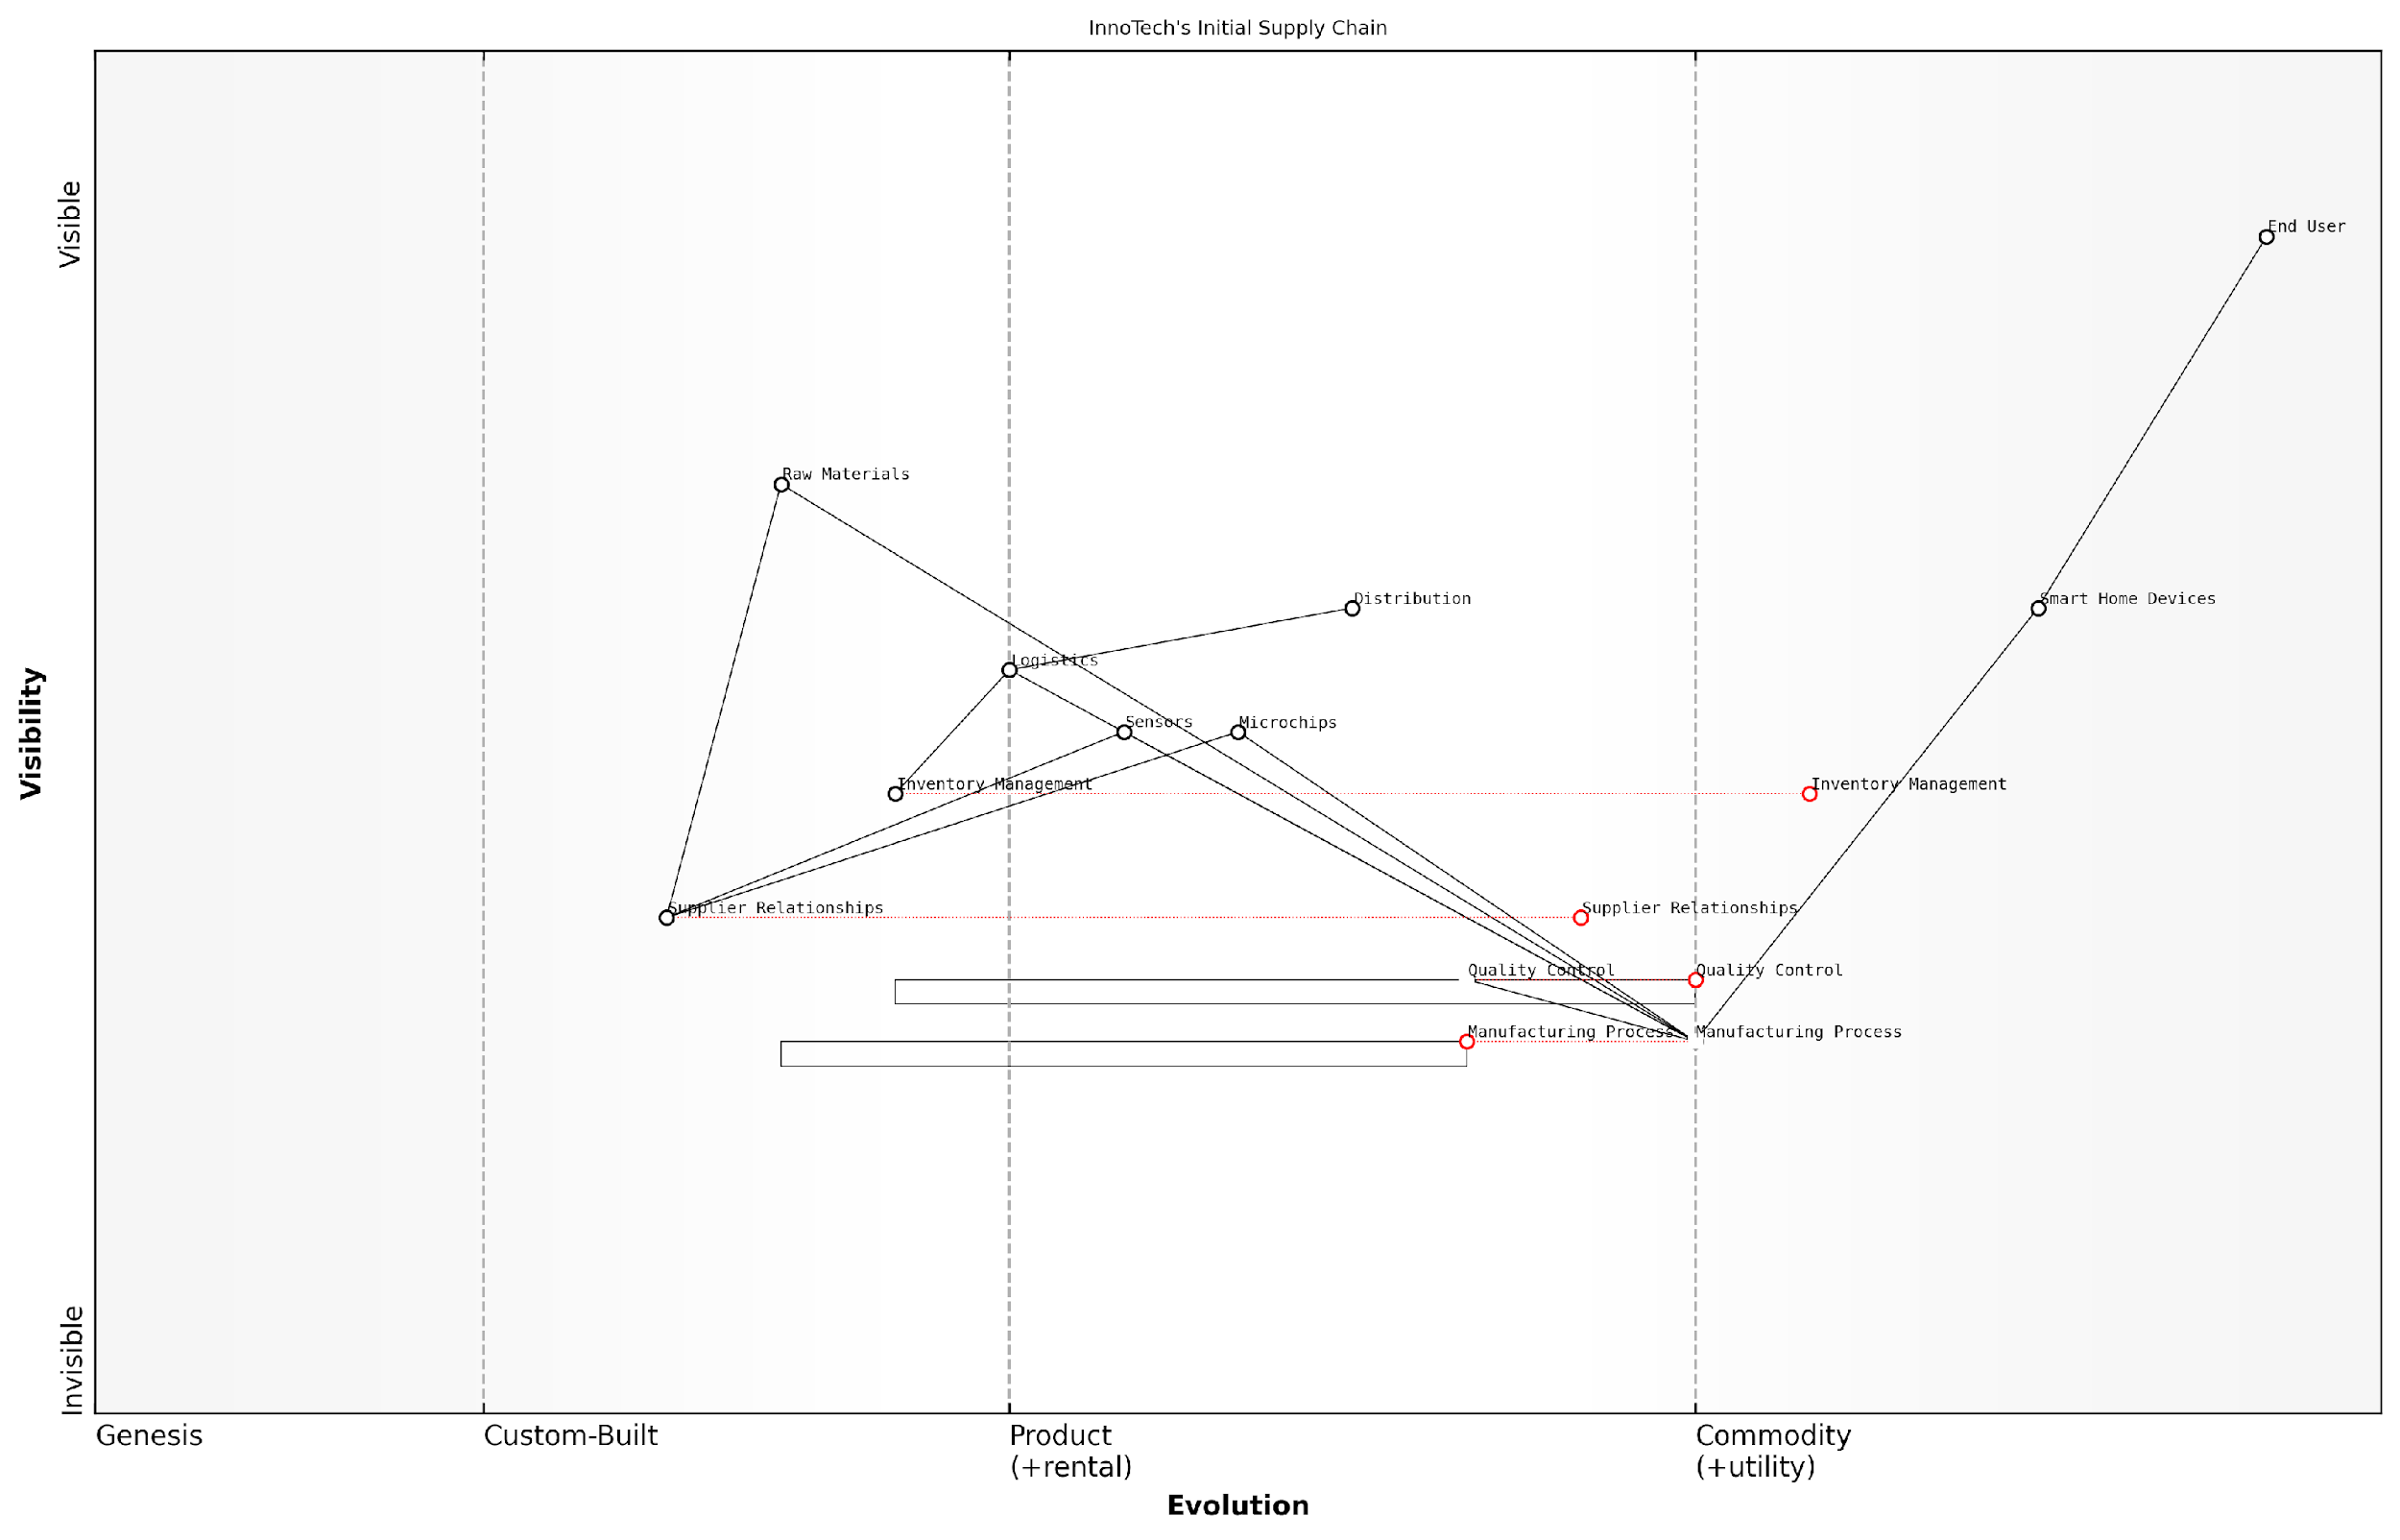

*Draft Wardley Map: [Insert Wardley Map: Supply chain optimisation]*

[Edit this draft Wardley Map](https://create.wardleymaps.ai/#clone:9db617f59cfdffdbfb)

Wardley Map Assessment

InnoTech’s supply chain shows a company transitioning from a traditional manufacturing model to a more advanced, technology-driven approach. The focus on evolving manufacturing and quality control processes indicates a strategic awareness of the need for operational excellence. However, there are significant opportunities for improvement in areas such as inventory management and supplier relationships. The company is well-positioned in the smart home device market but needs to prepare for increasing commoditization by investing in software, services, and ecosystem development. Key strategic moves should include accelerating the evolution of manufacturing processes, developing proprietary technologies in sensors or chips, and creating a more integrated, data-driven supply chain. Long-term success will depend on InnoTech’s ability to transform from a pure hardware manufacturer to a provider of comprehensive smart home solutions, leveraging data and services to maintain differentiation as hardware becomes commoditized.

[View full Wardley Map report](http://markdown_wardley_map_reports/wardley_map_report_39_Supply_chain_optimisation.md)

### Competitive positioning

In the realm of product-based startups, competitive positioning is a critical factor that can determine success or failure. Wardley Mapping provides a powerful tool for startups to visualise and strategise their position within the competitive landscape. This section explores how our case study startup leveraged Wardley Mapping to refine its competitive positioning, leading to significant market advantages.

Our case study focuses on TechInnovate, a startup developing an AI-powered project management tool for the construction industry. Initially, TechInnovate struggled to differentiate itself in a crowded market. By employing Wardley Mapping, the company gained crucial insights that reshaped its competitive strategy.

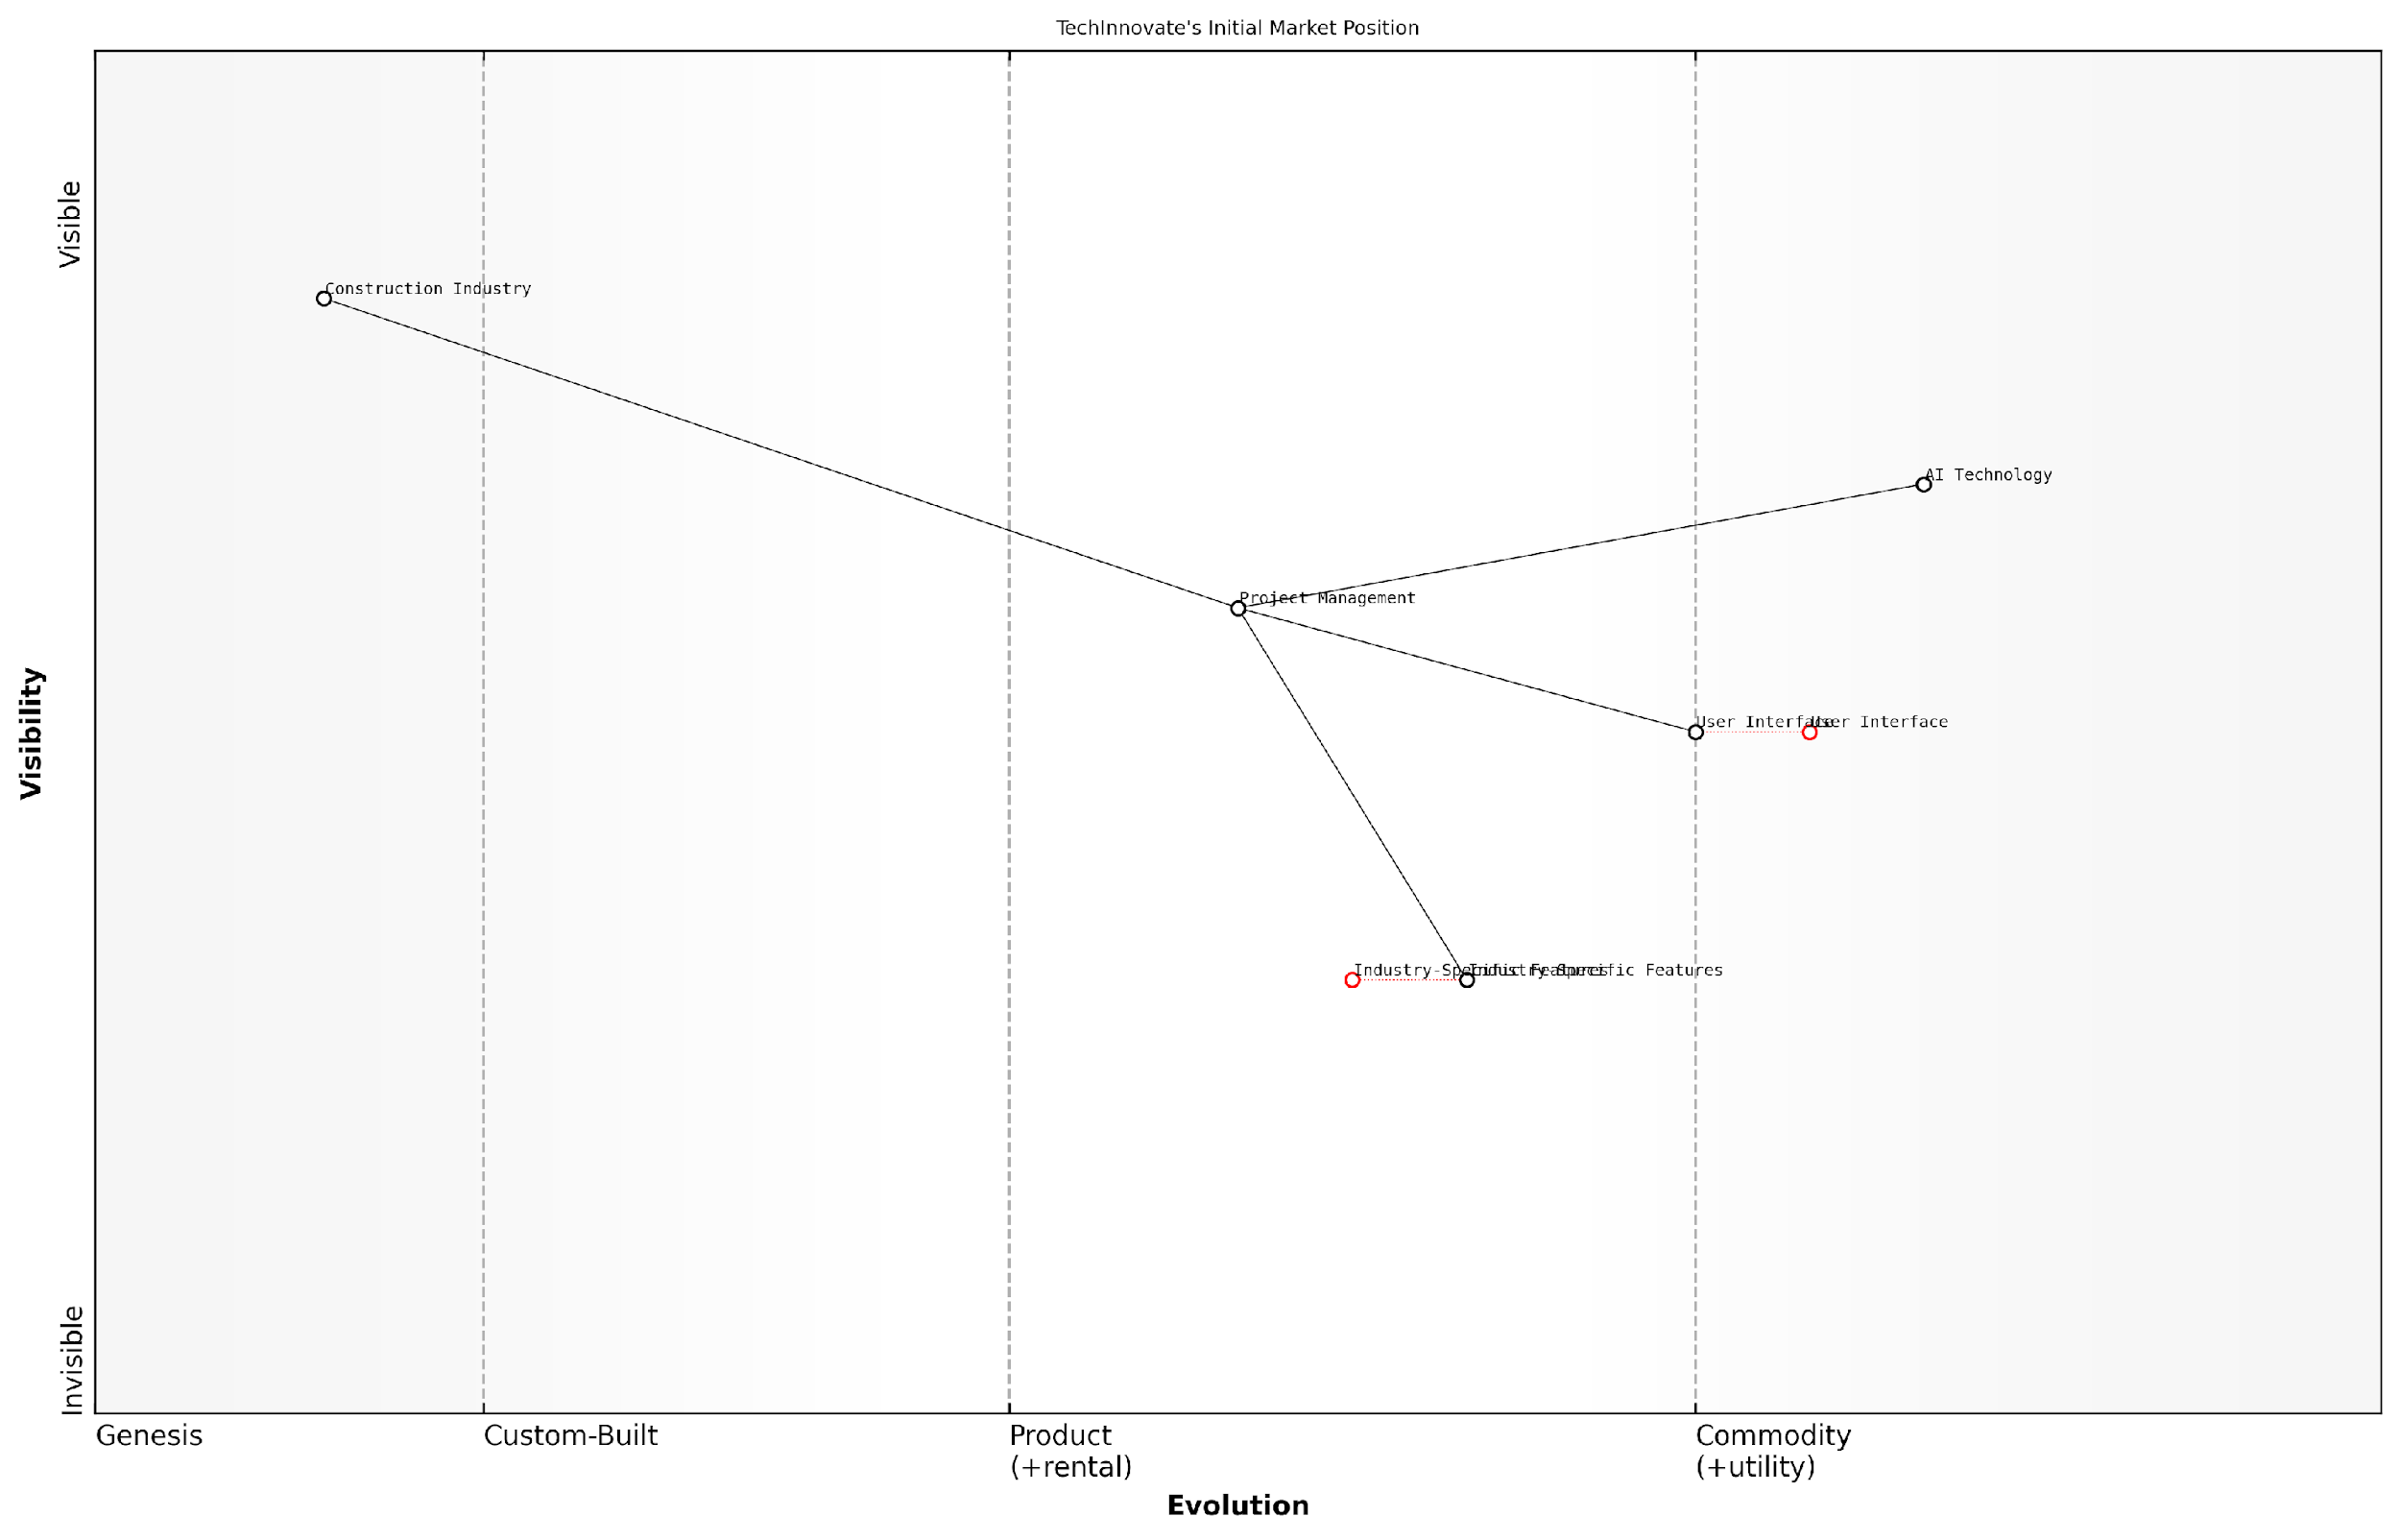

*Draft Wardley Map: [Insert Wardley Map: Competitive positioning]*

[Edit this draft Wardley Map](https://create.wardleymaps.ai/#clone:4380b8ea0eb64c6d08)

Wardley Map Assessment

TechInnovate shows strong potential in disrupting the construction project management space with its AI-driven approach. However, to fully capitalize on this opportunity, it must rapidly develop its industry-specific features and align its advanced technology with practical construction needs. The company is well-positioned to lead in AI-driven project management but must balance innovation with market-specific requirements to ensure sustainable growth and competitive advantage.

[View full Wardley Map report](http://markdown_wardley_map_reports/wardley_map_report_40_Competitive_positioning.md)

The initial Wardley Map revealed that while TechInnovate’s core AI technology was highly evolved, its user interface and industry-specific features were lagging behind competitors. This visualisation prompted a strategic pivot.

Wardley Mapping opened our eyes to opportunities we hadn’t considered. It showed us where we were truly innovative and where we needed to catch up.

Based on the map insights, TechInnovate implemented the following strategies to enhance its competitive position:

* Focused development on construction-specific features, moving these components from ‘Product’ to ‘Custom Built’ on the evolution axis
* Partnered with leading construction firms to co-develop and test new features, enhancing credibility and market fit
* Invested in user experience design to move the UI component from ‘Product’ to ‘Commodity’, matching industry leaders
* Leveraged the advanced AI capabilities to offer predictive analytics, a feature absent in most competitors’ offerings

The revised Wardley Map clearly illustrated TechInnovate’s new competitive positioning:



*Draft Wardley Map: [Insert Wardley Map: Competitive positioning]*

[Edit this draft Wardley Map](https://create.wardleymaps.ai/#clone:4380b8ea0eb64c6d08)

Wardley Map Assessment

TechInnovate shows strong potential in disrupting the construction project management space with its AI-driven approach. However, to fully capitalize on this opportunity, it must rapidly develop its industry-specific features and align its advanced technology with practical construction needs. The company is well-positioned to lead in AI-driven project management but must balance innovation with market-specific requirements to ensure sustainable growth and competitive advantage.

[View full Wardley Map report](http://markdown_wardley_map_reports/wardley_map_report_40_Competitive_positioning.md)

This strategic repositioning yielded significant benefits:

* Market share increased by 27% within six months
* Customer acquisition costs decreased by 35% due to improved product-market fit
* The startup secured a major round of funding, with investors citing the clear strategic vision as a key factor

The TechInnovate case study demonstrates the power of Wardley Mapping in shaping competitive positioning for product-based startups. By visually representing the competitive landscape, startups can identify unique opportunities for differentiation and strategic advantage.

Key lessons for startups using Wardley Mapping for competitive positioning include:

* Regularly update your Wardley Map to track changes in the competitive landscape
* Focus on moving key components along the evolution axis to differentiate from competitors
* Use the map to identify potential partnerships or acquisition targets that could strengthen your position
* Align your marketing and sales strategies with the insights gained from the map
* Communicate your unique position to investors using the visual clarity of Wardley Maps

Wardley Mapping transformed our understanding of the market. It’s not just about where you are, but where you’re heading and how fast you’re evolving compared to the competition.

It’s crucial to note that competitive positioning is not a one-time exercise. The market is constantly evolving, and startups must regularly reassess their position. Wardley Mapping facilitates this ongoing process by providing a clear, visual representation of the changing landscape.

Moreover, the map can help startups anticipate future market movements. By understanding the natural evolution of components, startups can predict where the market is heading and position themselves accordingly. This foresight is particularly valuable in fast-moving tech sectors where being ahead of the curve can provide a significant competitive advantage.

In conclusion, the TechInnovate case study illustrates how Wardley Mapping can be a game-changer for product-based startups in terms of competitive positioning. By providing a clear visualisation of the market landscape, enabling strategic decision-making, and facilitating ongoing market analysis, Wardley Mapping empowers startups to carve out a unique and defensible market position. As the startup ecosystem continues to evolve, mastery of this tool will become increasingly valuable for entrepreneurs seeking to navigate the complexities of competitive positioning.

# Conclusion: Integrating Wardley Mapping into Your Startup’s DNA

## Building a Map-Driven Culture

### Regular mapping sessions

Regular mapping sessions are a cornerstone of building a map-driven culture within startups, particularly those operating in the government and public sector contexts. These sessions serve as a vital mechanism for continuously aligning strategy, fostering collaboration, and adapting to the ever-changing landscape of public service delivery and technological innovation. By institutionalising the practice of Wardley Mapping, startups can embed strategic thinking into their organisational DNA, ensuring that decision-making at all levels is informed by a shared understanding of the evolving ecosystem.

The importance of regular mapping sessions cannot be overstated, especially for startups navigating the complex waters of government contracts and public sector partnerships. These sessions provide a structured approach to visualising the current state of the business, anticipating future challenges, and identifying opportunities for innovation and growth. Let’s delve into the key aspects of implementing effective regular mapping sessions within your startup.

Frequency and Scheduling

The optimal frequency of mapping sessions will vary depending on the startup’s stage, the volatility of the public sector environment, and the pace of technological change. However, as a general rule, startups should aim to conduct comprehensive mapping sessions at least quarterly, with more frequent, focused sessions on specific areas of the business or particular projects as needed.

In my experience advising government tech startups, those that conduct monthly mini-mapping sessions, coupled with quarterly deep dives, tend to stay ahead of the curve in terms of strategic positioning and adaptability.

It’s crucial to schedule these sessions in advance and treat them as non-negotiable commitments. This ensures that mapping becomes an integral part of your startup’s operational rhythm, rather than an ad hoc activity that gets pushed aside in the face of day-to-day pressures.

Participants and Facilitation

While Wardley Mapping can be a powerful tool for individual strategists, its true value emerges when it becomes a collaborative exercise. Regular mapping sessions should involve a cross-section of your startup’s team, including:

* Founders and C-level executives
* Product managers and developers
* Sales and business development representatives
* Operations and customer support staff
* Subject matter experts relevant to your public sector focus

This diverse group ensures that the mapping process benefits from a range of perspectives and expertise. It’s particularly important in the public sector context to include team members who have a deep understanding of government processes, policy frameworks, and citizen needs.

Effective facilitation is key to productive mapping sessions. Consider designating a ‘Mapping Champion’ within your startup – someone who has a strong grasp of Wardley Mapping principles and can guide the team through the process. This role can rotate among team members to build widespread mapping competency.

Session Structure and Focus

A well-structured mapping session typically follows this format:

* Review of previous maps and actions (15-20 minutes)
* Definition of the current mapping objective (10 minutes)
* Collaborative mapping exercise (60-90 minutes)
* Discussion of insights and implications (30 minutes)
* Action planning and assignment of responsibilities (20 minutes)

The focus of each session should alternate between broad, strategic maps of your entire value chain and more targeted maps of specific projects or challenges. For startups in the government tech space, it’s particularly valuable to create maps that visualise the evolving landscape of public service delivery, regulatory frameworks, and citizen expectations.

One of the most powerful outcomes I’ve observed from regular mapping sessions is the ability to anticipate regulatory changes and position the startup to capitalise on new policy directions before competitors even recognise the opportunity.

Tools and Documentation

While Wardley Maps can be created with simple tools like whiteboards or paper, digital mapping tools can significantly enhance the effectiveness of regular sessions, especially for distributed teams. Tools like Wardley Maps Online or Miro with custom Wardley Mapping templates allow for real-time collaboration and easy iteration.

It’s crucial to document not just the final maps, but also the discussions, insights, and action items that emerge from each session. This documentation serves as a valuable record of your startup’s strategic evolution and can be particularly useful when engaging with government stakeholders or potential investors.

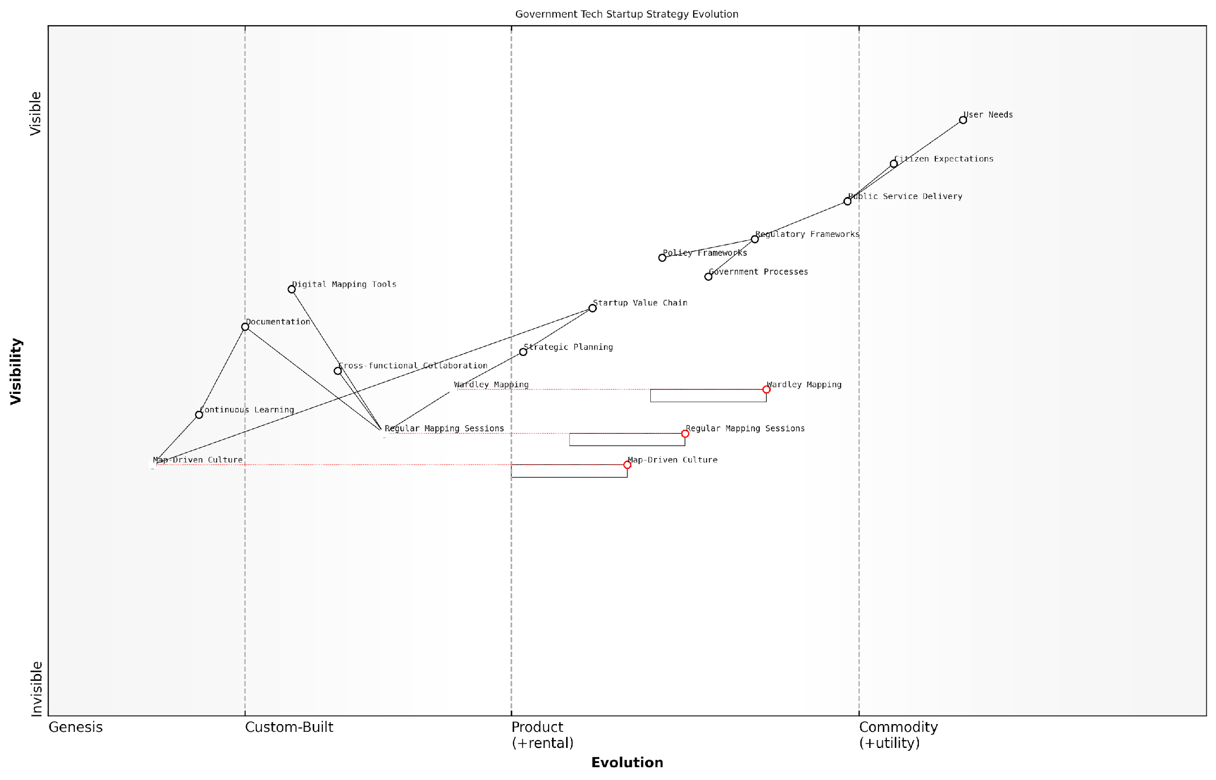

*Draft Wardley Map: [Insert Wardley Map: Regular mapping sessions]*

[Edit this draft Wardley Map](https://create.wardleymaps.ai/#clone:e54aade5ec946a48f7)

Wardley Map Assessment

This Wardley Map reveals a government tech startup landscape in transition, moving from traditional, process-driven approaches to more agile, map-driven strategies. The integration of Wardley Mapping and the evolution towards a Map-Driven Culture represent significant opportunities for innovation and competitive advantage. However, challenges remain in aligning rapidly evolving tech capabilities with slower-moving regulatory and policy frameworks. Success will depend on effectively bridging this gap, fostering cross-functional collaboration, and continuously aligning strategies with evolving user needs. The map suggests that organisations able to successfully navigate this transition and fully embrace map-driven approaches will be well-positioned to lead in the government tech space.

[View full Wardley Map report](http://markdown_wardley_map_reports/wardley_map_report_41_Regular_mapping_sessions.md)

Continuous Learning and Improvement

Regular mapping sessions should be viewed as opportunities for continuous learning and improvement, both in terms of your startup’s strategy and the team’s mapping skills. Encourage participants to reflect on the accuracy of previous maps, discuss what has changed in the landscape, and refine their understanding of component evolution within the public sector context.

Consider incorporating ‘map reviews’ where you compare your evolving maps with actual market developments. This practice can sharpen your team’s strategic acumen and improve the predictive power of your mapping efforts over time.

The true power of regular mapping sessions lies not just in the maps themselves, but in the shared language and strategic mindset they foster across the organisation. I’ve seen startups transform their ability to navigate complex public sector ecosystems through consistent, thoughtful mapping practices.

Integration with Other Strategic Practices

To maximise the impact of regular mapping sessions, integrate them with other strategic practices within your startup. For example:

* Use insights from mapping sessions to inform OKR (Objectives and Key Results) setting
* Incorporate Wardley Maps into pitch decks and business plans when seeking government contracts or funding
* Align product roadmaps with the evolutionary trajectories identified in your maps
* Use maps to guide decisions about partnerships and acquisitions in the govtech space

By weaving Wardley Mapping throughout your startup’s strategic processes, you create a coherent approach to decision-making that is particularly well-suited to the complexities of the public sector market.

In conclusion, regular mapping sessions are not just a best practice – they are a fundamental building block of a map-driven culture. For startups operating in the government and public sector space, these sessions provide a structured approach to navigating complex ecosystems, anticipating change, and aligning the entire organisation around a shared strategic vision. By committing to consistent, well-executed mapping practices, your startup can develop a significant competitive advantage in the rapidly evolving landscape of public sector innovation.

### Encouraging strategic thinking at all levels

Encouraging strategic thinking at all levels of a startup is crucial for fostering a map-driven culture and maximising the benefits of Wardley Mapping. This approach not only enhances the overall strategic capabilities of the organisation but also ensures that insights and innovations can emerge from any part of the company. As startups grow and evolve, cultivating this mindset becomes increasingly important for maintaining agility and competitive advantage.

To effectively encourage strategic thinking across all levels of a startup, several key approaches can be implemented:

* Education and Training
* Inclusive Mapping Sessions
* Cross-functional Collaboration
* Empowerment and Autonomy
* Feedback Loops and Iteration

Let’s explore each of these approaches in detail:

Education and Training: The foundation of strategic thinking lies in understanding the principles and methodologies that underpin it. For Wardley Mapping to become a ubiquitous tool within a startup, it’s essential to provide comprehensive education and training to all employees, regardless of their role or seniority.

* Conduct regular workshops on Wardley Mapping principles and techniques
* Develop an internal knowledge base or wiki with resources, case studies, and best practices
* Encourage team members to attend external conferences or seminars on strategic thinking and Wardley Mapping
* Create a mentorship programme where experienced mappers can guide newcomers

Investing in the strategic capabilities of every team member is not just about skill development; it’s about cultivating a shared language and framework for decision-making across the entire organisation.

Inclusive Mapping Sessions: To truly embed strategic thinking at all levels, it’s crucial to involve team members from various departments and hierarchies in mapping sessions. This inclusive approach not only brings diverse perspectives to the table but also helps in creating a sense of ownership and engagement with the strategic direction of the startup.

* Organise regular cross-functional mapping sessions
* Rotate the facilitation role among team members to build confidence and skills
* Encourage junior team members to present their insights and challenge assumptions
* Use digital collaboration tools to enable remote participation and asynchronous contributions

Cross-functional Collaboration: Strategic thinking thrives when individuals from different areas of expertise come together to solve problems. By fostering cross-functional collaboration, startups can break down silos and create a more holistic view of their ecosystem and challenges.

* Form cross-functional teams for specific projects or challenges
* Implement job rotation or shadowing programmes to broaden perspectives
* Create shared objectives that require collaboration across departments
* Use Wardley Maps as a common language for discussing strategy across functions

When we bring together diverse viewpoints and expertise, we create a fertile ground for strategic innovation. It’s in these intersections that we often find our most valuable insights and opportunities.

Empowerment and Autonomy: To truly encourage strategic thinking at all levels, startups must create an environment where employees feel empowered to make decisions and take ownership of their areas of responsibility. This involves delegating authority, providing resources, and fostering a culture of trust and experimentation.

* Delegate decision-making authority to the appropriate levels
* Provide access to necessary data and tools for strategic analysis
* Encourage experimentation and learning from failures
* Recognise and reward strategic initiatives and insights, regardless of their origin within the organisation

Feedback Loops and Iteration: Strategic thinking is not a one-time exercise but an ongoing process of learning and adaptation. Establishing robust feedback loops and embracing iteration are essential for refining strategic insights and ensuring that Wardley Mapping remains a dynamic and valuable tool within the startup.

* Regularly review and update Wardley Maps to reflect new information and changing conditions
* Implement post-mortem analyses on strategic decisions to extract learnings
* Create channels for continuous feedback on strategic initiatives
* Use metrics and KPIs to measure the impact of strategic decisions informed by Wardley Mapping

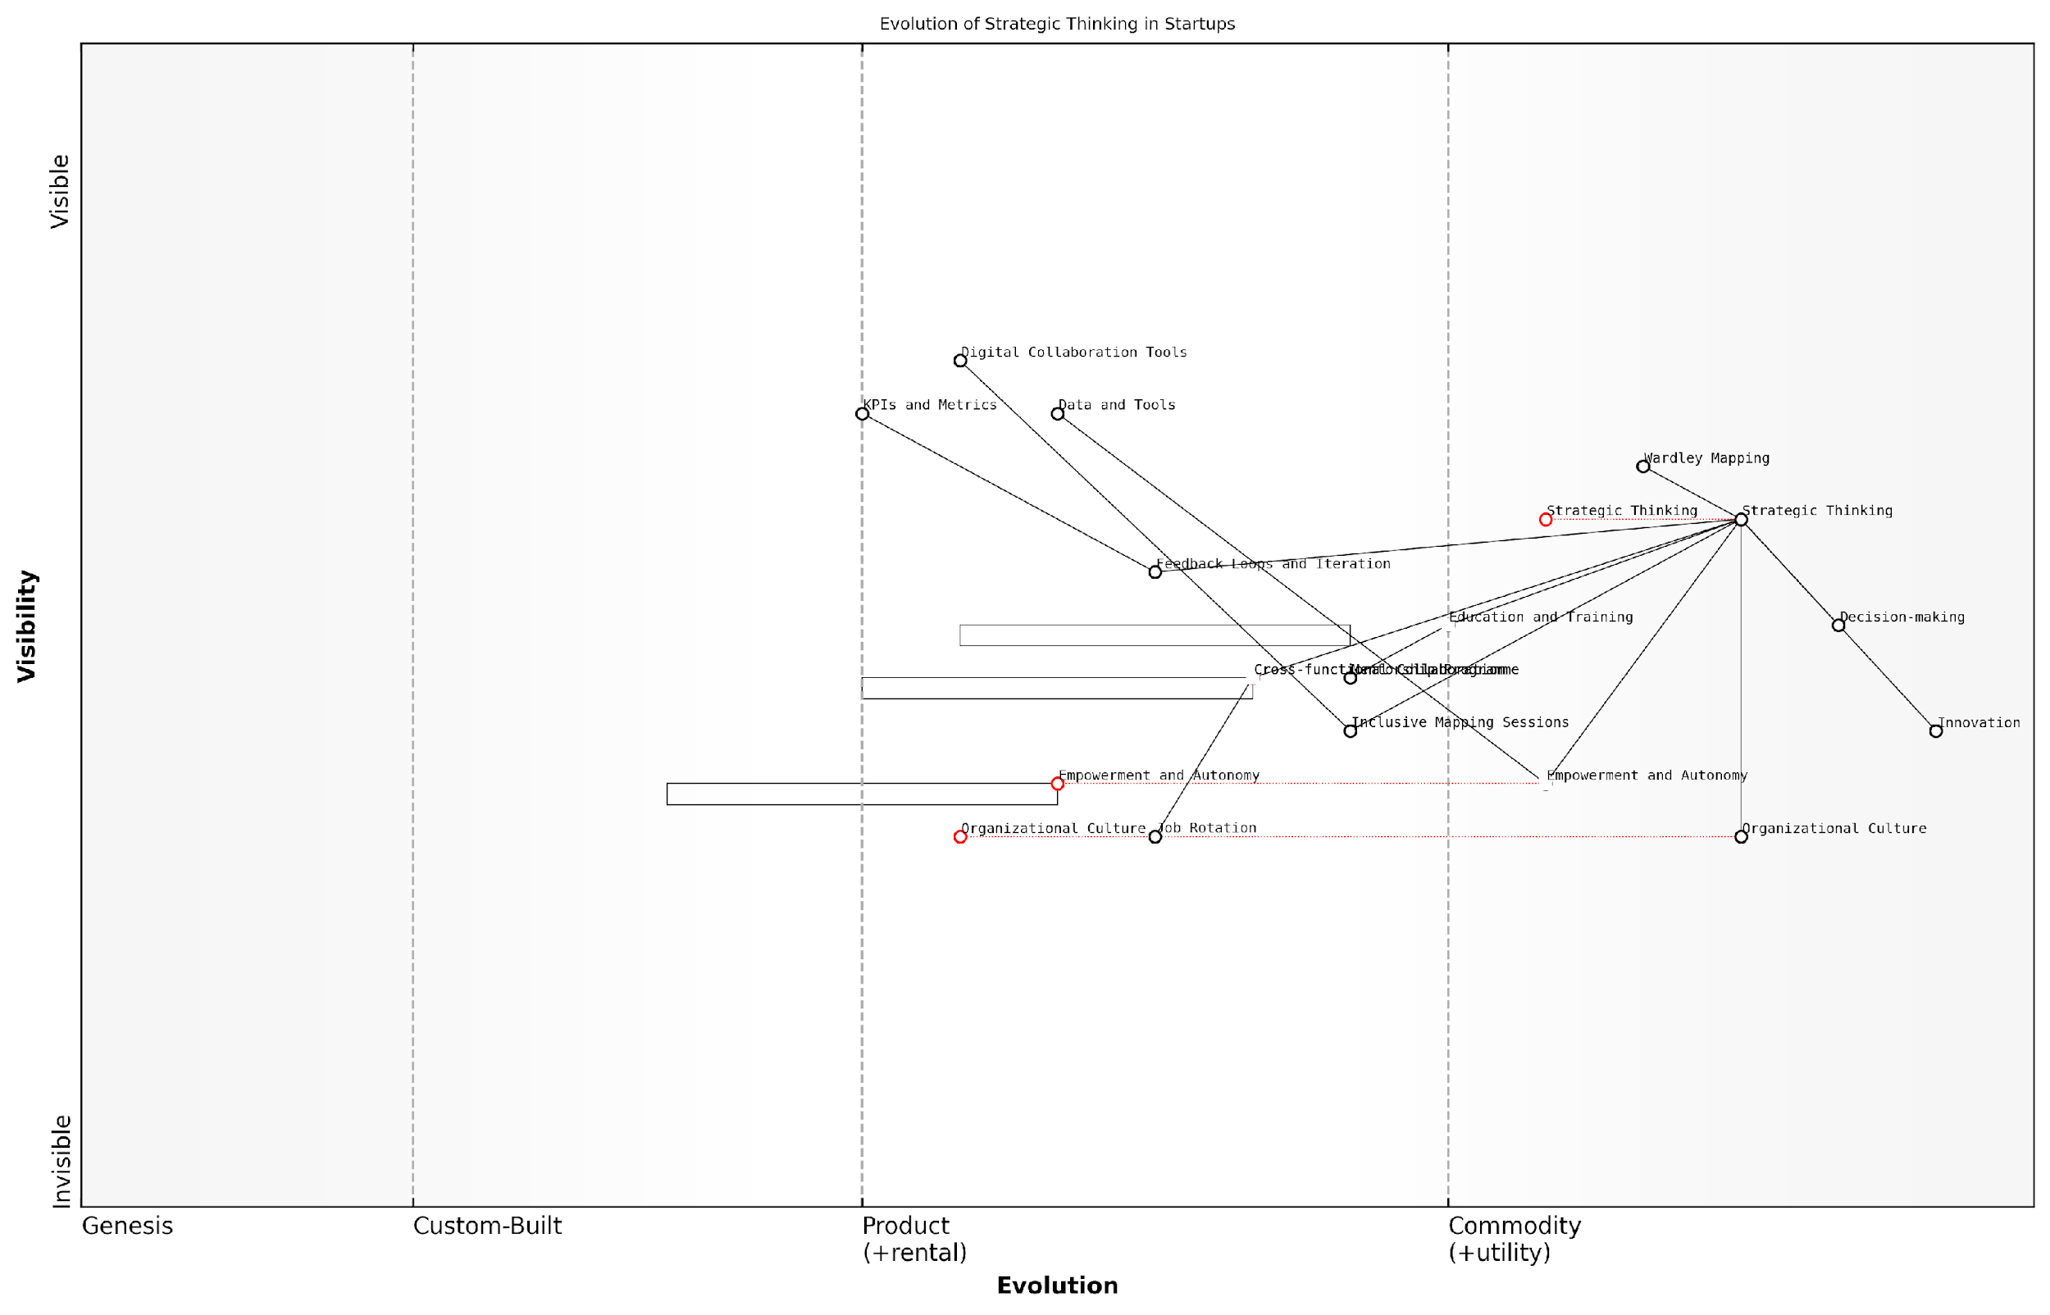

*Draft Wardley Map: [Insert Wardley Map: Encouraging strategic thinking at all levels]*

[Edit this draft Wardley Map](https://create.wardleymaps.ai/#clone:976e086f6c1a2dceac)

Wardley Map Assessment

This Wardley Map reveals a startup with a strong focus on developing strategic thinking capabilities across all levels. The organisation shows a good balance between high-level strategic components and practical enabling tools. However, there are opportunities for improvement in areas such as cross-functional collaboration and data analytics. The startup is well-positioned to leverage its strengths in Wardley Mapping and empowerment to drive innovation and competitive advantage. To maintain this edge, the organisation should focus on evolving its organisational culture, enhancing data capabilities, and continuously innovating its approach to strategy formulation and execution. The integration of emerging technologies and the development of a robust ecosystem strategy will be crucial for long-term success in fostering strategic thinking at all levels.

[View full Wardley Map report](http://markdown_wardley_map_reports/wardley_map_report_42_Encouraging_strategic_thinking_at_all_levels.md)

By implementing these approaches, startups can create an environment where strategic thinking becomes second nature to employees at all levels. This not only enhances the overall strategic capabilities of the organisation but also ensures that the startup remains agile and responsive to market changes.

However, it’s important to note that encouraging strategic thinking at all levels is not without its challenges. Some common obstacles include:

* Resistance to change from employees accustomed to traditional top-down strategy
* Time constraints in fast-paced startup environments
* Difficulty in measuring the immediate impact of strategic thinking initiatives
* Potential for analysis paralysis if not balanced with action

To overcome these challenges, startups should focus on creating a supportive culture that values continuous learning and improvement. This involves setting clear expectations, providing adequate resources and time for strategic activities, and demonstrating the tangible benefits of strategic thinking through concrete examples and success stories.

The true power of Wardley Mapping in startups is unleashed when it becomes part of the organisational DNA, informing decisions and driving innovation at every level. It’s not just about creating maps; it’s about cultivating a map-driven mindset throughout the entire company.

In conclusion, encouraging strategic thinking at all levels is a critical component of building a map-driven culture within startups. By investing in education, fostering inclusive participation, promoting cross-functional collaboration, empowering employees, and establishing feedback loops, startups can harness the full potential of Wardley Mapping. This approach not only enhances decision-making and innovation but also positions the startup for long-term success in an increasingly complex and competitive business landscape.

### Adapting to change with agility

In the dynamic landscape of startups, the ability to adapt to change with agility is not just an advantage—it’s a necessity for survival and growth. Wardley Mapping provides a powerful framework for cultivating this agility, enabling startups to navigate uncertainty and respond swiftly to evolving market conditions. By integrating Wardley Mapping into the core of a startup’s culture, organisations can develop a shared language for strategy, foster a proactive mindset, and build the resilience needed to thrive in rapidly changing environments.

To truly embed agility through Wardley Mapping, startups must focus on three key areas: continuous environmental scanning, rapid experimentation, and adaptive planning. Let’s explore each of these in detail.

Continuous Environmental Scanning

Wardley Mapping encourages startups to maintain a constant awareness of their business landscape. This involves regularly updating maps to reflect changes in user needs, technological advancements, and competitive movements. By doing so, startups can identify potential disruptions and opportunities before they become apparent to competitors.

In my experience advising government bodies, those who consistently scan their environment using Wardley Maps are able to anticipate policy changes and technological shifts months, if not years, before their peers.

* Implement a routine for updating Wardley Maps, involving key stakeholders from various departments
* Establish clear ownership for different map components, ensuring comprehensive coverage
* Utilise data analytics and market intelligence tools to inform map updates
* Create a centralised repository for maps, making them easily accessible to all team members

Rapid Experimentation

Wardley Mapping provides a visual framework for identifying areas ripe for innovation and experimentation. By understanding the evolutionary stage of different components, startups can strategically allocate resources to test new ideas and validate assumptions quickly.

A senior government official once told me, ‘Wardley Mapping transformed our approach to innovation. We now run targeted experiments based on map insights, allowing us to fail fast and learn faster.’

* Develop a culture of hypothesis-driven development, using maps to guide experiment design
* Implement short feedback loops to quickly assess the impact of changes
* Encourage cross-functional teams to collaborate on experiments, leveraging diverse perspectives
* Use map-driven insights to prioritise experiments with the highest potential impact

Adaptive Planning

Traditional long-term planning often falls short in the face of rapid change. Wardley Mapping enables startups to adopt a more flexible, adaptive approach to planning. By visualising the entire value chain and its evolution, startups can make informed decisions about where to invest resources and how to pivot when necessary.

As a leading expert in the field once remarked, ‘Wardley Mapping doesn’t predict the future, but it gives you the tools to adapt quickly when the future arrives.’

* Implement rolling quarterly planning sessions, using updated Wardley Maps as a foundation
* Develop scenario plans based on potential evolutionary paths identified in the maps
* Create flexible budgets that allow for rapid reallocation of resources based on map insights
* Establish clear triggers for when to reassess and potentially pivot strategies

To truly embed these practices and foster a culture of agility, startups must also focus on developing the right mindset and skills across the organisation. This includes:

* Providing ongoing training in Wardley Mapping techniques and strategic thinking
* Encouraging open communication and knowledge sharing about market changes and map updates
* Recognising and rewarding agile behaviours and successful adaptations
* Leading by example, with leadership actively participating in mapping sessions and demonstrating agility in decision-making

It’s important to note that adapting to change with agility is not about constant, reactive shifts. Rather, it’s about creating a structured approach to sensing and responding to change in a way that aligns with the startup’s overall vision and strategy. Wardley Mapping provides the visual tools and shared language to make this possible.

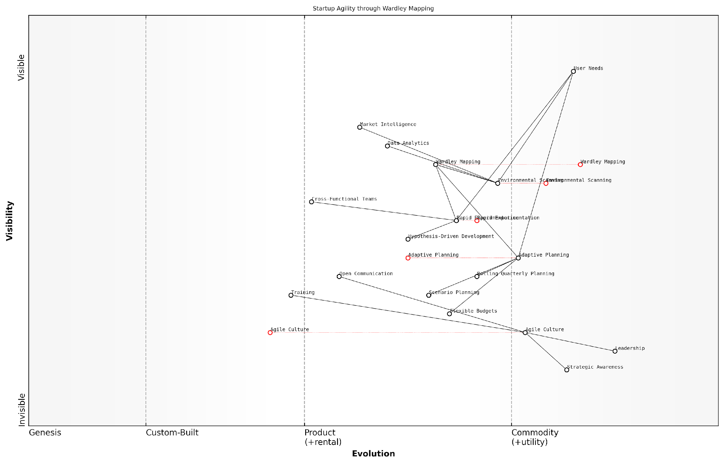

*Draft Wardley Map: [Insert Wardley Map: Adapting to change with agility]*

[Edit this draft Wardley Map](https://create.wardleymaps.ai/#clone:7102fcc541c9dc9e91)

Wardley Map Assessment

This Wardley Map represents a startup with a strong foundation in agile methodologies and strategic planning, particularly through the use of Wardley Mapping. The organisation is well-positioned to adapt to change, with a clear focus on user needs and environmental awareness. However, to maintain this advantage, the startup must continue to evolve its capabilities, particularly in data analytics and market intelligence. The central position of Wardley Mapping provides a unique strategic advantage, but efforts should be made to institutionalise this capability and potentially productize it. The emphasis on Agile Culture as a core component is commendable and should be further developed as a key differentiator. Overall, the startup has a solid base for achieving and maintaining agility, but must remain vigilant in evolving its practices and tools to stay ahead in a rapidly changing business environment.

[View full Wardley Map report](http://markdown_wardley_map_reports/wardley_map_report_43_Adapting_to_change_with_agility.md)

By integrating Wardley Mapping into the fabric of a startup’s operations and decision-making processes, organisations can develop a level of agility that goes beyond mere responsiveness. They can become truly anticipatory, shaping their industry rather than simply reacting to it. This approach is particularly crucial in the public sector, where startups often face complex regulatory environments and the need to deliver social impact alongside financial sustainability.

In conclusion, adapting to change with agility through Wardley Mapping is not a one-time effort, but an ongoing commitment to strategic awareness and flexible action. It requires dedication from all levels of the organisation and a willingness to challenge assumptions continually. However, for startups that successfully embed this approach, the rewards are significant: increased resilience, improved decision-making, and the ability to thrive in even the most turbulent of markets.

## Future Trends in Wardley Mapping for Startups

### Emerging tools and technologies

As Wardley Mapping continues to gain traction in the startup ecosystem, a new wave of tools and technologies is emerging to support and enhance its application. These innovations are set to revolutionise how startups leverage Wardley Mapping for strategic decision-making, offering more sophisticated analysis, improved collaboration, and deeper insights. As we look to the future, it’s crucial for startup founders and strategists to stay abreast of these developments to maintain a competitive edge in an increasingly complex business landscape.

One of the most significant trends we’re observing is the rise of AI-powered Wardley Mapping tools. These advanced platforms are capable of analysing vast amounts of market data, competitor information, and internal metrics to generate preliminary Wardley Maps automatically. While human insight remains invaluable, these AI assistants can dramatically reduce the time and effort required to create initial maps, allowing startups to focus more on strategic interpretation and decision-making.

AI-powered Wardley Mapping tools are not just about efficiency; they’re about uncovering patterns and insights that might be missed by human analysis alone. This technology has the potential to level the playing field for startups, giving them access to strategic insights that were once the domain of large corporations with extensive research teams.

Another exciting development is the integration of real-time data feeds into Wardley Mapping software. This allows startups to create dynamic, constantly updating maps that reflect the latest market conditions, competitor moves, and technological advancements. For startups operating in fast-moving sectors like fintech or biotech, this real-time capability can be a game-changer, enabling rapid response to market shifts and emerging opportunities.

* AI-powered map generation and analysis
* Real-time data integration for dynamic mapping
* Virtual and augmented reality interfaces for collaborative mapping
* Blockchain-based systems for secure, decentralised strategy sharing
* Natural language processing for converting strategic narratives into visual maps

Virtual and augmented reality (VR/AR) technologies are also making their mark on Wardley Mapping. These immersive interfaces allow startup teams to collaborate on maps in virtual spaces, regardless of physical location. Imagine a scenario where founders, investors, and advisors can ‘walk through’ a 3D Wardley Map together, discussing strategy and making real-time adjustments. This level of interactive, visual collaboration can significantly enhance strategic discussions and decision-making processes.

Blockchain technology is another area with potential to impact Wardley Mapping practices. Some startups are exploring the use of blockchain to create secure, decentralised platforms for sharing and collaborating on Wardley Maps. This could be particularly valuable for startups working on open-source projects or those collaborating with multiple partners across different organisations. Blockchain can ensure the integrity and provenance of strategic maps while allowing controlled access to sensitive information.

The application of blockchain to Wardley Mapping isn’t just about security; it’s about creating new models of collaborative strategy development. We’re seeing the emergence of ‘strategy DAOs’ where multiple stakeholders can contribute to and benefit from shared strategic insights, all underpinned by the transparency and trust that blockchain provides.

Natural Language Processing (NLP) is another technology set to transform Wardley Mapping practices. Advanced NLP algorithms are being developed that can analyse strategic narratives, business plans, and even social media discussions to automatically generate Wardley Maps. This could be particularly valuable for startups in the early stages, helping them to quickly visualise their strategic positioning based on their business plan or pitch deck.

As these tools and technologies continue to evolve, it’s important for startups to approach them with a critical eye. While they offer tremendous potential, they should be seen as aids to strategic thinking rather than replacements for human insight and creativity. The most successful startups will be those that can effectively blend these technological advancements with deep market understanding and innovative thinking.

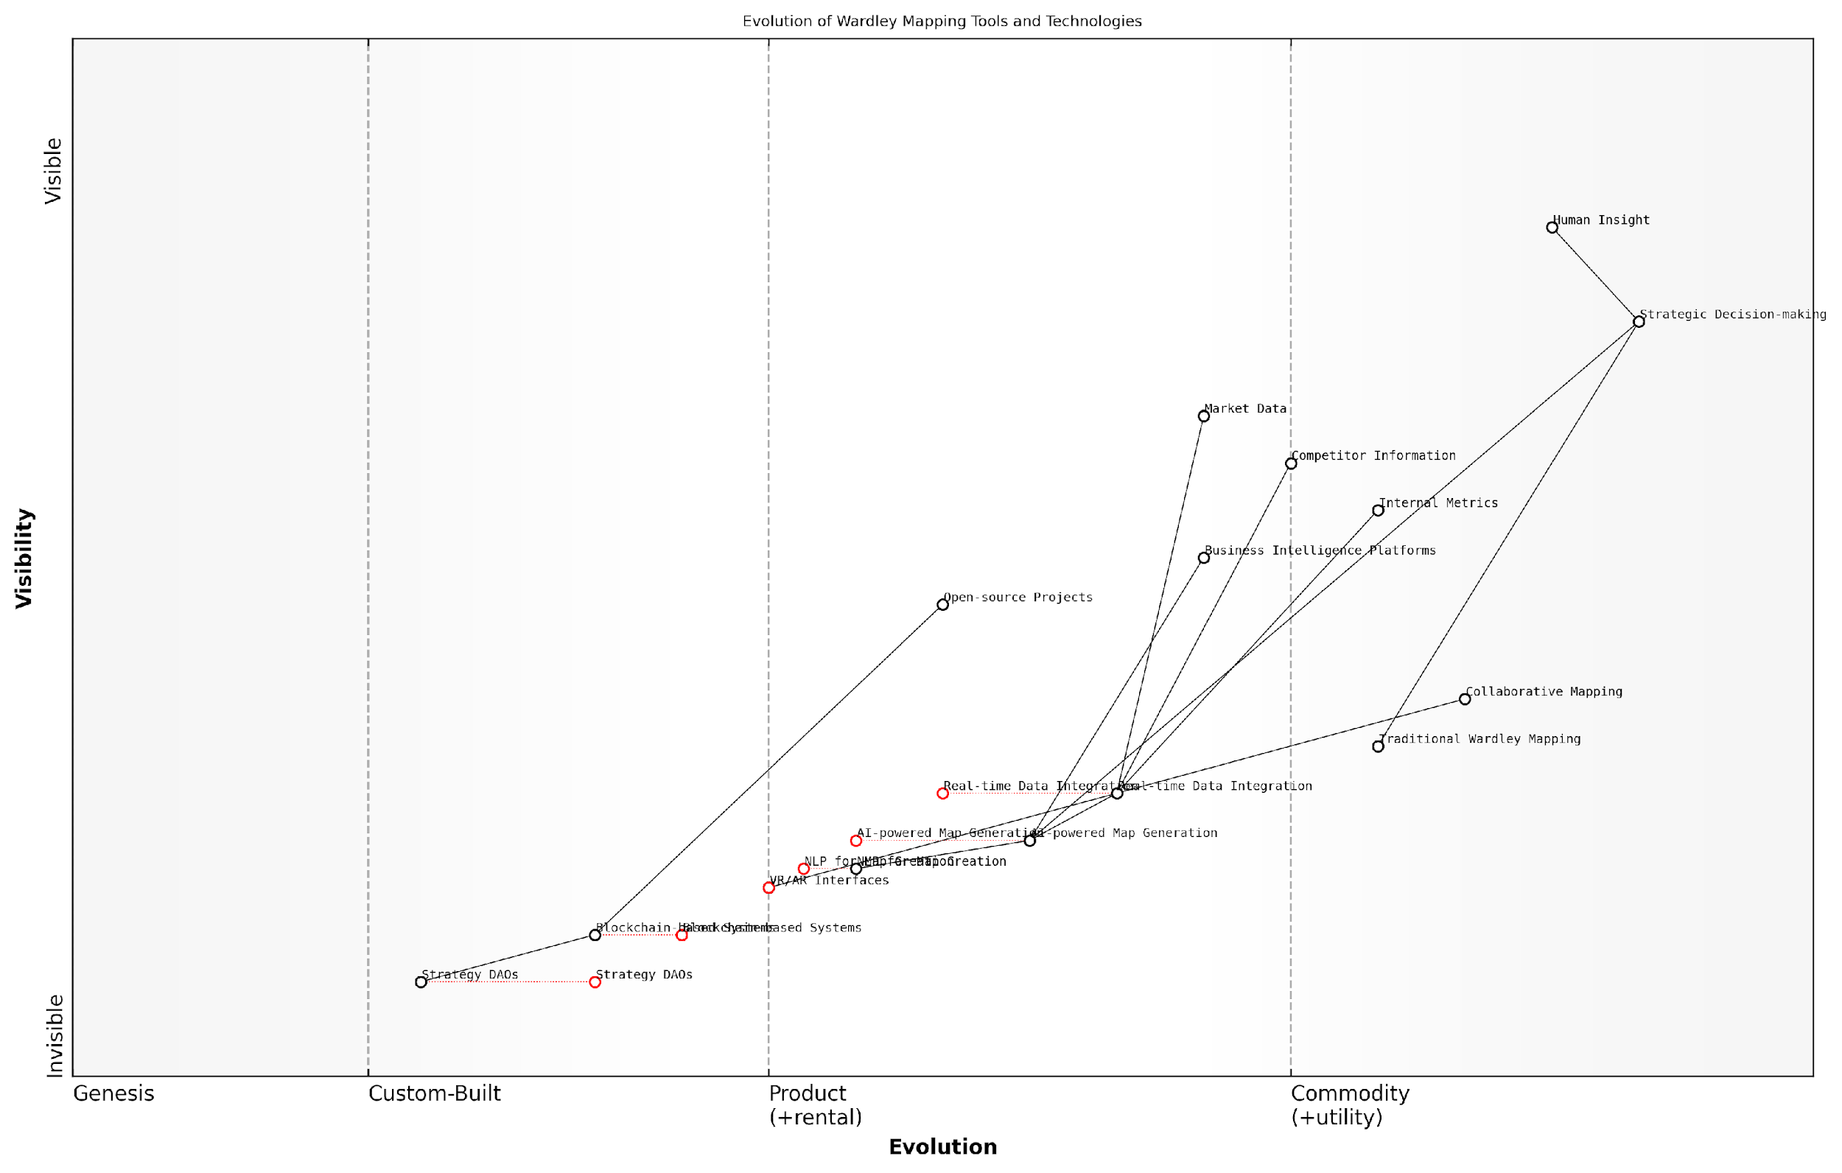

*Draft Wardley Map: [Insert Wardley Map: Emerging tools and technologies]*

[Edit this draft Wardley Map](https://create.wardleymaps.ai/#clone:102698a557b33dc484)

Wardley Map Assessment

The Wardley Mapping landscape is on the cusp of significant transformation, driven by AI, real-time data, and emerging technologies. Organisations that can effectively integrate these advanced tools while maintaining the crucial element of human insight will gain a significant competitive advantage in strategic planning and execution. The key challenge will be balancing the adoption of cutting-edge technologies with the need for practical, actionable strategic insights.

[View full Wardley Map report](http://markdown_wardley_map_reports/wardley_map_report_44_Emerging_tools_and_technologies.md)

Looking ahead, we can expect to see further integration of Wardley Mapping tools with other strategic frameworks and business intelligence platforms. This convergence will create powerful ecosystems for strategic analysis, allowing startups to seamlessly combine insights from Wardley Maps with data from financial modelling, market research, and competitive intelligence tools.

However, with these advancements come new challenges. Startups will need to develop competencies in data interpretation, AI ethics, and digital collaboration to fully leverage these tools. There’s also a risk of over-reliance on technology, potentially leading to a loss of the nuanced understanding that comes from manually creating and analysing Wardley Maps.

The future of Wardley Mapping for startups is not about replacing human strategists with AI, but about augmenting human capabilities. The most successful startups will be those that can harness these new tools to enhance their strategic thinking, while still maintaining the creativity and intuition that are hallmarks of successful entrepreneurship.

In conclusion, the emerging tools and technologies in Wardley Mapping present exciting opportunities for startups to enhance their strategic capabilities. From AI-powered analysis to immersive VR collaboration, these advancements have the potential to democratise access to sophisticated strategic tools, levelling the playing field for innovative startups competing against established players. As we move forward, it will be crucial for startup founders and strategists to stay informed about these developments and to thoughtfully integrate them into their strategic processes, always keeping in mind that technology should serve strategy, not dictate it.

### Integration with other strategic frameworks

As Wardley Mapping continues to gain traction in the startup ecosystem, a key trend emerging is its integration with other strategic frameworks. This synergy allows startups to leverage the unique strengths of Wardley Mapping whilst complementing it with established methodologies, creating a more robust and comprehensive approach to strategy and decision-making.

One of the most promising integrations is between Wardley Mapping and the Lean Startup methodology. Whilst Lean Startup focuses on rapid iteration and validated learning, Wardley Mapping provides a visual representation of the competitive landscape and evolutionary patterns. By combining these approaches, startups can not only validate their hypotheses quickly but also position their experiments within the broader context of market evolution.

The marriage of Wardley Mapping and Lean Startup principles has revolutionised how we approach product development. It’s like having a compass and a map – we can navigate the terrain whilst always knowing our true north.

Another significant integration is with the Business Model Canvas (BMC). Whilst the BMC provides a static snapshot of a business model, Wardley Maps add a dynamic, evolutionary perspective. This combination allows startups to not only articulate their current business model but also anticipate how it might need to evolve as components in their value chain mature.

* Identify which elements of the business model are most susceptible to change
* Anticipate when pivots or transitions might be necessary
* Align the business model with the natural evolution of the market

The integration of Wardley Mapping with Agile methodologies is another trend gaining momentum. Agile’s focus on iterative development and continuous improvement aligns well with the dynamic nature of Wardley Maps. By incorporating Wardley Mapping into their sprint planning and retrospectives, startups can ensure that their short-term actions are aligned with long-term strategic goals.

Furthermore, we’re seeing innovative combinations of Wardley Mapping with scenario planning techniques. This integration allows startups to not only map their current situation but also to visualise potential future scenarios and their implications. This is particularly valuable in rapidly changing or uncertain markets, where the ability to anticipate and prepare for multiple futures can be a significant competitive advantage.

Combining Wardley Mapping with scenario planning has transformed our strategic foresight capabilities. We’re no longer just reacting to change; we’re anticipating it and shaping our future proactively.

The integration of Wardley Mapping with data analytics and machine learning is an exciting frontier. As startups collect more data about their operations and market, there’s potential to automate aspects of map creation and analysis. This could lead to real-time, data-driven Wardley Maps that provide continuous strategic insights.

However, it’s crucial to note that integrating Wardley Mapping with other frameworks is not without challenges. There’s a risk of overcomplexity, where the combined approach becomes too cumbersome for the fast-paced startup environment. Startups must strike a balance, leveraging the strengths of multiple frameworks without losing the agility that is often their key advantage.

* Ensure team members are well-versed in both Wardley Mapping and the complementary framework
* Start with simple integrations and gradually increase complexity as needed
* Regularly review the integrated approach to ensure it’s adding value and not creating unnecessary overhead

Looking ahead, we can expect to see more standardised approaches to these integrations emerging. As best practices are established and case studies accumulate, startups will have clearer guidelines on how to effectively combine Wardley Mapping with other strategic tools.

Moreover, we anticipate the development of software tools that facilitate these integrations, making it easier for startups to adopt multi-framework approaches. These tools could potentially automate the translation between different frameworks, allowing startups to seamlessly switch between views of their strategy.

In conclusion, the integration of Wardley Mapping with other strategic frameworks represents a significant trend in startup strategy. By combining the unique insights of Wardley Mapping with the strengths of established methodologies, startups can develop more comprehensive, dynamic, and resilient strategies. As these integrations mature and become more accessible, they have the potential to significantly enhance startups’ ability to navigate complex, rapidly evolving markets and drive sustainable growth.

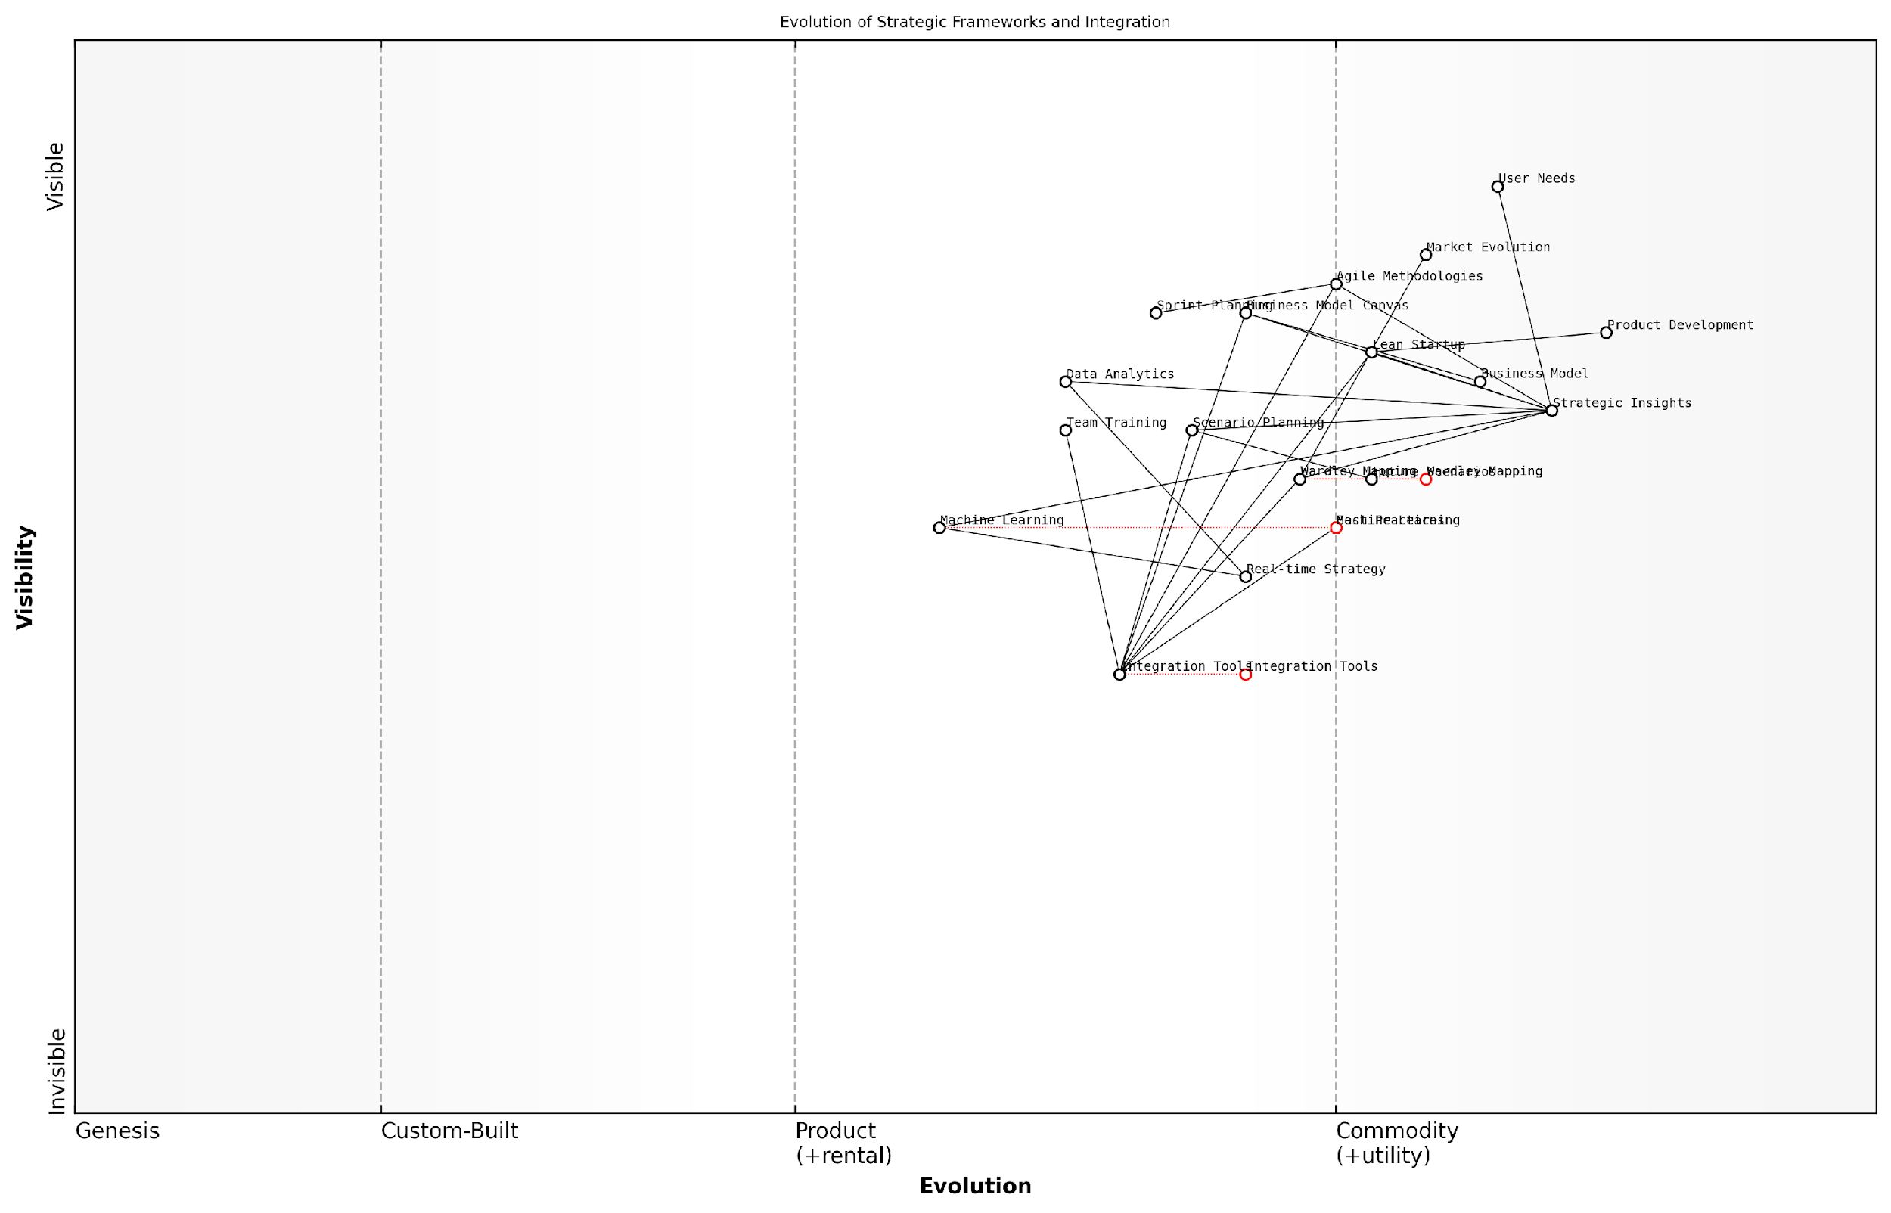

*Draft Wardley Map: [Insert Wardley Map: Integration with other strategic frameworks]*

[Edit this draft Wardley Map](https://create.wardleymaps.ai/#clone:6d2c85906ebfdd68df)

Wardley Map Assessment

This Wardley Map reveals a strategic landscape in flux, with traditional frameworks being integrated and augmented by emerging technologies and methodologies. The future of startup strategy lies in real-time, data-driven, and AI-enhanced approaches that can adapt quickly to market changes. Success will depend on mastering integration across frameworks, leveraging advanced analytics and machine learning, and fostering a culture of continuous strategic adaptation. Startups that can navigate this complex, evolving landscape will be well-positioned to create sustainable competitive advantages.

[View full Wardley Map report](http://markdown_wardley_map_reports/wardley_map_report_45_Integration_with_other_strategic_frameworks.md)

### The evolving startup ecosystem

As we conclude our exploration of Wardley Mapping for startups, it’s crucial to consider the dynamic nature of the startup ecosystem itself. The landscape in which startups operate is constantly evolving, driven by technological advancements, changing market demands, and shifts in the global economy. Understanding these changes and how they impact the application of Wardley Mapping is essential for startups aiming to maintain a competitive edge and navigate the complexities of their respective industries.

The startup ecosystem of today is markedly different from that of even a few years ago. We’re witnessing a convergence of several trends that are reshaping how startups form, grow, and interact with their environment. These changes have profound implications for how Wardley Mapping can be applied and the insights it can provide.

* Increased access to capital and resources
* Globalisation of talent and markets
* Rapid technological advancements
* Shifting regulatory landscapes
* Growing emphasis on sustainability and social impact

Let’s examine each of these trends and their implications for Wardley Mapping in the startup context.

Firstly, the increased access to capital and resources has democratised the startup landscape. With the rise of crowdfunding, angel investing networks, and a proliferation of venture capital firms, startups now have more funding options than ever before. This abundance of capital has implications for how startups map their value chains and make strategic decisions. Wardley Maps in this context need to account for a more complex financial ecosystem, with components related to funding sources and capital allocation becoming increasingly important.

The democratisation of startup funding has fundamentally altered the strategic landscape. Wardley Mapping must now account for a more diverse and complex financial ecosystem, where access to capital is no longer the primary differentiator it once was.

Secondly, the globalisation of talent and markets has expanded the playing field for startups. Remote work and digital collaboration tools have made it possible for startups to access global talent pools and enter international markets more easily than ever before. This trend necessitates a more nuanced approach to Wardley Mapping, where geographical considerations and cultural factors play a more significant role in mapping value chains and assessing component evolution.

Rapid technological advancements, particularly in areas such as artificial intelligence, blockchain, and the Internet of Things, are continually reshaping the competitive landscape. For startups using Wardley Mapping, this means an increased focus on technology forecasting and the need to regularly reassess the evolution axis of their maps. Components that were once considered novel may quickly become commoditised, while new technologies can create entirely new value chains and market opportunities.

In today’s rapidly evolving technological landscape, the evolution axis of a Wardley Map is more dynamic than ever. Startups must develop the capability to continually reassess and update their maps to reflect the accelerating pace of technological change.

The shifting regulatory landscape, particularly in areas such as data privacy, financial services, and environmental protection, adds another layer of complexity to the startup ecosystem. Wardley Mapping in this context must incorporate regulatory components and their potential evolution, helping startups navigate compliance requirements and identify opportunities arising from regulatory changes.

Lastly, the growing emphasis on sustainability and social impact is reshaping consumer preferences and investor priorities. Startups are increasingly expected to consider their environmental and social impact alongside traditional business metrics. This trend necessitates the inclusion of sustainability-related components in Wardley Maps, potentially introducing new anchors based on social or environmental outcomes.

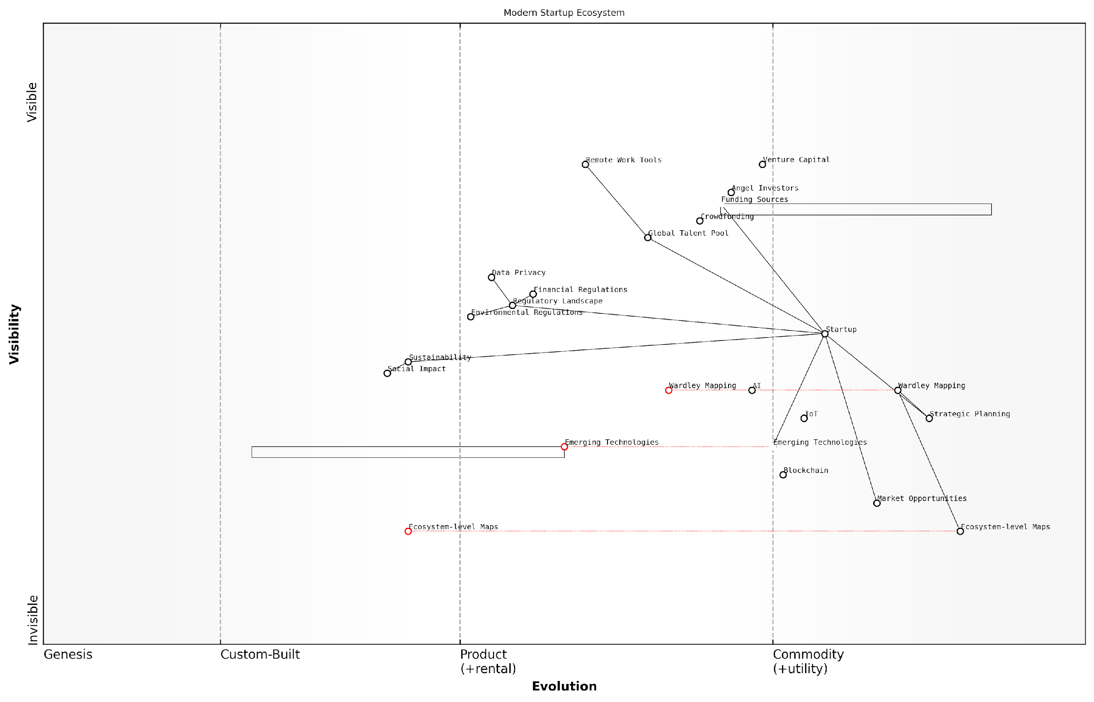

*Draft Wardley Map: [Insert Wardley Map: The evolving startup ecosystem]*

[Edit this draft Wardley Map](https://create.wardleymaps.ai/#clone:12626b64fdba68b768)

Wardley Map Assessment

The modern startup ecosystem is evolving towards a more interconnected, globally distributed, and sustainability-focused environment. Startups that can effectively leverage strategic mapping tools, embrace emerging technologies, and navigate complex regulatory landscapes while prioritising sustainability will be best positioned for success. The integration of ecosystem-level thinking and the ability to adapt to rapid changes in funding models, talent acquisition, and technological advancements will be crucial for long-term viability and growth.

[View full Wardley Map report](http://markdown_wardley_map_reports/wardley_map_report_46_The_evolving_startup_ecosystem.md)

As the startup ecosystem continues to evolve, so too must our approach to Wardley Mapping. The following adaptations will be crucial for startups looking to leverage Wardley Mapping effectively in this changing landscape:

* Increased frequency of mapping exercises to keep pace with rapid changes
* Greater emphasis on scenario planning and alternative futures within maps
* Integration of real-time data and AI-driven insights into the mapping process
* Collaborative mapping exercises that leverage diverse, global perspectives
* Incorporation of sustainability metrics and social impact considerations into map components

Moreover, as the startup ecosystem becomes more interconnected and complex, we’re likely to see the emergence of ecosystem-level Wardley Maps. These maps will go beyond individual company value chains to illustrate the relationships and dependencies between multiple startups, established companies, regulators, and other stakeholders within a given industry or market.

The future of Wardley Mapping for startups lies in its ability to capture and visualise the increasing complexity and interconnectedness of the modern business ecosystem. We’re moving towards a world where individual company maps are just one layer in a rich, multi-dimensional representation of entire industries and markets.

In conclusion, the evolving startup ecosystem presents both challenges and opportunities for the application of Wardley Mapping. By staying attuned to these changes and adapting their mapping practices accordingly, startups can continue to leverage this powerful tool to navigate uncertainty, identify opportunities, and make informed strategic decisions. As we look to the future, Wardley Mapping will undoubtedly play an increasingly crucial role in helping startups not just survive, but thrive in an ever-changing business landscape.

# Appendix: Book Generation Details

* Initial Topic: Understanding Wardley Mapping for Startups
* Refined Topic: Understanding Wardley Mapping for Startups
* Total Output Tokens: 228640
* Total LLM Cost: $3.43

# Appendix: Further Reading on Wardley Mapping

The following books, primarily authored by Mark Craddock, offer comprehensive insights into various aspects of Wardley Mapping:

## Core Wardley Mapping Series

1. **Wardley Mapping, The Knowledge: Part One, Topographical Intelligence in Business**
   * Author: Simon Wardley
   * Editor: Mark Craddock
   * Part of the Wardley Mapping series (5 books)
   * Available in Kindle Edition
   * [Amazon Link](https://www.amazon.com/dp/B0BVSXB5W5)

* This foundational text introduces readers to the Wardley Mapping approach:
  + Covers key principles, core concepts, and techniques for creating situational maps
  + Teaches how to anchor mapping in user needs and trace value chains
  + Explores anticipating disruptions and determining strategic gameplay
  + Introduces the foundational doctrine of strategic thinking
  + Provides a framework for assessing strategic plays
  + Includes concrete examples and scenarios for practical application
* The book aims to equip readers with:
  + A strategic compass for navigating rapidly shifting competitive landscapes
  + Tools for systematic situational awareness
  + Confidence in creating strategic plays and products
  + An entrepreneurial mindset for continual learning and improvement

1. **Wardley Mapping Doctrine: Universal Principles and Best Practices that Guide Strategic Decision-Making**
   * Author: Mark Craddock
   * Part of the Wardley Mapping series (5 books)
   * Available in Kindle Edition
   * [Amazon Link](https://www.amazon.com/dp/B0C2SFTR7Z)

* This book explores how doctrine supports organisational learning and adaptation:
  + Standardisation: Enhances efficiency through consistent application of best practices
  + Shared Understanding: Fosters better communication and alignment within teams
  + Guidance for Decision-Making: Offers clear guidelines for navigating complexity
  + Adaptability: Encourages continuous evaluation and refinement of practices
* Key features:
  + In-depth analysis of doctrine’s role in strategic thinking
  + Case studies demonstrating successful application of doctrine
  + Practical frameworks for implementing doctrine in various organisational contexts
  + Exploration of the balance between stability and flexibility in strategic planning
* Ideal for:
  + Business leaders and executives
  + Strategic planners and consultants
  + Organisational development professionals
  + Anyone interested in enhancing their strategic decision-making capabilities

1. **Wardley Mapping Gameplays: Transforming Insights into Strategic Actions**
   * Author: Mark Craddock
   * Part of the Wardley Mapping series (5 books)
   * Available in Kindle Edition
   * [Amazon Link](https://www.amazon.com/dp/B0C7CR9R9Q)

* This book delves into gameplays, a crucial component of Wardley Mapping:
  + Gameplays are context-specific patterns of strategic action derived from Wardley Maps
  + Types of gameplays include:
    - User Perception plays (e.g., education, bundling)
    - Accelerator plays (e.g., open approaches, exploiting network effects)
    - De-accelerator plays (e.g., creating constraints, exploiting IPR)
    - Market plays (e.g., differentiation, pricing policy)
    - Defensive plays (e.g., raising barriers to entry, managing inertia)
    - Attacking plays (e.g., directed investment, undermining barriers to entry)
    - Ecosystem plays (e.g., alliances, sensing engines)
* Gameplays enhance strategic decision-making by:
  1. Providing contextual actions tailored to specific situations
  2. Enabling anticipation of competitors’ moves
  3. Inspiring innovative approaches to challenges and opportunities
  4. Assisting in risk management
  5. Optimising resource allocation based on strategic positioning
* The book includes:
  + Detailed explanations of each gameplay type
  + Real-world examples of successful gameplay implementation
  + Frameworks for selecting and combining gameplays
  + Strategies for adapting gameplays to different industries and contexts

1. **Navigating Inertia: Understanding Resistance to Change in Organisations**
   * Author: Mark Craddock
   * Part of the Wardley Mapping series (5 books)
   * Available in Kindle Edition
   * [Amazon Link](https://www.amazon.com/dp/B0C34FX8XC)

* This comprehensive guide explores organisational inertia and strategies to overcome it:
* Key Features:
  + In-depth exploration of inertia in organisational contexts
  + Historical perspective on inertia’s role in business evolution
  + Practical strategies for overcoming resistance to change
  + Integration of Wardley Mapping as a diagnostic tool
* The book is structured into six parts:
  1. Understanding Inertia: Foundational concepts and historical context
  2. Causes and Effects of Inertia: Internal and external factors contributing to inertia
  3. Diagnosing Inertia: Tools and techniques, including Wardley Mapping
  4. Strategies to Overcome Inertia: Interventions for cultural, behavioral, structural, and process improvements
  5. Case Studies and Practical Applications: Real-world examples and implementation frameworks
  6. The Future of Inertia Management: Emerging trends and building adaptive capabilities
* This book is invaluable for:
  + Organisational leaders and managers
  + Change management professionals
  + Business strategists and consultants
  + Researchers in organisational behaviour and management

1. **Wardley Mapping Climate: Decoding Business Evolution**
   * Author: Mark Craddock
   * Part of the Wardley Mapping series (5 books)
   * Available in Kindle Edition
   * [Amazon Link](https://www.amazon.com/dp/B0BVHF2MBH)

* This comprehensive guide explores climatic patterns in business landscapes:
* Key Features:
  + In-depth exploration of 31 climatic patterns across six domains: Components, Financial, Speed, Inertia, Competitors, and Prediction
  + Real-world examples from industry leaders and disruptions
  + Practical exercises and worksheets for applying concepts
  + Strategies for navigating uncertainty and driving innovation
  + Comprehensive glossary and additional resources
* The book enables readers to:
  + Anticipate market changes with greater accuracy
  + Develop more resilient and adaptive strategies
  + Identify emerging opportunities before competitors
  + Navigate complexities of evolving business ecosystems
* It covers topics from basic Wardley Mapping to advanced concepts like the Red Queen Effect and Jevon’s Paradox, offering a complete toolkit for strategic foresight.
* Perfect for:
  + Business strategists and consultants
  + C-suite executives and business leaders
  + Entrepreneurs and startup founders
  + Product managers and innovation teams
  + Anyone interested in cutting-edge strategic thinking

## Practical Resources

1. **Wardley Mapping Cheat Sheets & Notebook**
   * Author: Mark Craddock
   * 100 pages of Wardley Mapping design templates and cheat sheets
   * Available in paperback format
   * [Amazon Link](https://www.amazon.com/dp/B09TPDM9PP)

* This practical resource includes:
  + Ready-to-use Wardley Mapping templates
  + Quick reference guides for key Wardley Mapping concepts
  + Space for notes and brainstorming
  + Visual aids for understanding mapping principles
* Ideal for:
  + Practitioners looking to quickly apply Wardley Mapping techniques
  + Workshop facilitators and educators
  + Anyone wanting to practise and refine their mapping skills

## Specialized Applications

1. **UN Global Platform Handbook on Information Technology Strategy: Wardley Mapping The Sustainable Development Goals (SDGs)**
   * Author: Mark Craddock
   * Explores the use of Wardley Mapping in the context of sustainable development
   * Available for free with Kindle Unlimited or for purchase
   * [Amazon Link](https://www.amazon.com/dp/B09PNKFHG4)

* This specialised guide:
  + Applies Wardley Mapping to the UN’s Sustainable Development Goals
  + Provides strategies for technology-driven sustainable development
  + Offers case studies of successful SDG implementations
  + Includes practical frameworks for policy makers and development professionals

1. **AIconomics: The Business Value of Artificial Intelligence**
   * Author: Mark Craddock
   * Applies Wardley Mapping concepts to the field of artificial intelligence in business
   * [Amazon Link](https://www.amazon.com/dp/B0C6V9VZ9B)

* This book explores:
  + The impact of AI on business landscapes
  + Strategies for integrating AI into business models
  + Wardley Mapping techniques for AI implementation
  + Future trends in AI and their potential business implications
* Suitable for:
  + Business leaders considering AI adoption
  + AI strategists and consultants
  + Technology managers and CIOs
  + Researchers in AI and business strategy

These resources offer a range of perspectives and applications of Wardley Mapping, from foundational principles to specific use cases. Readers are encouraged to explore these works to enhance their understanding and application of Wardley Mapping techniques.

Note: Amazon links are subject to change. If a link doesn’t work, try searching for the book title on Amazon directly.